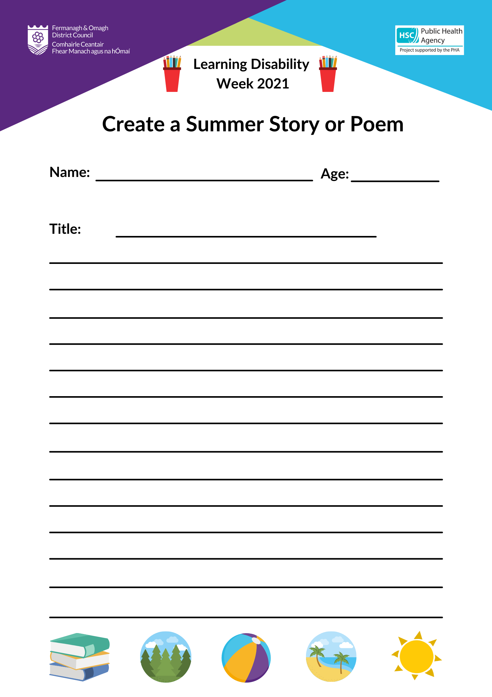

Name: ____________________________ Age: _________

Title: ____________________________________________



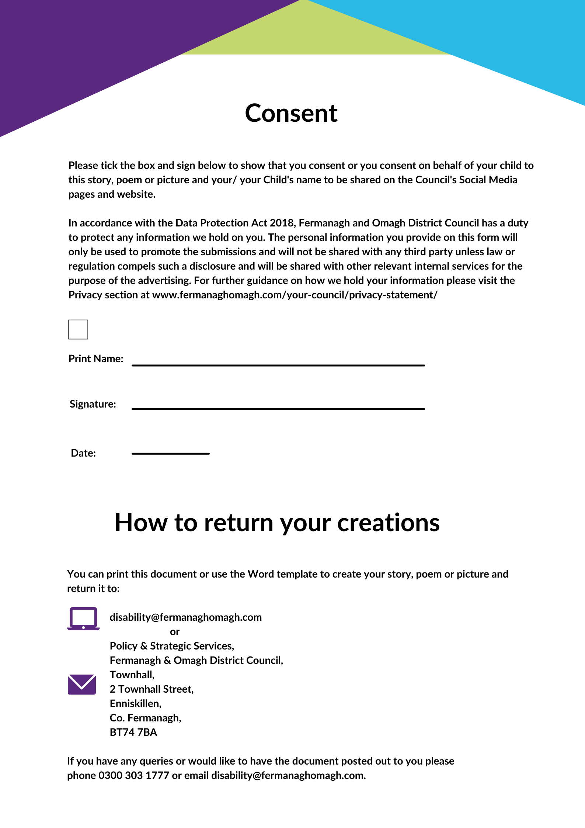

Date:

Signature:

Name: