Fermanagh and Omagh District Council
Draft Disability Action Plan
2025 - 2028
Easy Read Version

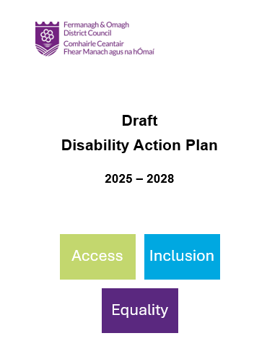

The Draft Disability Action Plan says what we will do in the next 3 years to improve our services and area.
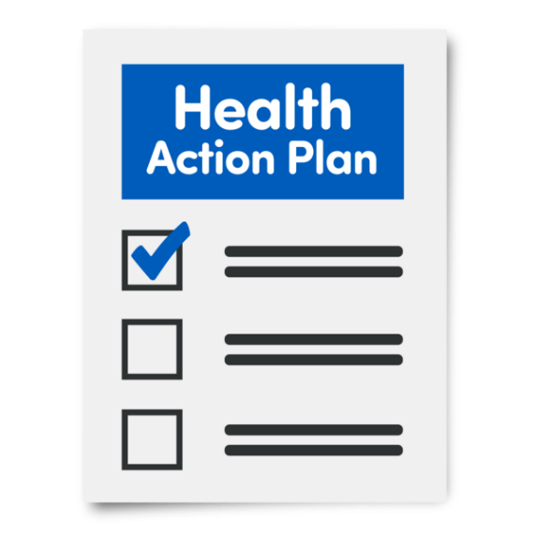
Disability
Action Plan

Actions in the plan come from:
- Feedback from people with disabilities
- Research
- Council priorities

The plan looks at:
- Accessibility of Services
- Inclusive Consultation and Engagement
- Inclusive Programme and Projects
- Awareness Raising and Capacity Building
- Diversity in the Workplace
- Implementation, Review and Screening
- Accessibility of Services
We will:
- Look at physical access at Council buildings
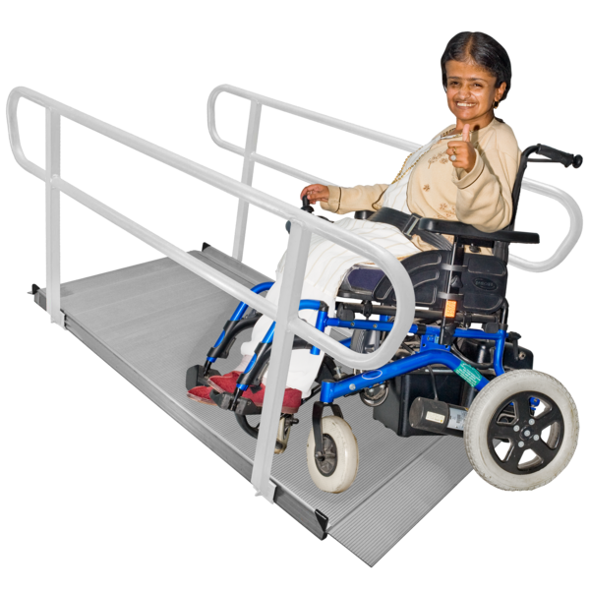
- Create a Changing Places Policy

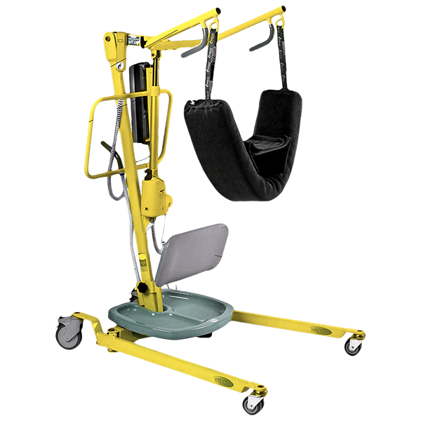
- Develop areas that support neurodiverse people

- Make the Council’s website easier to use


- Make it easier for people with sensory disabilities to communicate with the Council

- Make more easy read documents


- Inclusive Consultation and Engagement
We will:
- Meet 4 times a year with the Access and Inclusion Advisory Group
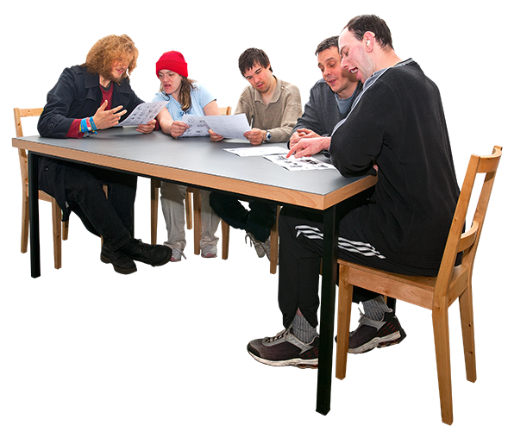
- Speak to the Access Advisory Group about new plans

- Speak with more people with disabilities on policies and plans
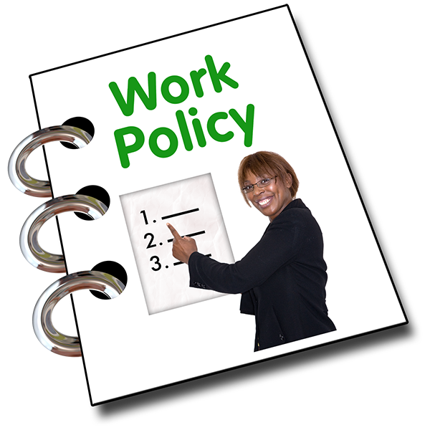
- Speak to people with disabilities about consultations

- Talk to people with disabilities about outside cafes
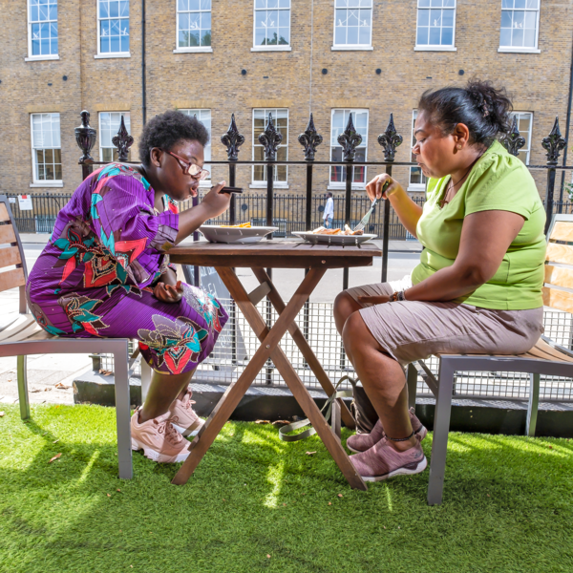
- Work with other organisations

- Inclusive Programmes and Projects
We will:
- Have more activities for people with disabilities including:
Arts and Heritage

Climate Change

Leisure
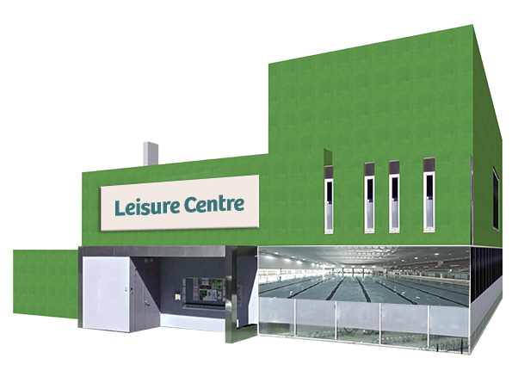
And employment skills


- Have more activities for children and young people with disabilities


- Awareness Rising and Capacity Building
We will:
- Have a Blue Badge Parking Campaign
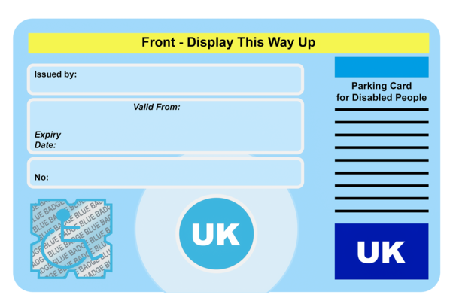
- Ask staff to complete training about different disabilities
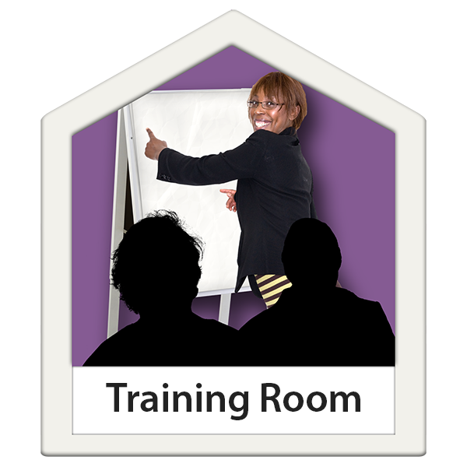
- Celebrate International Day of Persons with Disabilities

- Use more images of people with disabilities
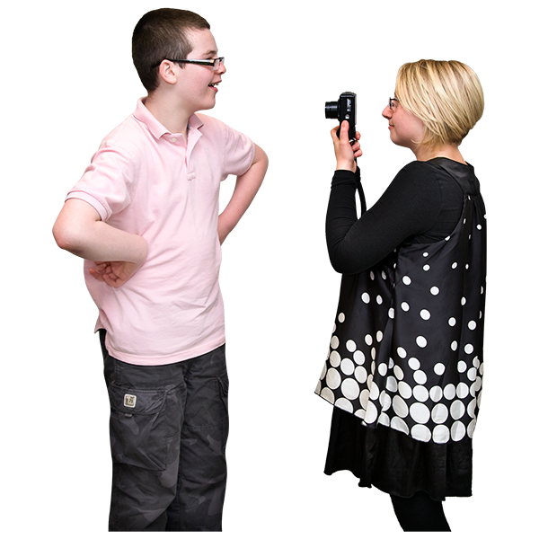

- Support some people with disabilities to shadow the Chair of the Council
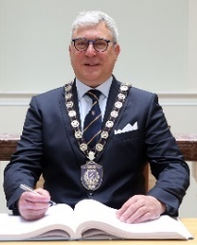

- Diversity in the Workplace
We will:
- Work with organisations to support employees with disabilities

- Help people with disabilities to volunteer
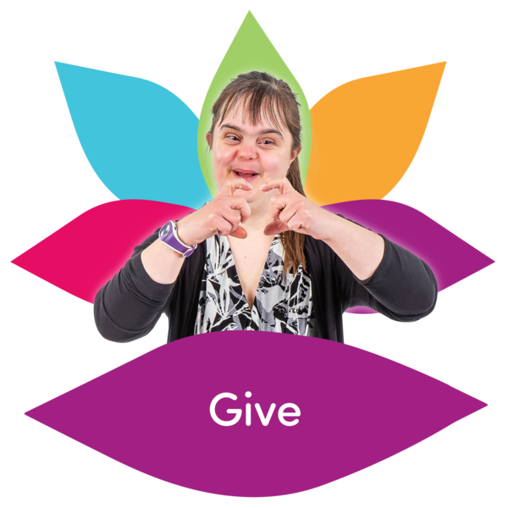
- Review our Work Placement Procedure
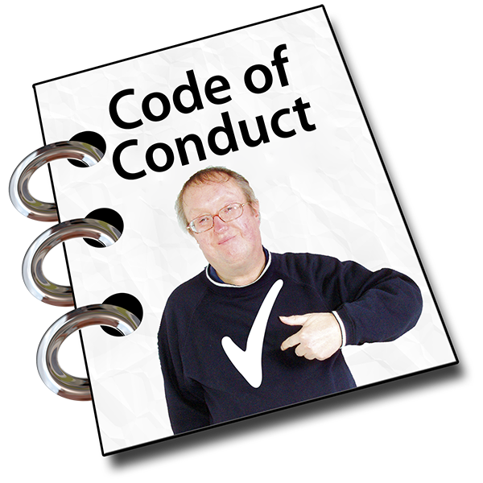
- Provide work placements for people with disabilities


If you would like to provide feedback on this draft plan please
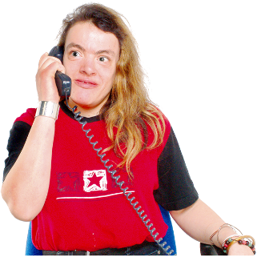
Telephone 0300 303 1777 and ask to speak to the Access Inclusion Officer

Or

Email disability@fermanaghomagh.com

