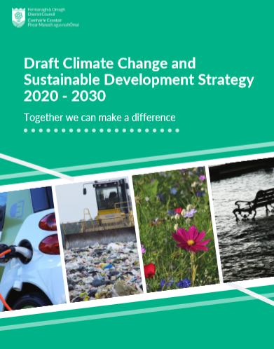
Draft Climate Change and Sustainable Development Strategy
Easy Read Consultation Response Questionnaire

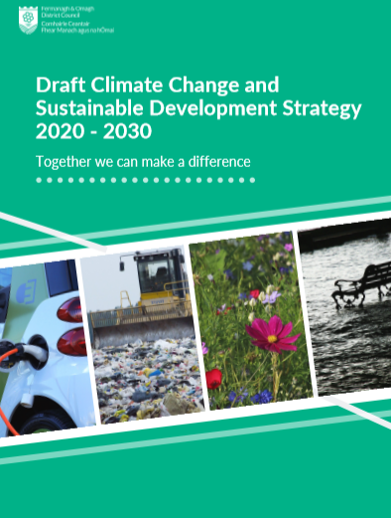 |  | This consultation is about climate change, sustainable development and what we need to do to make things better for the future.
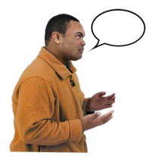 |  | We want to know what you think about our plans
When you have finished this questionnaire, you can send it back to us by:

Email: consultations@fermanaghomagh.com

Post to: Consultation Response,
Policy and Strategic Services, County Buildings, Enniskillen, County Fermanagh. BT74 7BW.

If you wish to tell us your answers on the phone, you can do this by giving us your name and telephone number and a member of staff will call you to help.

Please give us your name and telephone number by using one of the ways below to contact us:

Telephone: 0300 303 1777
Textphone: 028 8225 6216
Email: consultations@fermanaghomagh.com

 | 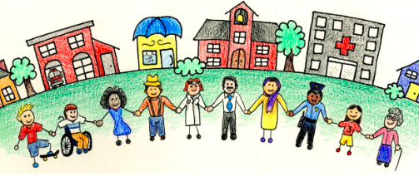 |  | Theme 1: Sustainable Communities  Sustainable communities are places where people want to live now and in the future.
Question 1:
Do you agree with the things that we say we will do to help communities be more sustainable?
Please tick one of (✓) below boxes

Yes ☐
No ☐

If you ticked No, please tell us why in the box below:

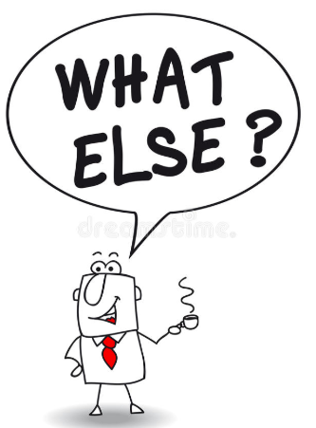 | Question 2:  Are there any other things you think we could do to help communities to be more sustainable?  Please tick one of (✓) below boxes  Yes ☐  No ☐  If you ticked Yes, please tell us more in the box below:

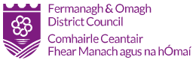 | Theme 2: Sustainable Council  This theme looks at how the Council can be improved.  Question 3:  Do you agree with the things that we say we will do to help improve the Council?  Please tick one of (✓) below boxes  Yes ☐  No ☐  If you ticked No, please tell us why in the box below:

Question 4:
Are there any other things you think we could do to help the Council to improve?

Please tick one of (✓) below boxes

Yes ☐
No ☐

If you ticked Yes, please tell us more in the box below:

Theme 3: Sustainable Environment

A sustainable environment will benefit everyone who lives in, works in or visits the District.

The environment is:

- The air we breathe.
- The water we drink.
- The parks we spend time in.

Question 5:
Do you agree with the things that we say we will do to make the environment better?

Please tick one of (✓) below boxes

Yes ☐
No ☐

If you ticked No, please tell us why in the box below:

Question 6:
Are there any other things you think we could do to make the environment better?

Please tick one of (✓) below boxes

Yes ☐
No ☐

If you ticked Yes, please tell us more in the box below:

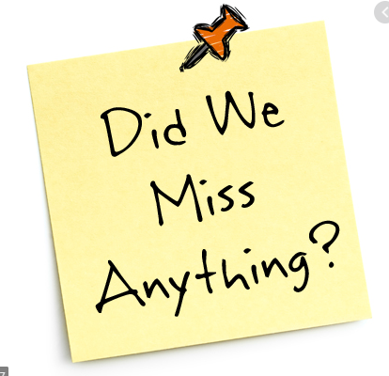 | Question 7: Is there anything else you would like to tell us about our strategy?  If there is, please tell us in the box below:

