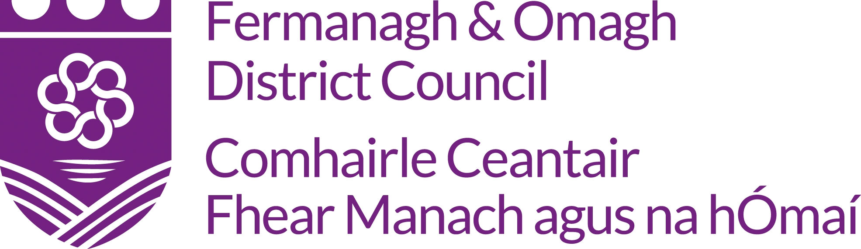
Official Complaint Form

Data Protection
In accordance with the Data Protection Act 2018, Fermanagh and Omagh District Council has a duty to protect any information we hold on you. The personal information you provide on this form will only be used for the purpose of dealing with your complaint. For further guidance on how we hold your information please visit the Privacy section at www.fermanaghomagh.com/your-council/privacy-statement/

Section One: Contact Details
Full Name (including title - Mr/Mrs/Ms)
Postal Address inc Postcode

Email Address
Home and/or Mobile phone number (a phone number would be helpful should we need to contact you for further information)
Preferred method of contact, for response, e.g. email, letter

Section Two: Your Complaint
Name of facility, service or person you are making the complaint about.
When did you first tell the Council about this complaint?
Who did you first contact?
Did you receive a response to your complaint? | Yes/No
Please give full details of your complaint including dates (continue on a separate sheet of paper if necessary).
What would you like the Council to do to put matters right?
Signed:
Date:

If you have any further documents or letters which may be useful, please attach them to this form.

Please send your completed form to:

Policy and Strategic Services
Fermanagh and Omagh District Council
2 Townhall Street
Townhall
Enniskillen
Co Fermanagh
BT74 7BA

Telephone: 0300 303 1777

Textphone: 028 8225 6216

Email: info@fermanaghomagh.com

