OPPORTUNITY TO BID FOR CAFÉ OPERATION AT

VISITOR CENTRE, ENNISKILLEN CASTLE

Document 3 of 8

SPECIFIC INFORMATION AND REQUIREMENTS

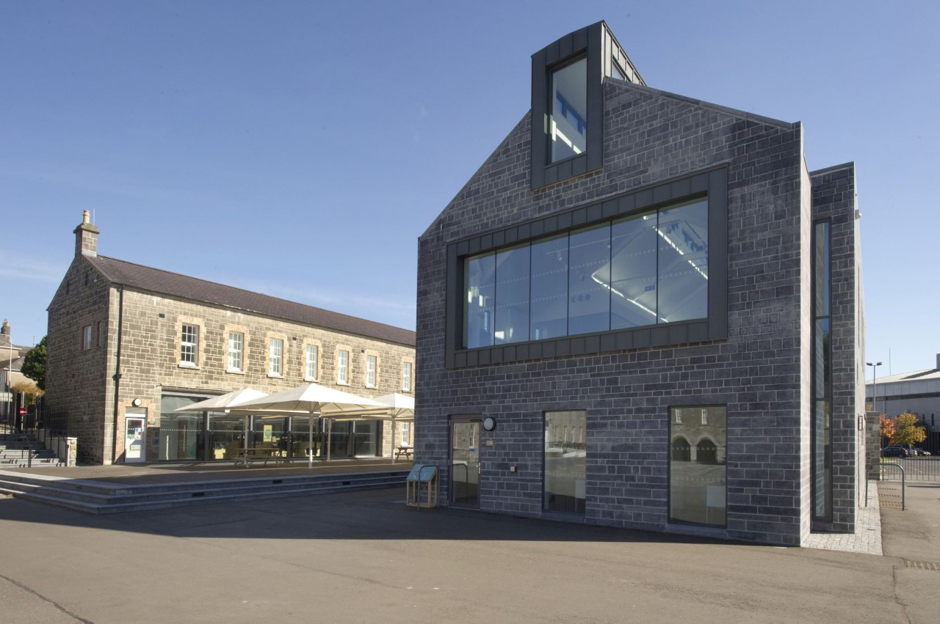

REFERENCE CHL OTB 001
Closing date for submission: no later than 12.00 Noon Friday 14 February 2020.

This document is one of eight parts, as listed below, which together form the Opportunity to Bid information documentation.
Please ensure that no part or page is missing or duplicated.

Document |  | Title
1 |  | General Information and Requirements  This section gives an outline of the requirements, the contract terms and the decision-making process.
2 |  | Instructions to Bidders  This section gives instruction on the process and how to submit a Bid.
3 |  | Specific Information and Requirements – Visitor Centre, Enniskillen Castle  This section details the opportunity, resources and requirements at the Visitor Centre, Enniskillen Castle
SUBMISSION PACKAGE | 4 | Selection Criterion – Compliance Information  This section must be completed by all bidders.
 | 5 | Selection Criterion – Relevant Experience  This section must be completed by all bidders
 | 6 | Award Criterion – Service Delivery  This section must be completed by all bidders; each opportunity for which you are bidding requires a separate submission although the template for the submission is common to all the opportunities.
 | 7 | Award Criterion – Annual Fee Payable  This section must be completed by all bidders; each opportunity for which you are bidding requires a separate submission although the template for the submission is common to all the opportunities.
 | 8 | Checklist  This document lists the documents that are required for a submission to be eligible.

VISITOR CENTRE, ENNISKILLEN CASTLE

Introduction

Following a £3.5 million development project, a new state-of-the-art Visitor Centre opened to the public in August 2016 at the entrance to Enniskillen Castle. The Visitor Centre is the key introductory point for exploring and enjoying Fermanagh's rich heritage for visitors and local communities alike.
The building includes Fermanagh Visitor Information Centre; Museum Reception; Shop; Genealogy Centre; Meeting Room, Discovery Space as well as the Castle Café. The overall Enniskillen Castle complex includes two museums within the historic site as well a major outdoor event space in the courtyard.
Since its refurbishment in 2016, the Castle complex has attracted an increasing number of visitors. In 2018, 65,000 people visited the Castle for visitor information; Castle Café; retail; meetings and conferences; individual and group museum visits; educational activities as well as a major exhibitions and events programme.
This year, the Castle has hosted events such as the Continental Market, Shoreline Music Festival and Festival Lough Erne.
Fermanagh and Omagh District Council is seeking a Caterer to take forward the catering provision for the Visitor Centre. Catering facilities comprise of a ground floor kitchen, server and café area (36 seats). In the summertime, there is also the facility for visitors to sit outside in a covered courtyard space adjacent to the Castle Café.

Opening Hours

 | June - Sept | Oct-May
Mon-Fri | 9.30 am – 5 pm | 9.30 am – 5 pm
Sat | 11 am – 5 pm | 11 am – 5 pm
Sun | 11 am – 5 pm | Closed
Bank Holidays | 9.30 am – 5 pm | 9.30 am – 5 pm

Specific Requirements

Fermanagh and Omagh District Council requires a catering facility to complement the opening hours (above). In the first instance this is six day a week opening (off-season) and seven day a week opening (high season). Fermanagh and Omagh District Council is looking for a service and a menu that complements the vision for the Enniskillen Castle site.

The successful Supplier will be required to enter into a formal Catering Agreement with Council in the format set out in this Agreement and without prejudice to the contents of that Agreement will be expected to:

- deliver consistently high standards, meeting and exceeding client expectations, through professional and experienced catering staff, management and systems.

- offer menu variety, quality and value for money for all aspects of service provision from tea/coffee through to lunch options and corporate hospitality/events catering.

- commit to the implementation of Minimum Nutritional Standards for Catering and the Calorie Wise (Silver) Award.

- cater for a range of events at the facility, ranging from small meetings to medium scale conferencing, to specialist functions and therefore must be able to adapt to varying requests.

- to operate during normal opening hours and at any time outside these hours when a Catering Service is required by service users.

- to consult with the Council on the development of the brand identity and will proactively market this catering service on-site, at related facilities and to appropriate target users.

- to ensure the highest standards of hygiene are attained and maintained in all areas of the Catering Service and that all current legislation and codes of practice relating to food hygiene are adhered to at all times.

- to be responsible for cleaning of the catering areas in compliance with Food Hygiene Regulations and will be responsible for the collection and disposal of litter from the Catering Area(s).

- to review prices annually only in negotiation with and with the consent of Council provided that any such increase must not exceed the annual rate of inflation.

Schedule of Equipment

Kitchen Equipment:

1 | Oven
1 | Extractor
1 | Panini grill
1 | Microwave Oven
1 | Dishwasher
1 | Sink Unit
1 | Inset Sink
1 | Handwash Basin
2 | Undercover Refrigerators
2 | Refrigerator Deli Display

Café Furniture:

All internal café furniture and external seating will be provided by Fermanagh and Omagh District Council.

Café Photos & Floor Plans

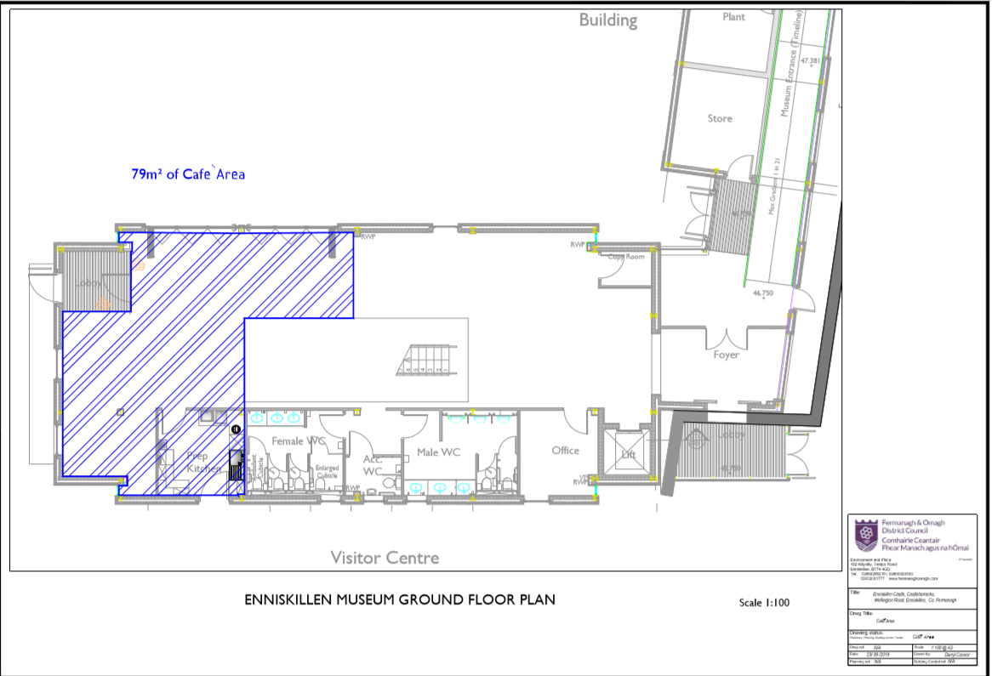

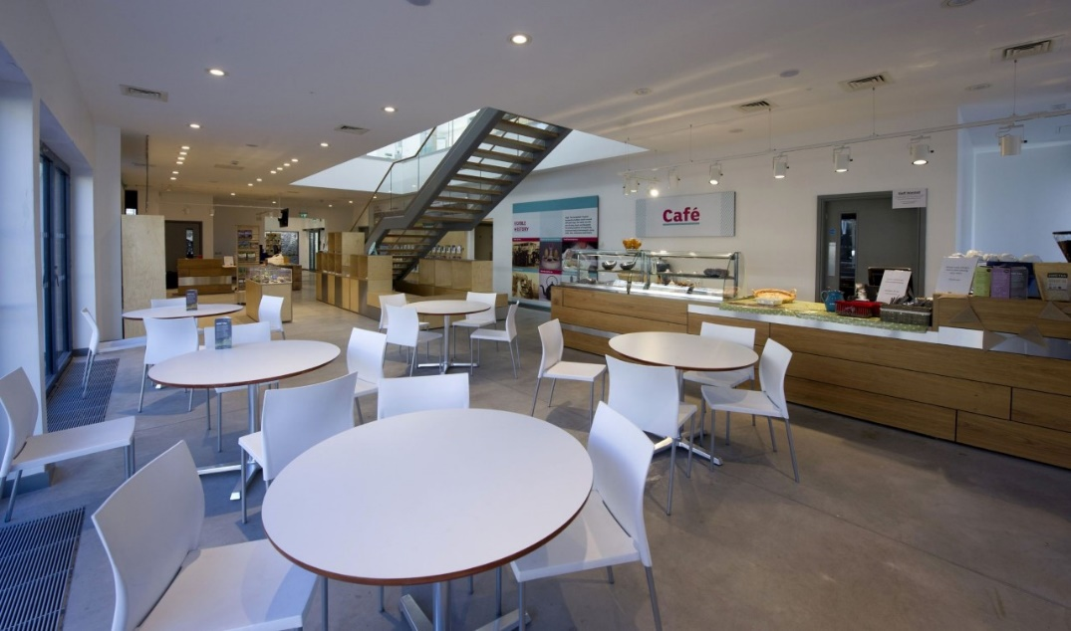
Images of the Café area at the Visitor Centre in Enniskillen Castle.
