OPPORTUNITY TO BID FOR PROVISION OF CAFÉ OPERATION AT VISITOR CENTRE,

ENNISKILLEN MUSEUM

Document 7 of 8

AWARD CRITERION - ANNUAL FEE PAYABLE

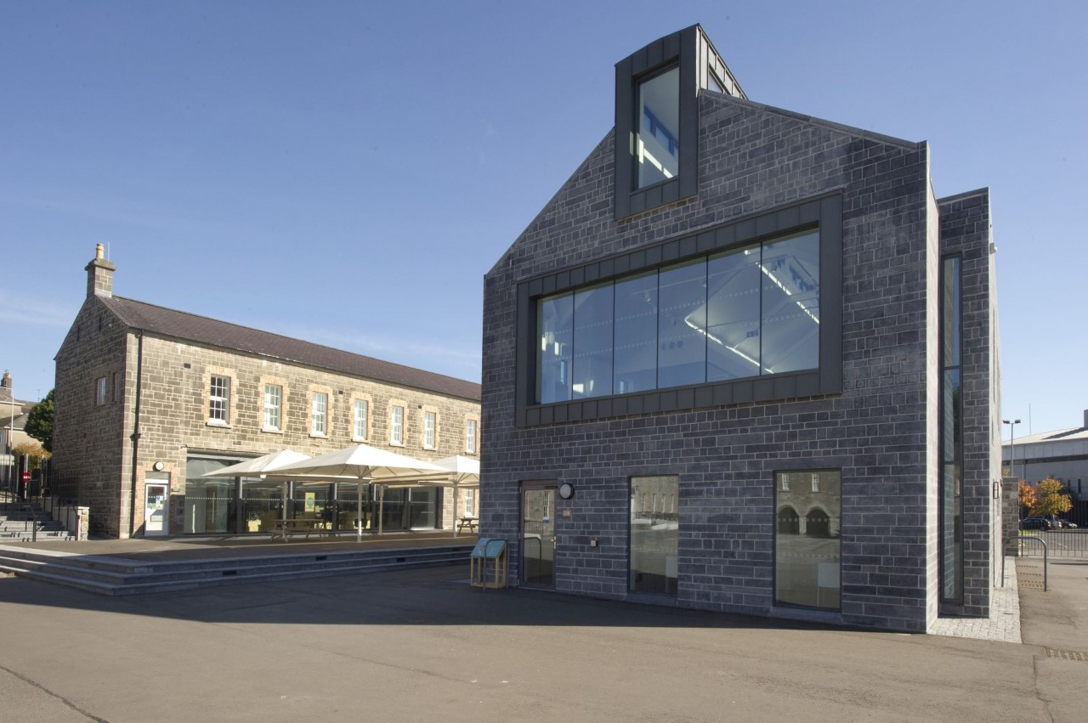

REFERENCE CHL OTB 001
Closing date for submission: no later than 12.00 Noon Friday 14 February 2020.

This document is one of eight parts, as listed below, which together form the Opportunity to Bid information documentation.
Please ensure that no part or page is missing or duplicated.

Document |  | Title
1 |  | General Information and Requirements  This section gives an outline of the requirements, the contract terms and the decision-making process.
2 |  | Instructions to Bidders  This section gives instruction on the process and how to submit a Bid.
3 |  | Specific Information and Requirements – Visitor Centre, Enniskillen Castle  This section details the opportunity, resources and requirements at the Visitor Centre, Enniskillen Castle
SUBMISSION PACKAGE | 4 | Selection Criterion – Compliance Information  This section must be completed by all bidders.
 | 5 | Selection Criterion – Relevant Experience  This section must be completed by all bidders
 | 6 | Award Criterion – Service Delivery  This section must be completed by all bidders; each opportunity for which you are bidding requires a separate submission although the template for the submission is common to all the opportunities.
 | 7 | Award Criterion – Annual Fee Payable  This section must be completed by all bidders; each opportunity for which you are bidding requires a separate submission although the template for the submission is common to all the opportunities.
 | 8 | Checklist  This document lists the documents that are required for a submission to be eligible.

ANNUAL FEE PAYABLE

Name: ____________________________________

Address: ________________________________________

_____________________________________________________

Postcode: ____________________

Telephone: ____________________

Mobile: _____________________

*Email: _______________________________________________

*Please note that this email address may be used for correspondence with regard to this Request for Quotation.

Contact Name (Print in Caps): ___________________________

Position in organisation: ________________________________

Signature: _____________________ Date: _________________

OPPORTUNITY TO BID FORM

To: Fermanagh and Omagh District Council

I / We offer: to pay to Fermanagh and Omagh District Council the following Annual Fee:

Details of Costs

Description | Fee in STG excluding VAT
Annual Fee Payable to Fermanagh and Omagh District Council | ENTER FEE HERE

NOTE:

All fees quoted shall be in pounds Sterling (GBP) and be exclusive of VAT

The cost submission represents the Annual Fee payable to Fermanagh and Omagh District Council.

All additional costs associated with the delivery of services by the Caterer will be their own responsibility. This will include but is not limited to:

- Business Rates
- Electricity usage (by separate metered reading or desk top calculation)
- Waste disposal
- Materials and equipment other than those detailed in the equipment portfolios supplied with the specific details of each franchise opportunity

Fees must include for all elements of the service requirements.

The payment of the Annual Fee to the Council will be on a monthly basis via Standing Order.

