Public Art CommiEnniskillen Public Realm 2021xpression of Interest Pack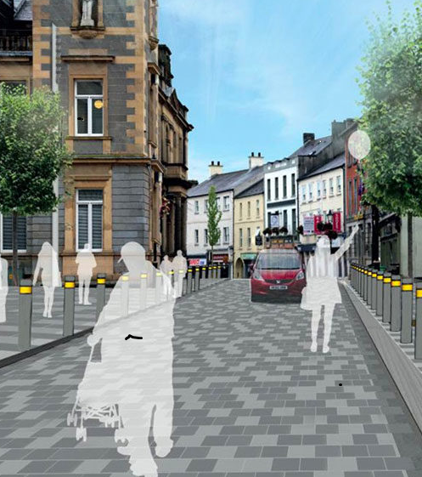

**Public Art Commission**

**Enniskillen Public Realm 2021**

**Expression of Interest Pack**

**Expression of Interest Pack**

Contents

**1.** **INTRODUCTION** 3

**2.** **BACKGROUND** 3

**3.** **THE COMMISSIONS** 3

**4.** **FINANCE** 5

**5.** **QUERIES** 5

**6.** **SELECTION PROCESS** 6

**7.** **SELECTION PANEL** 8

**8.** **SCHEDULE** 8

**9.** **TERMS AND CONDITIONS** 9

**Appendix 1 – What’s in a Name** 11

**Appendix 2 – Map of Locations** 14

**Expression of Interest Form** 15

# **INTRODUCTION**

Fermanagh and Omagh District Council invites Expressions of Interests from artists, designers, architects and/or design teams for the design, fabrication and installation of public art to form part of the £5.2 million Public Real project for Enniskillen.

The Enniskillen Public Realm Scheme, funded by the Department for Communities and Fermanagh and Omagh District Council, will enhance the appearance of the town centre with improvements to footpaths, street lighting, landscaping and street furniture.

Further details of the Enniskillen Public Realm Scheme can be found at https://www.fermanaghomagh.com/enniskillenpublic-realm/.

The public realm improvements give an opportunity to renew the streets and create a more inviting and engaging town for the people who live, work and visit the area.

**The closing date for this Expression of Interest is Friday, 06 November at 12 noon.**

# **BACKGROUND**

Enniskillen is the County Town of Fermanagh, located almost exactly in the Centre of the County on the natural island which separates the Upper and Lower sections of Lough Erne. It is home to a population of approximately 11,500 and is the largest settlement in the County.

The Town Centre is built along the long, narrow main street which changes name six times along its length. Enniskillen has a vibrancy with a strong retail offer of shops with their own unique character. High street stores sit comfortably with small independent traders, creating a special atmosphere for the place. Significant is the proximity of the Lough to the town; Enniskillen is Ireland’s only island town.

The town centre is designated as a Conservation Area and the Conservation Area Guide (<https://www.infrastructure-ni.gov.uk/sites/default/files/publications/infrastructure/enniskillen-ca.pdf>) gives a thorough historical background to the town and description of the townscape character. An article, *What’s in a Name* by Catherine Scott is attached as Appendix 1 and gives good an insight to the experience and history of the town.

# **THE COMMISSIONS**

Fermanagh and Omagh District Council in partnership with a range of stakeholders has identified four sites and opportunities for artist/designer led commissions across the town centre. Potential themes should be indicative and not proscriptive. Locations are marked on the map in Appendix 2.

**3.1 Commission 1 – East Bridge Street (the Intec Centre)**

Theme(s) – The Entrance to the Island Town

This is the gateway to Ireland’s only Island town and Fermanagh and Omagh District Council is seeking to commission a suitable gateway/entrance signage/feature.

Opportunities/Constraints

This is a sensitive site in many respects. It is within the Enniskillen conservation area and adjacent to a listed building. Signage has to be sensitive to this environment in terms of scale, massing and material.

The location is also in proximity to the site of the 1987 Remembrance Sunday bomb.

Basic site preparation to include concrete slab (insert dimensions here) and a power supply will be provided by the contractor.

Budget

A maximum of £20k to include all costs including professional/design fees, fabrication, transport and installation.

**3.2 Commission 2 – The Diamond**

Theme(s); The Centre; The Middle; Meeting.

This is the centre of Enniskillen; a town at the centre of the Lough Erne system. The Diamond was and is a meeting place and a place of commerce.

Opportunities/Constraints

Overlooked by the Townhall, this is a meeting place, a place for events and a place for street traders. It is not large, and Fermanagh and Omagh District Council is keen to ensure that the space remains. It is therefore envisaged that any the commissioned artwork should be in or on the paving or kerbs.

Budget

A maximum of £20k; this is in addition to the cost of the currently specified finishes.

**3.3 Commission 3 – Middleton Street**

Theme(s); Commerce; Trade; Flow

Middleton Street (leading to Water Street and the Buttermarket) was formed in 1876 to allow greater access to the markets. Middleton Street meets with Cross Street leading to Market Street, formerly School House Lane. The area as a whole was known locally as Boston. Cross Street was formerly Cole’s Row and connected Water Lane to School House Lane. The Royal School, located in the grounds of the cathedral was accessed here; it only became Portora Royal School when it moved to the present site in 1777.

Opportunities/Constraints

As part of the public realm scheme a shelter will be installed marked on the map at location 3. This commission provides the opportunity for artists/designers to propose creative interventions on a proprietary/pre-fabricated shelter or artists/architects to propose a design led shelter.

Budget

A maximum of £30k to include all costs including professional/design fees, fabrication, transport and installation.

**2.4 Commission 4 – Throughout the scheme**

Theme – The Story/Stories of the Town

With the exception of war memorials, the memorial at the Paupers' Graveyard and the Torii gate along the river at the workhouse marking the site of the stone jetty, there are few public art or heritage manifestations in Enniskillen. Two examples that serve as echoes of the past are the weighbridge in the Buttermarket and the stone plaques at the rear of the Impartial Reporter.

Opportunities/Constraints

There exists an opportunity for a number of small scale manifestations to suggest the history, heritage and development of the town and tell its story. These may be in the paving, on buildings or as street furniture.

Budget

A maximum of £20k to include all costs including professional/design fees, fabrication, transport and installation.

It is anticipated that the commissions will be undertaken by an artist or design team. It is anticipated that the artist/team selected for the commissions will be expected to address the following requirements:

* the preparation of detailed drawings of the proposed work covering all aspects of the site layout, sculpture, treatment, hard and soft landscaping, any planting and materials;
* presentation of the proposals and materials as required;
* the design, fabrication and installation of the work;
* the preparation of a maintenance schedule for the artwork detailing annual requirements;
* assist in the provision of promotional materials

# **FINANCE**

The maximum budget for each commission is exclusive of VAT.

Budget management will be the responsibility of the commissioned artist/Team.

The budget is fully inclusive of all costs including but not limited to fees (including time, consultation, expenses, third-party expertise), insurance, design, materials, site preparation, production, transport, installation, documentation and taxes. Planning fees and any other statutory permissions will be the responsibility of Fermanagh and Omagh District Council.

Shortlisted artists/teams will be paid a fee of £500 for completing the Stage Two submission/application process.

# **QUERIES**

Artists can submit queries about the commissioning process and this brief by 12 noon on 30th October 2020. Please email any enquiries to **culture@fermanaghomagh.com** with a reference in the subject line “Query: Public Art – EPRPA Commission”.

Bidders should note that responses to all queries will be circulated to all parties who download the invitation documentation, without identifying the source of any requests.

Queries may be answered in batches rather than one at a time. Queries received after the deadline may not be acknowledged or addressed.

In all circumstances, Fermanagh and Omagh District Council reserves the right to issue clarification responses to all enquirers at any stage when it believes, at its sole discretion, such clarifications are required.

Fax, telephone or oral enquires will ***NOT***be accepted.

# **SELECTION PROCESS**

This is a two-stage, open competition.

All submissions will be checked to ensure completeness and compliance of disclosures and declarations exclusions before progressing for review by the Selection Panel.

The Selection Panel will then evaluate submissions against the Shortlisting Criteria (below) with the intention of up to five submissions progressing to Stage 2. Shortlisted artists/teams will be invited to make a more detailed Stage 2 proposal. Following receipt of second stage proposals, the Assessment Panel will make a final decision.

**Stage 1 – EXPRESSION OF INTEREST AND PRE-QUALIFICATION**

Stage One is open to all interested artists and/or design teams.

Submissions should be submitted electronically to **culture@fermanaghomagh.com** by 12 noon on 06 November 2020.

Artists/teams must complete the Expression of Interest Form and provide the following supporting information as part of their submission:

1. CV: please submit an up-to-date curriculum vitae. Maximum 3 pages as a single PDF document.
2. Up to three examples of relevant, previous work, including written descriptions, photographs, All information should be compiled into a single PDF document
3. Proposal outlining:

• Artistic vision for the commission (e.g. concept, process and proposed work);

• How the vision for the work relates to the context and site;

• Visualisations and descriptions of the

Expressions of Interest submitted by the closing date will be assessed in three steps:

Step 1 - Completeness and Compliance (Pass/Fail)

Only submissions that have been received by the closing date, are fully completed and have passed against compliance of Disclosures and Declarations will progress to step 2.

Step 2- Previous Experience (Pass/Fail).

Based on the examples of previous work and the CV, the Selection Panel will assess using the following criteria. Only submissions that have received a pass will progress to Step 3.

|  |  |
| --- | --- |
| **Assessment** | **Indicators** |
| Pass | Sufficient demonstration of skills and experience of delivery of commissions of similar scope and complexity and sufficient evidence of creation of work of quality and originality. |
| Fail | Insufficient demonstration of skills and experience of delivery of commissions of similar scope and complexity and/or insufficient evidence of creation of work of quality and originality. |

Step 3 – Proposal (Scored)

At this stage, a high-level proposal and statement of intent is required. This should indicate an approach to design and project development if selected to proceed to stage 2 of the process.

Based on the proposal for this commission and informed by examples of previous work, the Selection Panel will make a scored assessment against the following criteria:

1. Potential for quality and originality (35%)
2. Approach to concept development and relevance to the context (35%)
3. Approach to stakeholder and project partner engagement (30%)

The following scoring matrix will be used against each of the four criteria:

|  |  |  |
| --- | --- | --- |
| **Assessment** | **Score** | **Indicators** |
| Excellent | 5 | The proposal provides excellent demonstration against the criterion and is fully supported by a comprehensive level of detail.  No omissions and / or weaknesses identified. |
| Very Good | 4 | The proposal provides very good demonstration against the criterion and is very well supported by a comprehensive level of detail.  Only minor omissions and/or weaknesses identified. |
| Good | 3 | The proposal provides good demonstration against the criterion and is supported by a good level of detail.  Some omissions/and or weaknesses identified. |
| Satisfactory | 2 | The proposal provides adequate demonstration against the criterion and is adequately supported by an adequate level of detail.  Significant omissions and/or weaknesses identified. |
| Unsatisfactory | 1 | The proposal provides poor demonstration against the criterion and is unsatisfactorily supported by a poor level of detail.  Major omissions/and or weaknesses have been identified. |
| Nil response/  Very Poor | 0 | No response or unacceptable information provided. |

It is anticipated that the five highest scoring submissions against each commission will be invited to make stage 2 submissions.

**STAGE 2 - SELECTION**

Stage Two will comprise of a limited competition with up to five shortlisted bidders invited by the Selection Panel to make submissions.

A detailed brief will be issued for this stage. Artists/teams will be requested to provide a more comprehensive analysis of the concept, methodology, technical information, time frame and finances of their proposal. The submission will include:

* Concept designs which may take the form drawings, photographs, maquettes, models, computer generated images etc.
* Required site preparation
* Project cost breakdown
* Demonstration of viability
* Timeline/Gantt Chart
* Project Team and sub-Contractors
* Anticipated management and maintenance requirements

Selection will be based on three step process:

Step 1 - Completeness and Compliance (pass/fail)

Step 2 - Feasibility (pass/fail)

Submissions will be required to demonstrate that the proposal is achievable within cost and timeframe and that the proposed work is durable, meets health and safety requirements and will have reasonable whole life costs.

Step 3 – Cost/Quality assessment (scored)

**For this commission and as a requirement of the lead funder cost/quality will be weighted at 20%/80%.**

Quality will be assessed against the following criteria:

1. Quality and originality (25%)
2. Concept and relevance to the theme (25%)
3. Relationship to the location and the site (25%)
4. Project Management and Delivery (25%)

# **SELECTION PANEL**

The selection panel will be comprised of two members from Fermanagh and Omagh District Arts Forum, two members from the Public Realm Steering Groups, officers of Fermanagh and Omagh District Council.

# **SCHEDULE**

08 October 2020 Issue of Artists Brief

30 October 2020 Deadline for Queries

06 November 2020 Closing Date for Expressions of Interest

09 – 13 November 2020 Shortlisting Panel and Selection

16 November 2020 Invitation to participate in Stage 2 issued

December 2020 Site Visits and Briefings

08 January 2021 Closing Date for Stage 2 Submissions

11 January – 22 January 2021 Shortlisting Panel

February – September 2021 Design Development, fabrication and installation

February 2022 Practical Completion; Public Realm Scheme and launched

# **TERMS AND CONDITIONS**

**SPECIFIC TERMS AND CONDITIONS**

**Proposals;** bidders may submit one proposal per commission. Bidders may submit proposals for more than one Commission, however, a separate Expression of Interest Form and supporting materials must be submitted for each commission.

**Fees;** no fees will be paid for Expression of Interest submissions and those making submissions will not be entitled to claim from Fermanagh and Omagh District Council any costs incurred in the preparation of their bids, whether or not it is successful.. Bidders shortlisted will receive a fee for the development of Stage 2 proposals payable on submission of the proposal.

**Whole Life;** the commissioned pieces must be considered as permanent with a lifespan of no less than 25 years.

**Decommissioning;** Provision will be made in the contract in the event that the work(s) have to be moved, placed in storage or removed.

**Copyright and Title;** The copyright, moral and legal rights to all commission drawings, and preliminary works and the completed works will rest with the artist(s). Fermanagh and Omagh District Council will have assigned joint rights to use the images from each stage of the process for press and promotional purposes, and in the event of any publications concerning the commission shall use all materials recognising the artists’ moral rights. On completion, a transfer of the title of the artwork will be made to National Museums NI.

**GENERAL TERMS AND CONDITIONS**

**Late submissions;** submissions received after the closing date and time will not be considered.

**Completed Submissions;** the Expression of Interest Form must be completed in full, signed and submitted with all requisite supporting documents; failure to do this will render your submission invalid.

**Checks;** the Council reserves the right to undertake any other relevant checks on any bidder’s proposed submission.

**Amendments and changes;** should any additions/amendments to this document be deemed necessary prior to the date for submissions, these will be issued to those interested parties downloading this invitation, in the form of Clarification Notices and will form part of the invitation document.

**Submissions;** Fermanagh and Omagh District Council does not bind itself to accept any submission.

**Bribery;** all those who make submissions to comply in full with the requirements of the Bribery Act 2010

**Confidentiality;** Those parties downloading this invitation shall treat the details of the document and any further amendments as Private and Confidential and they must ensure that their submission content, consideration or any other figure or particulars concerning their submission have not been disclosed to any other party.

the bidder shall take all necessary precautions to ensure that all Confidential Information obtained from the Council under or in connection with this invitation:

* is given only to such staff and professional advisors or consultants engaged to advise it in connection with the submission as is strictly necessary for the performance of the submission;
* is treated as confidential and not disclosed (without prior Council approval) or used by any staff or such professional advisors or consultants otherwise than for the purposes of the submission;
* The bidder shall ensure that staff or its professional advisors or consultants are aware of the bidder’s confidentiality obligations under this Invitation.
* The bidder shall not use any confidential Information it receives from the Council otherwise than for the purposes of the submission.
* In the event that the successful bidder fails to comply with this Condition the Council reserves the right to terminate any subsequent agreement by notice in writing with immediate effect.

**Contract;** successful bidders will be issued with a contract, details of which will be made available at Stage 2 of the selection process.

**Insurances;** prior to appointment, successful bidders will be required to have the following insurances:

a. Public Liability Insurance cover of £5 million

b. If applicable, employers Liability Cover of £10 million

**Health and Safety;** all works must comply with Health and Safety standards and successful submission will be subject to Health and Safety checks.

**Child and Vulnerable Adults Protection;** any proposal involving interaction with children, young people and/or vulnerable adults will be conducted in accordance with the Council’s policies on protecting children and vulnerable adults. This may require the successful bidder to undergo an Access NI check and/or receive appropriate training.

**Freedom of Information;** the Council is subject to the terms of the Freedom of Information Act 2000. Bidders should be aware that the information provided in the Expression of Interest could be disclosed in response to a request under the Freedom of Information Act. We will proceed on the basis of disclosure unless an appropriate exemption applies. No information provided will be accepted “in confidence” and the Council accepts no liability for loss as a result of any information disclosed in response to a request under the Freedom of Information Act.

**False Information;** bidders must ensure that all information provided within their tender submission is accurate. The inclusion of information which is found to be false or misleading will result in the tender being rejected. Furthermore, in the event that false or misleading information comes to light after the award of the contract, this may result in termination of the contract.

**Canvassing;** any party that directly or indirectly canvasses any official of the contracting authority in respect of this competition, or who directly or indirectly obtains or attempts to obtain information from such officials concerning the proposed or any other competition will be disqualified.

**Protection of Data;** in accordance with legislation, Fermanagh and Omagh District Council has a duty to protect any information we hold. All personal information you provide will only be used for the purpose of procurement and payment and will not be shared with any third party unless law or regulation compels such a disclosure or in the processing of external funding applications and associated claims. For further guidance on how we hold your information please visit the privacy section at [www.fermanaghomagh.com/your-council/privacy-statement/](http://www.fermanaghomagh.com/your-council/privacy-statement/).

# **Appendix 1 – What’s in a Name**

Camomile Hill to Mossman’s Quay

By Catherine Scott.

Enniskillen, founded by a charter of King James I in 1612, grew as a plantation town under the guidance of Captain William Cole. Cole began with all the obligated buildings & and as an island, bridges at the east & west of the town were a logical addition.

The church, on the site of the present cathedral, was located at the highest point of the town. The diamond & market-house were located at the centre of the town, typical of all plantation town planning. Smaller side streets, lanes and alleyways developed over the centuries, crossing at the Diamond, the Hollow, the church & the streets running parallel to the main thoroughfare.

Looking at the town-its streets, buildings & the significance of street names. Indeed, former street names are often much more informative & interesting than their modern equivalents.

A wonderful illustration of the diversity of street names can be gained by looking at the main residential areas of the town in 1841: Abbey Street, Barrack Street, Dame Street, Darling Street, Eldon Place, Hall’s Lane, Mary Street, Preaching Lane, Strand Street, Beggar Street, Boston, Galbraith’s Row, Padget’s Lane, Pig Market, Pudding Lane, School House Lane, Water Lane & Gaol Street.

The main thoroughfare retains its C17th settlement pattern with a single street running the length of the island. This thoroughfare changes name eight times from the East Bridge, formerly the Draw Bridge & Ann Street.

Take the short walk in your mind. East Bridge Street, dating from the plantation period- the former end house, now demolished was once the post office & later lived in by Richard Hurles, a famous cutler for European Royalty.

Then we meet Regal Pass or Entry, at one time providing access to the water for steamboats such as the “Wide Awake”, operated by Lemon’s Hardware Shop (now Dowlers). Onwards to Townhall Street we pass Nugent’s Entry-Nugent’s Public House once stood on the site. Note too the initials “B.B.C” on the upper edifice of The Northern Bank, representing Belfast Banking Co.,

At the Diamond we meet the Townhall, completed in 1901, at the corner of Water Street, formerly Water Lane. The Diamond was the site of the stock & pillary in the town until 1837. At one time Water Lane was a thriving commercial & residential street, so-called as it provided the most direct route to the water’s edge.

Across from Water Street we meet Eden Street, formerly Pudding Lane or Cole’s Lane.

‘Pudding’ Street because of the slaughter houses located here in the early C19th, two of which were still here in 1836. Much like Water Lane, much of Eden Street is now gone. Gone is Eden House & date-stone formerly attached to 10 Eden Street, which reads: **B.U.L.T by L.H. AD 1731 & now in Fermanagh County Museum.** An 1816 advertisement read: “To be let the dwelling houses, offices and garden of Eden.”

Back to the Diamond & High Street we pass Middleton Street on the right & Paget Lane on the left. Middleton Street was formed in 1876 to allow greater access to the markets. Middleton Street meets with Cross Street leading to Market Street, formerly School House Lane. The area as a whole was known locally as Boston. Cross Street was formerly Cole’s Row and connected Water Lane to School House Lane. The Royal School, located in the grounds of the cathedral was accessed here; it only became Portora Royal School when it moved to the present site in 1777.

Paget (Padget) Lane at one time provided access to the Pig Market from Main Street & Hollow. As suggested by John Mc Cabe it may be that the square & street are so named because of an affiliation between the English House of Paget and the Coles of Florencecourt. Due to this the third Earl of Enniskillen, William Willoughby, expressed the desire that the street and square be called Paget.

Towards the church we meet Blakes of the Hollow or the Bottom Shop and Church Street itself. Beside the church we can run down Bank Lane to Wellington Place. Formed around 1830 & taking its name from the Provincial bank located at the top of the lane, it is of course more widely known as “**Peggy the Bulls”.** It is said to relate to an old woman called Peggy who sold ‘Bulls Eyes’ from a confectionery stall located at the top of the lane.

Peggy may well be Margaret who gave her name to Margaret’s Gutter, an open sewer located in the Hollow that ran from the Broad meadow to the shore at the present Queen Elizabeth Road, formerly Ferry Shore.

Across the top of Hall’s Lane, named after James Hall, a coach agent living here in 1803, & onwards we pass into Darling Street, named after Edward Darling who first leased the land from 1777. Off Darling Street we meet Wesley Street, formerly Hospital Lane, formerly Preaching Lane. The early county hospital (1767) was located on the present site of the Ulster Bank hence Hospital Lane, the hospital then moved to Breandrum. Infirmary or Hospital Lane became Preaching Lane, which then became Wesley Street, with a Wesleyan Methodist Chapel on the site in 1792. From Darling Street we pass the head of Queen Street, formerly Barracks Street or Brewery Lane & into Ann Street. It is here that we will resume our walk next week.

This short walk from bridge to bridge has introduced us to only a small number of the streets. Next week will we stroll to the west of the town to Beggars Row, the Brook, Mossman’s Quay & Willoughby Place. Later, we will go to the east-the Forthill (once Camomile Hill), Frith’s Alley, the Commons & the Fairgreen. We will look too at the lost streets & communities Wellington Place, New Row, “The Back Streets” & Friths Alley.

The town has witnessed many changes & more are planned. However, as you stroll along from bridge to bridge, it is possible to see a great continuity; the main thoroughfare has retained many of its tall elegant buildings. If we look up from the shop fronts to the upper floors we can admire the architecture, the windows & the beauty of the buildings. It is possible to celebrate the architectural heritage of the town & the uniformity of the familiar skyline of steeples, Cole’s Monument, the Townhall & the Watergate.

# **Appendix 2 – Map of Locations**

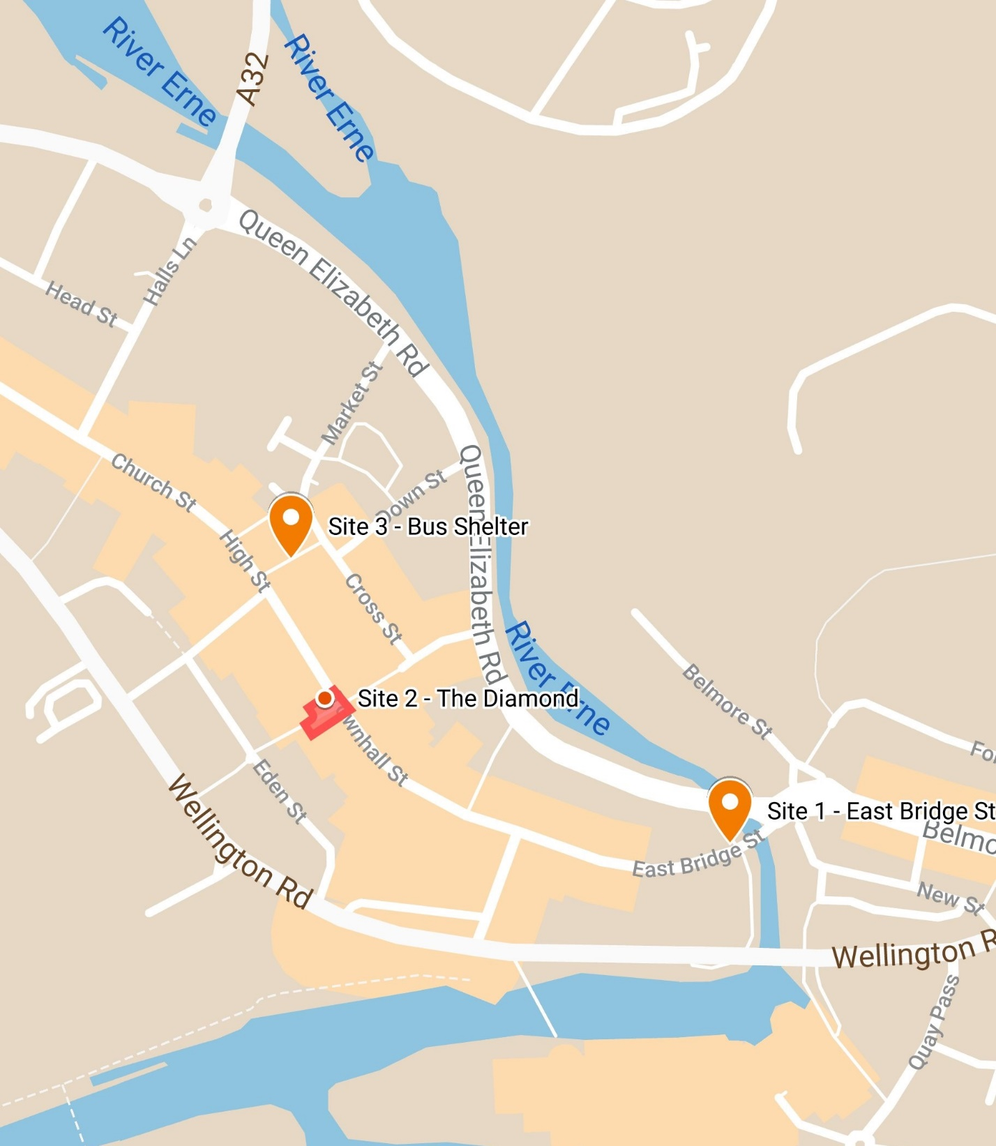



# **Expression of Interest Form**

**Public Art Commissions – Enniskillen Public Realm 2021**

The Closing Date for submission of completed Expressions of Interest is 06 November 2020.

Submissions should be by e-mail to [culture@fermanaghomagh.com](mailto:culture@fermanaghomagh.com) and titled *Submission–EPRPA*.

|  |  |  |  |  |  |
| --- | --- | --- | --- | --- | --- |
| **Section 1. Contact Details** | | | | | |
| **Are you a….** | Individual Artist | Managing Agent | Company/Organisation | Charity/Collective | |
| Other  Please specifyClick or tap here to enter text. | | | | |
| **Name** | Enter Name Here | | | | |
| **Address** | Enter Address Here | | | | |
| **Contact number** | **Tel:**  [Enter number here]  **Mob:**  [Enter number here] | | | | |
| **Email** | [Enter text here] | | | | |
| **Website** | [Enter text here] | | | | |
| **Section 2. Commission**  Please indicate for which commission you are making this submission. You may submit for more than one commission but each must complete a separate submission for each commission opportunity. | | | | | |
| **Commission 1; East Bridge Street** | | | | | ☐ |
| **Commission 2; The Diamond** | | | | | ☐ |
| **Commission 3; Middleton Street** | | | | | ☐ |
| **Commission 4; Throughout the Scheme** | | | | | ☐ |

|  |  |  |
| --- | --- | --- |
| **Section 3. About Your Experience**  In this section you should detail previous experience and should demonstrate that you have the skills, expertise and ability to successfully deliver the commission for which you are expressing interest.  **You must send an up to date Curriculum Vitae**. This should be as a single PDF document of no more than 3 pages and titled EPRPA/*your name/CV*.  **You may submit up to three examples of previous work** and each example you must send accompanying illustrative images. | | |
| **Example of Previous Work 1**  **You must send accompanying illustrative images** in support of this example. These should be presented as a single PDF named *EPRPA/your name/example1*. | | |
| **Name**  Please give the name of the work | [Enter text here] | |
| **Commissioning Body**  Please give the name and address of the commissioning body | [Enter text here] | |
| **Date/s** | From (start date of contract)  [Enter date here mm/yy] | To (date of practical completion)  [Enter date here mm/yy] |
| **Location**  Provide detail of the location and the site | [Enter text here] | |
| **Budget**  Please give the total commission value and detail of what costs were included in the commission | [Enter text here] | |
| **Description**  Give a description including detail of concept & design development, materials, fabrication and installation. If applicable, describe any community and stakeholder engagement undertaken as part of the commission. You must be clear about your role and the tasks that you undertook.  **(Maximum 250 words)** | [Enter text here] | |
| **Referee**  Give name and contact details of a referee. | [Enter text here] | |

|  |  |  |
| --- | --- | --- |
| **Example of Previous Work 2**  **You must send accompanying illustrative images** in support of this example. These should be presented as a single PDF named *EPRPA/your name/example*2 | | |
| **Name**  Please give the name of the work | [Enter text here] | |
| **Commissioning Body**  Please give the name and address of the commissioning body | [Enter text here] | |
| **Date/s** | From (start date of contract)  [Enter date here mm/yy] | To (date of practical completion)  [Enter date here mm/yy] |
| **Location**  Provide detail of the location and the site | [Enter text here] | |
| **Budget**  Please give the total commission value and detail of what costs were included in the commission | [Enter text here] | |
| **Description**  Give a description including detail of concept & design development, materials, fabrication and installation. If applicable, describe any community and stakeholder engagement undertaken as part of the commission. You must be clear about your role and the tasks that you undertook.  **(Maximum 250 words)** | [Enter text here] | |
| **Referee**  Give name and contact details of a referee. | [Enter text here] | |

|  |  |  |
| --- | --- | --- |
| **Example of Previous Work 3**  **You must send accompanying illustrative images** in support of this example. These should be presented as a single PDF named *EPRPA/your name/example3*. | | |
| **Name**  Please give the name of the work | [Enter text here] | |
| **Commissioning Body**  Please give the name and address of the commissioning body | [Enter text here] | |
| **Date/s** | From (date of contract)  [Enter date here mm/yy] | To (date of practical completion)  [Enter date here mm/yy] |
| **Location**  Provide detail of the location and the site | [Enter text here] | |
| **Budget**  Please give the total commission value and detail of what costs were included in the commission | [Enter text here] | |
| **Description**  Give a description including detail of concept & design development, materials, fabrication and installation. If applicable, describe any community and stakeholder engagement undertaken as part of the commission. You must be clear about your role and the tasks that you undertook.  **(Maximum 250 words)** | [Enter text here] | |
| **Referee**  Give name and contact details of a referee. | [Enter text here] | |

|  |  |
| --- | --- |
| **Section 4. Your Proposal**  In this section you should give a high-level statement of outlining your vision for this commission. You may support this with statement with visualisations. You should send these as a single PDF and title it EPRPA/*your name*/Proposal. | |
| **Working Title** | [Enter text here] |
| **Description**  Give a brief written statement including:   * Artistic Vision for the commission including concept and process for design development * How you would develop your proposal related to the location and the site * Possible materials, fabrication methods and installation requirements * Your methodology for engaging with stakeholders   **(Maximum 1500 words)** | [Enter text here] |

|  |  |  |
| --- | --- | --- |
| **Section 5. Disclosures and Declarations**  You must complete this section. | | |
| **Acknowledgement**  I have read and understood the General and specific Terms and Conditions detailed in the Expression of Interest Pack | |  |
| **Mandatory Exclusions**  Please indicate below whether you or your organisation or any of its directors, partners or any other person who has powers of representation, decision or control, have been convicted of any of the following offences (including those which are spent within the meaning of the Rehabilitation of Offenders Act 1974):   1. Conspiracy within the meaning of section 1 or 1a of the Criminal Law Act 1977 or article 9 or 9a of the Criminal Attempts and Conspiracy (Northern Ireland) order 1983 where that conspiracy relates to participation in a criminal organisation as defined in Article 2(1) of Council Framework Decision 2008/841/ JHA 2. Corruption within the meaning of section 1 of the Public Bodies Corrupt Practices Act 1889 or section 1 of the Prevention of Corruption Act 1906   3a. The offence of bribery, where the offence relates to active corruption;  3b. Bribery within the meaning of section 1 or 6 of the Bribery Act 2010  4. Fraud, where the offence relates to fraud affecting the financial interests of the European Communities as defined by Article 1 of the Convention relating to the protection of the financial interests of the European Union, within the meaning of:-   * + the offence of cheating the Revenue;   + the offence of conspiracy to defraud;   + fraud or theft within the meaning of the Theft Act 1968 and the Theft Act 1978 or the Theft (Northern Ireland) order 1978   + fraudulent trading within the meaning of section 458 of the Companies Act 1985, article 451 of the Companies (Northern Ireland) Order 1986 or section 993 of the Companies Act 2006   + defrauding the Customs within the meaning of the Customs and Excise Management Act 1979 and the Value Added Tax Act 1994;   + an offence in connection with taxation in the European Community within the meaning of section 71 of the Criminal Justice Act 1993; or   + destroying, defacing or concealing of documents or procuring the extension of a valuable security within the meaning of section 20 of the Theft Act 1968, or Section 19 of the Theft Act (Northern Ireland) 1969   + Fraud within the meaning of Section 2, or 3 or 4 of the Fraud Act 2006   + Making, adapting, supplying or offering to supply articles for use in frauds within the meaning of section 7 of Fraud Act 2006  1. Money laundering within the meaning of Money Laundering Regulations 2003   6a. Any other offence within the meaning of Article 45(1) of the Public Sector Directive as defined by the national law of any relevant State  6b. an offence in connection with the proceeds of criminal conduct within the meaning of section 93A, 93B or 93C of the Criminal Justice Act 1988 or article 45, 46 or 47 of the Proceeds of Crime (Northern Ireland) Order 1996  6c. An offence in connection with the proceeds of drug trafficking within the meaning of section 49, 50 or 51 of the Drug Trafficking Act 1994; or  6d. any other offence within the meaning of Article 45(1) of the Public Sector Directive as defined by the national law of any relevant State. | | Choose an item.  If you have indicated “yes” Fermanagh and Omagh District Council will contact you for further details. |
| **Freedom of Information**  I acknowledge that Fermanagh and Omagh District Council is subject to the terms of the Freedom of Information Act 2000 and that the information provided in this Expression of Interest could be disclosed in response to a request under this act. | |  |
| **Accuracy of Information**  I acknowledge that that all information provided within their tender submission is accurate. The inclusion of information which is found to be false or misleading will result in the Expression of Interest being rejected. Furthermore, in the event that false or misleading information comes to light after the award of the contract, this may result in termination of the contract. | |  |
| **Insurance**  I confirm that I am willing to put in place the required insurance cover if successful.  Please note evidence of Insurance cover will be required at Award Stage. | |  |
| **Equality Declaration**  I confirm that I will not to act in any way that would contravene the Council’s statutory obligations and are committed to promoting good relations and equality of opportunity in all our activities (including in the recruitment, promotion and training of all our staff).  Under Section 75 of the Northern Ireland Act 1998 Fermanagh and Omagh District Council must have due regard to the need to promote equality of opportunity between persons of different religious belief, political opinion, racial group, age, marital status or sexual orientation; between men and women generally; between persons with a disability and persons without; between persons with dependants and persons without.  The Council must also have regard to the desirability of promoting good relations between persons of different religious belief, political opinion or racial group. | |  |
| **Fair Employment**  I confirm that I am not unqualified for the purposes of Article 64 to 66 of the Fair Employment and Treatment (Northern Ireland) Act 1998 and undertake to inform Fermanagh and Omagh District Council should any notice stating that I am/we are unqualified be served upon me/us by the Equality Commission. | |  |
| **Financial Standing**  I confirm that I or the group/organisation submitting this application is of good financial standing and acknowledge that if successful I may be asked to provide further detail. | |  |
| **Personal Data**  I consent that my details are shared with the relevant Council services and project partners for purposes of this Expression of Interest.  I consent that the relevant Council services contact me for the purposes of this Expression of Interest. | |  |
| **Name**  **Date**  **Signed**  **On behalf of (if applicable)**  **Position (if applicable)** | [Enter Name here]  [Enter Date here]  [Enter Organisation here]  [Enter Position here] | |