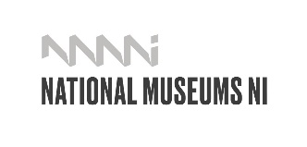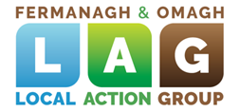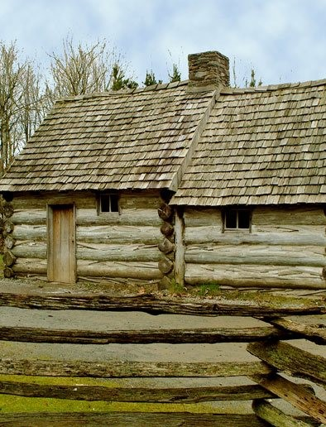

**Public Art Commission**

**Ulster American Folk Park; The International Appalachian Trail 2021**

**Expression of Interest**

**Instructions and Guidance Notes**

Contents

**1.** **INTRODUCTION** 2

**2.** **BACKGROUND** 2

**3.** **THE COMMISSION** 3

**4.** **FINANCE** 4

**5.** **QUERIES** 4

**6.** **SELECTION PROCESS** 4

**7.** **SELECTION PANEL** 7

**8.** **SCHEDULE** 7

**9.** **TERMS AND CONDITIONS** 7

**Appendix 1 – Site Plan and Images** 10

**Expression of Interest Form** 11

# **INTRODUCTION**

As part of the development of the International Appalachian Trail, Fermanagh and Omagh District Council in partnership with National Museums NI wish to commission public art to be located at the Ulster American Folk Park in Omagh.

This is a two-stage open competition with Expressions of Interest invited from suitable qualified and experienced artists and design teams.

The closing date for submission of Expressions of Interest is 12 noon on 07 December 2020.

Artists/teams selected through the Expression of Interest assessment will then be paid a fee to prepare a detailed proposal.

# **BACKGROUND**

**The International Appalachian Trail**

The Appalachian National Scenic Trail, generally known as the Appalachian Trail or simply the A.T., is a marked hiking trail in the Eastern United States extending between Springer Mountain in Georgia and Mount Katahdin in Maine. The trail is about 2,200 miles (3,500 km) long, though the exact length changes over time as parts are modified or rerouted. It is the longest hiking-only trail in the world. More than 2 million people are said to take a hike on part of the trail at least once each year.

The International Appalachian Trail (IAT) is an extension of the original trail from the northern terminus of the Appalachian Trail at Mount Katahdin, Maine, through New Brunswick, to the Gaspé Peninsula of Quebec, after which it follows a ferry route to Newfoundland, and then continues to the northern-easternmost point of the Appalachian Mountains at Belle Isle, Newfoundland and Labrador.

Since 2009 with a series of international partners there were IAT walking trails in Greenland, Iceland, Norway, Sweden, Denmark, Scotland, Northern Ireland, Ireland, Isle of Man, Wales, England, France, Spain, Portugal and Morocco.

In 2014 the IAT Ulster-Ireland section was developed. The IAT continues to expand into new areas of Appalachian Terrains, based on the original premise that the trail will eventually connect all the mountains that were created when the ancient continent Pangaea was formed 300 million years ago.

Further details on the International Appalachian Trail can be found at:

<http://www.appalachiantrail.org/>

<https://www.iat-sia.org/about>

<http://www.walkni.com/iat/>

**The Ulster American Folk Park**

The Ulster American Folk Park is an open-air museum that examines and explores emigration from Ulster to America in the 18th, 19th and early 20th century. Its buildings reflect the vernacular tradition of both rural Ulster and frontier America. The museum portrays the lifestyles of people on both sides of the Atlantic and the strong links between both societies. We provide through our ‘living museum’ concept, experiences and interpretation that engage directly with the visitor encouraging a participative approach. We deliver an annual programme of exhibitions and activities on the theme of folk life and migration with the aim of attracting audience from home and abroad.

Further details on the International Appalachian can be found at:

<https://www.nmni.com/our-museums/ulster-american-folk-park/Home.aspx>

# **THE COMMISSION**

This is an open commission with no pre-determined expectation in terms of the nature of the work. It may be functional or figurative, representational or abstract. It must, however, have a resonance with the connections between Tyrone, Northern Ireland and Appalachia. Artists/teams should consider what the Ulster American Folk Park and the *New World* aspect of the museum, think about the human links between Ulster and Appalachia and consider the geology that underpins the IAT.

Partners are keen that the artwork is unique and of high quality, becoming a recognised feature for visitors and users of this area. A key ambition is that the work is original, that it is artistically strong, that it acts as a recognisable feature within the environment and that it is durable.

The work will be located outside the visitors centre at the Ulster American Folk park (see Appendix 1). Consideration needs to be given to access, visual and physical, to the site and to the environment. Services such as electricity, can be provided to the proposed artwork. Detailed technical survey information on services and ground conditions can be provided to shortlisted candidates. At present there are no planning considerations for this project, however, the proposals for the commission are likely to be subject to planning controls. Artworks must be designed to minimise future maintenance costs.

It is anticipated that the commission will be undertaken by an artist or design team. It is anticipated that the artist selected for the commission will be expected to address the following requirements:

* the preparation of detailed drawings of the proposed work covering all aspects of the site layout, sculpture, treatment, hard and soft landscaping, any planting and materials;
* presentation of the proposals and materials as required;
* the design, fabrication and installation of the work;
* the preparation of a maintenance schedule for the artwork detailing annual requirements;
* assist in the provision of promotional materials

Ulster American Folk Park, National Museums Northern Ireland and Fermanagh and Omagh District Council will prepare press and promotional materials concerning the commission including the use of images on websites and social media in relation to public consultation and all media work.

It is hoped that the commission will provide opportunities for exhibition to be agreed with partners and the appointed artist/team at Stage 2. Any artists costs incurred in preparing work for exhibition will be met within the fees for the commission.

# **FINANCE**

The total maximum budget for this commission is £80,000. This excludes VAT.

Budget management will be the responsibility of the commissioned artist/Team.

The budget is fully inclusive of all costs including, but not limited to, fees (including time, consultation, expenses, third-party expertise), insurance, design, materials, site preparation, production, transport, installation, documentation and taxes.

Shortlisted artists/teams will be paid a fee of £750 for completing the Stage Two submission/application process.

# **QUERIES**

Artists can submit queries about the commissioning process and this brief by 12 noon on 27 November 2020. Please email any enquiries to artsandheritage@fermanaghomagh.com with a reference in the subject line “Query: Public Art – IAT Commission”.

Bidders should note that responses to all queries will be circulated to all parties who download the invitation documentation, without identifying the source of any requests.

Queries may be answered in batches rather than one at a time. Queries received after the deadline may not be acknowledged or addressed.

In all circumstances, Fermanagh and Omagh District Council reserves the right to issue clarification responses to all enquirers at any stage when it believes, at its sole discretion, such clarifications are required.

Fax, telephone or oral enquires will ***NOT***be accepted.

# **SELECTION PROCESS**

This is a two-stage, open competition.

All submissions will be checked to ensure completeness and compliance of disclosures and declarations exclusions before progressing for review by the Selection Panel.

The Selection Panel will then evaluate submissions against the Shortlisting Criteria (below) with the intention of up to five submissions progressing to Stage 2. Shortlisted artists/teams will be invited to make a more detailed Stage 2 proposal. Following receipt of second stage proposals, the Assessment Panel will make a final decision.

**Stage 1 – EXPRESSION OF INTEREST AND PRE-QUALIFICATION**

Stage One is open to all interested artists and/or design teams.

Submissions should be submitted electronically to [artsandheritage@fermanaghomagh.com](mailto:artsandheritage@fermanaghomagh.com) by 12 noon on 07 December 2020.

Artists/teams must completed the Expression of Interest Form and provide the following supporting information as part of their submission:

1. CV: please submit an up-to-date curriculum vitae. Maximum 3 pages as a single PDF document.
2. Up to three examples of relevant, previous work, including written descriptions, photographs, All information should be compiled into a single PDF document
3. Proposal outlining:

• Artistic vision for the commission (e.g. concept, process and proposed work);

• How the vision for the work relates to the context and site;

• Visualisations and descriptions of the

Expressions of Interest submitted by the closing date will be assessed in three steps:

Step 1 - Completeness and Compliance (Pass/Fail)

Only submissions that have been received by the closing date, are fully completed and have passed against compliance of Disclosures and Declarations will progress to step 2.

Step 2- Previous Experience (Pass/Fail).

Based on the examples of previous work and the CV, the Selection Panel will assess using the following criteria. Only submissions that have received a pass will progress to Step 3.

|  |  |
| --- | --- |
| **Assessment** | **Indicators** |
| Pass | Sufficient demonstration of skills and experience of delivery of commissions of similar scope and complexity and sufficient evidence of creation of work of quality and originality. |
| Fail | Insufficient demonstration of skills and experience of delivery of commissions of similar scope and complexity and/or insufficient evidence of creation of work of quality and originality. |

Step 3 – Proposal (Scored)

Based on the proposal for this commission, the Selection Panel will make a scored assessment against the following criteria:

1. Quality and originality (25%)
2. Concept and relevance to the context (25%)
3. Stakeholder and project partner engagement (25%)
4. Technical and financial feasibility (25%)

The following scoring matrix will be used against each of the four criteria:

|  |  |  |
| --- | --- | --- |
| **Assessment** | **Score** | **Indicators** |
| Excellent | 5 | The proposal provides excellent demonstration against the criterion and is fully supported by a comprehensive level of detail.  No omissions and / or weaknesses identified. |
| Very Good | 4 | The proposal provides very good demonstration against the criterion and is very well supported by a comprehensive level of detail.  Only minor omissions and/or weaknesses identified. |
| Good | 3 | The proposal provides good demonstration against the criterion and is supported by a good level of detail.  Some omissions/and or weaknesses identified. |
| Satisfactory | 2 | The proposal provides adequate demonstration against the criterion and is adequately supported by an adequate level of detail.  Significant omissions and/or weaknesses identified. |
| Unsatisfactory | 1 | The proposal provides poor demonstration against the criterion and is unsatisfactorily supported by a poor level of detail.  Major omissions/and or weaknesses have been identified. |
| Nil response/  Very Poor | 0 | No response or unacceptable information provided. |

It is anticipated that the five highest scoring submissions will be invited to make stage 2 submissions.

**STAGE 2 - SELECTION**

Stage Two will comprise of a limited competition with up to five shortlisted bidders invited by the Selection Panel to make submissions.

A detailed brief will be issued for this stage. Artists/teams will be requested to provide a more comprehensive analysis of the concept, methodology, technical information, time frame and finances of their proposal. The submission will include:

* Concept designs which may take the form drawings, photographs, maquettes, models, computer generated images etc.
* Required site preparation
* Project cost breakdown
* Demonstration of viability
* Timeline/Gantt Chart
* Project Team and sub-Contractors
* Anticipated management and maintenance requirements

Selection will be based on three step process:

Step 1 - Completeness and Compliance (pass/fail)

Step 2 - Feasibility (pass/fail)

Submissions will be required to demonstrate that the proposal is achievable within cost and timeframe and that the proposed work is durable, meets health and safety requirements and will have reasonable whole life costs.

Step 3 – Cost/Quality assessment (scored)

**For this commission and as a requirement of the lead funder cost/quality will be weighted at 50%/50%.**

Quality will be assessed against the following criteria:

1. Quality and originality (25%)
2. Concept and relevance to the theme (25%)
3. Relationship to the location and the site (25%)
4. Project Management and Delivery (25%)

# **SELECTION PANEL**

The selection panel will be comprised of two representatives from National Museums NI, two representatives from Fermanagh and Omagh District Council and a representative from the Local Action Group.

# **SCHEDULE**

02 November 2020 Issue of Artists Brief

27 November 2020 Deadline for Queries

07 December 2020 Closing Date for Expressions of Interest

08 – 11 December 2020 Shortlisting Panel and Selection

14 December 2020 Invitation to participate in Stage 2 issued

18 January 2021 Closing Date for Stage 2 Submissions

19 - 29 January 2021 Shortlisting Panel

01 February 2021 Appointment of Artist

February – August 2021 Design Development and Fabrication

September 2021 Installation and Launch

# **TERMS AND CONDITIONS**

**SPECIFIC TERMS AND CONDITIONS**

**Fees;** no fees will be paid for Expression of Interest submissions and those making submissions will not be entitled to claim from Fermanagh and Omagh District Council any costs incurred in the preparation of their bids, whether or not it is successful. Bidders shortlisted will receive a fee for the development of Stage 2 proposals payable on submission of the proposal.

**Whole Life;** the commissioned pieces must be considered as permanent with a lifespan of no less than 25 years.

**Decommissioning;** Provision will be made in the contract in the event that the work(s) have to be moved, placed in storage or removed.

**Copyright and Title;** The copyright, moral and legal rights to all commission drawings, and preliminary works and the completed works will rest with the artist(s). Fermanagh and Omagh District Council and National Museums NI will have assigned joint rights to use the images from each stage of the process for press and promotional purposes, and in the event of any publications concerning the commission shall use all materials recognising the artists’ moral rights. On completion, a transfer of the title of the artwork will be made to National Museums NI.

**Proposals;** bidders may submit a maximum of three proposals. However, a separate Expression of Interest Form and supporting materials must be submitted for each proposal.

**GENERAL TERMS AND CONDITIONS**

**Late submissions;** submissions received after the closing date and time will not be considered.

**Completed Submissions;** the Expression of Interest Form must be completed in full, signed and submitted with all requisite supporting documents; failure to do this will render your submission invalid.

**Checks;** the Council reserves the right to undertake any other relevant checks on any bidder’s proposed submission.

**Amendments and changes;** should any additions/amendments to this document be deemed necessary prior to the date for submissions, these will be issued to those interested parties downloading this invitation, in the form of Clarification Notices and will form part of the invitation document.

**Submissions;** Fermanagh and Omagh District Council does not bind itself to accept any submission.

**Bribery;** all those who make submissions to comply in full with the requirements of the Bribery Act 2010

**Confidentiality;** Those parties downloading this invitation shall treat the details of the document and any further amendments as Private and Confidential and they must ensure that their submission content, consideration or any other figure or particulars concerning their submission have not been disclosed to any other party.

the bidder shall take all necessary precautions to ensure that all Confidential Information obtained from the Council under or in connection with this invitation:

* is given only to such staff and professional advisors or consultants engaged to advise it in connection with the submission as is strictly necessary for the performance of the submission;
* is treated as confidential and not disclosed (without prior Council approval) or used by any staff or such professional advisors or consultants otherwise than for the purposes of the submission;
* The bidder shall ensure that staff or its professional advisors or consultants are aware of the bidder’s confidentiality obligations under this Invitation.
* The bidder shall not use any confidential Information it receives from the Council otherwise than for the purposes of the submission.
* In the event that the successful bidder fails to comply with this Condition the Council reserves the right to terminate any subsequent agreement by notice in writing with immediate effect.

**Contract;** successful bidders will be issued with a contract, details of which will be made available at Stage 2 of the selection process.

**Insurances;**. prior to appointment, successful bidders will be required to have the following insurances:

a. Public Liability Insurance cover of £5 million

b. If applicable, employers Liability Cover of £10 million

**Health and Safety;** all works must comply with Health and Safety standards and successful submission will be subject to Health and Safety checks.

**Child and Vulnerable Adults Protection;** any proposal involving interaction with children, young people and/or vulnerable adults will be conducted in accordance with the Council’s Policies on protecting children and vulnerable adults. This may require the successful bidder to undergo n Access NI check and/or receive appropriate training.

**Freedom of Information;** the Council is subject to the terms of the Freedom of Information Act 2000. Bidders should be aware that the information provided in the Expression of Interest could be disclosed in response to a request under the Freedom of Information Act. We will proceed on the basis of disclosure unless an appropriate exemption applies. No information provided will be accepted “in confidence” and the Council accepts no liability for loss as a result of any information disclosed in response to a request under the Freedom of Information Act.

**False Information;** bidders must ensure that all information provided within their tender submission is accurate. The inclusion of information which is found to be false or misleading will result in the tender being rejected. Furthermore, in the event that false or misleading information comes to light after the award of the contract, this may result in termination of the contract.

**Canvassing;** any party that directly or indirectly canvasses any official of the contracting authority in respect of this competition, or who directly or indirectly obtains or attempts to obtain information from such officials concerning the proposed or any other competition will be disqualified.

**Protection of Data;** in accordance with legislation, Fermanagh and Omagh District Council has a duty to protect any information we hold. All personal information you provide will only be used for the purpose of procurement and payment and will not be shared with any third party unless law or regulation compels such a disclosure or in the processing of external funding applications and associated claims. For further guidance on how we hold your information please visit the Privacy section at [www.fermanaghomagh.com/your-council/privacy-statement/](http://www.fermanaghomagh.com/your-council/privacy-statement/).

# **Appendix 1 – Site Plan and Images**

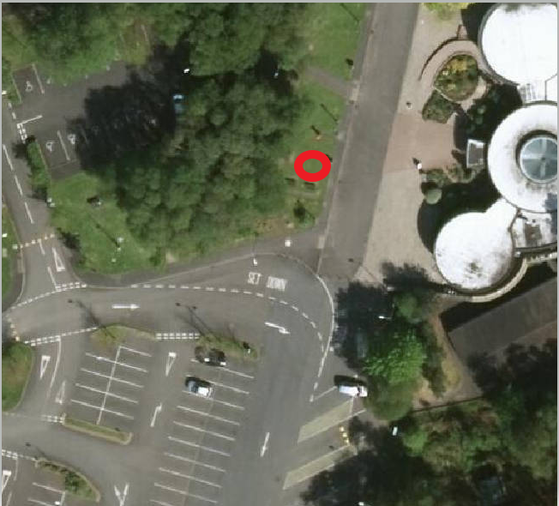

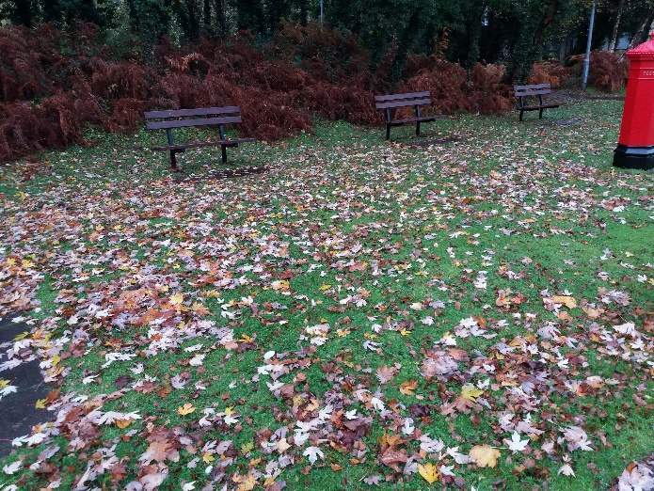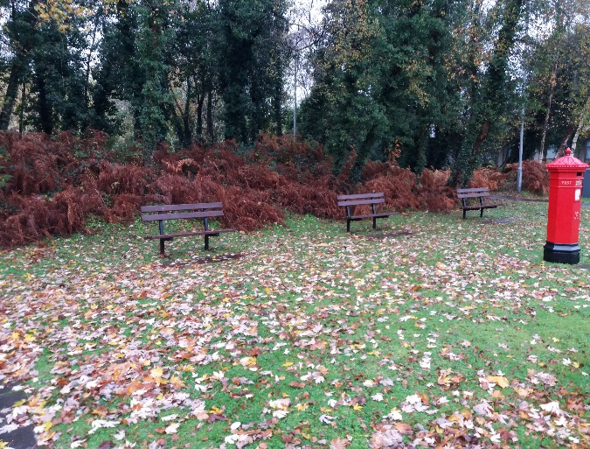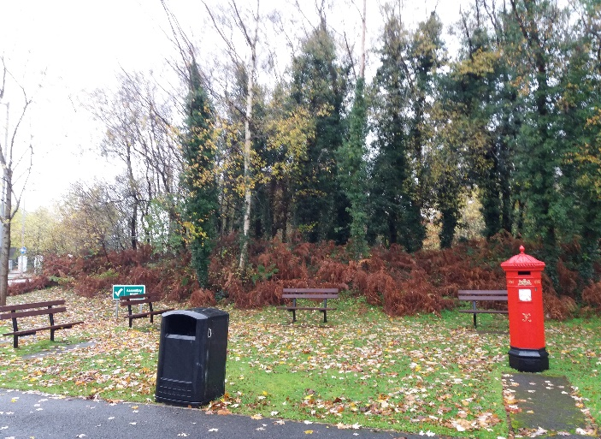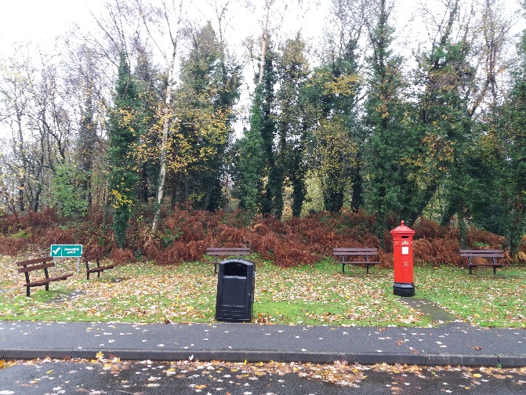

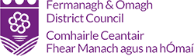

# **Expression of Interest Form**

**Public Art Commission**

**Ulster American Folk Park; The International Appalachian Trail 2021**

The Closing Date for submission is 12 noon on 07 December 2020 by e-mail to [artsandheritage@fermanaghomagh.com](mailto:artsandheritage@fermanaghomagh.com) and titled *Submission – IAT Public Art.*

|  |  |  |  |  |
| --- | --- | --- | --- | --- |
| **Section 1. Contact Details** | | | | |
| **Are you a….** | Individual Artist | Managing Agent | Company/Organisation | Charity/Collective |
| Other  Please specifyClick or tap here to enter text. | | | |
| **Name** | Enter Name Here | | | |
| **Address** | Enter Address Here | | | |
| **Contact number** | **Tel:**  [Enter number here]  **Mob:**  [Enter number here] | | | |
| **Email** | [Enter text here] | | | |
| **Website** | [Enter text here] | | | |
| **Social Media Platforms**  *Provide links* | Facebook Address    Twitter Account | | **Other**  [Enter text here] | |

|  |  |  |
| --- | --- | --- |
| **Section 2. About Your Experience**  In this section you should detail previous experience and should demonstrate that you have the skills, expertise and ability to successfully deliver the commission for which you are expressing interest.  **You must send an up to date Curriculum Vitae**. This should be as a single PDF document of no more than 3 pages and titled IAT/*your name/CV*.  **You may submit up to three examples of previous work** and each example you must send accompanying illustrative images. | | |
| **Example of Previous Work 1**  **You must send accompanying illustrative images** in support of this example. These should be presented as a single PDF named *IAT/your name/example1*. | | |
| **Name**  Please give the name of the work | [Enter text here] | |
| **Commissioning Body**  Please give the name and address of the commissioning body | [Enter text here] | |
| **Date/s** | From (start date of contract)  [Enter date here mm/yy] | To (date of practical completion)  [Enter date here mm/yy] |
| **Location**  Provide detail of the location and the site | [Enter text here] | |
| **Budget**  Please give the total commission value and detail of what costs were included in the commission | [Enter text here] | |
| **Description**  Give a description including detail of concept & design development, materials, fabrication and installation. If applicable, describe any community and stakeholder engagement undertaken as part of the commission. You must be clear about your role and the tasks that you undertook.  **(Maximum 250 words)** | [Enter text here] | |
| **Referee**  Give name and contact details of a referee. | [Enter text here] | |

|  |  |  |
| --- | --- | --- |
| **Example of Previous Work 2**  **You must send accompanying illustrative images** in support of this example. These should be presented as a single PDF named *IAT/your name/example*2 | | |
| **Name**  Please give the name of the work | [Enter text here] | |
| **Commissioning Body**  Please give the name and address of the commissioning body | [Enter text here] | |
| **Date/s** | From (start date of contract)  [Enter date here mm/yy] | To (date of practical completion)  [Enter date here mm/yy] |
| **Location**  Provide detail of the location and the site | [Enter text here] | |
| **Budget**  Please give the total commission value and detail of what costs were included in the commission | [Enter text here] | |
| **Description**  Give a description including detail of concept & design development, materials, fabrication and installation. If applicable, describe any community and stakeholder engagement undertaken as part of the commission. You must be clear about your role and the tasks that you undertook.  **(Maximum 250 words)** | [Enter text here] | |
| **Referee**  Give name and contact details of a referee. | [Enter text here] | |

|  |  |  |
| --- | --- | --- |
| **Example of Previous Work 3**  **You must send accompanying illustrative images** in support of this example. These should be presented as a single PDF named *IAT/your name/example3*. | | |
| **Name**  Please give the name of the work | [Enter text here] | |
| **Commissioning Body**  Please give the name and address of the commissioning body | [Enter text here] | |
| **Date/s** | From (date of contract)  [Enter date here mm/yy] | To (date of practical completion)  [Enter date here mm/yy] |
| **Location**  Provide detail of the location and the site | [Enter text here] | |
| **Budget**  Please give the total commission value and detail of what costs were included in the commission | [Enter text here] | |
| **Description**  Give a description including detail of concept & design development, materials, fabrication and installation. If applicable, describe any community and stakeholder engagement undertaken as part of the commission. You must be clear about your role and the tasks that you undertook.  **(Maximum 250 words)** | [Enter text here] | |
| **Referee**  Give name and contact details of a referee. | [Enter text here] | |

|  |  |
| --- | --- |
| **Section 3. Your Proposal**  In this section you should give a high-level statement of outlining your vision for this commission. You may support this with statement with visualisations. You should send these as a single PDF and title it IAT/*your name*/Proposal. | |
| **Working Title** | [Enter text here] |
| **Description**  Give a brief written statement including:   * Artistic Vision for the commission including concept and process for design development * How your proposal related to the location and the site * Materials, fabrication methods and installation requirements * Your methodology for engaging with stakeholders   **(Maximum 1500 words)** | [Enter text here] |

|  |  |  |
| --- | --- | --- |
| **Section 4. Disclosures and Declarations**  Ypu must complete this section. | | |
| **Mandatory Exclusions**  Please indicate below whether you or your organisation or any of its directors, partners or any other person who has powers of representation, decision or control, have been convicted of any of the following offences (including those which are spent within the meaning of the Rehabilitation of Offenders Act 1974):   1. Conspiracy within the meaning of section 1 or 1a of the Criminal Law Act 1977 or article 9 or 9a of the Criminal Attempts and Conspiracy (Northern Ireland) order 1983 where that conspiracy relates to participation in a criminal organisation as defined in Article 2(1) of Council Framework Decision 2008/841/ JHA 2. Corruption within the meaning of section 1 of the Public Bodies Corrupt Practices Act 1889 or section 1 of the Prevention of Corruption Act 1906   3a. The offence of bribery, where the offence relates to active corruption;  3b. Bribery within the meaning of section 1 or 6 of the Bribery Act 2010  4. Fraud, where the offence relates to fraud affecting the financial interests of the European Communities as defined by Article 1 of the Convention relating to the protection of the financial interests of the European Union, within the meaning of:-   * + the offence of cheating the Revenue;   + the offence of conspiracy to defraud;   + fraud or theft within the meaning of the Theft Act 1968 and the Theft Act 1978 or the Theft (Northern Ireland) order 1978   + fraudulent trading within the meaning of section 458 of the Companies Act 1985, article 451 of the Companies (Northern Ireland) Order 1986 or section 993 of the Companies Act 2006   + defrauding the Customs within the meaning of the Customs and Excise Management Act 1979 and the Value Added Tax Act 1994;   + an offence in connection with taxation in the European Community within the meaning of section 71 of the Criminal Justice Act 1993; or   + destroying, defacing or concealing of documents or procuring the extension of a valuable security within the meaning of section 20 of the Theft Act 1968, or Section 19 of the Theft Act (Northern Ireland) 1969   + Fraud within the meaning of Section 2, or 3 or 4 of the Fraud Act 2006   + Making, adapting, supplying or offering to supply articles for use in frauds within the meaning of section 7 of Fraud Act 2006  1. Money laundering within the meaning of Money Laundering Regulations 2003   6a. Any other offence within the meaning of Article 45(1) of the Public Sector Directive as defined by the national law of any relevant State  6b. an offence in connection with the proceeds of criminal conduct within the meaning of section 93A, 93B or 93C of the Criminal Justice Act 1988 or article 45, 46 or 47 of the Proceeds of Crime (Northern Ireland) Order 1996  6c. An offence in connection with the proceeds of drug trafficking within the meaning of section 49, 50 or 51 of the Drug Trafficking Act 1994; or  6d. any other offence within the meaning of Article 45(1) of the Public Sector Directive as defined by the national law of any relevant State. | | Choose an item.  If you have indicated “yes” Fermanagh and Omagh District Council will contact you for further details. |
| **Freedom of Information**  I acknowledge that Fermanagh and Omagh District Council is subject to the terms of the Freedom of Information Act 2000 and that the information provided in this Expression of Interest could be disclosed in response to a request under this act. | |  |
| **Accuracy of Information**  I acknowledge that that all information provided within their tender submission is accurate. The inclusion of information which is found to be false or misleading will result in the Expression of Interest being rejected. Furthermore, in the event that false or misleading information comes to light after the award of the contract, this may result in termination of the contract. | |  |
| **Insurance**  I confirm that I am willing to put in place the required insurance cover if successful.  Please note evidence of Insurance cover will be required at Award Stage. | |  |
| **Equality Declaration**  I confirm that I will not to act in any way that would contravene the Council’s statutory obligations and are committed to promoting good relations and equality of opportunity in all our activities (including in the recruitment, promotion and training of all our staff).  Under Section 75 of the Northern Ireland Act 1998 Fermanagh and Omagh District Council must have due regard to the need to promote equality of opportunity between persons of different religious belief, political opinion, racial group, age, marital status or sexual orientation; between men and women generally; between persons with a disability and persons without; between persons with dependants and persons without.  The Council must also have regard to the desirability of promoting good relations between persons of different religious belief, political opinion or racial group. | |  |
| **Fair Employment**  I confirm that I am not unqualified for the purposes of Article 64 to 66 of the Fair Employment and Treatment (Northern Ireland) Act 1998 and undertake to inform Fermanagh and Omagh District Council should any notice stating that I am/we are unqualified be served upon me/us by the Equality Commission. | |  |
| **Financial Standing**  I confirm that I or the group/organisation submitting this application is of good financial standing and acknowledge that if successful I may be asked to provide further detail. | |  |
| **Personal Data**  I consent that my details are shared with the relevant Council services and project partners for purposes of this Expression of Interest.  I consent that the relevant Council services contact me for the purposes of this Expression of Interest. | |  |
| **Name**  **Date**  **Signed**  **On behalf of (if applicable)**  **Position (if applicable)** | [Enter Name here]  [Enter Date here]  [Enter Organisation here]  [Enter Position here] | |