

**EXPRESSSIONS OF INTEREST TO BID FOR PROVISION OF CAFÉ OPERATION AT OMAGH AGRICULTURAL MART**

**Document 4 of 8**

**SELECTION CRITERIA - COMPLIANCE INFORMATION**

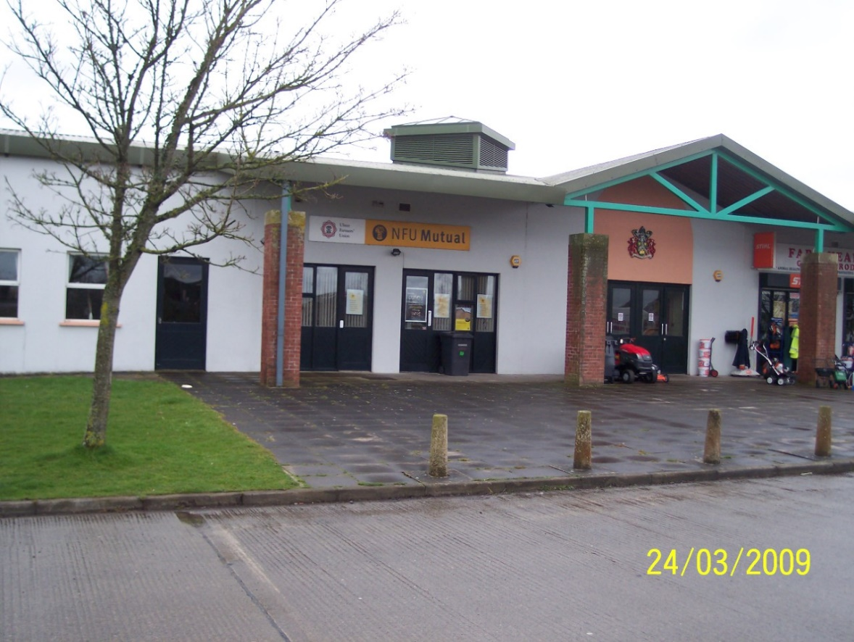

**REFERENCE 2021 EOI OTB 001**

**Closing date for submission: no later than 12.00 Noon Friday 30 October 2020.**

**This document is one of eight parts, as listed below, which together form the Expressions of Interest information documentation.**

**Please ensure that no part or page is missing or duplicated.**

|  |  |  |
| --- | --- | --- |
| **Document** | | **Title** |
| 1 | | **General Information and Requirements**  This section gives an outline of the requirements, the contract terms and the decision-making process. |
| 2 | | **Instructions to Bidders**  This section gives instruction on the process and how to submit a Bid. |
| 3 | | **Specific Information and Requirements – Mart Canteen, Omagh Agricultural Mart**  This section details the opportunity, resources and requirements at Mart Canteen, Omagh Agricultural Mart |
| SUBMISSION PACKAGE | 4 | **Selection Criterion – Compliance Information**  This section must be completed by all bidders. |
| 5 | **Selection Criterion – Relevant Experience**  This section must be completed by all bidders |
| 6 | **Award Criterion – Service Delivery**  This section must be completed by all bidders; each opportunity for which you are bidding requires a separate submission although the template for the submission is common to all the opportunities. |
| 7 | **Award Criterion – Annual Fee Payable**  This section must be completed by all bidders; each opportunity for which you are bidding requires a separate submission although the template for the submission is common to all the opportunities. |
| 8 | **Checklist**  This document lists the documents that are required for a submission to be eligible. |

BIDDER INFORMATION



**Name: ____________________________________**

**Address: ________________________________________**

**_____________________________________________________**

**Postcode: ____________________**

**Telephone: ____________________**

**Mobile: _____________________**

**\*Email: _______________________________________________**

**\*Please note that this email address may be used for correspondence.**

**Contact Name (Print in Caps): ___________________________**

**Position in organisation: ________________________________**

**Signature: _____________________ Date: _________________**

**COMPLIANCE CRITERIA**

This stage will be assessed on a **Pass/ Fail** basis only those submissions that achieve a pass against each element of this stage will progress to assessment of Previous Experience.

**a. Mandatory Exclusion(s)**. **Pass/Fail** This will be assessed based on responses to Appendix A.

**b. Fair Employment & Treatment**. **Pass/Fail** This will be assessed based on responses to Appendix B.

**c. Bone Fide Bid**. **Pass/Fail** This will be assessed based on responses to Appendix C.

**d. Equality Declaration**. **Pass/Fail** This will be assessed based on responses to Appendix D.

**e. Freedom of Information**. **Pass/Fail** This will be assessed based on responses to Appendix E.

**f. Insurance** **Pass/Fail** This will be assessed based on responses to Appendix F.

The successful company will be expected to hold the following insurances:

1. Employers Liability cover of at least £10 million any one incident
2. Public/Product Liability – at least £5 million any one accident and unlimited any one period of insurance

In the event that your company does not have adequate insurance cover at the time of application, please confirm in writing that you are willing to put in place the required cover if your submission is successful.

(Please complete Appendix F Insurance Requirements)

The successful contractor will be required to provide evidence of allrequired insurance cover, prior to confirmation of award of the contract

**g. Health & Safety Pass/Fail** This will be assessed based on responses to Appendix G

(Please complete Appendix I and enclose a copy of your Health & Safety Policy)

**h. The Bribery Act 2010** (No response necessary; Appendix H)

1. **Safeguarding Pass/Fail** This will be assessed based on responses to Appendix I

**j. Financial Standing**

Please submit with your Expressions of Interest submission a formal statement from your Bank or Auditor confirming your company’s financial standing over the last three years. Please note that this statement must be as recent as possible and (***dated no earlier than 01 July 2020.* Undated statements will not be accepted and may render your submission ineligible**;



**Appendix A**

Fermanagh and Omagh District Council

Mandatory Exclusions

**Regulation 23 of the Public Contracts Regulations 2006**

The public sector and procurement Directives, as implemented by the Public Contracts Regulation 2006, include a mandatory requirement for contracting authorities to exclude economic operators (Suppliers, Contractors, Consultants and Service providers) from public contracts where they have been convicted of certain offences.

A contracting authority may apply to the relevant competent authority to obtain further information regarding the economic operator and in particular details of convictions of the offences listed if it considers it needs such information to decide on any exclusion referred to.

Please indicate below whether your firm or any of its directors, partners or any other person who has powers of representation, decision or control, have been convicted of any of the following offences (including those which are spent within the meaning of the Rehabilitation of Offenders Act 1974):

1. Conspiracy within the meaning of section 1 or 1a of the Criminal Law Act 1977 or article 9 or 9a of the Criminal Attempts and Conspiracy (Northern Ireland) order 1983 where that conspiracy relates to participation in a criminal organisation as defined in Article 2(1) of Council Framework Decision 2008/841/ JHA
2. Corruption within the meaning of section 1 of the Public Bodies Corrupt Practices Act 1889 or section 1 of the Prevention of Corruption Act 1906

3a. The offence of bribery, where the offence relates to active corruption;

3b. Bribery within the meaning of section 1 or 6 of the Bribery Act 2010

4. Fraud, where the offence relates to fraud affecting the financial interests of the European Communities as defined by Article 1 of the Convention relating to the protection of the financial interests of the European Union, within the meaning of:-

* + the offence of cheating the Revenue;
  + the offence of conspiracy to defraud;
  + fraud or theft within the meaning of the Theft Act 1968 and the Theft Act 1978 or the Theft (Northern Ireland) order 1978
  + fraudulent trading within the meaning of section 458 of the Companies Act 1985, article 451 of the Companies (Northern Ireland) Order 1986 or section 993 of the Companies Act 2006
  + defrauding the Customs within the meaning of the Customs and Excise Management Act 1979 and the Value Added Tax Act 1994;
  + an offence in connection with taxation in the European Community within the meaning of section 71 of the Criminal Justice Act 1993; or
  + destroying, defacing or concealing of documents or procuring the extension of a valuable security within the meaning of section 20 of the Theft Act 1968, or Section 19 of the Theft Act (Northern Ireland) 1969
  + Fraud within the meaning of Section 2, or 3 or 4 of the Fraud Act 2006
  + Making, adapting, supplying or offering to supply articles for use in frauds within the meaning of section 7 of Fraud Act 2006

1. Money laundering within the meaning of Money Laundering Regulations 2003

6a. Any other offence within the meaning of Article 45(1) of the Public Sector Directive as defined by the national law of any relevant State

6b. an offence in connection with the proceeds of criminal conduct within the meaning of section 93A, 93B or 93C of the Criminal Justice Act 1988 or article 45, 46 or 47 of the Proceeds of Crime (Northern Ireland) Order 1996

6c. An offence in connection with the proceeds of drug trafficking within the meaning of section 49, 50 or 51 of the Drug Trafficking Act 1994; or

6d. any other offence within the meaning of Article 45(1) of the Public Sector Directive as defined by the national law of any relevant State.

**Any convictions to be declared: *(Please circle as appropriate)***

YES

NO

**Signed: __________________________________**

**Dated: ___________________**



**Appendix B**

Fermanagh and Omagh District Council

Fair Employment and Treatment (Northern Ireland)

Act 1998

Article 64 of the Fair Employment and Treatment (NI) Order 1998 (“The Order”) provides inter alia that a public authority shall not accept an offer to execute any work or supply any goods or services where the offer is made by an unqualified person in response to an invitation by the public authority to submit offers. Article 64 also provides that the public authority shall take all such steps as are reasonable to secure that no work is executed, or goods or services supplied for the purposes of such contracts as are mentioned above by an unqualified person.

1. An unqualified person is either an employer who, having been in default in the circumstances specified in Article 62 (1) of the Order, has been served with a notice by the Equality Commission stating that he is not qualified for the purposes of Articles 64 to 66 of the Order, or an employer who, by reasons of connection with an employer on whom has been served a notice to that effect, has also been served with such a notice.
2. Mindful of its obligations under the Order, Fermanagh and Omagh District Council has decided that it shall be a condition of inclusion or retention on its Approved List that a Contractor shall not be an unqualified person for the purposes of Articles 64 to 66 of the Order.
3. Contractors are therefore asked to complete and return this Declaration and Undertaking, to confirm that they are not unqualified persons and to undertake that no work shall be executed or goods or services supplied by an unqualified person for the purposes of any contract with Fermanagh and Omagh District Council to which Article 64 of the Order applies.

I/we …………………………………………………………….. hereby declare that I am/we are not unqualified for the purposes of Article 64 to 66 of the Fair Employment and Treatment (Northern Ireland) Act 1998. I/we undertake forthwith to inform Fermanagh and Omagh District Council should any notice stating that I am/we are unqualified be served upon me/us by the Equality Commission.

Signed: …………………………………………... Dated: …………………………...

For and on behalf of

……………………...………………………………………………………………………



**Appendix C**

Fermanagh and Omagh District Council

Certificate relating to Bona Fide Bid

1. The essence of submitting Bids is that the client shall receive bona fide competitive Bid from all firms. In recognition of this principle, we certify that this is a bona fide Bid intended to be competitive, and that we have not fixed or adjusted the amount of the Bid by or under or in accordance with any agreement or arrangement with any other person.
2. We also certify that we have not:
3. Communicated to a person other than the person calling for these Bids the amount or approximate amount of the proposed quote, except where the disclosure, in confidence, of the approximate amount of the quote was necessary to obtain insurance premium Bids required for the preparation of the Bid;
4. Entered into any agreement or arrangement with any other person that he shall refrain from quoting or as to the amount of any Bid to be submitted;
5. Offered or paid or given or agreed to pay or give any sum of money or valuable consideration directly or indirectly or any person for doing or having done or causing or having caused to be done in relation to any other Bid or proposed Bid for the said work any act or thing of the sort described above.
6. We undertake that we will not do any of the acts mentioned in paragraphs 2a, 2b, 2c above at any time before acceptance or decline of this Bid.
7. In this certificate the word “person” includes any person and any body or association, corporate or unincorporate and “any agreement or arrangement” includes any such transaction, formal or informal and whether legally binding or not.

I / We * ………………………………………. have read and now understand the requirements of the quotation system in relation to bona fide compliance as detailed in the attached ‘Certificate Relating To Bona Fide quotation ’.

Signed: …………………………………………... Dated: …………………………...

For and on behalf of

………………………………………………………………………………………



**Appendix D**

**Fermanagh and Omagh District Council**

**Equality Declaration**

**Declaration of Commitment to Promoting Equality of Opportunity and Good Relations**

1.

1.1 Under Section 75 of the Northern Ireland Act 1998 Fermanagh and Omagh District Council must have due regard to the need to promote equality of opportunity:

Between persons of different religious belief, political opinion, racial group, age, marital status or sexual orientation;

Between men and women generally;

Between persons with a disability and persons without;

Between persons with dependants and persons without.

1.2 In addition the Council must also have regard to the desirability of promoting good relations between persons of different religious belief, political opinion or racial group.

1.3 The Council is committed to fulfilling these obligations and is keen to not only to ensure that suppliers of goods and services, contractors undertaking work on behalf of the Council, and groups who receive support from the Council do not act in any way that would contravene the Council’s statutory equality duties but also that they help promote equality of opportunity and good relations within their own area of work and organisation.

1.4 It is therefore a condition of any offer of grant aid/support or contract for goods or services that the Chief Executive, Managing Director or other authorised person signs, on behalf of their organisation, the declaration below. This declaration will confirm that the organisation is committed to promoting equality of opportunity and good relations and will not act in any way that will undermine the Council’s commitment to fulfil its statutory obligations.

1.5 The Council will not enter into any contract or provide support/grant aid to any organisation which does not sign the Declaration of Commitment to the Promotion of Equality of Opportunity and Good Relations.

We (insert name of firm): __________________________________

Recognise Fermanagh and Omagh District Council’s duty to have due regard to the need to promote equality of opportunity:

Between persons of different religious belief, political opinion, racial group, age marital status or sexual orientation;

Between men and women generally;

Between persons with a disability and persons without

Between persons with dependants and persons without,

and to have regard to the desirability of promoting good relations between persons of different religious belief, political opinion or racial group.

We undertake not to act in any way that would contravene the Council’s statutory obligations and are committed to promoting good relations and equality of opportunity in all our activities (including in the recruitment, promotion and training of all our staff).

Signed by: ___________________________________________________

Name in block letters___________________________________________

Position in Firm: ________________________________________

Date: ________________________________________________________

On behalf of: __________________________________________________

(name of firm)

Address: ___________________________________________________

___________________________________________________



**Appendix E**

**Fermanagh and Omagh District Council**

**Freedom of Information Act – Bids (Appendix E)**

Bidders should be aware that the information provided in the completed Bid and contractual documents could be disclosed in response to a request under the Freedom of Information Act. We will proceed on the basis of disclosure unless an appropriate exemption applies. No information provided by bidders will be accepted “in confidence” and Fermanagh and Omagh District Council accepts no liability for loss as a result of any information disclosed in response to a request under the Freedom of Information Act.

Fermanagh and Omagh District Council has no discretion whether or not to disclose information in response to a request under the Freedom of Information Act, unless an exemption applies. Disclosure decisions will be taken by appropriate individuals in Fermanagh and Omagh District Council having due regard to the exemptions available and the Public Interest. Bidders should be aware that despite the availability of some exemptions, information may still be disclosed if the Public Interest in its disclosure outweighs the Public Interest in maintaining the exemption. Bidders are required to highlight information that they include in the Bid documents, which they consider to be commercially sensitive or confidential in nature, and should state the precise reasons, why that view is taken. In particular, issues concerning trade secrets and commercial sensitivity should be highlighted. Bidders are advised against recording unnecessary information.

In accordance with the Lord Chancellors Code of Practice on the discharge of public functions, Fermanagh and Omagh District Council will **not** accept any contractual term that purports to restrict the disclosure of information held by the Council in respect of the contract or Bid exercise save as permitted by the Freedom of Information Act. The decision whether to disclose information rests solely with Fermanagh and Omagh District Council

Fermanagh and Omagh District Council will consult with bidders, where it is considered appropriate, in relation to the release of controversial information.

I/we have read and now understand the requirements in relation to freedom of information as detailed on the attached information sheet.

Signed:…………………………………………Dated: ………………………………

For and on behalf of

……………………………………………………………………………………………



**Appendix F**

Fermanagh and Omagh District Council

Insurance Information - Bid (Appendix F) DELETE IF NOT REQUIRED

**Please confirm the level of Insurance cover currently in place.**

|  |  |
| --- | --- |
| Section One. Insurance. | |
| Public/Products Liability Insurance Minimum £5 million | Yes/No* |
| Limit of cover: Public Liability Product Liability | £ £ |
| Insurance company name |  |
| Broker name and address |  |
| Expiry date |  |
| 1. **Employer Liability Insurance Minimum £10 million** | Yes/No* |
| Limit of cover |  |
| Insurance company name |  |
| Broker name and address |  |
| Expiry date |  |

* Delete as appropriate– if No please provide further details

**1** To be completed as appropriate depending on the nature of the contract.

Signed: …………………………………………………. Date: ….……………………

Duly authorised to sign for and on behalf of:

………………………………………………………………………………………………

**In the event that your firm does not have the required level of insurance cover at the time of application, please confirm in writing that you are willing to put in place the required cover if your submission is successful. Please note evidence of Insurance cover will be required prior to issue of contracts.**



**Appendix G**

**Fermanagh and Omagh District Council**

**Health and Safety Questionnaire**

|  |  |  |  |  |  |  |  |  |  |  |  |  |  |  |
| --- | --- | --- | --- | --- | --- | --- | --- | --- | --- | --- | --- | --- | --- | --- |
| **Please complete the following sections and supply relevant information as requested** | | | | | | | | | | | | | | |
| 1. Company Name and Address (including contact information) | | | | | | | | | | | | | | |
| 1. **Supply a copy of your company health and safety organisation chart.** | | | | | | | | | | | | | | |
| 1. **Who in your organisation is ultimately responsible for health and safety?** | | | | | | | | | | | | | | |
| Name | | | | Position | | | | | | Contact details | | | | |
| 1. **Who in your organisation is ultimately responsible for managing health and safety?** | | | | | | | | | | | | | | |
| Name | | | Position | | | | | Contact Details | | | | Qualifications | | |
| 1. **Supply a copy of your organisation's health and safety policy.** | | | | | | | | | | | | | | |
| **Supply details of relevant health and safety training provided to your employees in the past 12 months** (Attach example certificates) | | | | | | | | | | | | | | |
| Course Title | | | | | | | Provider | | | | | | | Dates |
| 1. **Does your organisation use sub-contractors? YES/NO**   If yes, please provide details of how you ensure competence of sub-contractors (use a continuation sheet if required) | | | | | | | | | | | | | | |
| **Complete the following table with the number of accidents/incidents reported by your organisation over the past 3 years** | | | | | | | | | | | | | | |
| **Year** | | **Fatalities** | | | **Major accidents** | | | | **Dangerous occurrences** | | **Over 3-day lost time injuries** | | | |
|  | |  | | |  | | | |  | |  | | | |
|  | |  | | |  | | | |  | |  | | | |
|  | |  | | |  | | | |  | |  | | | |
|  | |  | | |  | | | |  | |  | | | |
|  | | | | | | | | | | | | | | |
| **Year** | **Prosecution / Notice** | | | | | **Details** | | | | | | | **Remedial Action** | |
|  |  | | | | |  | | | | | | |  | |
|  |  | | | | |  | | | | | | |  | |
|  |  | | | | |  | | | | | | |  | |

**You must also submit a copy of your company’s Health and Safety policy**



**Appendix H**

**The Bribery Act 2010.**

**Fermanagh and Omagh District Council**

**Statement of Commitment.**

Fermanagh and Omagh District Council is committed to carrying out business fairly, honestly and openly and has a zero tolerance towards bribery.

Fermanagh and Omagh District Council expects full compliance with the requirements of the Bribery Act 2010 from Councillors, Employees, Agents, Partners, **Suppliers** and Groups or Individuals applying for, or in receipt, of grant aid.



**Appendix I**

**Fermanagh and Omagh District Council**

**Safeguarding**

Everyone has a responsibility to ensure the safeguarding of children and adults at risk of harm.

Fermanagh and Omagh District Council requires all contractors to have a Child and Adult Safeguarding Policy in place. If the contractor does not have such policies in place, then they should revert to the Council’s Safeguarding Policies and Codes of Practices.

The Council’s Policies and Codes of Practices can be found online at [www.fermanaghomagh.com](http://www.fermanaghomagh.com) or by contacting the Policy and Strategic Services Unit via telephone: 0300 303 1777, textphone: 18001 0300 303 1777 or via email: [finbar.maguire@fermanaghomagh.com](mailto:finbar.maguire@fermanaghomagh.com).

By checking this box, you are acknowledging the importance of Safeguarding, as well as your role with regards to the safeguarding of children and adults at risk of harm, should you be successful in this procurement process. ☐

Signed: …………………………………………… Date: …….………

Duly authorised to sign for and on behalf of:

………………………………………………………………………………………………