


June 2026
Reference: 2627 CW LRS EOI 002

Expression of Interest

Café Services at
Omagh Leisure Centre

- Introduction

Fermanagh and Omagh District Council wishes to invite Expressions of Interest (EOI) from competent Service Providers for the provision of Café operations at Omagh Leisure Centre.
The provision required for a two-year period with an option by Fermanagh & Omagh District Council to extend for a further three periods of 12 months, subject to satisfactory performance and at the sole discretion of the Council.

You can read more about this facility in the associated Information Booklet.
- Process
The overall process is in two stages
Stage 1: Expression of Interest
- Complete the EOI submission
- Tell us about your experience.
then:
- If you have the relevant experience, which will be assessed as a Pass / Fail
we will contact you to arrange a site visit and answer any questions you may have.
Stage 2: Opportunity to Bid
- If you progress to Stage 2 Opportunity to Bid will require more information from you on compliance, quality of the service you intend to provide and the fee you will pay to the Council. See information on this submission in the Stage 2 section.

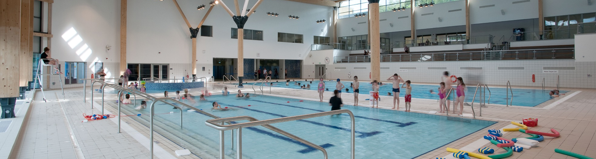

Stage 1 Submission
Reference: 2627 CW LRS EOI 002

Stage 1 EOI Submission
Reference: 2627 CW LRS EOI 002

This Expression of Interest is for the catering and bar provision at the Strule Arts Centre, Omagh.

Please complete the online application by clicking the link below.

Apply Here

Closing date for receipt of submissions: no later than
12 noon Friday 31st July 2026
Late submissions will not be accepted.

For queries please email:
wellbeingandculture@fermanaghomagh.com

Stage 2 Submission
Opportunity to Bid
Please note this stage does not need to be completed until after Stage 1 assessment and site visit.
Applicants that progress to Stage 2 must successfully complete all forms in this stage to enable their submission to be assessed this includes compliance criteria below:

Mandatory Exclusion - Pass / Fail
Fair Employment - Pass / Fail
Bona Fide Submission - Pass / Fail
Equality Declaration - Pass / Fail
Freedom of Information - Pass / Fail
Insurance - Pass / Fail
Financial Good Standing - Pass / Fail
Safeguarding - Pass / Fail

You will then be asked to provide more information on the quality of service you intend to provide and the fee you will pay to the Council:

Quality: (50%)
Applicants will be asked for information on service delivery, nutritional standards, marketing and customer experience information. Service Delivery criteria will be assessed using a score out of 5 against the following scoring *indicators.
Assessment | Score | Indicators
Excellent | 5 | The submission provided is of excellent relevance and is fully supported by a comprehensive Level of detail  No omissions and / or weaknesses identified
Good | 4 | The submission provided is of good relevance and is well supported by a good level of detail  Only minor omissions and / or weaknesses identified
Satisfactory | 3 | The submission provided is of satisfactory relevance and is supported by an adequate level of detail  Some omissions / and or weaknesses identified
Limited | 2 | The submission provided of limited relevance and partially detailed  Several material omissions / and or weaknesses have been identified
Poor | 1 | The submission provided is of poor relevance and is inadequately detailed  Major omissions / and or weaknesses have been identified
Nil response/  Very Poor | 0 | No response or unacceptable information provided.

Those submitting an opportunity to bid must achieve a minimum of 3 against the scoring indicators for each quality criteria; any submission which achieves less than a score of 3 against the scoring indicators will be considered unsatisfactory & will be excluded from the assessment process.
Cost: (50%)
Applicants will also be asked to include an annual fee.
The maximum mark will be awarded to the bidder submitting the highest acceptable price. Other suppliers will then be awarded a pro rata percentage using the following formula:
Available marks [50%] x Bidder’s price
Highest acceptable price
This score will be added to that obtained for Quality and the bidder with the highest overall score will be awarded the contract.

Contract Award
The bidder with the highest overall scoring bid (out of 100%) will be awarded the contract.

To Note:
All fees quoted shall be in pounds Sterling (GBP) and be exclusive of VAT.
All additional costs associated with the delivery of services by the Caterer will be their own responsibility. This will include but is not limited to:

- Business Rates
- Electricity usage (by separate metered reading or desk top calculation)
- Waste disposal
- Materials and equipment other than those detailed in the equipment portfolios supplied with the specific details of each franchise opportunity
- Fees must include for all elements of the service requirements.
- The payment of the Annual Fee to the Council will be on a monthly basis via Standing Order

