

**EXPRESSIONS OF INTEREST FOR CAFÉ OPERATION AT**

**OMAGH AGRICULTURAL MART**

**Document 3 of 8**

**SPECIFIC INFORMATION AND REQUIREMENTS**

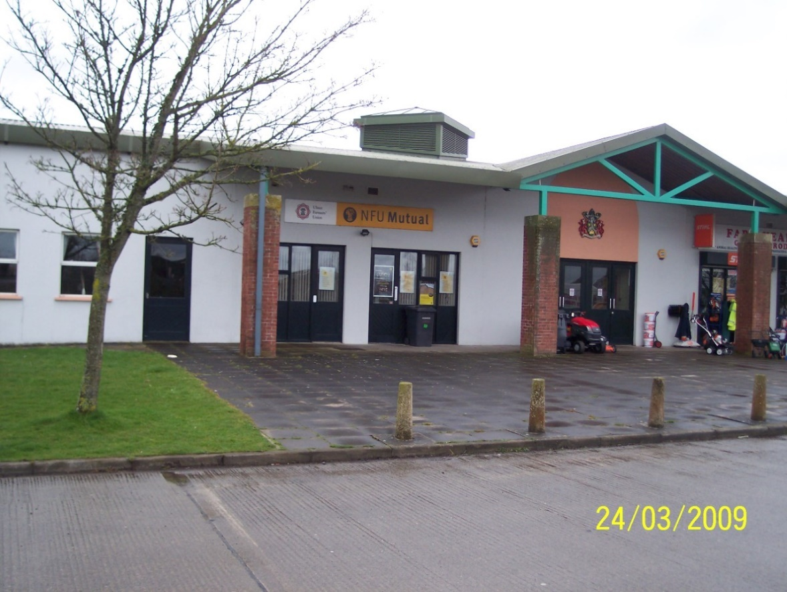

**REFERENCE 2023 EP EOI 001**

**Closing date for submission: no later than 12.00 Noon Friday 17 February 2023**

**This document is one of eight parts, as listed below, which together form the Expressions of Interest information documentation.**

**Please ensure that no part or page is missing or duplicated.**

|  |  |  |
| --- | --- | --- |
| **Document** | | **Title** |
| 1 | | **General Information and Requirements**  This section gives an outline of the requirements, the contract terms and the decision-making process. |
| 2 | | **Instructions to Bidders**  This section gives instruction on the process and how to submit a Bid. |
| 3 | | **Specific Information and Requirements – Mart Canteen, Omagh Agricultural Mart**  This section details the opportunity, resources and requirements at Mart Canteen, Omagh Agricultural Mart |
| SUBMISSION PACKAGE | 4 | **Selection Criterion – Compliance Information**  This section must be completed by all bidders. |
| 5 | **Selection Criterion – Relevant Experience**  This section must be completed by all bidders |
| 6 | **Award Criterion – Service Delivery**  This section must be completed by all bidders; each opportunity for which you are bidding requires a separate submission although the template for the submission is common to all the opportunities. |
| 7 | **Award Criterion – Annual Fee Payable**  This section must be completed by all bidders; each opportunity for which you are bidding requires a separate submission although the template for the submission is common to all the opportunities. |
| 8 | **Checklist**  This document lists the documents that are required for a submission to be eligible. |

**OMAGH AGRICUTURAL MART**

**Introduction**

Fermanagh and Omagh District Council is seeking a Caterer to take forward the catering provision for the Omagh Agricultural Mart Canteen. Catering facilities comprise of a ground floor kitchen, server and café area seating up to 70 people.

There are currently three businesses operating in the Mart complex and Auction Mart sale days are held as follows, but may be subject to change:

Monday at 10.30 am - Store and Beef Cattle, Fat Cows and Calves  
Wednesday at 7.00 pm - Suck Calves and Sucklers  
Saturday at 10.30 am - Sheep

In addition, special sales may be held throughout the year.

**Specific Requirements**

The successful Supplier will be required to enter into a formal Catering Agreement with Council in the format set out in this Agreement and without prejudice to the contents of that Agreement will be expected to:

1. deliver consistently high standards, meeting and exceeding client expectations, through professional and experienced catering staff, management and systems.
2. offer menu variety, quality and value for money for all aspects of service provision from tea/coffee through to lunch options.
3. to ensure the highest standards of hygiene are attained and maintained in all areas of the Catering Service and that all current legislation and codes of practice relating to food hygiene are adhered to at all times.
4. to be responsible for cleaning of the catering areas in compliance with Food Hygiene Regulations and will be responsible for the collection and disposal of litter from the Catering Area(s).

**Schedule of Equipment**

**Kitchen Equipment**:

|  |  |
| --- | --- |
| 1 | Wash Basin (Scissons) |
| 1 | Sink Unit |
| 4 | Wall Benches with shelf under |
| 1 | Microwave (Panasonic) |
| 2 | Refrigerators (Stephens) |
| 2 | Dishwasher Tables with inset sink bowl and shelf |
| 1 | Dishwasher (Hobart) |
| 2 | Freezers (Stephen’s) |
| 1 | Stockpot Stove (Monarch Gas stockpot stove with 2 burners) |
| 1 | Oven Range (Lincat) |
| 1 | Combi-Oven (Eloma) |
| 1 | Work Bench |
| 1 | Griddle (Stratford FP-24G) |
| 1 | Twin Fryer (Falcon) |
| 1 | Boiler |
| 1 | Veg Prep Sink Unit |
| 1 | Veg Storage Wall Bench |
| 1 | Peeler (Fields Pimbrett) |
| 1 | Servery Counter plus Display Fridge |

**Images of the Café area at the Omagh Agricultural Mart**

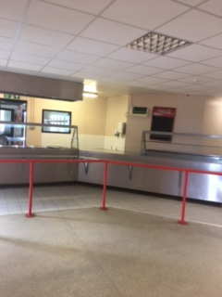

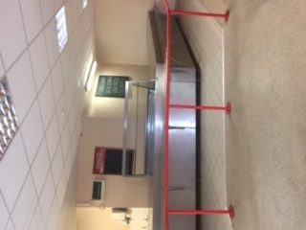



**Floor Plan of Omagh Agricultural Mart**