

**EXPRESSIONS OF INTEREST FOR PROVISION OF CAFÉ OPERATION AT OMAGH AGRICULTURAL MART**

**Document 5 of 8**

**SELECTION CRITERIA - RELEVANT EXPERIENCE**

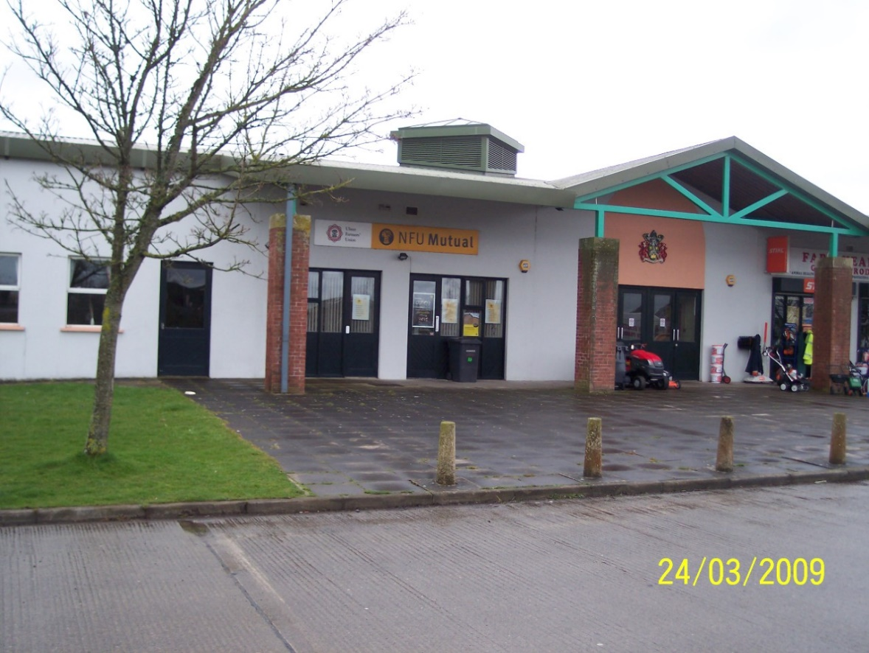

**REFERENCE 2023 EP EOI 001**

**Closing date for submission: no later than 12.00 Noon Friday 17 February 2023**

**This document is one of eight parts, as listed below, which together form the Expressions of Interest information documentation.**

**Please ensure that no part or page is missing or duplicated.**

|  |  |  |
| --- | --- | --- |
| **Document** | | **Title** |
| 1 | | **General Information and Requirements**  This section gives an outline of the requirements, the contract terms and the decision-making process. |
| 2 | | **Instructions to Bidders**  This section gives instruction on the process and how to submit a Bid. |
| 3 | | **Specific Information and Requirements – Mart Canteen, Omagh Agricultural Mart**  This section details the opportunity, resources and requirements at the Mart Canteen, Omagh Agricultural Mart |
| SUBMISSION PACKAGE | 4 | **Selection Criterion – Compliance Information**  This section must be completed by all bidders. |
| 5 | **Selection Criterion – Relevant Experience**  This section must be completed by all bidders |
| 6 | **Award Criterion – Service Delivery**  This section must be completed by all bidders; each opportunity for which you are bidding requires a separate submission although the template for the submission is common to all the opportunities. |
| 7 | **Award Criterion – Annual Fee Payable**  This section must be completed by all bidders; each opportunity for which you are bidding requires a separate submission although the template for the submission is common to all the opportunities. |
| 8 | **Checklist**  This document lists the documents that are required for a submission to be eligible. |

BIDDER INFORMATION



**Name: ____________________________________**

**Address: ________________________________________**

**_____________________________________________________**

**Postcode: ____________________**

**Telephone: ____________________**

**Mobile: _____________________**

**\*Email: _______________________________________________**

**\*Please note that this email address may be used for correspondence**

**Contact Name (Print in Caps): ___________________________**

**Position in organisation: ________________________________**

**Signature: _____________________ Date: _________________**

**B. SELECTION CRITERION**

This stage will be assessed on a **Pass/ Fail** basis only those submissions that achieve a pass will progress to assessment of the Service Delivery proposal.

To pass you must demonstrate relevant experience within the past 3 years of delivering catering services within a similar environment and on a similar scale. Including information on: Food Hygiene rating; Business Growth & Development; Business Marketing.

**Experience Pass/Fail**

Evidence of relevant experience of **up to** three catering franchises undertaken within the past three years within a similar environment and on a similar scale.

Please provide: -

i) name and address

ii) contract award date and duration

iii) a brief description of the services provided

1. contact name and telephone number

**Please note that contacts provided may be contacted during the assessment process.**

**Financial Standing Pass/Fail**

Please submit with your tender submission a formal statement from your Bank or Auditor confirming your company’s financial standing over the last three years. Please note that this statement must be as recent as possible and (***dated no earlier than 01 December 2022.* Undated statements will not be accepted and may render your submission ineligible**;

Appendix (i) – Relevant Experience

|  |  |
| --- | --- |
| **Example 1** | |
| Title | [Enter text here] |
| Start date (mth/yr) & duration | [Enter text here] |
| Client (if applicable) | [Enter text here] |
| Client Contact Name, Telephone and Email Details | [Enter text here] |
| **Please use this text box to describe the project (max 1 A4 Arial font 12)** | |

Appendix (i) – Relevant Experience

|  |  |
| --- | --- |
| **Example 2** | |
| Title | [Enter text here] |
| Start date (mth/yr) & duration | [Enter text here] |
| Client (if applicable) | [Enter text here] |
| Client Contact Name, Telephone and Email Details | [Enter text here] |
| **Please use this text box to describe the project (max 1 A4 Arial font 12)** | |

Appendix (i) – Relevant Experience

|  |  |
| --- | --- |
| **Example 3** | |
| Title | [Enter text here] |
| Start date (mth/yr) & duration | [Enter text here] |
| Client (if applicable) | [Enter text here] |
| Client Contact Name, Telephone and Email Details | [Enter text here] |
| **Please use this text box to describe the project (max 1 A4 Arial font 12)** | |