

**EXPRESSIONS OF INTEREST FOR PROVISION OF CAFÉ OPERATION AT OMAGH AGRICULTURAL MART**

**Document 8 of 8**

**SUBMISSION CHECKLIST**

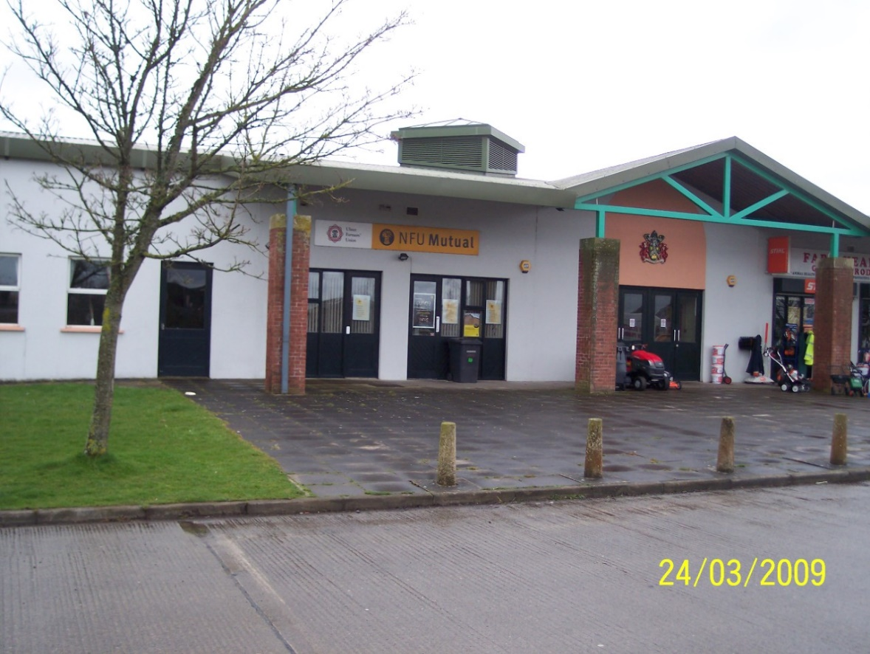

**REFERENCE 2023 EP EOI 001**

**Closing date for submission: no later than 12.00 Noon Friday 17 February 2023**

**This document is one of eight parts, as listed below, which together form the Expression of Interest information documentation.**

**Please ensure that no part or page is missing or duplicated.**

|  |  |  |
| --- | --- | --- |
| **Document** | | **Title** |
| 1 | | **General Information and Requirements**  This section gives an outline of the requirements, the contract terms and the decision-making process. |
| 2 | | **Instructions to Bidders**  This section gives instruction on the process and how to submit a Bid. |
| 3 | | **Specific Information and Requirements – Mart Canteen, Omagh Agricultural Mart**  This section details the opportunity, resources and requirements at Mart Canteen, Omagh Agricultural Mart |
| SUBMISSION PACKAGE | 4 | **Selection Criterion – Compliance Information**  This section must be completed by all bidders. |
| 5 | **Selection Criterion – Relevant Experience**  This section must be completed by all bidders |
| 6 | **Award Criterion – Service Delivery**  This section must be completed by all bidders; each opportunity for which you are bidding requires a separate submission although the template for the submission is common to all the opportunities. |
| 7 | **Award Criterion – Annual Fee Payable**  This section must be completed by all bidders; each opportunity for which you are bidding requires a separate submission although the template for the submission is common to all the opportunities. |
| 8 | **Checklist**  This document lists the documents that are required for a submission to be eligible. |

**BIDDER INFORMATION**



**Name: ____________________________________**

**Address: ________________________________________**

**_____________________________________________________**

**Postcode: ____________________**

**Telephone: ____________________**

**Mobile: _____________________**

**\*Email: _______________________________________________**

**\*Please note that this email address may be used for correspondence with regard to this request for quotation.**

**Contact Name (Print in Caps): ___________________________**

**Position in organisation: ________________________________**

**Signature: _____________________ Date: _________________**

Please indicate the documents that you are submitting. All documents must be submitted to Christine Clingen, Fermanagh and Omagh District Council, The Grange, Mountjoy Road, Omagh, BT79 7BL or via email to [christine.clingen@fermanaghomagh.com](mailto:christine.clingen@fermanaghomagh.com) **not later** than **12.00 Noon on Friday 17 February 2023**

|  |  |  |  |
| --- | --- | --- | --- |
| **Document** | | **Title** | **Mart Canteen, Omagh Agricultural Mart** |
| SUBMISSION PACKAGE | 4 | **Selection Criterion**  **Compliance Information** | **Yes/No** |
| 5 | **Selection Criterion Relevant Experience**  **Financial Standing** | **Yes/No**  **Yes/No** |
| 6 | **Award Criterion**  **Service Delivery** | **Yes/No**  **Yes/No** |
| 7 | **Award Criterion**  **Annual Fee Payable** |
| 8 | **Checklist** | **Yes/No** |