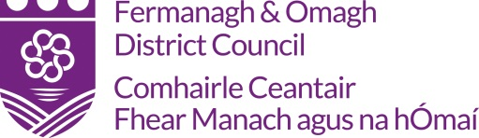

Claim Pack

Community & Wellbeing
(For Grant Awards, Up to £500)

A sample claim pack can be viewed on the Council’s website: www.fermanaghomagh.com, under Grants Sponsorship & Bursaries / Community Grants or if you require Officer assistance please contact the Grants & Investment Unit
Tel: 0300 303 1777 Email: grants@fermanaghomagh.com

Data Protection
In accordance with the Data Protection Act 2018, Fermanagh and Omagh District Council has a duty to protect any information we hold on you. The personal information you provide on this form will only be used for the purpose of contacting you about your grant aid claim and will only be shared with other relevant FODC sections and external funder and/or agencies (if applicable) for administrating your grant. For further guidance on how we hold your information please visit the Privacy section at: https://www.fermanaghomagh.com/your-council/privacy-statement/grants-and-investment/grants-and-bursary-call-application-forms-and-claims/

Fermanagh and Omagh District Council
Claim Checklist

CHECKLIST:

 |  | YES/NO
1. | Completed Claim Form  (Signed by two office bearers, attached)
2. | Original Invoices
3. | Procurement (if applicable)  Quotations Please refer to Point 2 of your Letter of Offer - Terms & Conditions.  Original Quotations must be submitted with claim.
4.. | Evidence of Outputs & Specific Requirements  (As outlined in your Letter of Offer)
5. | Bank Automated Clearing System - (BACS)  (Signed, attached)
6. | Post-Project Evaluation Form  (Signed, attached)
7. | Any Other Information as Requested

Please complete this claim pack once the project has taken place and submit
the necessary documentation by the Claimed By Date Outlined In Your
Letter Of Offer.

The completed claim pack can emailed to: grants@fermanaghomagh.com
Or
Post to:-
Grants and Investment Unit
Fermanagh and Omagh District Council

Either:

2 Townhall Street The Grange
Enniskillen or Mountjoy Road
Co Fermanagh Omagh
BT74 7BA Co Tyrone BT79 7BL

Audit: Please note your project/event could be selected for a full audit at any time by Fermanagh and Omagh District Council. All relevant documentation in relation to your project/event must be made available, if requested.
Grants and Investment - Expenditure Claim Form

Name Of Organisation:
Project Title:
Project / Event Date: |  |  | Grant Funding Awarded:
Invoice Date | Description of Eligible Expenditure | Supplier | Date Paid | Net | Vat | Total | Office Use
 |  |  |  |  |  |  | Inv
 |  |  | Total

Grant Aid Requested ………£……………………………… Date of Letter of Offer ……………………………………… Is applicant group VAT registered: …YES / NO….. (please circle)

Declaration: I certify that all the figures provided in respect of this project / event has been verified to be true and accurate.
I certify that all documents are held to support all the figures included on this claim form and in relation to all income and expenditure associated with the project/event.
Signed: ____________________________________________ Position: _________________________________________ Date: ________________________

Witnessed by: _______________________________________ Position: __________________________________________ Date: ________________________

OFFICIAL USE ONLY
Checked: ____________________________________________________________ (Grants & Investment Officer/Project Officer) Date: _________________________

Comments: __________________________________________________________________________________________________________________________________

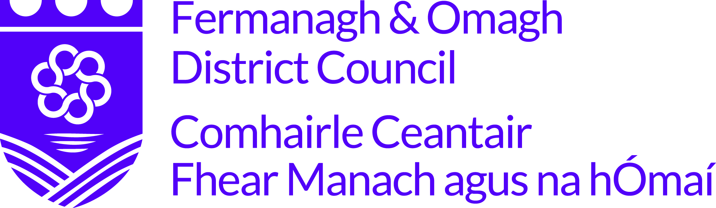
BANK AUTOMATED CLEARING SYSTEM (BACS)
In order to process your grant payment FODC require your bank account details.
To facilitate this please complete and return this form along with your grant aid claim.
NAME OF ORGANISATION/INDIVIDUAL:
ADDRESS:
POSTCODE:
TELEPHONE:
BANK NAME & ADDRESS:
NAME OF ACCOUNT HOLDER:
SORT CODE:
ACCOUNT NO:
BUILDING SOCIETY ROLL NO (if applicable):
As a remittance will be issued by email please provide an email address:
EMAIL:
NAME:
SIGNATURE:
POSITION IN ORGANISATION:
DATE:
Data Protection
In accordance with the Data Protection Act 2018, Fermanagh and Omagh District Council has a duty to protect any information we hold on you. The personal information you provide here will only be used for the purpose of procurement and payment and will not be shared with any third party unless law or regulation compels such a disclosure or in the processing of external funding applications and associated claims. For further guidance on how we hold your information please visit the Privacy section at www.fermanaghomagh.com/your-council/privacy-statement/

Post-Project Evaluation Form
Please Note A Completed Post-Project Evaluation Form Must Be Completed and Returned With Your Claim

Project/Event Name:
Project/Event Date(s):

Project/Event Location & Postcode:
Please outline how the project has met the outputs as outlined in your Letter of Offer and how the grant award has assisted your group. (Please use additional paper if required):

How much did we do?

Number of people who participated in the Project:

How well did we do it?
How satisfied were attendees with the delivery of your project?

Is anyone better off?
How your project made a difference within your community?

Print Name: ___________________________________ Date: _______________________

