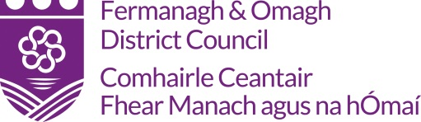

Claim Pack

Bursary - Irish Language
Family

A sample claim pack can be viewed on the Council’s website: www.fermanaghomagh.com, under Grants Sponsorship & Bursaries / Community Grants or if you require Officer assistance please contact the Grants & Investment Unit
Tel: 0300 303 1777 Email: grants@fermanaghomagh.com

Data Protection
In accordance with the Data Protection Act 2018, Fermanagh and Omagh District Council has a duty to protect any information we hold on you. The personal information you provide on this form will only be used for the purpose of contacting you about your grant aid claim and will only be shared with other relevant FODC sections and external funder and/or agencies (if applicable) for administrating your grant. For further guidance on how we hold your information please visit the Privacy section at: https://www.fermanaghomagh.com/your-council/privacy-statement/grants-and-investment/grants-and-bursary-call-application-forms-and-claims/

Fermanagh and Omagh District Council
Claim Checklist

Checklist:

 |  | YES/NO
1. | Claim Form  (Signed, attached)
2. | Original Invoices
3. | Bank Automated Clearing System - (BACS)  (Signed, attached)
4. | Post-Project Evaluation Form  (Signed, attached)
5. | Evidence of Outputs & Specific Requirements  (As outlined in your letter of offer)
6. | Any Other Information as Requested

Please complete this claim pack once the project has taken place and submit the
necessary documentation by the Claimed By Date Outlined In Your Letter Of Offer.

The completed claim pack can emailed to: grants@fermanaghomagh.com
Or
Post to:-
Grants and Investment Unit
Fermanagh and Omagh District Council

Either:

2 Townhall Street The Grange
Enniskillen or Mountjoy Road
Co Fermanagh Omagh
BT74 7BA Co Tyrone BT79 7BL

Audit: Please note your project/event could be selected for a full audit at any time by Fermanagh and Omagh District Council. All relevant documentation in relation to your project/event must be made available, if requested.

Grants and Investment - Expenditure Claim Form

Participant Name
Project Title:
Project / Event Date: |  |  | Grant Funding Awarded:
Invoice Date | Description of Eligible Expenditure | Supplier | Date Paid | Net | Vat | Total | Office Use
 |  |  |  |  |  |  | Inv
 |  |  | Total

I request grant assistance from Fermanagh and Omagh District Council’s Grants and Investment Unit on the eligible expenditure of ……………….as detailed above and agreed in the
Letter of Offer dated………………………….

Signed: ________________________________________________________ Date: ________________________________________________________________

OFFICIAL USE ONLY
Checked: ____________________________________________________________ (Grants & Investment Officer/Project Officer) Date: _________________________

Comments: __________________________________________________________________________________________________________________________________

BANK AUTOMATED CLEARING SYSTEM (BACS)
In order to process your grant payment FODC require your bank account details.
To facilitate this please complete and return this form along with your grant aid claim.
NAME
ADDRESS:
POSTCODE:
TELEPHONE:
BANK NAME & ADDRESS:
NAME OF ACCOUNT HOLDER:
SORT CODE:
ACCOUNT NO:
BUILDING SOCIETY ROLL NO (if applicable):
As a remittance will be issued by email please provide an email address:
EMAIL:
NAME:
SIGNATURE:
DATE:

Data Protection
In accordance with the Data Protection Act 2018, Fermanagh and Omagh District Council has a duty to protect any information we hold on you. The personal information you provide here will only be used for the purpose of procurement and payment and will not be shared with any third party unless law or regulation compels such a disclosure or in the processing of external funding applications and associated claims. For further guidance on how we hold your information please visit the Privacy section at www.fermanaghomagh.com/your-council/privacy-statement/

Post-Project Evaluation Form
Bursary - Irish Language Family
Please Note A Completed Post-Project Evaluation Form Must Be Completed and
Returned With Your Claim

Applicant Name:

Event Bursary awarded for:
Event Bursary Date(s):

Event Bursary Location:

Please detail how your bursary has benefited you?

Other funding
Please confirm if you have received other funding in respect of this project?
[Grab your reader’s attention with a great quote from the document or use this space to emphasize a key point. To place this text box anywhere on the page, just drag it.]
Yes
No
[Grab your reader’s attention with a great quote from the document or use this space to emphasize a key point. To place this text box anywhere on the page, just drag it.]

If yes, please provide details below:-

Print Name: ___________________________________ Date: _______________________

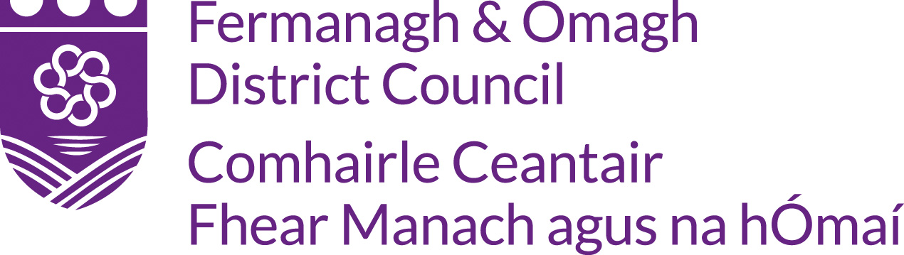

Confirmation of Attendance - FAMILY
This form must be completed by the relevant Gaeltacht Course Co-Coordinator and returned to Fermanagh and Omagh District Council in order to claim the bursary award.
Ainm/ Name
Ainmneacha teaghlach/ Names of family members attending
Seoladh/ Address
Cúrsa Gaeltachta/ Gaeltacht Course | Ainm:  Seoladh:  Guthán:
Dátaí tinrimh/ Dates of Attendance | Ó Go dtí
Dearbhaíonn an fhoirm seo gur fhreastail an Cúrsa Gaeltachta iomlán thuasluaite.

Síniú Stiúrthóir Cúrsa Dáta

