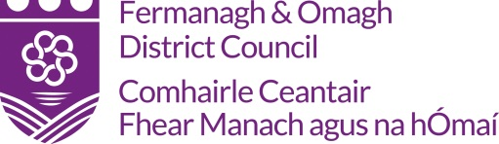
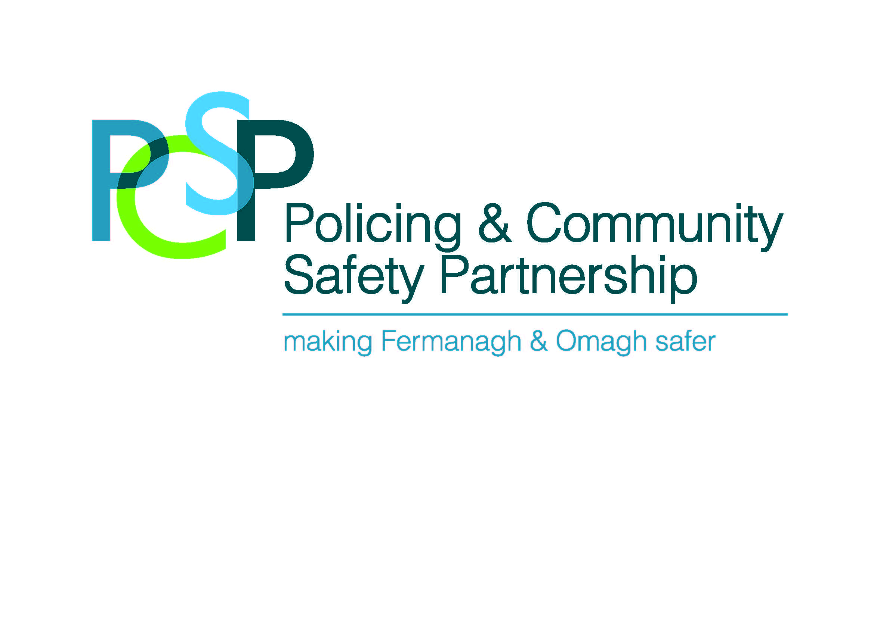

Claim Pack
PCSP Community Engagement Project

Organisation
Project Title
Contact Person
Contact Details
Amount Awarded

A sample claim pack can be viewed on the Council’s website: www.fermanaghomagh.com, under Grants Sponsorship & Bursaries / Community Grants or if you require Officer assistance, please contact the Grants & Investment Unit
Tel: 0300 303 1777 Email: grants@fermanaghomagh.com

Data Protection
In accordance with the Data Protection Act 2018, Fermanagh and Omagh District Council has a duty to protect any information we hold on you. The personal information you provide on this form will only be used for the purpose of contacting you about your grant aid claim and will only be shared with other relevant FODC sections and external funder and/or agencies (if applicable) for administrating your grant. For further guidance on how we hold your information please visit the Privacy section at: https://www.fermanaghomagh.com/your-council/privacy-statement/grants-and-investment/grants-and-bursary-call-application-forms-and-claims/

Fermanagh and Omagh District Council
Checklist

Checklist:

 |  | YES/NO
1. | Completed Expenditure Form  (Signed by two office bearers, attached)
2. | Original Invoices  (Please note if emailing, please retain originals as they may be requested at a later date)
3. | Procurement  Quotations Please refer to Point 2 of your Letter of Offer - Terms & Conditions.  Original Quotations must be submitted with claim
4. | Bank Statements*  (Please note if emailing, please retain originals as they may be requested at a later date)
5. | Evidence of Outputs & Specific Requirements  (As Outlined in Your Letter of Offer)
6. | Bank Automated Clearing System - (BACS Form)  (attached)
7. | PCSP – End of Project Reporting Form  (attached)
8. | Any other Information as Requested

* If you are unable to provide an original bank statement, please see Terms and Conditions
for acceptable bank statement formats.

Please complete this claim pack once the project has taken place and submit
the necessary documentation by the Claimed For By Date Outlined In Your
Letter Of Offer.

The completed claim pack can emailed to: grants@fermanaghomagh.com
Or
Post to:-
Grants and Investment Unit
Fermanagh and Omagh District Council

Either:

2 Townhall Street The Grange
Enniskillen or Mountjoy Road
Co Fermanagh Omagh
BT74 7BA Co Tyrone BT79 7BL

Grants and Investment - Expenditure Form

Name Of Organisation:
Project Title:
Grant Funding Awarded:
Grant Funding Claimed:
Invoice Date | Description of Eligible Expenditure | Supplier | Date Paid | Cheque Number/ Debit or Credit Card Ref | Net | Vat | Total | Office Use
 |  |  |  |  |  |  |  | Inv | BS | Chq
 |  |  | Total

Is applicant group VAT registered: …YES / NO….. (please circle)

Declaration: I certify that all the figures provided in respect of this project / event has been verified to be true and accurate.
6

I certify that all documents are held to support all the figures included on this claim form and in relation to all income and expenditure associated with the project/event.

Signed: ____________________________________________ Position: _________________________________________ Date: ________________________

Witnessed by: _______________________________________ Position: __________________________________________ Date: ________________________

OFFICIAL USE ONLY
Checked: ____________________________________________________________ (Grants & Investment Officer/Project Officer) Date: _________________________

Comments: __________________________________________________________________________________________________________________________________
2

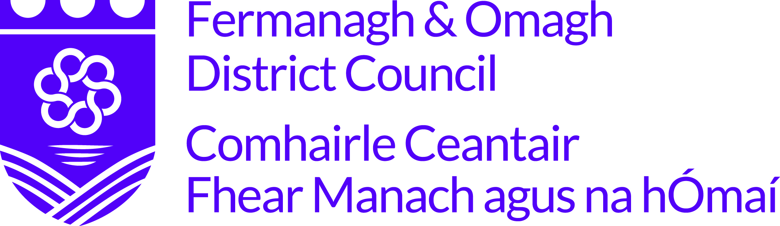

BANK AUTOMATED CLEARING SYSTEM (BACS)
In order to process your grant payment FODC require your bank account details.
To facilitate this please complete and return this form along with your grant aid claim.
NAME OF ORGANISATION/INDIVIDUAL:
ADDRESS:
POSTCODE:
TELEPHONE:
BANK NAME & ADDRESS:
NAME OF ACCOUNT HOLDER:
SORT CODE:
ACCOUNT NO:
BUILDING SOCIETY ROLL NO (if applicable):
As a remittance will be issued by email please provide an email address:
EMAIL:
NAME:
SIGNATURE:
POSITION IN ORGANISATION:
DATE:
Data Protection
In accordance with the Data Protection Act 2018, Fermanagh and Omagh District Council has a duty to protect any information we hold on you. The personal information you provide here will only be used for the purpose of procurement and payment and will not be shared with any third party unless law or regulation compels such a disclosure or in the processing of external funding applications and associated claims. For further guidance on how we hold your information please visit the Privacy section at www.fermanaghomagh.com/your-council/privacy-statement/

End of Project Reporting Form

Fermanagh and Omagh District Council will ask for regular reporting updates.

Name of Organisation/Group:
Amount of Funding Awarded:
Project Activity
Describe the project activity undertaken. Where relevant include activities, no. of contact sessions, no. of participants, age category.
How were the participants recruited?
How did your project address the issues identified?

If relevant, how did you involve the PSNI in project delivery?

How did you evaluate the project?  What methods did you use to evaluate the project e.g., survey, focus group etc.  Please share key evaluation material  How much did we do?  # programmes delivered  # participants  How well did we do it?  #/% participants reporting satisfaction with the programme  Is anyone better off?  #/% participants more likely to engage with PSNI following programme  How has the project made a difference in your community?  Include any comments from participants or any other anecdotal evidence. | How much did we do?  # programmes delivered  # participants  How well did we do it?  #/% participants reporting satisfaction with the programme  Is anyone better off?  #/% participants more likely to engage with PSNI following programme
PCSP Acknowledgment
How did you acknowledge the funding support from the PCSP?
Future learning
What would you change/do differently if running the project in the future?

Please note, Fermanagh and Omagh District Council reserve the right to contact you for further information and seek clarification if deemed necessary and if requested by any other funder providing funding to this project

Please note that the completion of this form is an essential requirement of the funding awarded. You will be required to provide regular monitoring returns throughout the duration of your project.

Please return completed form to grants@fermanaghomagh.com

