

**Cemetery**

**Rules and Regulations**

**Breandrum Cemetery**

**Enniskillen Cross Cemetery**

**Dublin Rd, Greenhill and Fintona Cemetries**

**FERMANAGH AND OMAGH DISTRICT COUNCIL**

**RULES AND REGULATIONS**

**Relating to**

**BREANDRUM CEMETERY**

**CONTENTS**

**Page No**

Ownership of right of burial ground ……………………… 5, 6

Testing graves for opening ……………………………….. 6

Opening of graves for interment ………………………….. 6, 7

Fees ……………………………………………………….. 7

Exhumation ……………………………………………….. 7

Signing the Register of Burials ……………………………. 8

Erections on Graves ……………………………………….. 8

Erection of Headstones ……………………………………. 8

Erection of Surrounds ……………………………………… 9

Wreaths …………………………………………………….. 10

General ……………………………………………………… 10, 11

***RULES AND REGULATIONS***

**Made by Fermanagh and Omagh District Council, for the General Management, Regulations and Control of the Burial Ground provided by them at Breandrum, Enniskillen, and prescribing the restrictions and conditions under which the right of burial may be purchased.**

**OWNERSHIP OF RIGHT OF BURIAL**

1. Only one person shall be registered as the proprietor of the right of burial in each plot, joint proprietorship is not permitted.
2. The person only in whose name a plot is registered will be recognised by the Council as the legal proprietor of the right of burial for the time being.
3. In the burial ground the exclusive right of burial in each plot shall be granted in perpetuity to the purchaser thereof, his and her heirs and assigns, and shall confer upon the purchaser, his or her heirs and assigns, the right to erect headstones, subject to the conditions in that behalf hereinafter contained.
4. A person desiring to purchase the right of burial in a plot shall conform to all rules and regulations in force or thereafter to be made by the Council for the regulation, management and control of the Burial Ground, and upon payment of the prescribed charge for the plot the Grant of the right of burial shall be issued to the purchaser in due course.
5. An entry of the date of each Grant of a right of burial, and of the purchaser’s name and residence, the number on the plan of the plot and, the section of the ground in which the right of burial has been purchased, shall, upon the execution of each such Grant, be made in the Register. The Register may be perused at all reasonable times by a grantee or assignee of any such right.
6. Subject as hereinafter mentioned, the right of burial in more than one plot shall not be sold or vested in any one person; and no sub-division of any plot purchased shall take place without the consent of the Council having been first obtained.
7. If the registered proprietor of a right of burial shall prove by statutory declaration to the satisfaction of the Council that he/she has lost his/her Grant, he/she shall be entitled, upon payment of the prescribed fee to receive a duplicate thereof. Provided that if the original Grant should afterwards be discovered, the duplicate Grant shall not be considered to have any force or effect, and it shall be endorsed with a memorandum to that effect. In such circumstances no refund will be made of the fee for issue of the duplicate Grant.
8. The right of burial shall be considered as the estate of the registered proprietor thereof, and may be transferred by him/her in his/her lifetime or bequeathed by his/her Will, and, if not so conveyed or bequeathed, shall be the property of the heir-at-law of the registered proprietor.
9. No person claiming right to succeed to a deceased registered proprietor shall be recognised, or have his name inserted in the Register as proprietor, until evidence shall have been produced to the satisfaction of the Council that the claimant is entitled to succeed. No transfer by an inter vivos deed shall have any strength or effect unless approved by the Council which shall have the right of pre-emption and power to accept and reserve to the Council the right of burial in any plot in respect of which a transfer by way of sale is intended to be effected. No person claiming a plot, either by succession or transfer, shall be recognised or have his name inserted without production of the certificate or document granted to the original registered proprietor, or such other evidence of ownership as may satisfy the Council.
10. The Council shall determine in which order the Plots and/or Sections for the right of burial be sold.

**TESTING GRAVES FOR OPENING**

On an application to open a grave for the purpose of a burial, the opinion of the Supervisor of the Cemetery as to whether the interment can take place, having regard to the regulations as to interments and the depth at which coffins are to be placed below the surface of the ground, shall be final.

**OPENING OF GRAVES FOR INTERMENT**

1. Each grave space shall measure 122cm wide by 270cm long and will **ONLY** be opened when a completed and signed application for interment has been made and has been received by Fermanagh and Omagh District Council. The Council cannot be held responsible for any claim whatsoever that may arise from the opening of a grave.
2. Every grave shall, in the first instance, be opened to a minimum depth of 214cm and no coffin shall be laid in the grave nearer to the surface than 1 metre (70cm where ground conditions are suitable) therefrom, (nor from any surrounding ground) measuring from the uppermost part of the coffin; and no grave in which a coffin shall have been laid at a depth of 1 metre or 70cm from the surface shall be re-opened, without a special resolution of the Council. Any interments shall be separated from other coffins by means of a layer of earth not less than 30cm thick.
3. On occasions before a grave is opened for interment, an application in writing from the registered owner, or some person purporting to act on his behalf, and producing the Grant of right of burial, may be necessary. With no grant being available the person purporting to act as the owner must complete an application for interment and indemnity form.
4. A person requiring to have an interment made in any grave, shall sign an application for that purpose, giving the following particulars for registration:

* The Christian and Surname
* Time of Death
* Sex
* Age
* Religious Persuasion
* Occupation or Rank in Life
* Last place of Residence
* Condition (as whether “married” or “single”, “widower” or “widow” or “the child of”) of the person to be buried
* Name and Address of the person having the management of the interment.

1. All applications shall be accompanied by the statutory certificate of death of the Registrar of Births and Deaths, or the statutory Order for Burial of a Coroner, which certificate or order is by law required to be delivered up at the time of burial.
2. An application for interment must be made at least 24 hours before the interment can take place.
3. In the case of more than one funeral, interments will take place in the order in which the funerals arrive, as arranged by the Council.
4. No interment shall be permitted in the Cemetery, nor shall any dead body be received previous to interment, unless the body be enclosed in a coffin of wood or other sufficiently strong material.

**FEES**

The scale of charges for the purchase of Burial Plots/Interment fees, etc, shall be as prescribed by the Council at the time of the Purchase/Interment etc, and the Council shall have the right to revise the scales as and when it feels it necessary to do so. Copy of current fees attached (see annex 1).

**EXHUMATION**

No grave shall be opened, or shall any body or the remains of any body be removed from a grave, or transferred from one place of burial to another, or exhumed, except under those circumstances and conditions specially provided by law and with the written consent of the Council.

**SIGNING THE REGISTER OF BURIALS**

The person having the management of the interment, shall, submit relevant details of the burial on or before the interment takes place and sign the registry book as required by law.

**ERECTIONS ON GRAVES**

In all sections of the Cemetery, no monument, headstone, headlock, surround or other erection shall be removed, altered or installed without the prior written permission of the Council. All applications to carry out such work shall be made to the Head of Parks and Open Spaces, Killyvilly Depot 152 Tempo Rd, Enniskillen BT74 4GD.Tel: 03003031777. No work can commence until written approval has been received from the Council and the Cemetery Supervisor has been informed and agreed for work to commence.

All graves in the Cemetery are permitted to have headstones and or surrounds. Before any work proceeds, it is imperative that you consult the Cemetery Supervisor.

**ERECTION OF HEADSTONES**

All Headstones to be placed on graves shall be subject to the prior approval laid down by the Council and to the following conditions and specifications:

* All headstones shall be of stone and if applicable, shall be placed upon the foundation provided by the Council.
* No Headstones shall exceed 130cm in height measuring from the uppermost part of the foundation. For the purpose of determining this height any device upon the Headstone (a cross, etc) shall be deemed to form part of the Headstone.

* The maximum width of a headstone shall be 122cm, and shall not exceed a breadth of 30cm.

* However, in the event of the proprietor wishing to erect a linear type stone, exceeding the above widths, on a multiple grave, the Council will consider such applications based on individual submissions. The decision of the Director of Environmental Services in such instances will be binding.

**ERECTION OF SURROUNDS**

1. All surrounds to be placed on graves shall be subject to the prior approval of the Council and to the following conditions and specifications laid down by the Council.

* All surrounds shall be of stone.
* The maximum external measurement of a surround should be no greater than 122cm across the width of the plot, 30cm in height, no greater than 270cm in length measured from centre of the concrete plinth or from the rear of the headstone if a plinth has not been provided. NB: The external width 122cm does not include the provision of a corner post which can project an additional 2.5cm each side of the surround.
* The minimum internal measurement of a surround is width 90cm, length 230cm (leaving internal open for grave to width of 90cm and length of 230cm).
* Foundations for surrounds are essential. Foundations when being laid **must** leave an internal clear opening of width 90cm and length 230cm.

1. Every application to erect a Headstone, monument or surround shall be made to the Head of Parks and Open Spaces. No sculptural or construction work should be commissioned or commenced in advance of approval being received from the Council, and agreement with the Cemetery Supervisor being obtained, with the prescribed fee to be invoiced accordingly.
2. Hewing of or dressing of stones is not permitted in the Cemetery.
3. A person erecting a Headstone, monument or surround shall remove all debris resulting from the erecting and shall make good any damage done to turf, shrubbery, adjacent graves, paths or other, all at his/her own expense.

1. All sculptors must report to the Cemetery Supervisor before proceeding to do any work in the Cemetery and no construction work shall be commenced until the approval of a Council representative has been given. Unless prior approval has been given by the Council, all works should cease during burial services within the Cemetery.
2. The owner of any Headstone, surround, monument or other allowed to fall into a bad state of repair shall be advised so by the Council and requested to make the necessary repairs within a specified period. If in the interests of safety or default by the owner in effecting the repairs requested, the Council may remove or repair the Headstone, surround, monument or other and the cost of doing so in either case shall be a debt from the registered proprietor of the grave to the Council and recoverable as such.

**WREATHS**

On graves which do not seem to have been tended, at the expiry of **ninety days** after the date of interment, if not already done by the proprietor, the Council shall remove all but one of floral sprays, wreaths, etc, from the grave plot. The Council disclaims any responsibility or the damage or displacement of floral sprays, wreaths, etc.

**GENERAL**

1. In these Rules “The Council” means the Fermanagh and Omagh District Council.
2. All burials shall be duly entered in the Register by a person appointed by the Council.
3. No person shall plant any tree, shrub, flower or other plant on any grave.
4. A person tending a grave shall cause as little refuse as possible and shall clear away same immediately when finished and shall not on any account allow same to fall or collect upon an adjoining grave, or injure or disturb an adjoining or other grave. If any default shall be made in observing this rule the Council will have same remedied and the expense thereof shall be of a debt from the Registered owner of the grave to the Council and recoverable accordingly.
5. Proprietors and friends who may accompany them shall have free access on foot to the Cemetery subject to such restrictions as the Council may from time to time deem it necessary to impose.
6. No person shall enter or leave the Cemetery except by the entrance gates, or walk or trespass upon any of the shrubberies/borders or graves, or injure any plant, flower or shrub, or interfere with any Headstone. Children must be accompanied by an adult person in charge of them. A person shall not enter or remain in the Cemetery at any hour when it is closed to the public unless authorised by or on behalf of the Council.
7. Dogs must be kept on a lead at all times, no animals shall be allowed to graze therein.
8. Any person who shall wilfully destroy or injure any building, wall or fence in or connected with the Cemetery, or destroy or injure any tree, shrub, plant or flower in it, or rub or disfigure any of the walls, or put up any bill thereon; or wilfully destroy, injure or deface any of the Headstones/plinths, or do any wilful damage, or play at any game or sport, or discharge firearms (save at a Military Funeral) in the Cemetery; or wilfully disturb any persons property assembled therein for the purpose of burying any body, or who shall commit any nuisance, shall forfeit the cost of repair for any damage caused.
9. No person shall be permitted to use a metal detector in the Cemetery.
10. Ministers and Clergymen of the various religious denominations shall be at liberty to officiate at the graves of persons to perform ceremonies of their respective Churches or bodies.
11. In the normal course of events only funeral hearses and official funeral cars may enter the Cemetery beyond the car parking area (except for Council vehicles and monumental sculptors properly attending the Cemetery). This is subject to the Council’s discretion. However, in the case of elderly, disabled or infirm visitors, prior arrangements may be made with the Cemetery Supervisor to have access with a vehicle beyond the car parking area. In such cases those afforded this facility must drive the vehicle only on those areas indicated by the Cemetery Supervisor.
12. These rules are subject to amendment or alteration from time to time, as the Council shall see fit.
13. The foregoing Rules shall remain in force, and be binding on the right of burial in the Cemetery, and all other persons, until same be altered by the Council.

**FERMANAGH AND OMAGH DISTRICT COUNCIL**

**RULES AND REGULATIONS**

**Relating to**

**ENNISKILLEN CROSS CEMETERY**

# CONTENTS

**Page No**

Ownership of a Right of Burial…………………………………….. 15, 16

Opening graves for interment (burial)…………………………….. 16, 17

Application for interment (burial)…………………………………... 17, 18

Funeral Services…………………………………………………….. 18

Fees…………………………………………………………………… 18

Exhumation…………………………………………………………… 18

Signing the Register of Burials……………………………………... 18

Maintenance and Memorials……………………………………….. 18

Erection of Headstones……………………………………………… 19

Grave Maintenance………………………………………………….. 20, 21, 22

General Provisions…………………………………………………… 22, 23, 24

***RULES AND REGULATIONS***

**The Council appreciates that the preparation of funeral arrangements is a difficult time for families and will be as helpful as possible. However there are some rules governing the administration of Cross Cemetery which must be adhered to as outlined below:**

**Undertakers are required to explain the operating procedures of the Cemetery prior to burial. However, Council staff are also happy to answer any questions which a family may have. Please phone the Council on 028 66323533 or 0300 3031777.**

**OWNERSHIP OF A RIGHT OF BURIAL**

For the purposes of clarity for the remainder of this documentthe term ‘plot’ refers to the defined area of the Cemetery for which a right of burial has been granted for the purpose of opening of a grave.

1. A ‘right of burial’ in a plot can only be acquired by a person with a requirement for an immediate interment (burial). When a right of burial is granted, the applicant’s name and address is entered into the Cemetery Register as the “Proprietor” of a right of burial for the plot and the Proprietor will receive a ‘Deed of Right of Burial’. The Deed grants to the Proprietor a right of up to three burials per single plot, or six burials per double plot (in addition to any cremated remains (ashes) being interred in the plot). Please note that purchasing a right of burial does not mean the Proprietor has purchased the land, only a right to interment (burial) in the assigned plot.
2. Only one person can be registered as legal Proprietor of a right of burial for each plot. The Proprietor may purchase rights for a single or a double plot permitting respectively a maximum of 3 or 6 burials. The Council will determine in which order plots and/or sections for a right of burial will be granted within the Cemetery. Plots will be allocated on the basis of the next space available in any section.
3. Details of the Proprietor’s name, address, the plot number and the section of the ground in which a right of burial has been granted will be recorded in the Cemetery Register. The Cemetery Register will be maintained by the Council and may be viewed at all reasonable times. The exclusive right of burial in a plot is granted in perpetuity to the Proprietor and his/her heirs or nominated successor. A right of burial may not be sold, nor may any plot be sub-divided without Council consent being obtained in advance.
4. A right of burial may be transferred during a Proprietor’s lifetime to a nominated successor, or on death to such person to whom the right is bequeathed by the Proprietor’s Will. In the absence of such nomination, or bequest on the death of the Proprietor, the title can only be transferred to a successor (family member) if the Council is reasonably satisfied that such transfer is appropriate. Please note the Council can only accept a request for burial from the Proprietor, their nominated successor, or such other person as the Council, acting reasonably, may approve and can only grant permission to a living Proprietor for the erection of memorials. This means that should the Proprietor pass away without assigning the right of burial to a successor, there may be a delay in opening the grave until ownership or reasonable entitlement is established with another family member. It is therefore recommended that the Deed of Right of Burial is assigned, transferred or bequeathed to a successor as soon as possible to avoid distress to bereaved families.
5. If the registered Proprietor loses a Deed of Right of Burial the Proprietor may obtain a duplicate for a specified fee.

**OPENING GRAVES FOR INTERMENT (BURIAL)**

1. Interments (burials) can only take place on the authorisation of the Council upon receipt of a request from the Proprietor (or such other person as the Council shall permit under the terms of Para 4 above) and on receipt of a signed application for interment. Each grave space will measure 122cm wide by 270cm long. The undertaker is also required to sign the application for interment.
2. On receipt of an application to open a grave for burial, the decision of the Cemetery Supervisor on whether the burial can take place will be final. The Cemetery Supervisor will consider burial regulations, ground conditions and the depth at which coffins are to be placed below the surface of the ground in reaching a decision.
3. Each plot shall, in the first instance, be opened to a depth of 214cm to allow for a maximum of three burials. No coffin will be laid in the grave nearer than 1 metre to the surface (70cm where ground conditions are suitable) measuring from the uppermost part of the coffin. No grave in which a coffin has been laid at a depth of 1 metre (or 70cm) from the surface can be re-opened without Council approval. Each coffin at interment will be separated from other coffins by means of a layer of earth of at least 30cm deep.
4. The Council will not be held responsible for any claim whatsoever that may arise from the opening of a grave.

**APPLICATION FOR INTERMENT (BURIAL)**

1. An application form must be completed and submitted to the Council for approval, providing the following information:

* Entry number in the registry book
* Section
* Plot number

(Please note for applications for a new plot the three pieces of information listed above will be provided by the Cemetery Supervisor).

* Proposed date of Burial
* Details of the Undertaker
* Proprietor of a Right of Burial (person with legal entitlement to a right of burial in the plot) or such other person approved under Para 4.
* Contact address

1. The following information is also required relating to the person to be interred (buried):

* First name and Surname
* Address
* Date of death
* Sex
* Age
* Religious Persuasion
* Occupation
* Marital Status

1. All applications need to be accompanied by either a Medical Certificate of Cause of Death, the statutory certificate of death of the Registrar of Births and Deaths, or the statutory Order for Burial of a Coroner
2. Applications for interment (burial) must be made at least 24 hours before the intended time of burial.
3. The Council will continue to offer childrens’ plots at Breandrum Cemetery while space permits. In Cross Cemetery children will be buried in full size plots.

**FUNERAL SERVICES**

1. In the case of more than one funeral, interments will take place in the order in which the funerals arrive, as arranged by the Council. Funerals must arrive at the Cemetery between the hours of 9am and 6pm unless by prior arrangement with the Cemetery Supervisor. However, the Cemetery will remain open during the hours of daylight should families wish to visit.
2. No interment (burial) will be permitted in the Cemetery, nor shall any dead body be received prior to interment, unless the body is enclosed in a coffin of wood or other sufficiently strong material.

**FEES**

The scale of charges for the purchase of a right of burial/interment, etc., will be as prescribed by the Council at the time of the purchase/interment. The Council has the right to revise the scale of charges as and when it feels necessary to do so. A copy of the current scale of charges is available from Fermanagh and Omagh District Council, Townhall, Enniskillen or Fermanagh and Omagh District Council Killyvilly Depot, Tempo Road Enniskillen, or on the Council website at [www.fermanaghomagh.com](http://www.fermanaghomagh.com)

**EXHUMATION**

Exhumations are strictly controlled and Fermanagh and Omagh District Council does not have the authority to approve exhumation. No grave shall be opened, or shall any remains be removed from a grave, or transferred from one place of burial to another, or exhumed, except under circumstances specifically provided by law.

**SIGNING THE REGISTER OF BURIALS**

The Proprietor of a right of burial or the person responsible for the management of the funeral is required to sign the registry book as required by law.

**MAINTENANCE AND MEMORIALS**

It is necessary for Fermanagh and Omagh District Council to ensure that the size and type of memorials within Cross Cemetery are appropriate and that graves are appropriately maintained in accordance with the following guidance.

**ERECTION OF HEADSTONES**

1. Applications to erect a headstone should be made to the Head of Parks and Open Space and approval must be granted before any work is undertaken.   
   Headstones must:

* Be made of stone and be placed on the foundation already provided by the Council;
* Be no more than 130cm in height, 122cm in width and 30cm in breadth, measuring from the uppermost part of the foundation, inclusive of any projecting feature such as a cross.
* Be erected centrally at the head of the plot. Where two graves are within a plot, two headstones may be erected (max dimensions as above) but with the second only being permitted following opening of the second grave.

Applications to erect a headstone should be made to the Head of Parks and Open Spaces. Applications to erect a linear type stone, exceeding the above widths, on a double plot will be assessed on a case by case basis. The decision of the approved Officer in these cases will be binding, not withstanding an applicant’s right of appeal.

1. No sculptural or construction work of any kind should be commissioned or commenced before approval of the design, wording and detail has been obtained from the Council’s approved officer, agreement is reached with the Cemetery Supervisor and the appropriate fee has been paid. Please note hewing or dressing of stones is not permitted in the Cemetery.
2. When erecting headstones within the Cemetery:

* All sculptors must report to the Cemetery Supervisor before proceeding to do any work
* The person erecting the headstone is responsible for the removal of all debris resulting from the work and making good any damage done to turf, shrubbery, adjacent graves or plots, paths or other Cemetery features at their own expense
* Unless prior approval has been given by the Council, all work should cease during burial services within the Cemetery.

1. The erection of pillars, railings, fences, plinths, hoops, surrounds or other structures for the purposes of enclosing graves, or elsewhere in the Cemetery, is expressly prohibited and if so placed will be removed immediately by Council staff with the associated costs being recovered from the Proprietor of the right of burial.

**GRAVE MAINTENANCE**

Families who have purchased a right of interment (burial) within the Cemetery will have an option to either:

* Maintain the grave themselves or
* Allow Council employees to maintain the grave in accordance with a “lawn type” system.

MAINTENANCE BY FAMILY

Where families opt to maintain graves they shall inform the Council after which the Council will install a thin metal edging sunken to ground level around the plot. No other form of grave surround is permitted.

Families will then be permitted to place floral tributes, mementos or other tributes within the confines of this edging. Where families wish to undertake planting this must be restricted to plants placed within a pot. The maximum permitted height of any planting or memento placed on a grave is 500mm inclusive of any pot or container used.

Graves must be maintained to a suitable standard clear of weeds and debris. The following photographs are offered as a guide:

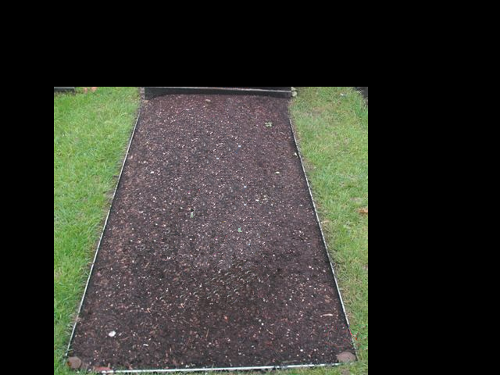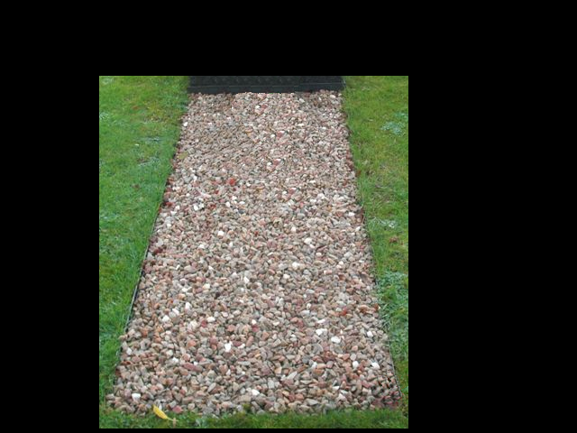   
 Condition 1 Condition 1

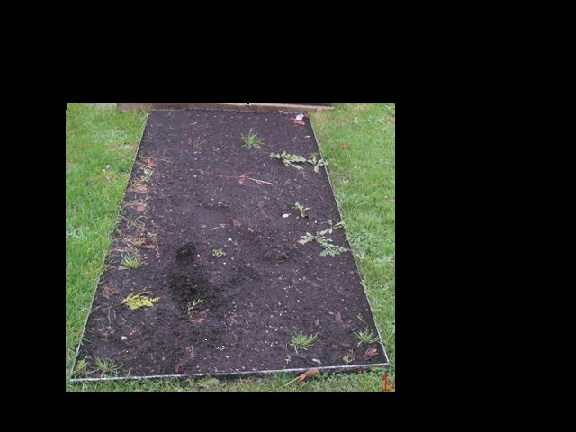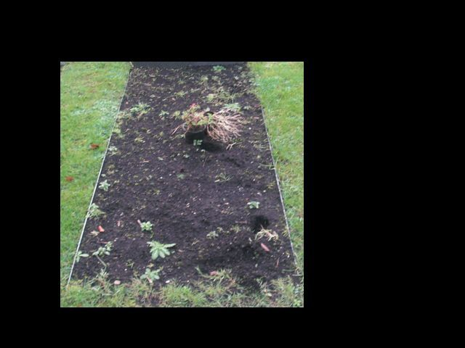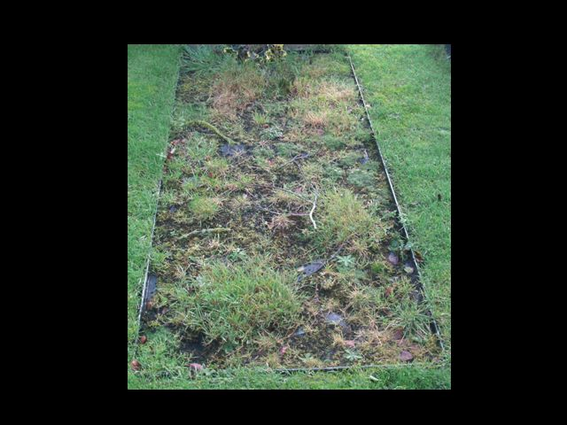

Condition 2 Condition 3 Condition 4

If the Council considers that the quality of grave maintenance is falling below the required standard, contact will be made with the family and a request for maintenance made.

* Where standards have fallen to those shown in Condition 2, this will be noted with a view to further action if necessary.
* Where standards have fallen to those shown in Condition 3, the family will be informed in writing and given 14 days to maintain the grave, bringing it back to Condition 1.
* Where standards have fallen to those shown in Condition 4, the family will be informed in writing that the Council intends to assume responsibility for maintenance of the grave and to lay amenity turf. The family will be notified that this is the Council’s intention, subject to a 7 day period when an appeal can be lodged.

If the Council is required to contact a family regarding failure to meet maintenance standards more than 3 times the Council will immediately lay amenity turf and assume responsibility for the maintenance of the grave.

It is the responsibility of the family to ensure that the Council has appropriate contact details for the current Proprietor of a right of burial. The Council will use the last recorded address for the Proprietor of the right of burial to contact the family to request grave maintenance, repairs to any grave feature, or advise the family of the Council’s intention to assume responsibility for maintenance. Should no satisfactory response be forthcoming, Council shall be entitled to take such grave maintenance action as is reasonably deemed necessary.

The Council requests that anyone tending a grave should ensure that all waste materials are removed as quickly as possible and placed in the receptacles provided. Care must also be taken not to disturb any adjacent graves/plots.

The Council understands that circumstances can change and if it becomes difficult for a family to maintain the grave/plot to the required standard they can request the Council to lay amenity turf and assume responsibility for maintenance.

MAINTENANCE BY COUNCIL

Where families opt for the Council to maintain plots within the Cemetery, Council will lay amenity turf over the grave after a period of 90 days from the date of interment and, upon request, install a granite memorial slab at the base of the headstone, or at the top of the grave where no headstone is present. This granite slab may then be used for the display of floral tributes or mementos. For ease of maintenance mementos/tributes must be placed on the memorial slab. Where no memorial slab is requested a maximum of two tributes or mementos, can be displayed upon the grave. Where families wish to undertake planting this must be restricted to plants placed within a pot. The maximum height for all mementos is 500mm including any pots/containers used.

A second memorial slab can be provided when the second grave in a double plot is opened.

Memorial slabs will only be provided by the Council in the areas of the Cemetery where the Council is responsible for the maintenance of graves/plots.

In the areas of the Cemetery where the Council is responsible for maintenance of graves/plots grass cutting equipment will be used. However, staff are required to carry out their duties with due regard to the sensitivities relating to the treatment of plots and the respect to be afforded to the deceased.

**GENERAL PROVISIONS**

1. In these rules “The Council” means Fermanagh and Omagh District Council.
2. All burials will be recorded in the Register of Burials by a person appointed by the Council.
3. No one is permitted to plant any tree, shrub, flower or any other plant on any grave/plot or elsewhere on Council property.
4. Should any damage be caused to adjacent graves/plots as a result of grave/plot maintenance, or the erection of memorials/tributes, the Council will make good the damage and recover the costs from the person registered as the Proprietor of a right of burial for the plot that was being maintained.
5. In the normal course of events only funeral hearses and official funeral cars may enter the Cemetery beyond the car parking area (except for Council vehicles and monumental sculptors properly attending the Cemetery). This is subject to the Council’s discretion.
6. Access to Cross Cemetery for funerals is via Carran Business Park. No access to, or egress from the Irvinestown Road is permitted.
7. Visitors to the Cemetery will have free pedestrian access during opening hours subject to such restrictions as the Council may from time to time deem necessary to impose. In the case of elderly, disabled or infirm visitors, prior arrangements may be made with the Cemetery Supervisor to have vehicular access beyond the parking area. Vehicles must only travel on those areas indicated by the Cemetery Supervisor.
8. No one will be allowed to enter the Cemetery except by the entrance gates, nor will they be allowed to walk or trespass on, or damage, any of the shrubberies/borders, headstones, or graves. No access is permitted to the Cemetery outside the normal opening hours unless authorised by the Council.
9. No dogs are permitted within the Cemetery except assistance dogs.
10. Any person who wilfully:

* Destroys or damages any building, wall, fence, grave, headstone, tree, shrub or flower in or connected with the Cemetery
* Or who posts any bills thereon
* Or who plays any game or sport
* Or who discharges firearms (save at a Military Funeral) in the Cemetery
* Or who wilfully disturbs any persons property assembled for the purpose of burial
* Or who commits any nuisance will be subject to sanction and will be liable for the cost of repair for any damage caused and to such Statutory Court proceedings as shall be available to the Council.

1. No metal detectors are permitted in the Cemetery.
2. Fermanagh and Omagh District Council will make every effort to accommodate the requirements of families in relation to different religious beliefs subject to the operational constraints of the Cemetery.
3. These rules are subject to amendment or alteration from time to time, as the Council deems necessary.
4. The foregoing rules will remain in force, and be binding on the proprietor of a right of burial within the Cemetery, and all other persons, until they are altered or amended by the Council.

**FERMANAGH AND OMAGH DISTRICT COUNCIL**

**RULES AND REGULATIONS**

**Relating to**

**DUBLIN ROAD, GREENHILL AND FINTONA CEMETERIES**

CONTENTS

**Page No**

Introduction…………………………………………………… 27

Definition……………………………………………………… 27

Authority to Operate these Regulations…………………... 27

Types of Burial Ground……………………………………… 27, 28

Purchasing Right of Burial………………………………….. 28

Disposing of Right of Burial………………………………… 29

Assignment of Right of Burial………………………………. 29

Internments and Funerals………………………………….. 30, 31

Exhumation………………………………………………….. 31

Headstones………………………………………………….. 31, 32

Maintenance of Headstones……………………………….. 32

Operations within the Cemetery…………………………… 32

Wreaths………………………………………………………. 33

Lawn Lay Out (Greenhill Cemetery)………………………. 33

Commemorative Plaques on Seating in Cemeteries……. 33

Commemorative Tree Planting…………………………….. 33

Opening Hours………………………………………………. 33

General Rules………………………………………………... 34

Appendix I…………………………………………………….. 35, 36

**INTRODUCTION**

These rules are made by Fermanagh and Omagh District Council for the general management, regulation and control of the three burial grounds within the District:-

* Dublin Road Cemetery
* Fintona Cemetery
* Greenhill Cemetery

**DEFINITION**

In these bye-laws

* “the Council” means Fermanagh and Omagh District Council.
* “the Cemetery” means the above Cemeteries.
* “the Caretaker” means the person in charge of the Cemetery.
* “a Grave” means a portion of ground, approximately 2.7 metres long and 1.2 metres wide, which shall accommodate a maximum of three full sized coffins.
* “a plot” means a portion of ground containing either one or two graves.

**AUTHORITY TO OPERATE THESE REGULATIONS**

The Council may authorise such officers as it deems necessary to operate these regulations. An Act necessary to the proper execution of his duty in the Cemetery by an Officer of the Council, or any person or servant of any person employed by the Council shall not be deemed an offence against these Regulations.

**TYPES OF BURIAL GROUND**

1. The Burial Grounds shall be divided into such portions as shall be allocated from time to time as proprietary ground and free ground respectively.
2. In the proprietary ground the exclusive right of burial in the various graves shall be granted in perpetuity to the purchasers thereof, their heirs and assigns, together with the right to erect headstones subject to the rules and regulations.
3. In Greenhill Cemetery the exclusive right of burial in the various graves and sections shall be granted consecutively in such order as may from time to time be determined.
4. No rights apply to the “Free Ground” nor can a memorial of whatever kind be erected.

**PURCHASING THE RIGHT OF BURIAL**

1. Every application for the purchase of the “right of burial” shall be on the prescribed form and accompanied by the prescribed fee and each purchaser of such right shall be furnished with a Deed of Grant under the hands of the Chairman and the Clerk and Chief Executive of the Council, stating the name of the purchaser, the amount of the purchase money paid, and the section and number of the plot. The purchaser shall be considered the proprietor of such right of burial, in perpetuity, in the portion or plot described in the grant**.** The purchase does not mean the person has purchased the land, only the right to internment.
2. One person only shall be registered as the proprietor of the Right of Burial: joint proprietorship is prohibited. The “right of burial” in more than two graves in the proprietary ground shall not be sold or vested in any one person, nor shall any graves be assigned, divided or sub-let to any person without the special permission of the Council given in writing.
3. On payment of the amount for the right or burial inclusive of the cost of the preparation of the grant and entry in the Register, the Purchaser of such right shall be entitled to his grant in the prescribed form executed under the seal of the Council.
4. The scale of fees for grants and the right of burial shall be of the amount stated in a scale of charges.
5. An entry of the date of each grant, and the purchaser’s name, residence, the amount of the purchase money and the number on the map of the plot in which the right of burial has been purchased shall be made in the Register, which shall be kept in the care of the Council. This Register may be examined at all reasonable times by the grantee or assignee of any such right, or by any other person upon production of an order of the Council, and upon payment of a prescribed fee.
6. The right of burial shall be considered as the personal estate of the grantee and may be conveyed by him in his lifetime (in prescribed form) or bequeathed by his will and if not so conveyed or bequeathed shall be the property of the heir of the grantee. If the conveyance or bequest be to two or more persons concurrently, the first named only shall be entered in the Register.

**DISPOSING OF THE RIGHT OF BURIAL**

Proprietors wishing to dispose of their ground otherwise than to a member of their respective family or by Will shall be required in the first instance to offer it to the Council. In any event it shall not be sold at a price other than fixed by the Council at the time of sale.

**ASSIGNMENT OF RIGHT OF BURIAL**

1. No person, claiming to be entitled to the right of burial under an assignment or bequest of such right, or of the personal representative of a deceased proprietor, shall be recognised or have his name inserted in the Register as such until the assignment, probate or letters of administration under which such person claims to be entitled and the grant made to the original proprietor, shall have been produced to the Council and such further evidence of such right as the Council may require, of the right thereto of the person so claiming. On such application being made, the Council shall be empowered, if necessary, to order public or other notice thereof to be given, at the expense of the claimant**.**
2. Within six months after the execution of any assignment of the right of burial, or Grant of Probate of any Will, by which such right shall be bequeathed, or grant of letters of administration to the effects of a deceased proprietor, such assignments or grants respectively shall be produced to the Council, and on such production and payment of the prescribed fee, an entry thereof shall be made in the Register, and a certificate given if required. Until such entry is made, no right of burial shall be acquired under such assignment, probate or letters of administration.
3. If the registered proprietor of a right of burial shall prove to the satisfaction of the Council that he has lost his grant, he shall be entitled, upon payment of the prescribed fee, to receive a duplicate. Provided that if the original grant shall be found afterwards, the duplicate grant shall not be considered to have any force or effect and must be surrendered to the Council.

**INTERMENTS AND FUNERALS**

1. No plot named in any Grant shall be opened for the interment of anyone other than the registered proprietor, except by the express authority in writing of such proprietor.
2. An order for interment, stating the plot where the interment is to be made, must be obtained from the Council and delivered to the Caretaker not later than 12 noon on the day before any interment can take place. Details of the name, date of death, place of residence, occupation and age at death, and such other particulars as may be necessaryfor the registration of the burial. The notice must state the hour at which the funeral will arrive at the Cemetery and be accompanied by the prescribed fee.
3. The charges and fees for opening, re-opening, or closing graves shall be the amount stated on the scale of charges. No ground shall be open or burial permitted until the charges and fees are fully paid.
4. All funerals must arrive at the cemetery

**April – October, weekdays between 9.00am – 4.00pm**

**November – March, weekdays between 9.00am – 3.30pm**

**Sundays between 10.00am – 3.00pm.**

1. The time to be named for a funeral is that when it will arrive at the Cemetery, and, to prevent inconvenience, the time fixed must be observed.
2. All interments shall take place in the order in which the funerals arrive at the Cemetery, to prevent confusion.
3. On the arrival of all funerals at Greenhill Cemetery, the hearse, chief mourner’s car, and the officiating clergy’s car shall proceed to the enclosed assembly area. All other mourners shall park their cars in the car park on the left of the entrance and proceed on foot from there to the assembly area, where they shall gather behind the hearse to continue their walk to the burial plot.
4. Ministers and clergymen of the various religious denominations shall be at liberty to officiate at the graves of the persons of their own communion, according to the forms and ceremonies of their respective churches and bodies.
5. No person shall unlawfully prevent, nor shall attempt to prevent, the interment of any body in the Cemetery, nor unlawfully prevent or disturb the performance of funeral rites over any person.
6. No grave shall be opened in any ground for interment until the Caretaker receives a certificate from the Registrar of Deaths or an authorisation from a Coroner.
7. In case a certificate, signed by a legally qualified medical practitioner, certifying that immediate interment of a body is essential to the public health, shall be produced to the Clerk and Chief Executive of the Council, he shall, on the production thereof, issue an order for the interment of the body without the requiring the prescribed length of notice.
8. In case the District of Omagh shall be visited by any epidemic diseases, the Council may make special orders regulating the order of interments and the length of notice required thereof.
9. No person other than the Caretaker, or persons employed by the Council, shall be permitted to dig graves, or make any excavations in the Cemetery, say with the express permission of the Clerk and Chief Executive of the Council.
10. No coffin shall be laid in any grave unless the level upper surface thereof shall be at least 1.2 metres below the ordinary level of the ground, and no more than three full sized coffins shall be laid in any one grave, and no coffin or remains shall be removed from any grave to make room for a new burial.
11. No interment shall be permitted, nor shall any body be admitted into any place or reception of bodies previous to interment unless the body is enclosed in a coffin made from wood or other sufficient strong material.
12. Undertakers or other persons shall not interfere with the Cemetery servants after any coffin shall have been laid in the place on burial.

**EXHUMATIONS**

Save as specially provided for in these rules, no grave shall be opened nor shall any body be removed from a grave nor transferred from one place of burial to another, nor exhumed, except under the circumstances and subject to the conditions specially provided by law in that behalf, and except with the consent of the Council and upon payment of the appropriate fees.

**HEADSTONES**

**(Surrounds are only permitted at Dublin Road and Fintona Cemeteries)**

Headstones and surrounds shall not be erected without prior approval from the Council. Applications must be accompanied by the prescribed fee and a special written statement and drawing of what is proposed to be so erected, with a copy of the proposed to be so erected, with a copy of the proposed inscription which shall not indicate the cause of death. Wooden crosses are not permitted on any graves within the Council cemeteries.

Regulations relating to the erection of a Headstone (Appendix 1).

**MAINTENANCE OF HEADSTONES**

1. The proprietor shall be responsible only for the maintaining their headstone, but should he default in his duty, this shall then be done by the Caretaker and an appropriate fee charged to the proprietor. This fee must be paid in advance, but in any event no burial in that plot shall be permitted until such fee shall be paid. All other maintenance will be undertaken by the Council.
2. No headstone inscription shall, on any account, be altered or erased without special sanction of the Council.
3. In the Dublin Road and Fintona Cemeteries the Council may from time to time cause all plants or shrubs etc, planted upon places of burial in the Cemetery to be pruned, and they may even cause the same to be removed, if it should be the opinion of the Council that by spreading of the roots or branches thereof, or otherwise, injury may be done to the adjoining portion of the Cemetery.

**OPERATIONS WITHIN THE CEMETERY**

1. No operations of any kind shall be permitted within the Cemetery ground or the approaches thereto, unless same is specially sanctioned by the Council.
2. No person, other than the Caretaker, or persons employed by him will be permitted to dig graves, or make any excavations in the Cemetery.
3. All workmen and others employed in the Cemetery shall be subject to and under the control of the Caretaker, who may remove them from the Cemetery, when he has reasonable cause for so doing, in which case he is required to report same to the Council. He shall also regulate the hours to be observed for the admission and departure of all persons employed in the Cemetery.

**WREATHS**

In Greenhill Cemetery only one permanent wreath shall be placed on any grave, and it shall be placed on the stone slab which is provided for this purpose. Alternatively a vase or similar vessel for holding flowers may be placed on the aforementioned slab. No planting or sowing of any description or kind shall be permitted. The council reserves the right to remove all wreaths in all cemeteries on the expiration of three months calculated from the date on which the burial took place**.** The council has the right to remove any surface fittings, objects, flowers or other plants.

**LAWN LAY OUT (GREENHILL CEMETERY)**

Greenhill Cemetery is laid out in a Lawn System which provides for a space at the head of the grave for placing of flowers and the erection of a memorial stone. The remaining portion of each grave shall be sown or planted with grass, which shall be left clear of any vases, holders, or other additions to allow grass cutting, which shall be undertaken by council staff. No person shall be permitted to plant a tree or shrub or sow grass on any grave.

**COMMEMORATIVE PLAQUES ON SEATING WITHIN CEMETERIES**

The Council will consider applications for commemorative plaques on seating within the cemeteries. Further information can be obtained from the Council offices.

**COMMEMORATIVE TREE PLANTING (Greenhill Cemetery)**

The Council will consider applications for commemorative tree planting at Greenhill Cemetery. Further information can be obtained from the Council offices.

**OPENING HOURS**

The hours during which the Cemetery shall be open to the Public may, from time to time, be fixed by the Council.

**GENERAL RULES**

1. Visitors are only permitted to access the Cemetery by one of the entrance gates. Visitors must confine themselves to the walks and on no account trespass on the grave plots, or grass and must not damage any tree, plant, shrub, or flower; or interfere with any wreath or memorial stones.
2. The Cemetery grounds should not be used for any purpose connected with any game or sport, nor discharge firearms (except at a Military Funeral).
3. No inebriated or riotous person shall be permitted to enter the grounds.
4. No dogs or other animals shall be admitted on any pretence whatsoever, with the exception of guide dogs.
5. Children must be accompanied by an adult into the Cemetery.
6. Cycling, motorcycling, use of metal detectorsand dropping of litter are prohibited.
7. The Caretaker, or other person, in charge of the cemeteries may remove any person who behaves improperly and may prevent any person from entering the Cemetery during prohibited hours.
8. Every person who shall offend against any of the aforementioned Regulations shall be liable on summary conviction to a penalty not exceeding one hundred pounds.
9. The foregoing Rules and Regulations shall remain in force and be binding on all proprietors of the right of burial in the Cemetery, and all other persons, until the same be altered by the Council.
10. All previous rules and regulations relating to Fermanagh and Omagh District Council’s cemeteries are hereby repealed.

January 2016

Appendix I FERMANAGH AND OMAGH DISTRICT COUNCIL

REGULATIONS RELATING TO ERECTION OF HEADSTONES

1. No inscription, rail, fence, chain surround, nor memorials other than standard headstones, nor planting of any description or kind whatever shall be erected or made in any place of burial in the Cemetery.
2. Headstones shall have been approved by the council to which a special written statement and drawing of what is proposed to be so erected, with a copy of the proposed inscription, shall be previously submitted.
3. The area of the inscribed face of any headstone is the area of the front face which is visible above the finished ground level and shall be not greater in area than 0.75 of a square metre for a single grave plot and not greater than .90 of a square metre for a double grave plot.

The overall width of any headstone shall not be greater than 1.10 metres for a single grave plot and not greater than 2.30 metres for a double grave plot, the maximum height from finished ground level shall not be greater than 1.50 meters and the overall thickness shall not be greater than 300 millimetres .

1. Foundations for headstones shall not be greater than 1.10 metres for a single grave plot and 2.30 metres for a double grave plot and shall not be more than 400 millimetres wide and of thickness or depth of concrete of at least 150 millimetres.

Foundations shall be laid using 1;2;4 concrete and shall be founded at such depth from the surface of any place of burial and in such manner as may be approved by the caretaker of the cemetery. No headstone shall be built or fitted in any wall of the cemetery.

1. In the erection of all headstones the caretaker shall have the authority to prevent encroachment on the neighbouring plots. In the event of such encroachment-taking place, the council reserves the right of removing the said headstone, at the expense of the person offending.
2. The council reserves the right to remove, at the proprietor’s expense, any headstone which contravenes the regulations contained in paragraph 3 and 4, or which shall have been placed or erected in the cemetery without the council’s authority.
3. All rubbish or refuse remaining after the erection of a headstone must be immediately removed from the site, under the directions of the caretaker, at the expense of the proprietor or of the person executing the work.
4. The proprietor shall be responsible only for maintaining his headstone, but should he default in his duty, this shall be done by the caretaker and an appropriate fee charged to the proprietor. This fee must be paid forthwith, but in any event, no burial in that plot shall be permitted until such a fee shall be paid. All other maintenance will be undertaken by the council.
5. No headstone inscription shall on any account, be altered or erased without special sanction of the council.
6. No operations of any kind shall be permitted within the cemetery ground or the approaches thereto, unless same is specially sanctioned by the council.
7. All workmen and others employed in the cemetery shall be subject to and under the control of the caretaker, who may remove them from the cemetery when he has reasonable cause for so doing, in which case he is required to report same to the council. He shall also regulate the hours to be observed for the admission and departure of all persons employed in the cemetery.

NOTE: In Fintona and Dublin Road (Omagh) Cemeteries, surrounds etc. may be erected with the prior approval of the Council.

Contact: Environment and Place Directorate

Killyvilly Depot The Grange

152 Tempo Road Mountjoy Rd,

Enniskillen BT74 4GD Omagh BT79 7BL

Tel: 0300 303 1777

Email: [ts@fermanaghomagh.com](mailto:ts@fermanaghomagh.com)

Web: [www.fermanaghomagh.com](http://www.fermanaghomagh.com)