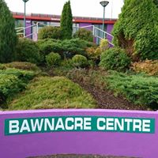

Bawnacre Centre
Aerobic Cycling
Get Fit! Have Fun!

With the ultimate 45 minute workout!
Classes will only run if 6 or more enrol. You must be 16 years old or over to take part in any classes.
To ensure you get a bike, your place can be secured by completing the below form and returning to the Bawnacre Centre with full payment.
We must receive payment before you take part in any class
For further information please contact Bawnacre reception on 028 686 21177

NAME__________________________________________________________________________
ADDRESS_______________________________________________________________________
_________________________________________________________________________________
CONTACT NUMBER_____________________________________________________________
EMAIL __________________________________________________________________________
Day | Starting Date/Duration | Time | Cost | Tick to enrol
Mon | 10TH Sept 2018 (6 weeks) | 9.15am | £20
Tues | 11th Sept 2018 (6 weeks) | 7.00pm | £25
Thurs | 13th Sept 2018 (6 weeks) | 7.30pm | £25

