APPENDIX I: Review of Previous Strategy

Introduction

Fermanagh and Omagh Age Friendly Strategy was launched in 2018, following extensive consultation with older people across the District which was carried out in line with the World Health Organisation’s eight Age Friendly domains. This review paper considers what progress which has been made on implementation of the strategy and the key outcomes which have been achieved. In addition, it identifies gaps in provision and actions which should be carried forward, to inform and influence the new strategy and action plan across 2025 – 2028.

Working Together
Key to strategy and action plan implementation has been agencies working in partnership, sharing resources, skills and connections to collaboratively improve the lives of older people in Fermanagh and Omagh. An Age Friendly Alliance (AFA) has been established and is Chaired by Fermanagh and Omagh District Council with representation from WHSCT, PHA, Department for Infrastructure, PSNI, NIHE and SWAP.

The AFA adopts a strategic, high level approach, identifying areas for co-operation and added value while the Fermanagh Omagh Interagency Forum (FOIF) functions at operational level, sharing experiences on service delivery and how gaps can be addressed. Collectively, this has provided a comprehensive network to promote and adopt Age Friendly practices among providers across the District.

Benefit has also been gained through participation in the Age Friendly Network NI which was launched in 2019 with the aim of promoting an Age Friendly ethos and practices in all eleven local authorities across Northern Ireland to promote the Age Friendly agenda. As the Age Sector Partnership for the District, South West Age Partnership (SWAP) has been pivotal to this work, with the support of FODC, Age NI, Department for Communities (DfC) and the Public Health Agency (PHA).

Sharing of best practice has been a hallmark of the strategy and action plan, this has enabled SWAP and FODC to work together with peer organisations to allow the strategy and action plan benefit from their experiences and share learning.
Examples of this include older people in FODC visiting a reminiscence trail in Cavan which was then replicated in Omagh and Enniskillen. In addition, a visit was arranged by the Age Friendly Network NI and a follow up by Age Friendly Mid Ulster saw a similar trail being planned for that area, demonstrating the value of building connections locally and regionally.

Achievements to Date
This report considers progress made through the last action plan under each of the WHO domains. It outlines key impacts and identifies potential areas for future focus and energy which should form part of the 2025 – 2028 action plan.

Theme: Outdoor Space & Buildings

Project Areas
- Promoting Accessible Streetscape
- Promoting Access to Public Buildings and Services

Successes - Actions Undertaken
- A SWAP Board member sat on the Enniskillen Public Realm Steering Group to ensure that the voice of the older person was heard in developing such schemes, recognising their importance to mobility and accessibility
- Additional pedestrian crossings and seating were included as part of the public realm in Enniskillen
- Work with FODCs Access and Inclusion officer to improve accessibility; videos on Council website highlighting accessibility of buildings
- Working to establish two pilot Age Friendly, Disability and Dementia friendly localities in the District (Belleek underway)
- Reminiscence Walks established in Enniskillen and Omagh which were developed as a result of a good practice visit to Co Cavan and included workshops and close working on development of walk signage
- RADAR keys for public toilets to increase accessibility
- Storyboards developed for Council public buildings to increase user experience of people with autism, dementia and learning disabilities

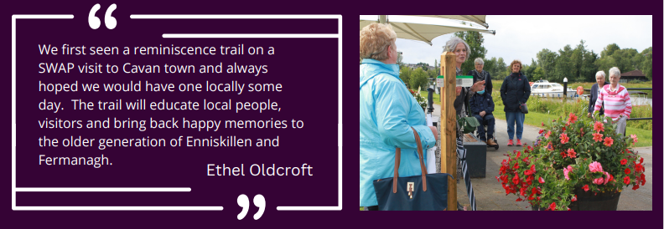

Case Study: The Broadmeadow - Around the Meadow
SWAP members were joined by Age Friendly staff from FODC to undertake a good practice visit to Co Cavan where they visited a Dementia Friendly Day Centre and award-winning garden and a reminiscence trail located in the heart of Cavan Town. This highlighted the need to replicate similar services for older people in the Fermanagh and Omagh District.

The main aim of the project was to create a Reminiscence Pathway and signage for older people, people with dementia and people with disabilities to enjoy. Following the best practice visit to Cavan, older people identified the Broadmeadow in Enniskillen as an ideal location for the proposed walk. A successful funding application to Department for Communities by FODC secured funding and the "Around the Meadow" project was created. Applying learning gained from the good practice visit to the Cavan walk resulted in identifying themes and using old photos for inclusion of work with Enniskillen Museum, Stories and local history were used to stimulate memories and prompt conversation. These prompts were included to encourage and enable people to delve into their own memories and experiences.

Mindful of co-design, older people and members of the Disability Access inclusion group were consulted during design and compilation of content to ensure the project concept reflected the voice of the older people and those with disabilities. A virtual guide with voiceover by an older person and accompanying booklet were also created, supported by funding from the Public Health Agency.

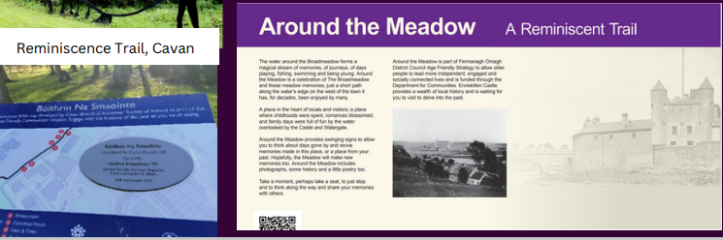

Following on from the success of 'Around the Meadow,' a further application was submitted and a walk developed in Omagh at the Lover’s Retreat, a popular walking spot. Post covid a reminiscence project engaging older people from the area was delivered and local stories and pictures collated. In addition Age Friendly benches were added, enhancing Lovers Retreat to become a more accessible and social area for exercising and meeting with others.

Outcomes Achieved
- Communication and co-operation among key stakeholders through the AFA, embedding a strategic approach to establishing an Age Friendly district
- Greater awareness of the needs of older people in public spaces and how older voices should inform design of these spaces through a co-design approach
- Improved user experience for people with autism, dementia and learning disabilities and a greater awareness of their needs. Over 400 people, including staff have completed JAM training.
- Shared learning and building connections locally and beyond the District for mutual benefit

Remaining Gaps - Future Action Areas
- Raise awareness of demand for increased Blue badge car parking space provision
- Progressing pilot Age Friendly villages initiative - proposed for Belleek and Gortin which can act as a template for future work across the District; to include walkability studies where appropriate
- Promoting greater awareness of the RADAR key initiative and mapping existing provision
- More accessibility studies for local buildings

Theme: Transportation

Project Areas
- Transport

Successes - Actions Undertaken
- Age Friendly Alliance established including a senior staff member from Department for Infrastructure (Roads Service)
- Community Transport providers (Fermanagh Community Transport and Easilink – Omagh) represented on the Fermanagh and Omagh Interagency Forum for Older People (FOIF) which is chaired and facilitated by SWAP to ensure that the voice of the older person is central to all discussions
- SWAP Manager sits on Fermanagh Community Transport Board
- Promotion of access and availability to Community Transport has been included in Age Friendly publications and at events to increase usage by older people
- A scoping report was carried out by FODC Transport Poverty sub-group in partnership with Community Transport to highlight the gaps in provision and levels of transport poverty in the District. The information gathered will be utilised to lobby for additional support on gaps in provision. The report on the Transport Poverty Analysis can be found on the Council website: https://fermanaghomagh.public-minutes.com/#c76ca7820a71b22eb888b74863fc4bb3
- Extensive work took place between FODC and Community Transport providers during Covid to provide services that support the delivery of initiatives to deliver food parcels (Covid) and people to warm spaces and community activities
- Community Transport worked with SWAP and FODC to deliver activity and conference packs during Covid thereby reducing loneliness and isolation.
- Rural Links to Health and Well-being: Easilink secured almost £500,000 of funding from the National Lottery in 2019 to run a 5 year programme aimed at providing transport to health and well-being appointments across WHSCT, including taking patients from Omagh to both Altnagelvin and SWAH in Enniskillen.
- Motability Funded Programme and District Wide Community Transport Provision: Easilink and Fermanagh Community Transport CT in partnership with two other Community Transport operators were successful in securing £3.42 million from The Motability Foundation. This will run from 2023 to 2026 and funding will be used to enhance transport options for individuals who have a disability, mobility issues and older people. The programme includes establishment of a scheme to provide transport to regional hospital and health appointments.
- Increase in Demand for Transport for Older People: Easilink delivered almost 21,500 Dial-A-Lift passenger trips during the 2022 - 2023 financial year, a year on year increase of 41%, demonstrating the importance of the CT scheme for older people in FODC

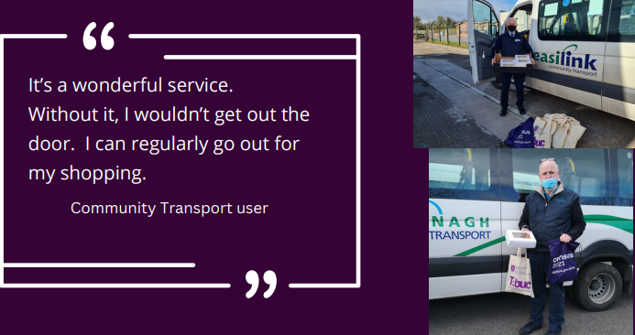

Case Study: Delivery in a Pandemic
Given the rurality of the District, reaching out to older people during the COVID-19 pandemic and associated public health restrictions often proved challenging. However, Community Transport providers worked extensively to respond to those exceptional circumstances to help those in need. A series of conferences were delivered online with conference packs (each pack including an afternoon tea box) being delivered by Community Transport. These efforts saw over seventy older people across the District participate in each conference which covered a range of topics including:

- Dying to Talk - Planning for Your Future
- Financial Inclusion
- Be Well, The Five Steps to Wellbeing

Other initiatives delivered to reduce loneliness and isolation for older people during the pandemic included FODC leading a Christmas Cheer Campaign with older people who lived alone or who were an informal unpaid lone carer receiving a small gift to spread a little ‘Christmas Cheer’ to older residents who were isolated in Christmas 2020. Working in partnership with other key stakeholders, Fermanagh and Omagh District Council also managed the Food Parcel Scheme, on behalf of the Department for Communities. Over the duration of the scheme, more than 17,000 food parcels were delivered to households across the District. The conference packs, Christmas Cheer parcels and Food Parcel Schemes were delivered by Easilink Community Transport and Fermanagh Community Transport, highlighting the importance of transport and access to services for older people in this rural catchment.

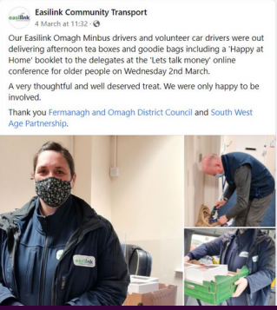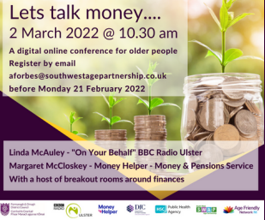

Outcomes Achieved
- Partnership working pooled resources and local knowledge to reach those most in need in very challenging (pandemic) circumstances
- Older people benefit from access to services and social connections through access to transport

Remaining Gaps - Potential Future Actions
- Continued working with public and community transport operators through AFA and FOIF to address gaps in transport provision
- Communication in relation to transport route planning: Clarity around which groups / statutory partners are responsible for the delivery of particular service i.e. Translink for public bus routes while Community Transport provide a one to one, door to door service which must be prebooked in advance by members

Theme: Housing

Project Area

Future Proofing the District’s housing stock

Successes - Actions Undertaken
- Northern Ireland Housing Executive (NIHE) and PSNI are strategic partners in the Age Friendly Alliance
- NIHE, PSNI, PCSP all represented on Fermanagh Omagh Interagency Forum for Older People
- Good practice visits carried out to Dial Centre at North West Regional College to view technology in the home
- PCSP delivers high level of safety for older people in their own home - social alarm scheme, neighbourhood watch schemes, scam awareness information sessions. Key outputs include:
2022/23
  - 272 home visits to elderly/ vulnerable,
  - 234 pieces of security equipment issued,
  - 218 referrals to other agencies
  - 89 active Neighbourhood Watch Schemes
  - 2 Neighbourhood watch development events
  - 133 active Neighbourhood watch co-ordinators
  - 6,122 households covered by Neighbourhood Watch
2023/2024
- 173 home visits to elderly/ vulnerable people
  - 149 pieces of security equipment issued
  - 63 referrals to other agencies
  - 90 active Neighbourhood Watch Schemes
  - 6 Neighbourhood watch development events
  - 134 active Neighbourhood watch co-ordinators
  - 6,146 households covered by Neighbourhood Watch
  - Scam awareness sessions: 2022/2023 (20) and 2023/2024 (23)

- Home safety checks for people aged over 65 carried out by Health Improvement Team e.g. Affordable Warmth scheme which includes grants for private tenants and homeowners (criteria apply) insulation and boiler replacements:
- 23/24 - 151 Home safety visits
- 22/23 - 213 Home Safety Visits
- 21/22 - 236 Home Safety Visits

- NIFRS provide free Home Fire safety checks targeted at people over 50, as this group being identified as an at risk group to be killed or seriously injured in fire
- Pilot project in Kesh DEA (The Old Courthouse) in partnership with NIHE Sustainable Tenancies officer to work with NIHE to meet the needs of NIHE housing tenants in order to help sustain tenancies
- FODC part funded project to allow support to be offered to private tenants as well as part of social supermarket delivery
- Outreach events, promotion and signposting in Age Friendly publications to increase older people’s knowledge of energy efficiency, housing adaptations and home safety
- Falls prevention programmes and events to reduce number of falls in your own home which can significantly impact on health 243 older people received falls messages in 2023-2024; 178 older people received falls messages in 2024-2025
- Cost of living - providing information and signposting to organisations to help support people with cost of living in your own home

Outcomes Achieved
- Benefit in cross sectoral working – delivering with community and voluntary sector partners in local communities to reach those most at risk of isolation, especially in remote rural areas
- Improved health outcomes through increased awareness of and actions to support falls prevention in the home
- Practical actions/projects enable older people remain in their homes safely and for longer

Remaining Gaps - Potential Future Actions
- Ongoing anti-poverty measures to overcome cost of living challenges, including fuel and food poverty

Continued efforts to future proof the District’s housing stock, including increased accessible housing stock for a growing ageing population
- Explore continued work with community and voluntary sector partners to reach isolated older people using local connections

Theme: Social Participation

Project Area

Encouraging Participation to Sustain Older Peoples Groups

Successes - Actions Undertaken
- Partnership working agreement SWAP to deliver on the District’s Age Friendly agenda in partnership with FODC
- SWAP as the Age Sector Network provides groups with support, funding and advice on delivery of their services including regular Cluster meetings for groups
- FODC grants being identified as difficult to access for older peoples groups resulted in a partnership agreement being developed between FODC and SWAP to deliver a simplified “Age Friendly approach” to funding for groups
- Funding opportunities to support older people’s groups included COVID recovery grants for Older People’s Groups; Positive Ageing Month Grants to increase participation; community wellbeing food programme to combat cost of living
- Age Sector Network (SWAP) delivering on funding provided by NIHE and PHA to support activities for older people’s groups
- WHSCT in collaboration with PHA, Council and SWAP has delivered a small grants programme annually in FODC - small grants of up to £500 are available for older peoples groups. In 2022/23 42 older peoples groups were funded, 2023/24 saw 36 older people's groups receive funding.
- COVID response to support older people including online support and activities
- Positive Ageing Month delivered virtually and face to face including an information booklet
- Interactive mapping exercise to show location of groups published on FODC website
- Annual Age Friendly conference was delivered virtually and in person to network and inform
- Older peoples groups help to address levels of physical activity through locally based delivery
- The Fermanagh and Omagh 2021 Residents’ Survey (the latest data) show that 16% of those aged 65 years + undertook at least the recommended amount of exercise (30 minutes per day for 5 days per week, or 150 minutes per week in total). This has fallen from 19% in the 2018 survey; however, the data did suggest that on average, people were exercising more in 2021 in comparison to 2018. This may be due to the affect of the Covid-19 lockdowns which were in place amid the 2021 survey. It would also suggest that those aged 65 years or older who are fit enough, are exercising more, but there is a higher proportion of those aged 65 years or older who feel they are unfit to undertake the recommended amount of physical exercise.
- Linking Generations NI awarded 13 small All Ages April grants to a range of settings including care homes, community groups and schools within FODC to facilitate Intergenerational events throughout April 2023. These brought generations together in mutually beneficial activities which help promote community cohesion, while tackling loneliness and isolation.
- LGNI also delivered Intergenerational training to staff and volunteers within Early years and older peoples settings across FODC to enable practitioners facilitate Intergenerational activities; this has led to two FODC groups coming on board as pilot's within a UK Creating Intergenerational Communities project (The Magic Roundabout Childcare Centre and Millcroft Care Home, Enniskillen)

Case Study - Age Friendly Grants
During consultation informing the action plan, older people had consistently highlighted the difficulties they experienced in applying directly to FODC for funding. As a result, Council worked closely with SWAP to provide a practical approach to this barrier to engagement. The outcome has been to include an older persons grant within the funding for community groups. Older people’s groups now apply directly to SWAP using a simplified form which can either be emailed or posted to access funding streams.

These small grants support the groups allowing them to deliver a range of programmes or events on behalf of their members, covering items such as tutors and transport. In addition it allows smaller older peoples groups who are not constituted a way to access funding not previously available to them and potentially reaching new participants not previously engaged. This approach to grants for older peoples grant was shared with Public Health Agency and WHSCT during their planning process for launching Positive Ageing Month Grants.

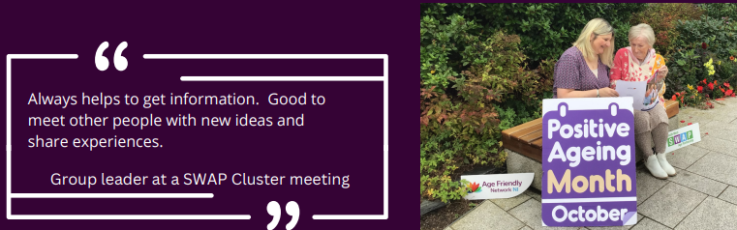

Outcomes Achieved
- Working in partnership to support groups and build capacity
- Sharing good practice and learning from others
- Promoting wellbeing (mental and physical) through a varied programme of activity which increases physical activity, reduces loneliness and social isolation and increases social connections amongst older people in their local areas
- Simplified funding processes to maximise group participation

Remaining Gaps - Potential Future Actions
- Reaching housebound older people who cannot attend events/activities
- Working with partners, encouraging them to recognise that older people's needs are different - some are digitally literate, some are not and there remains need to provide for those who like to meet in person or place a phone call.

Theme: Respect and Social Inclusion

Project Area

Tackling loneliness

Building respect

Successes - Actions Undertaken
- Age Friendly Alliance established – high level strategic alliance to deliver on Age Friendly strategy including representation by older people
- PLACE-EE – an intergenerational project to improve digital skills as well as creating relationships
- 58 people attended Age Awareness training.
- Access Inclusion and Age Friendly Charter in draft form at present
- Partnership working to increase digital skills and safety for older people:
  - 16 iPads purchased – let’s get connected PCSP, SWAP and Age Friendly
  - Work with libraries to increase digital opportunities
- Attendance at Catapult Conference showcasing digital responses to reducing loneliness and isolation
- SWAP Cluster meetings with appointed members forming a Board of Directors – regular consultation using this structure
- Grants for older peoples groups and organisations providing services for older people – 110 groups working with older people supported
- Age Friendly publications and website to promote groups and their achievements
- Delivery of digital social inclusion projects during restrictions – shared good practice on Fermanagh and Omagh Positive Ageing Month Goes Virtual | EPALE (europa.eu)

Outcomes Achieved
- Placing older people at the core of decision making through AFA membership
- Partnership working to avoid duplication of resources and maximise participation
- Reducing social isolation and loneliness through encouraging digital participation by older people
- Sharing information to promote and celebrate Age Friendly work delivered by groups
- Community development approach to consultation and community engagement through Cluster meetings

Remaining Gaps - Potential Future Actions
- Ensuring older people are not at risk of digital exclusion
- Ongoing actions tackling loneliness, especially for lone householders

Theme: Community and Health Care

Project Area

Health Planning and Delivery

Independent Living

Successes - Actions Undertaken
- Partnership working with FODC and SWAP to deliver on Age Friendly the agenda
- SWAP cluster meetings and Annual General Meeting to support older people and groups
- Community Wellbeing Co-ordinator in each DEA area to support Health and wellbeing in the District
- Advance Care Planning – projects and conference to normalise conversations around planning for death and dying
- Age Friendly Calendar to promote health and wellbeing messages in relation to mental health. The calendar was funded by PHA through the WHSCT for the whole Trust area.
- FODC listened to the concerns of older people in relation to difficulty in filling out grant aid application forms online with the result that the grant aid application form was reduced to a two page document and is now managed by SWAP. This grant aid is very important in enabling older people groups to apply for activities/programmes that are important to them, helping to build on their capacity and sense of ownership.
- Digital mapping of older peoples groups for easy accessibility
- Support through grants, signposting, community hub and Happy at Home and Keeping Well at Home publications for older people during Covid
- Residents survey satisfaction 2021 with people aged 60+: mental health and emotional wellbeing scored 6.8 (out of 10) in comparison to overall population score 7 (out of 10) compared with scores of 8 in 2018 survey results
- Residents survey (2021) satisfaction with physical health
  - 2018
  - 60+ = 7.7 out of 10; Overall population = 8.10 out of 10
  - 2021
  - 60+ = 6.45 out of 10; Overall population = 7.29 out of 10

- Social supermarket scheme including outreach support for those experiencing financial difficulties/food poverty. The model of offers a range of support and services, removing stigma.

Case Study - Dying to Talk - Advanced Care Planning
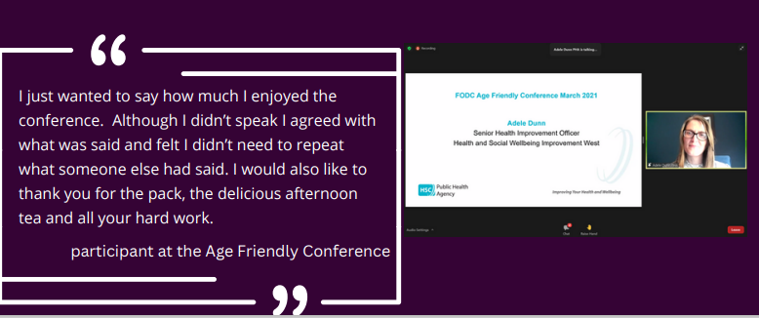

Key Areas which were addressed during the conference included:
- Spirituality
- Advance Care Plans
- Funeral Plans
- Digital Legacy
- Bereavement

The ‘Dying to talk' Conference was included as part of the Positive Ageing October 2021 programme to highlight the importance of being prepared for end of life. The event was delivered online during the Covid Pandemic at a time when many people were thinking ahead to a time when you will need to make key decisions for yourself or for others. Death is inevitable for everyone - death, dying and bereavement will impact all of us, multiple times. The message is that death is a life event we can and should plan for and that it is important to approach the different elements of planning. Planning and discussing our own death with the people who are important to us is an element of ‘self-care’ and allows us to live life more fully. It is however often a difficult topic to engage with family and friends.

FODC Age Friendly led on the event in partnership with the Integrated Care Partnership and Compassionate Communities with funding from the Public Health Agency. In addition SWAP showcased the 'Forget me Not' programme which complimented the topic. This programme facilitated the creation of a junk journal to start conversation with family and friends. Community Transport providers Easilink and Fermanagh Community Transport delivered conference packs.

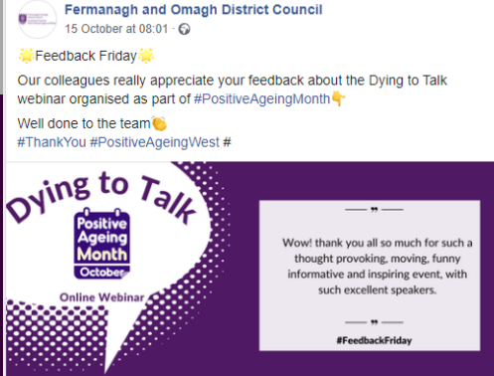

Outcomes Achieved
- Increasing participation by adopting an Age Friendly approach to FODC’s community grant scheme. Now facilitated through SWAP for easier processing, this has proved very successful with high numbers of older people’s groups applying.
- Co-operation among service providers, complementing each other’s work
- Encouraging older people to engage in sensitive conversations with families

Remaining Gaps - Potential Future Actions
- Ensuring co-ordination among service providers, recognising the multitude of delivery bodies in the sector
- Addressing falls prevention and frailty in older people through exercise programmes. It is recognised that work is ongoing regarding this such as PHA funded Stepping On Programme and FODC Healthy Towns of which older people are a priority group and Walking for Health etc, activities which have received positive feedback through focus groups and which older people are keen to further benefit from.
- Tackling the risk of food poverty and cost of living
- Transportation to appointments, including those outside the District

Theme: Communication and Information

Project Area

Scoping Study

Information and signposting

Positive Ageing Communications campaign

Successes - Actions Undertaken
- Fermanagh Omagh Age Friendly Alliance established with senior staff represented and chaired by FODC Chief Executive to drive the Age Friendly Strategy delivery and provide co-ordination and information
- Fermanagh and Omagh Interagency Forum for Older People (FOIF) is a forum information sharing across partner organisations to prevent duplication and drive services for older people in the District. Meeting bi-monthly, the group is made up from a range of community, voluntary and statutory bodies on an operational level and is facilitated and chaired by South West Age Partnership (SWAP).
- An internal Fermanagh and Omagh District Council working group established to ensure Age Friendly becomes integrated part of all Council decision making. Currently non-functioning, the new strategy and action plan will provide the impetus for this group to reconvene, ensuring co-ordination across FODC service delivery recognising that Age Friendly practices impacts across all service areas.
- 2021 Residents survey indicated that those aged 65+ prefer Council newsletter, leaflets etc. (68%) and press (20%). Residents also advised the information they found most relevant included within INFO publication were local news and bin collection information. This resulted in both topics being included in all Age Friendly publications with information on bins/recycling included within outreach events.
- Age Friendly officer works collaboratively with SWAP to provide a range of printed and online publications and Age Friendly communication. These support signposting and information on a range of topics and include INFO Residents Magazine, Age Friendly Calendar, Positive Ageing Month Booklet, Happy at Home booklets. All publications are checked by the Council Access and Inclusion Officer.
- Digital Upskilling Projects – Let’s get Connected. This is a collaborative project launched during Covid to get older people online within their own homes while further classes and activities still continue to upskill older people.
- Place EE project – was delivered over 4 years and was a digital intergenerational project using activities to allow younger people to engage and upskill older people. Uptake was as follows:
  - Phase one – Genealogy 35 Older People and 31 younger people
  - Phase two – Reminiscence 23 older people and 22 younger people
  - Phase three – Virtual Connects (during Covid) 44 Older people/135 training places
- In addition, the PLACE-EE Showcase event had 100 attendees, both older and younger Consumer Council delivered its first roadshows within the FODC area to inform older people on issues relating to scam, financial and debt, money saving and comparisons
- Online information on social media and websites
- Outreach events using local community venues on a range of topics
- Community hub set up as response to Covid to support and signpost older people

Case Study I
In response to the findings in the residents* survey a range of Age Friendly Publications were developed. These publications included the Keeping Well at Home Booklet which was reproduced by PHA and Age Friendly NI for a NI audience, with kind permission from the Institute for Collaborative Research on Ageing at Manchester University. The booklet was developed in during the Covid19 Pandemic and included information and health and wellbeing tips for use when at home.

“Happy at Home”, a Fermanagh and Omagh District Area publication produced in partnership with FODC, WHSCT and developed in during the Covid-19 Pandemic which included information and health and wellbeing tips for use when at home. Building on its success the publication is now in its third year.

“SWAP have facilitated a great interagency Forum for Fermanagh and Omagh, driving partnership working and collaboration for over 10 years. Age NI recognises that being an older people-led interagency, this is a leading and excellent model of partnership working involving key stakeholders coming together with older people to plan, design and develop health and wellbeing services that matter the most to them, promoting a positive approach to ageing. It’s an ideal interagency that can discuss issues raised by older people when partners work alongside older people to come up with creative solution to benefit the older population.”
Age NI

“I like the mix of info and puzzles in Happy at Home. The layout and font are also very clear and pleasing to the eye. Thank you for the magazines over a time where life was so limited and causing anxiety. Look forward to the next edition”.
FODC resident

*2021 Residents survey showed those aged 65+ prefer Council newsletter, leaflets etc. (68%) and press (20%)

Case Study II - Fermanagh Omagh Interagency Forum
Fermanagh Omagh Interagency Forum for Older People (FOIF) Fermanagh and Omagh Interagency Forum for Older People is a prime example of an approach to collaborative working. Through the forum, information is shared across partner organisations to try to prevent duplication and drive services for older people in the Fermanagh and Omagh district. Meeting bi-monthly, the group comprises of a range of community, voluntary and statutory bodies on an operational level and is facilitated and chaired by South West Age Partnership (SWAP). Information is filtered freely in both directions through SWAP ensuring older people have a voice and are kept up to date. In addition to information sharing at meetings, SWAP consequently disseminate information via social media channels and email. This was particularly important in the ongoing COVID-19 pandemic, ensuring that everyone was kept informed and reducing duplication in services when meetings moved online.

Outcomes Achieved
- Collaborative working at both strategic (AFA) and operational (FOIF) level
- Tailoring communication to the needs of older people

Remaining Gaps - Potential Future Actions
- Reconvene FODC internal working group on Age Friendly
- Maintain a hybrid of communication tools, including printed materials with financial resources to do so
- Reaching older people not involved in groups, including housebound older people

Theme: Civic Partnership and Employment

Project Area

Volunteering and participation

Successes - Actions Undertaken
- Age Friendly Alliance established
- Reminiscence Trail – content design and materials development
- Meeting with Employability and Skills Co-ordinator to look at projects to support older economically inactive people
- SWAP as the Age Sector Network for older people and groups is comprised of a Board of Directors of older volunteers and chaired by an older person
- SWAP led on Outcome 2 of Community Planning to ensure that the voice of the older person is heard
- Volunteering activities have included litter champion, meet and greet at the theatres, hospital liaison in addition to promotion of Volunteer Now opportunities
- Easilink Community Transport covers the Omagh area and relies heavily on a team of 38 volunteers, 15 of which are based with the former Omagh District Council area. In 2022 Easilink completed an Equality Monitoring Assessment on its volunteers and found that 78% of its volunteer base was aged over 59 years

Outcomes Achieved
- Partnership approach to Age Friendly through AFA
- Older people are placed at the core of decision making
- Community Planning ensures a co-ordinated, strategic approach to Age Friendly actions

Remaining Gaps - Potential Future Actions
- Encouraging new members onto older people’s groups – succession planning
- Encouraging Age Friendly working practices by employers
- Supporting volunteers, especially as many have not returned to volunteering post pandemic

Summary
This review paper has considered progress made by the 2018 – 2021 strategy and action plan, informed by feedback from stakeholders including service providers and older people themselves. It is clear that progress has been made under each WHO domain, with relationships and foundations in place which the 2025 – 2028 strategy can further develop and embed as Age Friendly principles.

The findings of this review paper have informed the new strategy and action plan and recognises the importance of partnership working in creating an Age Friendly District.

