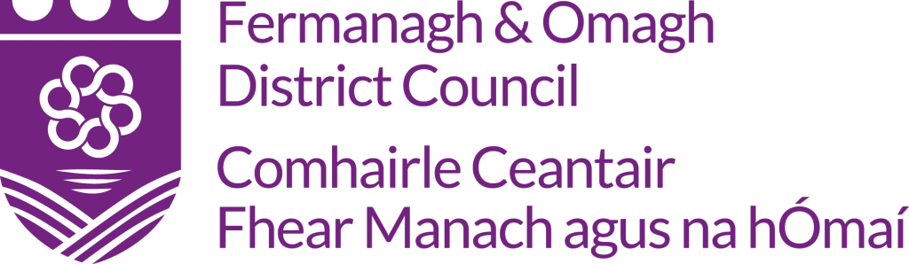

Cloth Nappy Refund Scheme
This scheme is only available to families living within the
Fermanagh & Omagh Council boundary
Name
Address

Postcode
Telephone Number
Email Address
To facilitate payment by BACS please complete the following:
Bank Name & Address
Name of Account Holder
Sort Code
Account Number

Terms and Conditions

- The child must be a permanent resident within the Fermanagh & Omagh Council boundary.
- Applicants must spend at least £50 on washable nappies to be eligible for refunds
- Refunds can only be made by BACs payment into bank account detailed on form
- Refunds cannot be made without the original, itemised receipt(s) which include date of purchase.
- The nappies must have been bought within 6 months of making the refund application.
- Participation in the nappy refund scheme is considered to be a ‘one off’ and does not constitute any commitment to future support.
- Only one nappy refund application per household.
- Fermangh & Omagh District Council may ask you to provide feedback and complete a feedback questionnaire.
- The schemes are subject to availability and may be withdrawn at any time.
☐ I have bought reusable nappies with a minimum spend of £50 and have
enclosed the itemised receipt(s)
☐ I understand and accept the terms and conditions of the scheme.
Signed: |  |  | Date:

Please return to: Climate Education Officer, Fermanagh and Omagh District Council, Killyvilly Depot, Tempo Road, Enniskillen, Fermanagh, BT74 4GD
Or email to Recycling@fermanaghomagh.com

