HOME COMPOSTING

**What is composting?**

Composting is a natural process where organic materials rot or biodegrade naturally into brown/black crumbly material that can be used in your garden as a soil improver or natural fertiliser. It is an easy way to recycle your garden and kitchen rubbish.

**What do I need?**

There are various methods of home composting – make your own compost heap or buy your own compost unit. Compost bins are available free of charge from Fermanagh & Omagh District Council (while stocks last) It comes complete with a small container (kitchen caddie) to collect your organic kitchen waste.

**Making our own compost heap?**

To erect your own bin, hammer into the ground four 10cm x 10cm (4in x 4in) posts to enclose an area about 1sq m (40sq in.) Then bash the soil with the back of a spade to consolidate it. Next either tack wire netting to the posts, or nail planks around them, leaving the front side easily detachable so you can get the finished compost out.

**Where should I place my compost bin?**

Compost bins should be located where they are easy to use both to put waste in and to get compost out. Ideally, place your compost bin on soil, in a partially sunny location sheltered from strong winds.

**How do I compost?**

Feed the compost bin with garden and kitchen waste – create a good mix of ‘green waste’ and ‘brown waste’ for the best results.

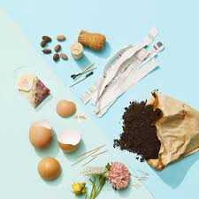

vegetable and fruit peelings, tea bags and flowers. Green materials act as a natural activator and help speed up the composting process. Brown materials are usually dry and include eggshells, sawdust and wood shavings, cardboard, dry leaves, straw and hair. Brown materials are slow to rot and rich in carbon. Turn the material over every so often to add more air if possible. When your compost is well rotted it will look dark brown / black and when dry will be crumbly. This usually takes approximately 1–2 years (although it may not take longer or shorter depending on the mix of materials going in the compost bin).

**Food Burial and Trenching**

Burying vegetative food scraps is an ancient practice and has been in use in Ireland for many years. The traditional methods used are food burial (where food is buried in holes) and trenching (where food is buried in trenches). Once you have your hole or trench dug, a batch of food is then added. The key is to chop up your food wastes into small pieces and then mix them with the soil at the bottom before covering over with the remaining soil. This is then allowed to break down in the ground and, because it is buried, will not attract any pests or animals.

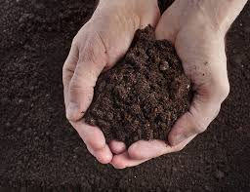

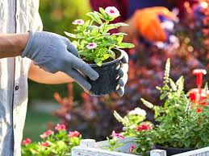

Usually 1/3 nitrogen (green) material and 2/3 carbon (brown) material gives the best results. Green materials are usually moist and include green leaves, grass cuttings,

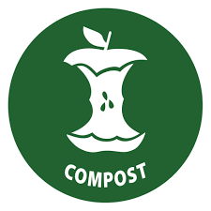



Call 0300 303 1777

www.femanaghomagh.com

BROWN MATERIALS

Kitchen paper

Straw

Wood, twigs & branches

(in small pieces)

Crushed egg shells

Cardboard egg boxes

|  |  |  |
| --- | --- | --- |
| Problem | Probable Cause | Solution |
| The compost is smelly | Lack of air – too wet, too compact, too many greens | Stir, empty bin, add extra layers of brown |
| The compost is slow to break down | Too many browns, pieces too large | Shred materials and add greens and water |
| The compost bin/heap is attracting rats and mice | Cooked food | Cooked food can be recycled in your brown caddy/bin collection |
| The compost bin/heap is attracting flies | They are probably eating the top layer of fruit & veg | Cover the top layer in the bin/heap with a layer for soil/grass cuttings or newspaper |

**Composting Agony Aunt**

**What can I do with compost?**

To harvest your finished compost, simply open the lid at the base of the compost bin and shovel it out. It can be used in your garden for the following:

**MULCH** Suppress weed growth, improve soil and hold moisture during the summer months

**TOP DRESSING** for lawns, it’s a good fertiliser. **POTTING MIXES** Only use well- rotted compost. One part sieved compost, one part sand and one part sieved soil.

**SOIL IMPROVER** Enrich the soil, vegetable and flower beds. Dig it into the soil in the autumn after the removal of summer crops or in beds at any time when needed.

**CONTAINER PLANTS** Remove an inch of existing soil and replace with sieved compost.

|  |  |  |  |  |  |
| --- | --- | --- | --- | --- | --- |
| X | Raw and cooked meat, bones | May attract pests |  |  |  |
| X | Poultry and fish | May attract pests |  |  |  |
| X | Dairy produce | May attract pests |  |  |  |
| X | Greasy oily food (e.g. butter/mayonnaise | May attract pests |  |  |  |
| X | Dog and cat litter | Contains pathogens (disease carrying organisms) | | | |
| X | Plastics, glass, cans, etc | Will not decompose/biodegrade | |  |  |
| X | Glossy papers/magazines | The glossy coating will not decompose | | |  |
| X | Weed seeds | Some may thrive in heated conditions | | |  |
| X | Diseased plants | Danger of spreading diseases to other plants | | | |
| X | Disposable nappies | Contains pathogens |  |  |  |

What not to compost and why

What you can compost

GREEN MATERIALS

Fruit & vegetables

Tea leaves/tea bags

Garden waste

Leaves

Some weeds

Dead plants & flowers

Grass & hedge cuttings





Call 0300 303 1777

www.femanaghomagh.com

HOME COMPOSTING