Annual Report 2022 - 2023
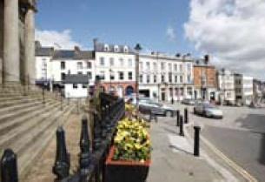
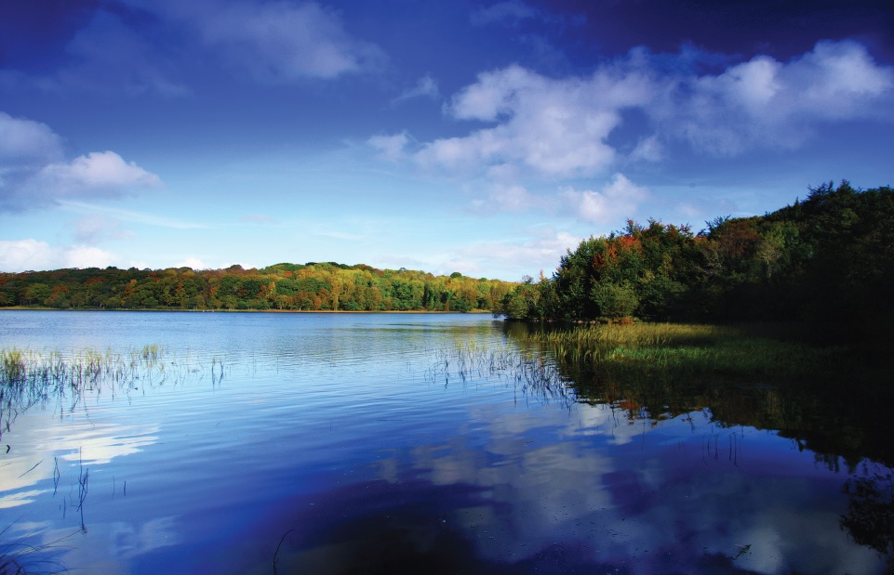
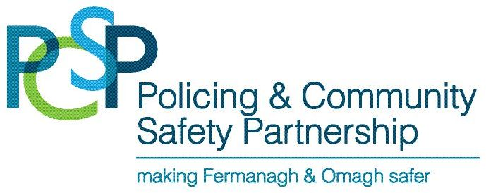
Fermanagh & Omagh Policing & Community Safety Partnership (PCSP)

CONTENTS | PAGE
Chairperson Foreword | 2
Vice Chair Foreword | 3
PSNI Acknowledgement | 4
Fermanagh & Omagh PCSP Membership | 5
Profile of the Fermanagh & Omagh District Council Area | 6
The Fermanagh & Omagh Community Plan | 7
Strategic Priority 1:

To Successfully Deliver the Functions of the PCSP | 9
Strategic Priority 2:

To Improve Community Safety by Tackling Actual and Perceived Crime and  Anti-Social Behaviour | 14
Strategic Priority 3:

To Support Community Confidence in Policing | 31
Appendices
Appendix A - Financial Statement 2022-2023 | 34
Appendix B - Fermanagh & Omagh Local Policing Plan 2022-2023  Appendix C - Policing Committee Report 2022-2023 | 35  37

CHAIRPERSON FOREWORD- Councillor Paul Blake

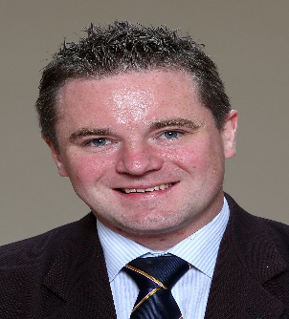
I have great pleasure in presenting the 2022-23 Annual Report for the Fermanagh and Omagh Policing and Community Safety Partnership (PCSP).

This year has proved to be challenging in respect of delivering the Action Plan working within changing restrictions and seeking to alleviate fears and concerns of Members, staff and the public whilst doing so. For the main we have continued to conduct PCSP and PC meetings face to face when restrictions permitted. PCSP staff combined working from home and the office ensuring that there was no break PCSP service delivery. The PCSP Members and I appreciate that staff continue to be flexible and adaptable to the challenges.

We are delighted to see our digital footprint grow with increases in engagement, likes and reach on our PCSP Facebook page and our Instagram account. Our annual community safety survey was conducted on line and the response rate demonstrates the power of social media as an engagement tool.

Some of the highlights this year include working in partnership with our statutory partners from the PSNI, NIFRS and the NIAS on a deaf awareness event at the Omagh Integrated Primary School. One of their pupils in Primary 2 is deaf and uses sign language. His class started to learn Sign Language to help him integrate. The PCSP helped to facilitate an event to raise awareness of the problems experienced by people with hearing difficulties. This initiative was showcased on UTV Live and did much to raise the profile of the PCSP. Other highlights include the return of our Emergency Services Day showcasing the work of the PCSP and our partners in a way which was both informative and entertaining.

I am very pleased that we have continued to work closely with all seven Neighbourhood Policing Teams undertaking joint community engagement initiatives to build relationships and increase community confidence in policing.

This year we have placed a greater emphasis on engaging with the most vulnerable in society through our role in the Support Hub and our Safer Home project assisting people living in their homes through referrals to other agencies, home security assessments and provision of security equipment and social alarms. Collaborative working cemented by partnership agreements and referral pathways is crucial to offering the most comprehensive and appropriate supports to people who find themselves in situations where they are vulnerable due to due to illness, isolation, victims of crime or other circumstances.

Finally, I would like to thank PCSP members for their commitment and co-operation in what has been another challenging year for us all. Members and staff have risen to the challenge and embraced new ways of working enabling the PCSP to function within the parameters of the restrictions making a difference to those who we engage with.

Councillor Paul Blake
Chairperson

VICE CHAIR FOREWORD – Sarah Mc Quaid


It has been a pleasure and a privilege to serve as Vice-chairperson of Fermanagh and Omagh Policing and Community Safety Partnership (PCSP).

The PCSP plays a key role in creating safer, shared and more confident communities and it is evident that we have played a crucial part over the past 12 months in reducing fear of crime and isolation, vulnerability and tackling anti-social behaviour in the council area and we will continue to build on this. I would like to commend the community and voluntary sector for its contribution to and assistance with the delivery of many PCSP initiatives. The ability of the sector to adapt to changing circumstances and continue to deliver is commendable and is valued by the PCSP.

I trust that as we move out of the pandemic era the PCSP will embrace the challenges that this too will bring and continue to build and enhance delivery into our neighbourhoods and villages by helping to create safer, shared and vibrant communities throughout the district.

Sarah Mc Quaid
Vice Chairperson

PSNI ACKNOWLEDGEMENT

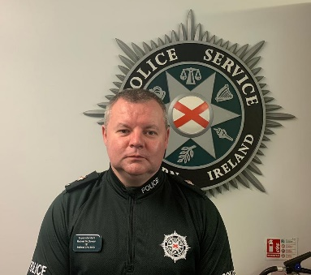
The vision of the Police Service is to help build a safe, confident and peaceful Northern Ireland. However, policing is far too important to be left to the police alone. It will only be through collaboratively working with our communities and partners that we will be able to deliver this vision. The Policing and Community Safety Partnership plays a critical role in ensuring success in this important area.

Policing will focus on ‘what matters’ to our communities and through collaboratively working with others we will strive to deliver local solutions to local problems so that people can be safe and feel safe.

Trust and confidence can be improved and crime, along with the fear of crime, can be reduced if we all play our part in reconnecting communities, protecting the vulnerable and working in partnership to deliver our vision.

This year’s local Policing Plan builds on the successes of previous years and remains testament to the excellent collaboration between the PCSP, the Police Service and the wider community. The Local Policing Plan for 2023/24 will focus on what matters most to our community and I am looking forward to being part of the journey to deliver for the people of Fermanagh and Omagh District.

I would like to thank the PCSP Chair and Members for their continued support and commitment in working in collaboration with local police to ensure Fermanagh and Omagh District remains a safe, confident and peaceful place.

Robert McGowan

District Commander

FERMANAGH & OMAGH PCSP MEMBERSHIP

Fermanagh & Omagh PCSP Membership (31 March 2023)
Elected Members | Independent Members | Statutory Bodies
Paul Blake (Chairperson) SDLP  Keith Elliott DUP  Josephine Deehan Ind  Stephen Donnelly A  Tommy Maguire SF  John McClaughry UUP  Barry McElduff SF  Thomas O’Reilly SF  Allan Rainey UUP  Paul Stevenson DUP | Mrs Sarah McQuaid  (Vice-Chairperson)  Mrs Monica Coyle  Ms Noeleen Hayes  Mr Norman Kirkpatrick  Mrs Vida Lake  Mrs Bernie McCrory  Miss Margaret McCrory  Ms Maria Thompson  Ms Pauline Treacy | Jacqueline Doherty (Western Health and Social Care Trust)  Sinead Dolan  (Youth Justice Agency)  Colum Duffy  (NI Probation Board)  Ryan McGee  (Education Authority)  Superintendent Robert McGowan  (Police Service NI)  Podge McKeon  (NI Fire and Rescue Service)  Helen Hicks  (NI Housing Executive)  Peter Melarkey  (NI Fire and Rescue Service)  Alan Murdoch  (NI Fire and Rescue Service)

PROFILE OF THE FERMANAGH & OMAGH DISTRICT COUNCIL AREA

The Fermanagh and Omagh district span approximately 3,000 km² and is home to 115,000 people. The district is the largest in Northern Ireland in terms of land mass and the smallest in terms of population, with a population density of 38 people per square kilometre.

Fermanagh and Omagh is primarily rural; approximately 30% of the population live in the two main towns of Enniskillen and Omagh. A further 7% live in the towns of Carrickmore, Dromore, Fintona, Irvinestown and Lisnaskea. The villages and small settlements account for a further 17% of the population, with 46% of people living in open countryside.

Lough Erne, the fourth largest lake in Ireland, is fully encompassed within the district. Part of the Sperrin Area of Outstanding Natural Beauty (AONB) also sits within the district, as does UNESCO Marble Arch Caves Global Geopark.

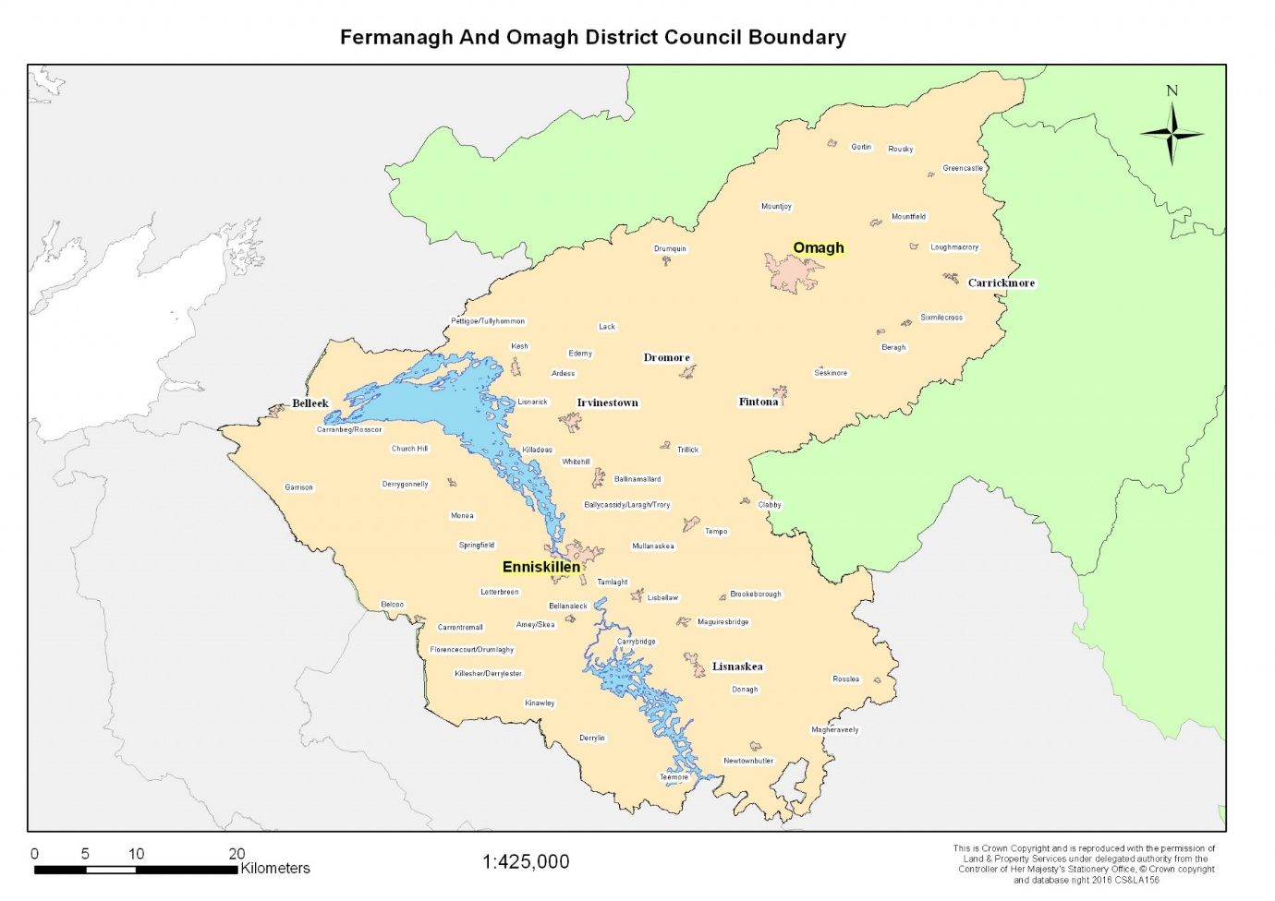

THE FERMANAGH & OMAGH 2030 COMMUNITY PLAN

The Community Plan sets the strategic direction for the district which all community planning partners, both at an individual organisation level and collectively, will work towards to achieve our shared vision and to improve quality of life for all our people.

“Our Vision for Fermanagh and Omagh is of a welcoming, shared, and inclusive district, where people and places are healthy, safe, connected, and prosperous; and where our outstanding natural, built, and cultural heritage is cherished and sustainably managed.

This strategic direction encompasses three thematic areas and six long term outcomes. An Outcome is the positive result which we aim to achieve for our population – it is not a reflection of how things are now, but of what we are aiming towards. We measure progress towards the achievement of the outcomes through a set of performance indicators.

Theme 1: People and Communities Outcomes:
1. Our people are healthy and well – physically, mentally, and emotionally.
2. Older people lead more independent, engaged, and socially connected lives.
3. Our communities are inclusive, safe, resilient, and empowered.
4. Our Children and Young people have the best start in life.

Theme 2: Economy, Infrastructure and Skills Outcome:
5. Our economy is thriving, expanding, and outward looking

Theme 3: Environment Outcome:
6. Our outstanding natural and built environment is sustainably managed and where possible enhanced.
The Action Plan identifies the prioritised headline issues that require collaborative practice to support progressing the outcomes. The actions included are those which will help to jointly tackle the major issues in the district which require a high level of partnership working underpinned with a commitment to an evidence led approach to decision making, prevention and early intervention. The process of community planning ensures that issues that are cross cutting are and ensure elevated and considered in policy led development and practices across all statutory, business and community and voluntary sector partners plans.

The priorities identified in the Emerging from Crisis 2020 Action Plan are outlined below. The Community Planning Partnership are currently reviewing the Community Plan and Action Plan content and it is expected that an updated document will be available in the Autumn 2023.

Support Positive Mental Health
Reduce Social Isolation and Loneliness
Tackle Poverty and Disadvantage
Nurture the CVS to enhance capacity and resilience, including promotion of volunteering
Trauma Aware Communities
Deliver on Tourism and Economic Recovery
Promote Green Recovery

The Community Planning Partnership is committed to:

- Work collectively to add value
- Utilise data and evidence to identify gaps in existing plans and strategies and, where required, develop new data and intelligence
- Challenge the status quo and make informed decisions based on ‘what works best’;
- Steer budgeting processes towards outcomes and priorities
- Support continuous improvement
- Ultimately, improve the wellbeing of citizens.

The Fermanagh and Omagh Policing and Community Safety Partnership are a key partner and currently support the work of the Community Plan through active participation in policy discussions, making evidence and data available upon request and highlighting key challenges and issues for residents through our own strategy and action plan. Strategic alignment has been a core element of the Community Planning Partnerships work over the past 12 months.

STRATEGIC PRIORITY 1:

TO SUCCESSFULLY DELIVER THE FUNCTIONS OF THE POLICING AND COMMUNITY SAFETY PARTNERSHIP

Restrictions impacted on the delivery of PCSP meetings and raising the profile of the PCSP. The PCSP continued to meet using a mixture of face to face and virtual meeting formats. Our independent members greatly valued the opportunity to meet and interact with other members and staff. Going forward we plan to use a mixture of face to face and virtual meetings depending on the nature of the business to be discussed.

The PSNI Chief Constable Simon Byrne visited the district in May and took the opportunity to engage with the public as well as with PCSP officers. He also attended a discussion with Women’s Aid and the PCSP to learn more about the collaboration with the PSNI in developing and delivering creative initiatives to raise awareness of domestic violence.

Task & Finish Groups continue to be an effective tool for developing and delivering different PCSP initiatives in a very time specific and focused manner. Members appreciate the opportunity for more detailed engagement in a topic and delivering a tangible outcome.

Mindful of the need to refresh our digital presence we reviewed our webpage W: PCSP Webpage https://www.fermanaghomagh.com/services/community/policing-and-community-safety-partnership/ to make it more user friendly and interactive. Our Instagram account https://www.instagram.com/fermanagh_and_omagh_pcsp_/ continues to broaden the digital footprint of the PCSP and attract a wider audience. We are pleased that traffic to our Facebook page has increased significantly, and we have used this platform to disseminate important community safety messages. We used survey monkey to conduct our community safety survey to inform the annual Action Plan; something that we will continue to use alongside focus groups and other engagement tools to ensure that our Action Plan is reflective of the needs and concerns of residents in the district.
Our PCSP members – elected, independent and designated have demonstrated their commitment to the PCSP through regular attendance at meetings, participation in Task & Finish Groups and at public events.

Superintendent Mervyn Seffen moved on towards the end of the year and he has been replaced by Superintendent Robert McGowan. Jacqueline Doherty from the Western Health and Social Care Trust also joined the partnership during the year.

FACEBOOK

This page provides details on PCSP events and community safety information promoted via the PCSP Facebook and Instagram pages.

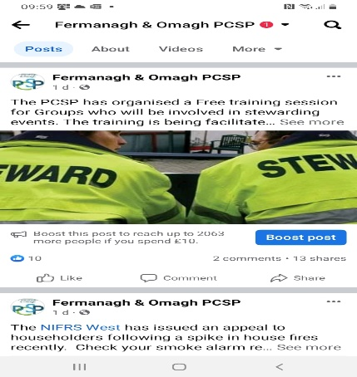
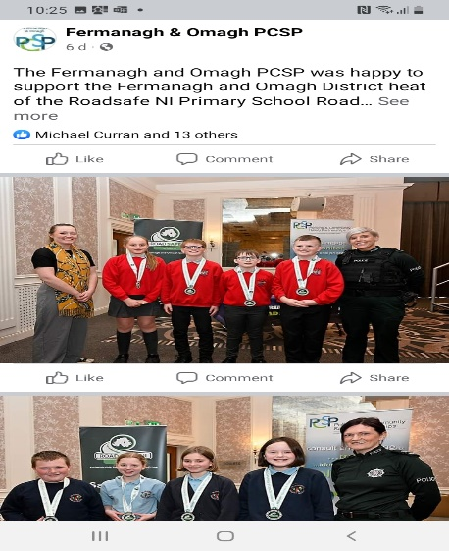
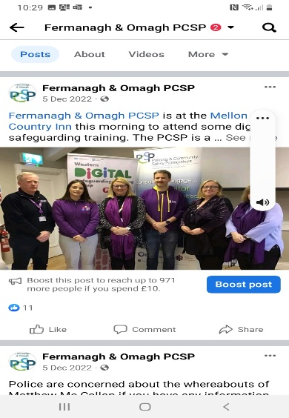
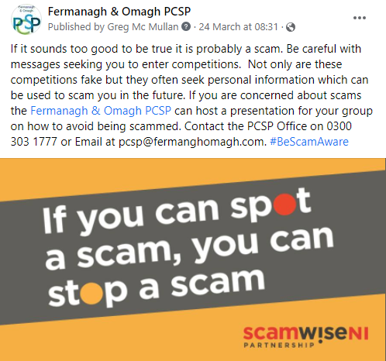
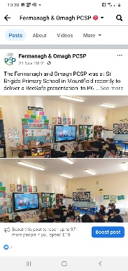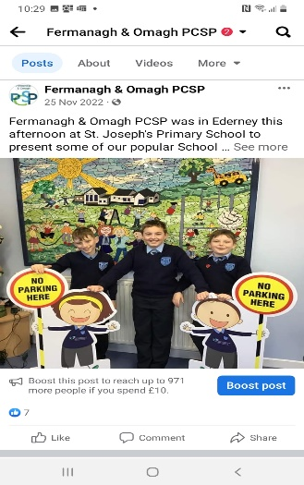
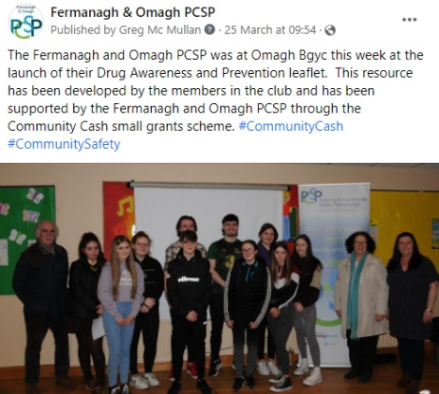
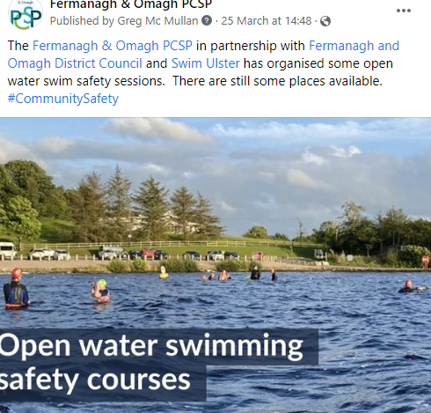
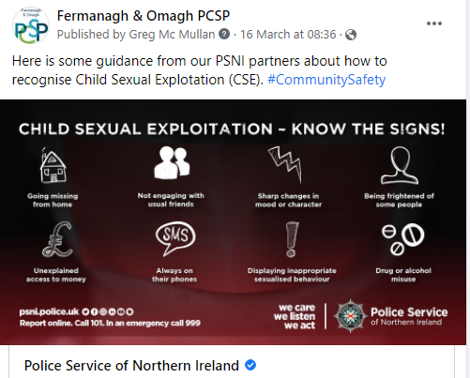
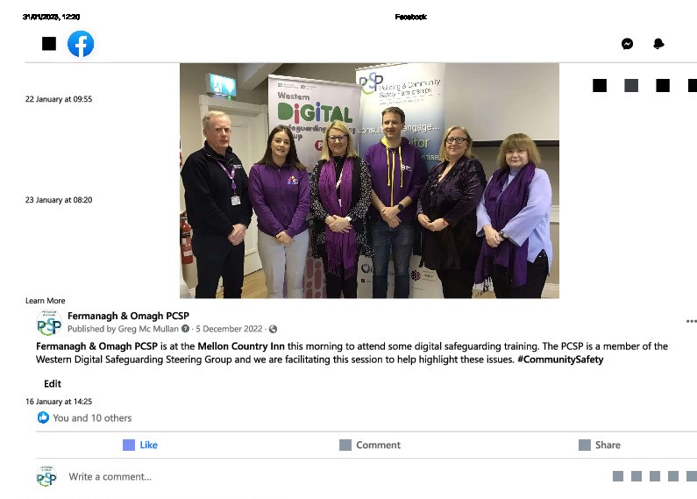

LOCAL PRESS

The PCSP received some coverage in the local press however the printed media has reduced significantly in 2022-2023, key features include:

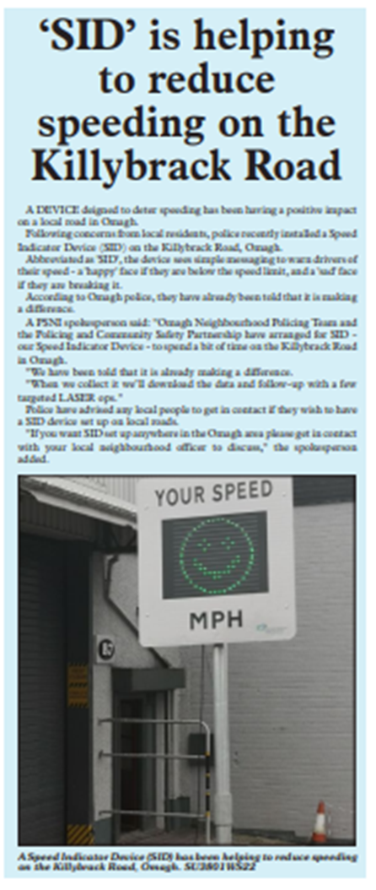
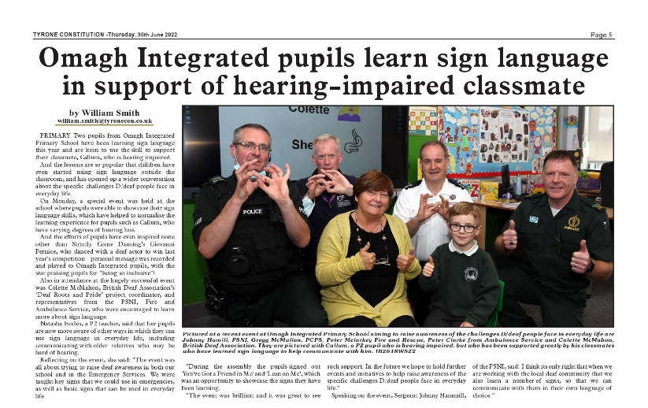

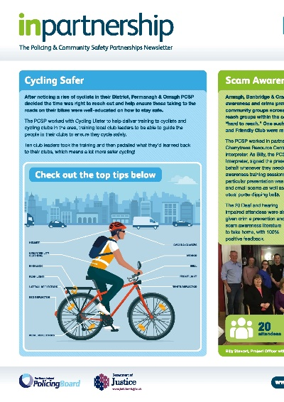

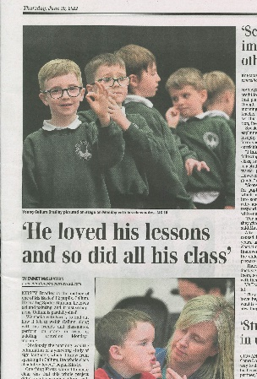

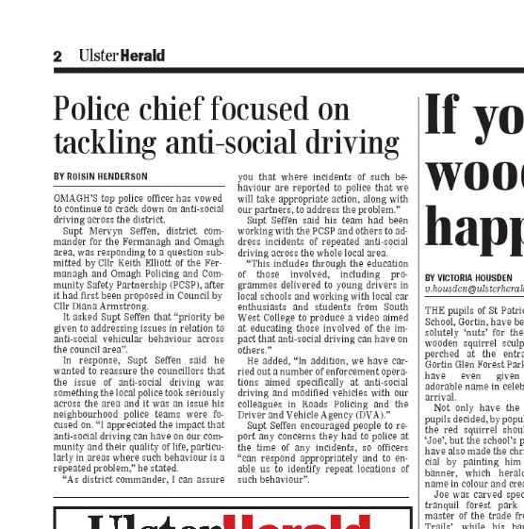
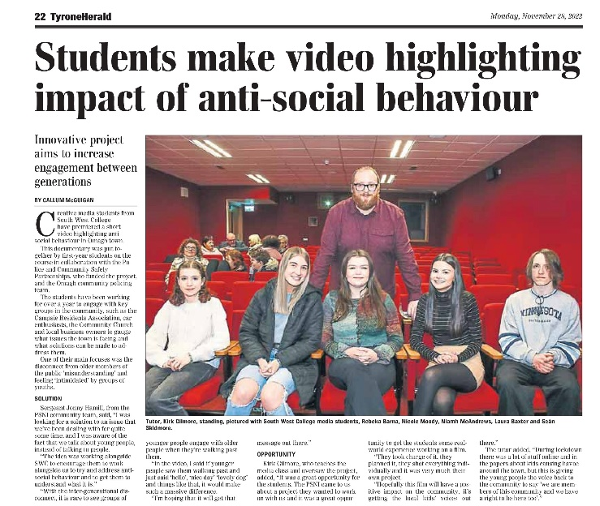

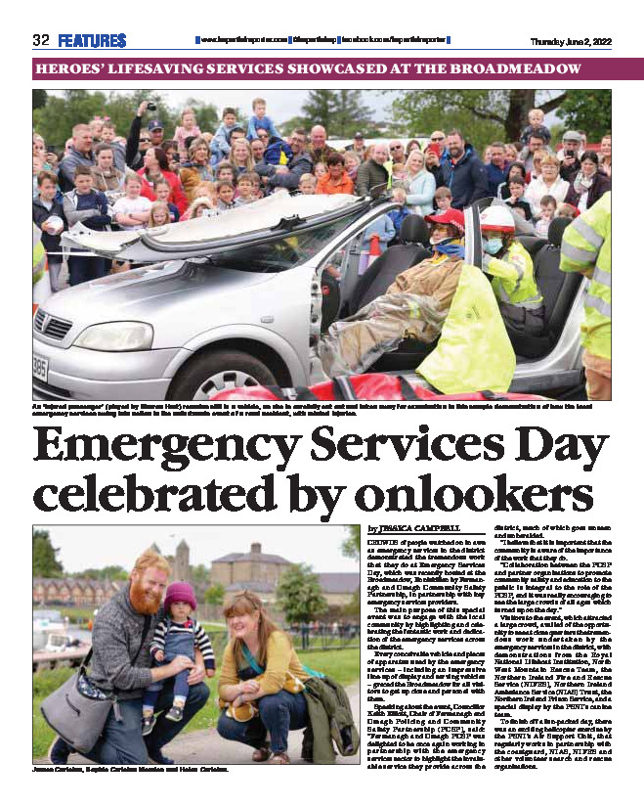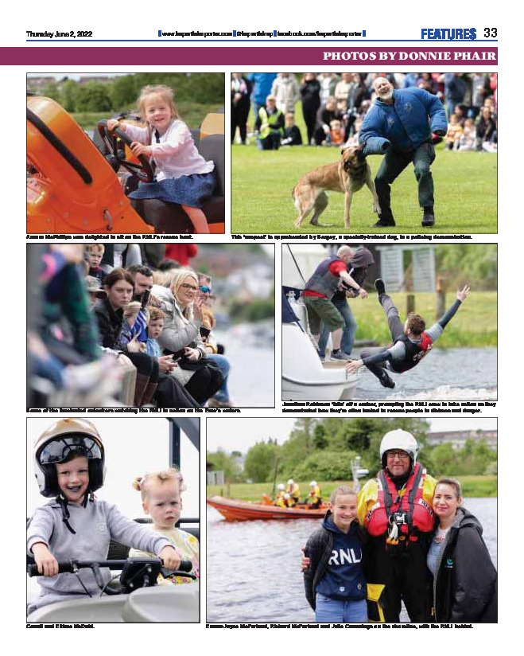

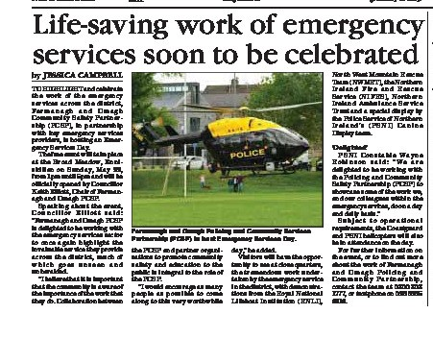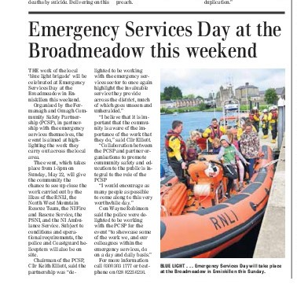

OVERVIEW OF THE WORK OF THE FERMANAGH & OMAGH PCSP

Overview of the work of the Fermanagh and Omagh PCSP – To successfully deliver the Policing and Community Safety Partnership
Project | Performance Measures | Budget
Organising the work of the PCSP  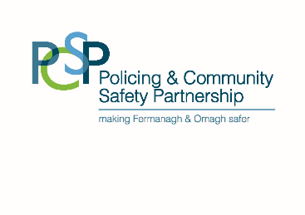 | How much did we do?  - 15 press reports relating to PCSP messaging  - 567 Facebook posts  - 150 Instagram Posts  - 1,800 PCSP leaflets distributed  - 10,750 people attended PCSP events  How well did we do it?  - 71,983 engagements on Facebook  Is anyone better off?  - 75% of community safety survey respondents were aware of the work of the PCSP | £3,000

STRATEGIC PRIORITY 2:

TO IMPROVE COMMUNITY SAFETY BY TACKLING ACTUAL AND PERCEIVED CRIME AND ANTI-SOCIAL BEHAVIOUR

Most of the resources of the PCSP are directed to the delivery of Strategic Priority 2 which reflects the strategic priorities of the Fermanagh and Omagh Policing and Community Safety Partnership addressing identified need.

- Road Safety
- Domestic Abuse and Sexual Violence
- Crime and the Fear of Crime
- Anti-social Behaviour

The actions detailed in Strategic Priority 2 take account of crime and anti-social behaviour hot spots and are designed to be imaginative and flexible in response to issues as they arise.

OVERVIEW OF PERFORMANCE

Road Safety

Road Traffic Collision demonstrations are a very stark visual illustration of the devastating impact of careless and dangerous driving, and we are appreciative of the work of other agencies to make these happen and the co-operation of schools. Working with New Driver NI we facilitated presentations to Year 13/14 students in schools in our district.
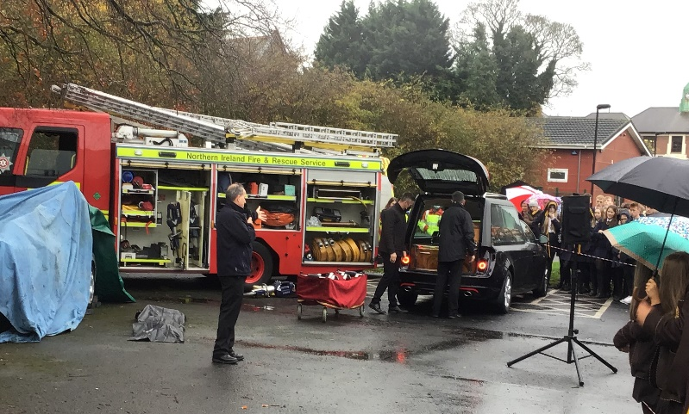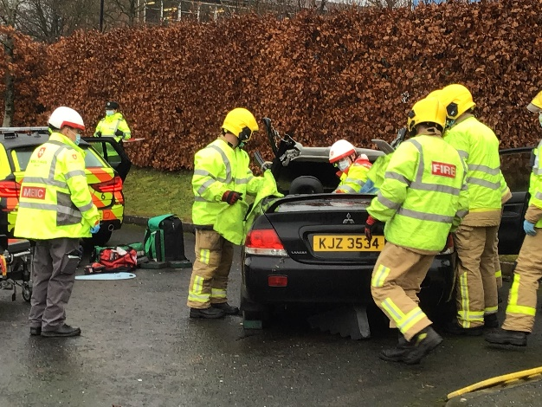
Scenes from RTC demo at Omagh High School

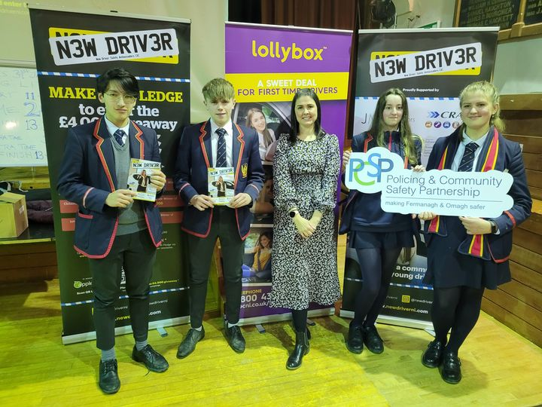

Scenes from New Driver presentations at Drumragh Integrated and Enniskillen Royal

Speed Indicator Devices (SID) were deployed in locations across the district where speeding was identified as an issue of concern by the community. The SID is deployed for a period of time as a tool to educate and remind road users of the speed limits and responsible driving. Community organisations can apply to the PCSP to deploy the SID in their own area.

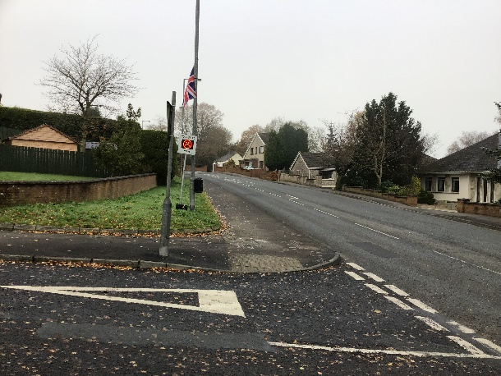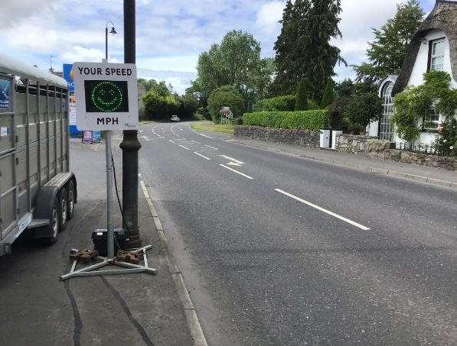
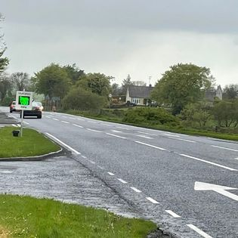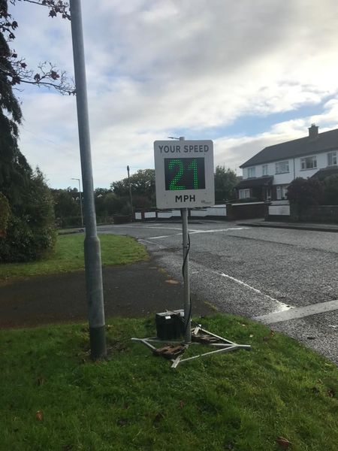
SID deployment around the district

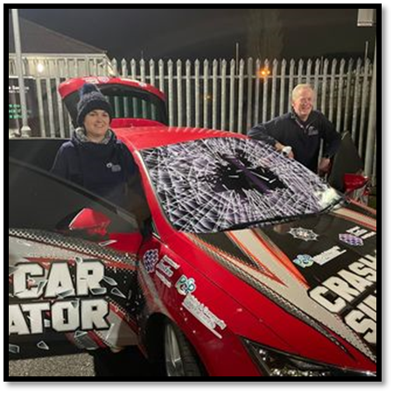
Crash Car Simulator
Working in collaboration with PSNI Roads Policing we continued to deliver road safety workshops using the Crash Car Simulator to illustrate the impact of dangerous driving. The Simulator is a joint “safer driving” initiative between Fermanagh and Omagh and Mid Ulster Policing and Community Safety Partnerships that allows young drivers to experience the devastating consequences of driving irresponsibly including the potential for injury and death through the simulation of a car crash. The vehicle has been adapted to represent a Road Traffic Accident in a rural setting to more properly reflect the devastating consequences which many young drivers and their passengers have and will experience in this area.

The simulator is a modified standard car and has been fitted with a high quality sound system, hydraulics, DVD player as well as a smoke and light system.

Crash Car at youth event
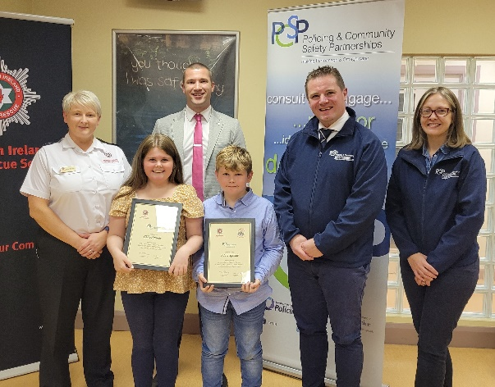
Fire Safety

Chloe and Adam Sproule from Kesh found themselves involved in a car fire in August but thanks to their situational awareness and quick thinking they prevented serious injury to themselves and others.

On Tuesday 30 August 2022 Chloe & Adam Sproule, who are 11 and 9, were travelling in a car with their grandmother when they could smell smoke inside the vehicle. Only moments after they exited the car it went up in flames.

They alerted their grandmother and recalled advice they had received from a Firefighter during a school talk - to pull over immediately, exit the car and look for a safe place to stand by as you call NIFRS. The PCSP attended an awards evening at the Enniskillen Fire station to recognise their bravery.

Road safety – Primary Schools

Linking with Neighbourhood Policing Teams we engaged with many primary schools to deliver road safety messages. We worked with 9 primary schools to raise awareness of speeding and inconsiderate parking near school buildings. Each participating school received two bespoke No Parking signs.

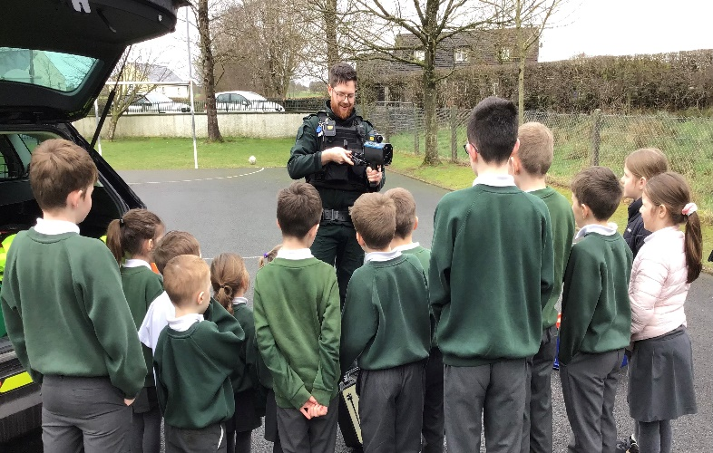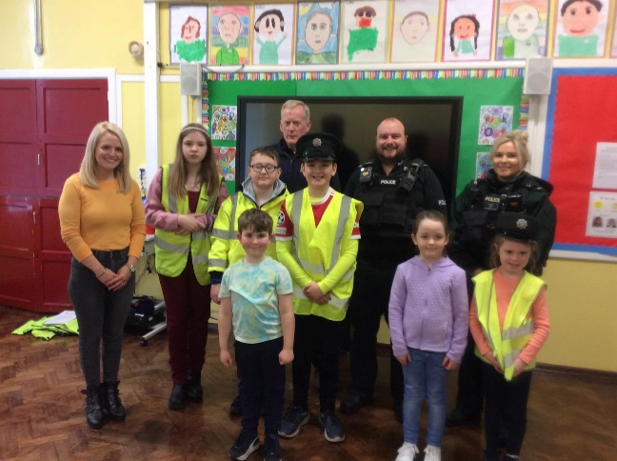
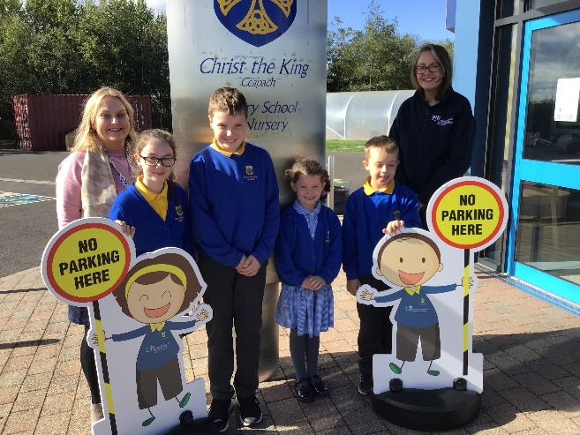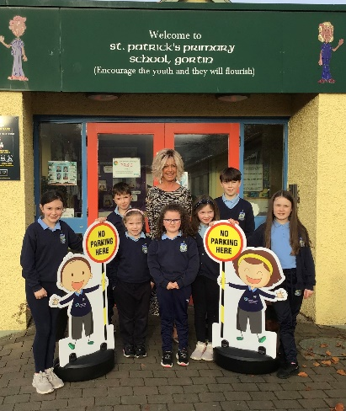

Road Safety engagement with Primary Schools in the district

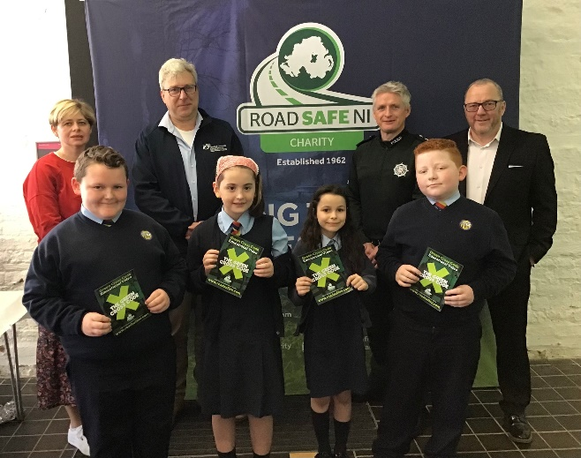
Green Cross Code

The Fermanagh and Omagh PCSP in partnership with Roadsafe NI hosted the launch of a new version of the Green Cross Code aimed at younger adults. The Northern Ireland launch for this video was hosted at the Enniskillen Castle where representatives from the PSNI, NIFRS, DFI and Roadsafe NI attended.

Launch of the Green Cross Code Video

Bike Safe

In collaboration with Roads Policing we hosted Bike Safe in June. This is a practical one day course to promote safer riding.
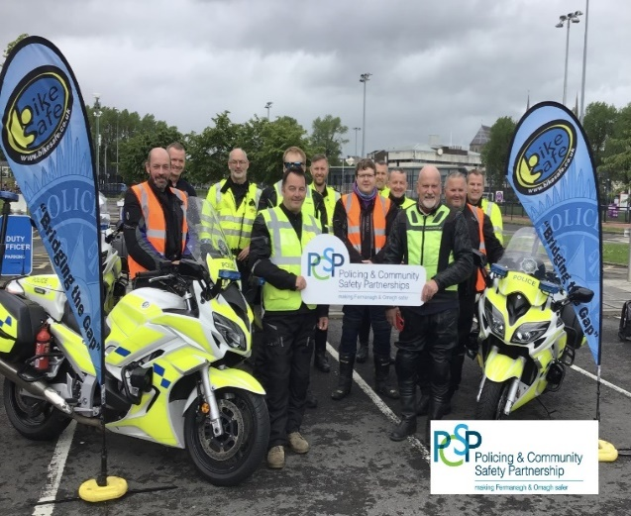
Participants at Bike Safe
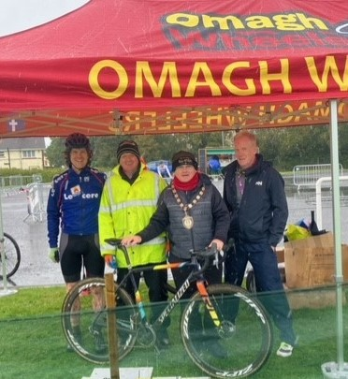
Cyclocross Event at Ecclesville
In collaboration with Omagh Wheelers, we hosted a safe cycling event at the Cycling Hub in the Ecclesville Centre, Fintona.
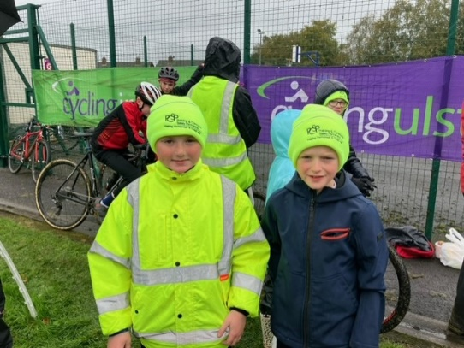
Council Chairperson & PCSP member Cllr Mc Elduff with members of Omagh Wheelers

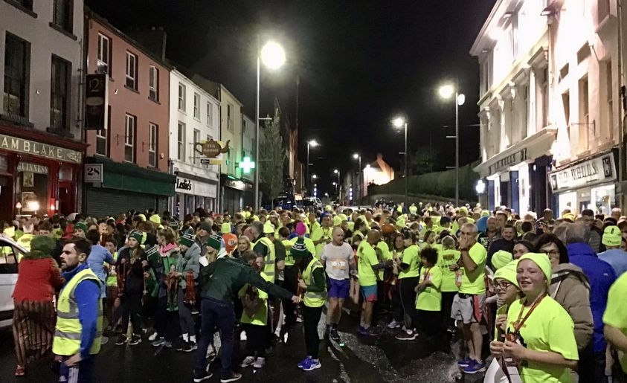
Spooktacular
Throughout the year we attended running and walking events to highlight the use of hi viz materials when outdoors. We attended the Halloween 5k event hosted in Enniskillen to highlight the use of Hi Visibility gear for runners.

Spooktacular Event, Enniskillen, Omagh
Safer Home

We delivered the Safer Home initiative which offered a range of supports such as home safety information, provision of equipment and referrals to other relevant supports to assist people to remain living in their homes. Demand for this service was significant with 272 home visits undertaken in the year with 234 homes in receipt of equipment and 218 referrals to other supports.


Fermanagh and Omagh Support Hub

We are members of the Fermanagh and Omagh Support Hub providing administrative support and chairing role. The rationale of the Hub is to help people improve their situation through effective interagency working bringing key professionals together to facilitate early better quality information sharing and decision making to work together.

ASB Forums
We manage two anti-social behaviour forums – Fermanagh and Omagh. The forums have a core membership of the PCSP, PSNI, NIHE and FODC Environmental Health. These agencies use a multi-agency problem solving approach to manage risk and reduce incidents of anti-social behaviour in the district.
Domestic Abuse and Sexual Violence
We continued to work with Fermanagh Women’s Aid and Omagh Women’s Aid with the delivery of the Right to be Safe Programme a bespoke project delivered directly to women who had experienced domestic violence. Those women accessing the programme were either awaiting full services and in need of immediate safety planning and guidance, had previously accessed services but had experienced a change or escalation which they needed fast access to support for or wanted to access refresher information without entering full services. For many women these included issues with child contact or a need to develop a fuller understanding of the protective legislation now in force under the Domestic Abuse and Civil Proceedings Act (Northern Ireland) 2021.
The programme was delivered over 5 sessions.
- Session 1 – What is Domestic Violence? Exploring emotional, physical, sexual, financial, spiritual abuse and coercive control.
- Session 2 – Safety Planning and How to leave safely identifying and managing risk, practical support to become safer from perpetrators of Domestic and Sexual Violence. Planning for how to leave safely and available support / remedies when the risk escalates.
- Session 3 – Safe at Home including Crime Prevention Officer with access to practical guidance on making the home safer.
- Session 4 – Coercive Control criminal and family justice exploring the legislation, what it means, the remedies available through criminal and civil justice and legal aid entitlements. Legal Representative in attendance to talk through the application of the law and remedies.
- Session 5 – Being Safe in the Future building on the learning so far tailored toward issues which may emerge in future.
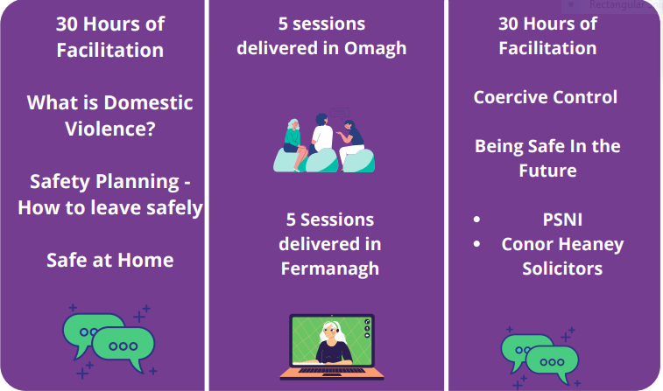

Where the Blame Lies Conference
Held on 8-9 March this 2 day conference attracted 306 attendees and 13 presenters including David Challen, Jane Monkton Smith and Karen Ingala Smith covering topics such as femicide census, advocacy after fatal domestic abuse and trauma alcohol and domestic violence.
Some of the key messages delivered by presenters.
Jane Monkton Smith
- Coercive control is the most significant high risk factor of serious harm and potential homicide
- If you are not providing the route to escape, you cannot ask her why she doesn't leave
- Domestic homicide is not inevitable as we can disrupt the timelines through interventions
- Perpetrators feel they are ‘entitled’ to be in charge of the relationship
Frank Mullane
- Perpetrators are playing outside the rules of the law
- The goal is to help the families after Fatal Domestic Abuse through interactions with authorities
- DHR – find the trail of abuse
- If the system is impotent – we have to know – something has to change

Karen Ingala Smith
- We must remember to see the names and faces of women who have been killed by men – they are not just a statistic
- How can you solve a problem if you don’t look at the perpetrator
- 5 levels of women killed by men: Individual, Relational, Cultural, Structural and Institutional
- ¼ abusers more than likely to be serial abusers
- What does it take for us to shift focus to the perpetrator
- 76% of domestic homicide’s happen in the first six months after women leave
- We need to make the invisible, visible
- Media deliberate framing of women as the problem
- Perpetrators blend in – they are not who we think they are
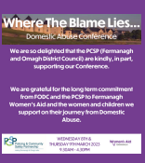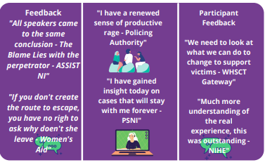

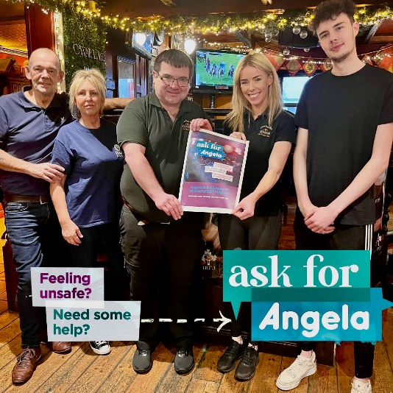
Ask for Angela

We supported the PSNI in the roll out of the Ask for Angela scheme where anyone who is feeling unsafe, vulnerable or threatended can discreetly seek help
by asking venue staff and asking them for ‘Angela’.
This code-phrase will indicate to staff that they require help, and a trained member of staff will then
look to support them.

Staff at Charlie’s Bar which has signed up to the scheme

Traveller Engagement Initiative

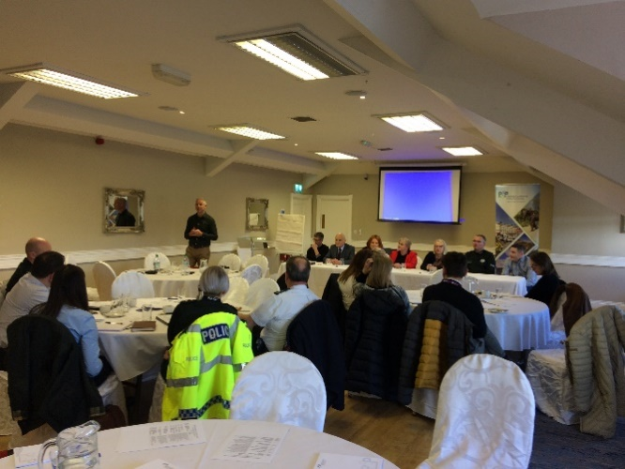
This pilot project looked at barriers to engagement between the Traveller community and the police and identify opportunities to build relationships based on shared experiences and understanding of each other’s perspective. In developing the project, we liaised extensively with the Traveller Mediation Service (TMS) and Offaly Traveller Movement to gain an insight into and understanding of the needs/issues influencing behaviours and the nuances which permeate the culture.

Stakeholder engagement event
As part of the project, we engaged with traveller specific supports in the FODC area to identify current activity and future needs. Awareness raising workshops for PSNI officers and Fermanagh and Omagh District Council staff such as registry were well received with further workshops are planned. One of the key outcomes of the project has been the coming together of key stakeholders to explore the appetite for a traveller led initiative for the Omagh area. Stakeholders including PSNI, NIHE, WHSCT, PHA and FODC heard from speakers promoting the benefits of having a traveller led project; these included the Offaly Traveller Movement, HSE Midlands Traveller Health Unit and Laois Offaly Education & Training Board. Initial discussion with the Traveller community in Omagh led by the PSNI have been very positive and there is a commitment on all parties to bring the concept to fruition.
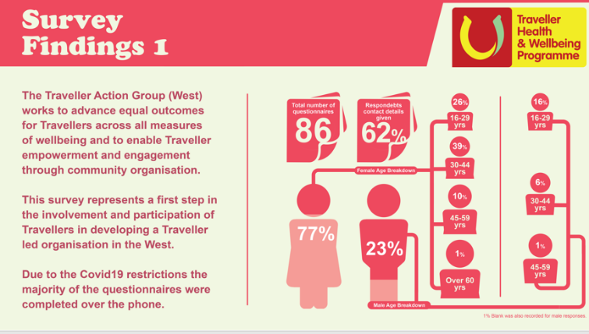

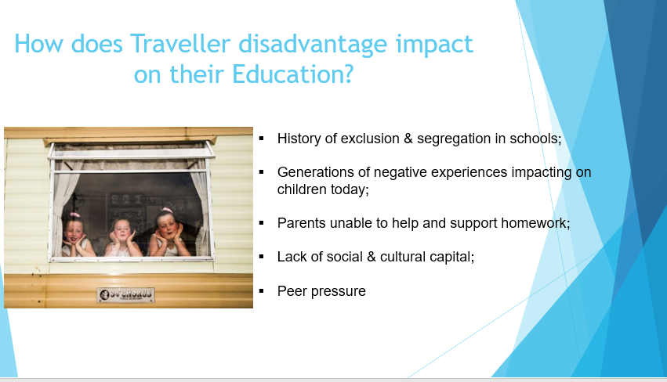

Water Safety

Fermanagh and Omagh Policing Community Safety Partnership (PCSP) in partnership with Fermanagh and Omagh District Council (FODC) and Swim Ulster organised introductory open water swimming safety courses during May 2022 for those aged 18 years and over. These courses were aimed at young people and adults with little or no experience in open water swimming and also for and more experienced swimmers.

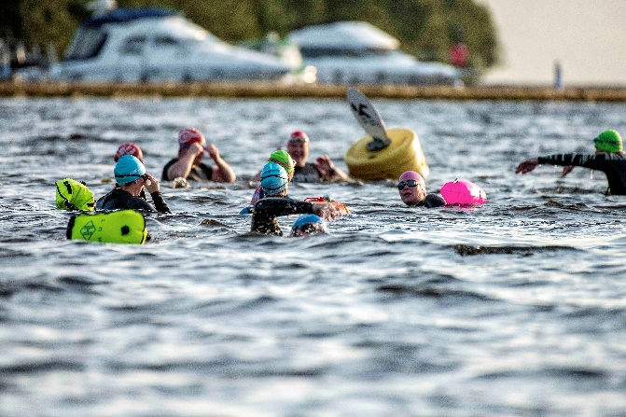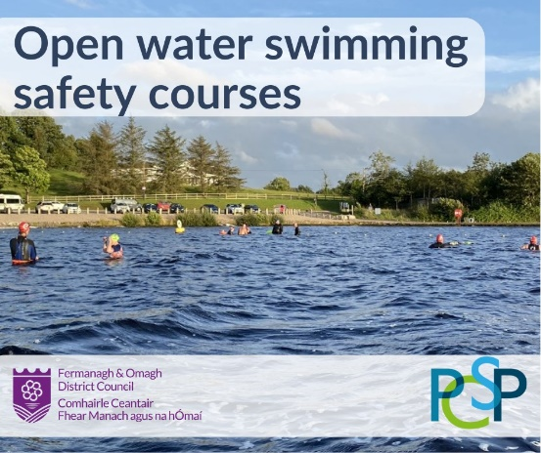
Open water swimming at Muckross Bay

RAPID Bins

There are now 10 bins across the district. This year a total of 11,918 drugs items were disposed in bins. Two new bins were installed – Lilley’s Centra in Enniskillen and Lakeland Community Care Healthy Living Centre in Belcoo.

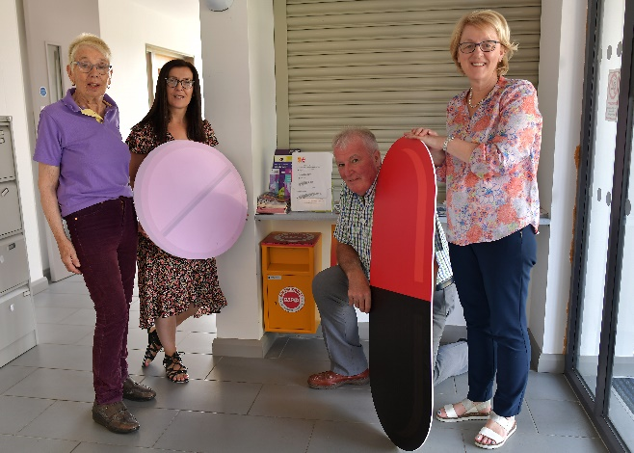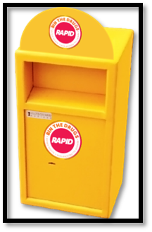
RAPID Bin in Belcoo

ASB Diversionary Activity

Castle Island, Enniskillen was the venue for a celebration event for the Youth on Water (YoW) project. Young people and their families with Blue Green Yonder and PSNI Neighbourhood Policing Teams from Enniskillen and Erne West gathered for an afternoon of certificate presentations, BBQ and water sports.

Funded by the Policing and Community Safety Partnership (PCSP) the Youth on Water project gave participants the opportunity to develop a range of water safety skills with the award of the Paddle Power BCU Certification and using the focus of water sports to explore deeper issues facing young people such as unconscious bias, community identity, risk taking behaviours and anti-social behaviour.

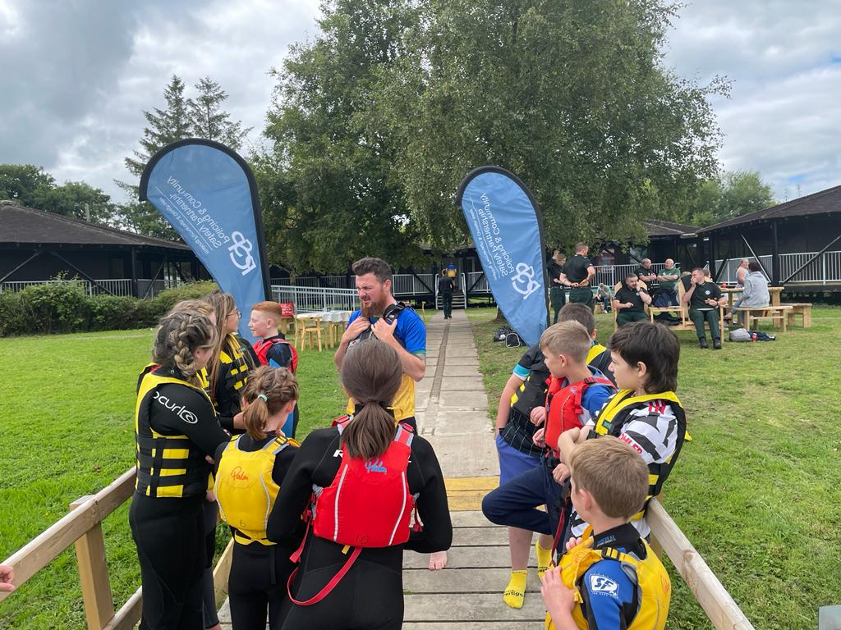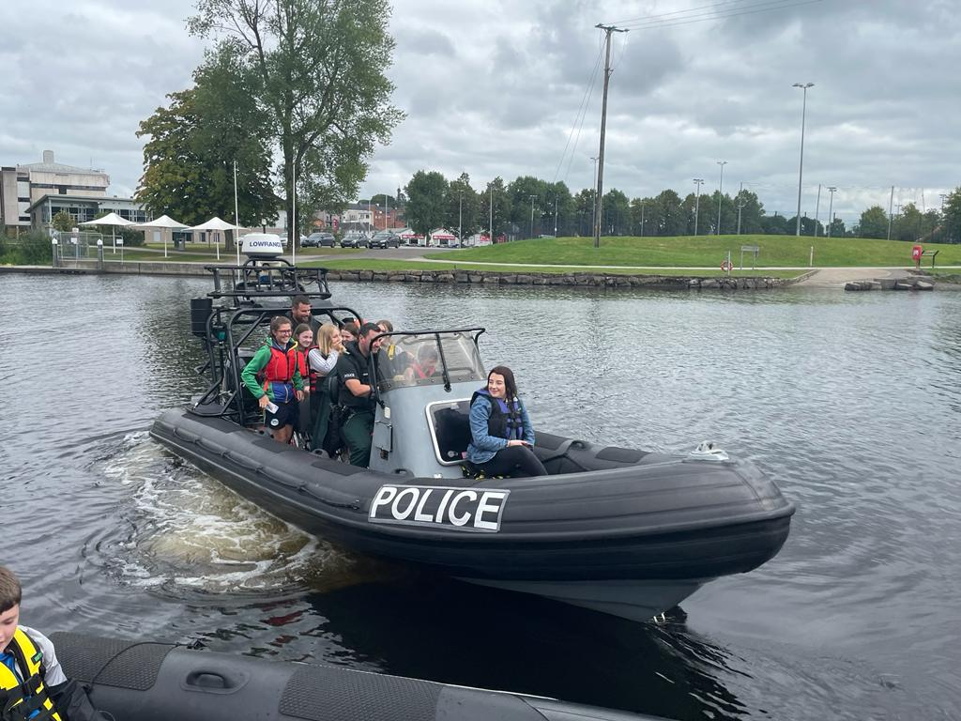
Diversionary activity at Castle Island Enniskillen

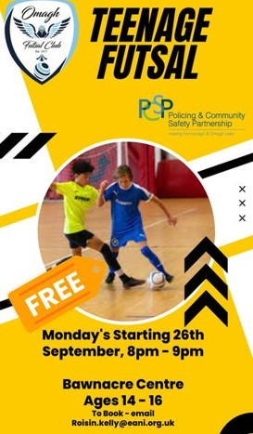
We supported sports projects for Ballinamallard Youth Soccer and Omagh Futsal Club where the focus was on creating opportunities for children and young people to be part of organised activity and to have the opportunity to meet and interact with Neighbourhood Police in a relaxed environment.


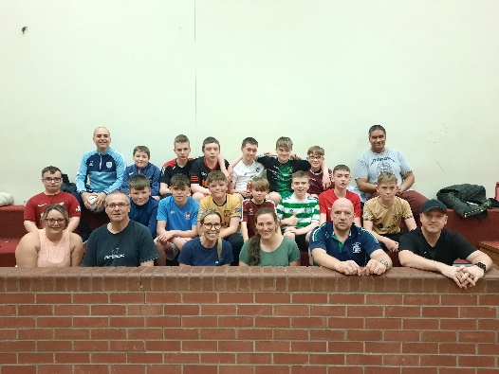
Relaxing after a game of Futsal Celebrations at Ballinamallard Youth Soccer Tournament

Devenish Partnership Forum received funding to deliver the Positive Peers Project to encourage young people to be more interactive with police, so they don’t just see them as a figure of authority.
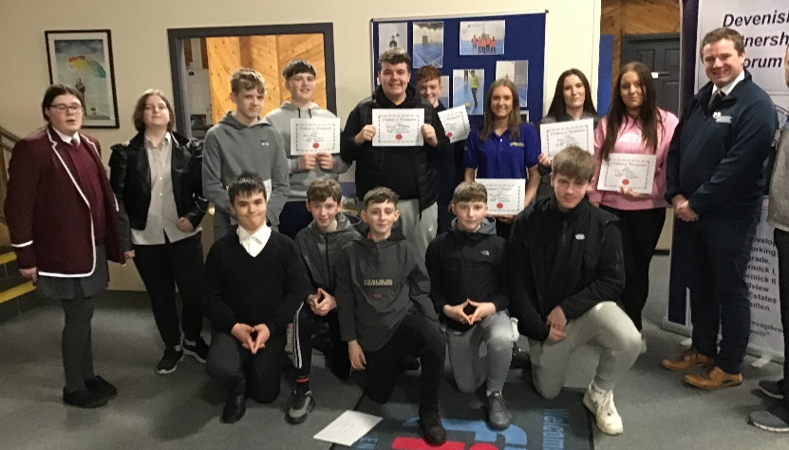

Participants receiving certificates of achievement for the Positive Peers Project

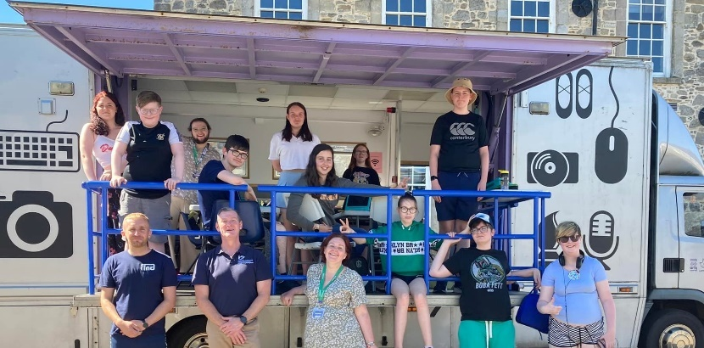
The Art Cart workshop was part of a three-day summer programme examining on line safety for young people attending the FIND Centre.

Bee Safe

This year we continued to address safety concerns around Covid-19 and continued with the format of Bee Safe using the videos produced previously. Presentations include:


- Home safety
- Fire safety
- Internet safety
- Water safety
- Farm safety
- Road safety
- Mental health and well being

Each video presented by radio DJ Pete Snodden features a question and answer segment with a guest speaker and contributions primary school pupils. The videos are no longer than 15 minutes duration and with accompanying workbook provide a wealth of age appropriate information on the specific topic equipping pupils with the knowledge and skills to stay safe and to cope effectively should they find themselves in a potentially dangerous situation. The initiative complements accident prevention and community safety work within the school setting and prepares pupils for the transition to secondary education.

We were delighted with the response from primary schools who accepted our offer to deliver Bee Safe in the school setting.

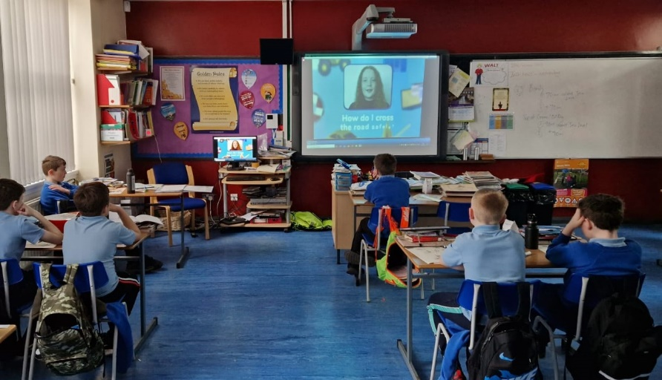
Bee Safe delivery

Crime Prevention

We delivered a series of crime prevention initiatives throughout the year including trailer marking.

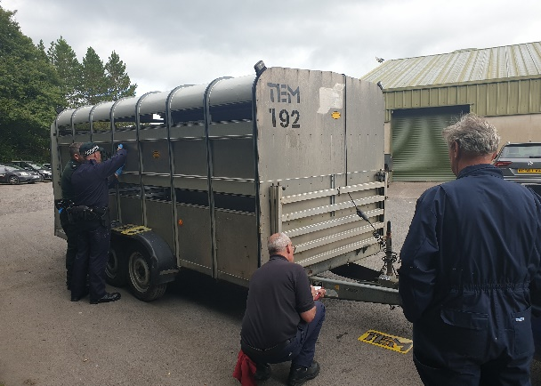
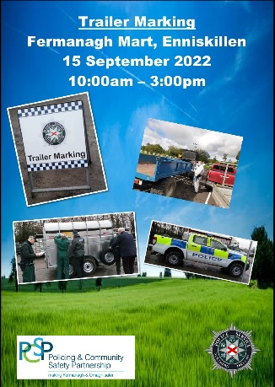
Trailer marking at Enniskillen Mart

We delivered crime awareness events to raise awareness of what people can do to prevent becoming a victim of crime. Events were held in venues across the district.

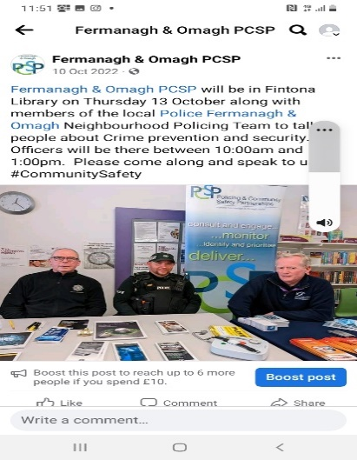 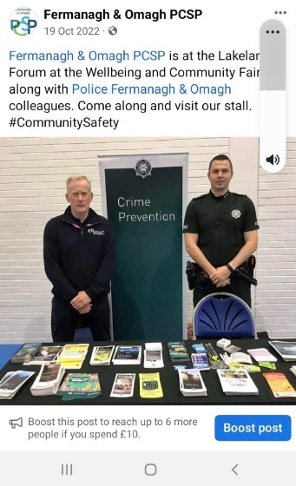Crime Prevention events

We also attended several events as part of Positive Ageing Month in October 2022.

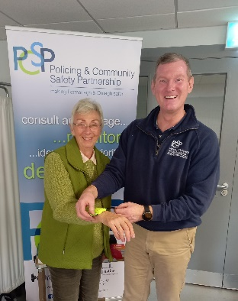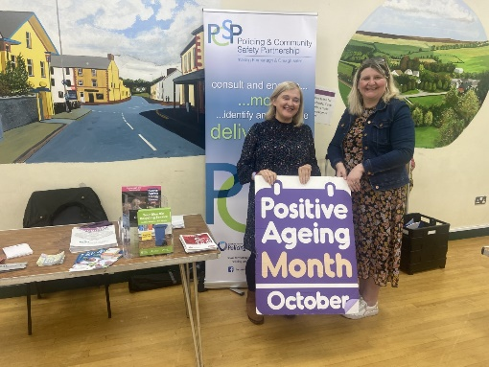

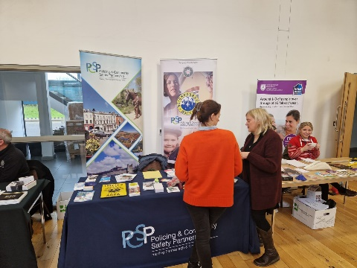

OVERVIEW: ROAD SAFETY

Overview of the work of the Fermanagh and Omagh PCSP - Road Safety

Project | Performance Measures | Budget
FATAL 4 Road Safety Campaigns    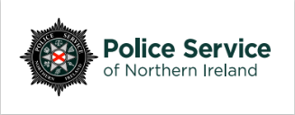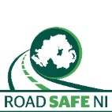  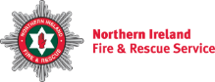 | How much did we do?  - 26 road safety awareness events  - 1,802 attendees  - 42 deployments of temporary SiDs  How well did we do it?  - 83% participants reporting satisfaction with the information provided  - 100% local community reporting satisfaction with the SIDs  Is anyone better off?  - 83% participants reporting increased knowledge of road safety  - 13% average reduction in speeds passing through the radar. | £55,107

OVERVIEW: CRIME AND THE FEAR OF CRIME

Overview of the work of the Fermanagh and Omagh PCSP - Crime and the Fear of Crime
Project | Performance Measures | Budget
Crime Prevention  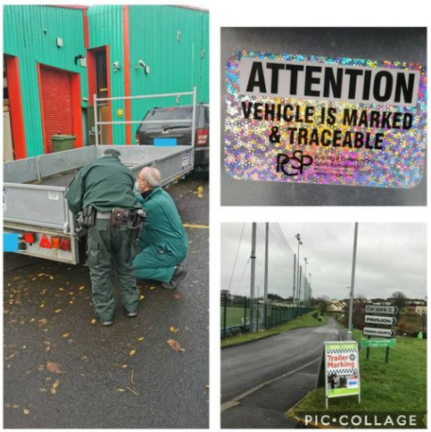   | How much did we do?  - 1 trailer marking event - 35 trailers marked  - 42 crime prevention assessments undertaken  - 47 crime prevention events delivered  How well did we do it?  - Of the 35 attendees surveyed at the trailer marking 100% were satisfied with the event  Is anyone better off?  - Of the 35 attendees surveyed at the trailer marking 90% reported improved knowledge of crime prevention | £10,000
Safer Home | How much did we do?  - 272 home visits  - 234 homes in receipt of equipment  - 218 referrals to other agencies/services  How well did we do it?  - Of those surveyed 100% beneficiaries reporting satisfaction with the information/equipment provided  Is anyone better off?  - Of those surveyed 100% of beneficiaries reporting increased confidence to remain in their own homes | £64,615

OVERVIEW: DOMESTIC AND SEXUAL VIOLENCE

Overview of the work of the Fermanagh and Omagh PCSP - Domestic and Sexual Violence
Project | Performance Measures | Budget
Awareness Raising    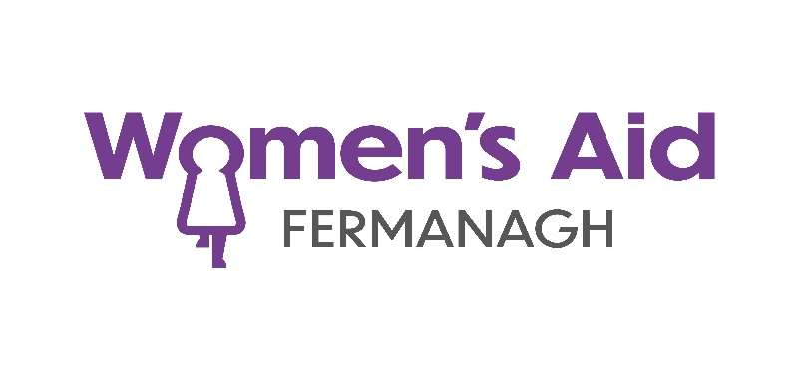 | # How Much?  - 1 Right to be Safe Programme delivered  - 32 participants  % How Well?  - 32/100% participants reporting satisfaction with the programme  # and % Better Off  - 30/91% participants reporting increased awareness/understanding of domestic abuse and sexual violence and of legislative protections  # How Much?  - 2-day conference 8-9 March  - 306 attendees  - 13 presenters  % How Well?  - Of the 95 survey respondents 95/100% found the conference extremely beneficial  # and % Better Off  - Of the 95 survey respondents 95/100% reporting increased understanding of risk control | £13,000

OVERVIEW: ANTI-SOCIAL BEHAVIOUR

Overview of the work of the Fermanagh and Omagh PCSP – Anti-Social Behaviour
Project | Performance Measures | Budget
RAPID Bins  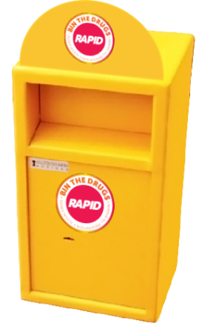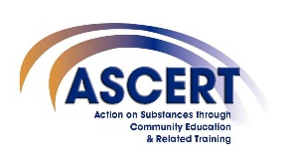 | How much did we do?  - 10 bins operational  - 2 New bins installed  - 115 views RAPID bins animation  How well did we do it?  - All members of the Fermanagh and Omagh Drugs and Alcohol Forums reporting satisfaction with RAPID bins.  Is anyone better off?  - 11,918 drugs items disposed in the RAPID bins | £2,000

STRATEGIC PRIORITY 3:

TO SUPPORT COMMUNITY CONFIDENCE IN POLICING
The Policing Committee is responsible for enhancing public confidence in policing through its work in monitoring police performance in the delivery of the Local Policing Plan, ensuring that policing services are delivered for local communities.

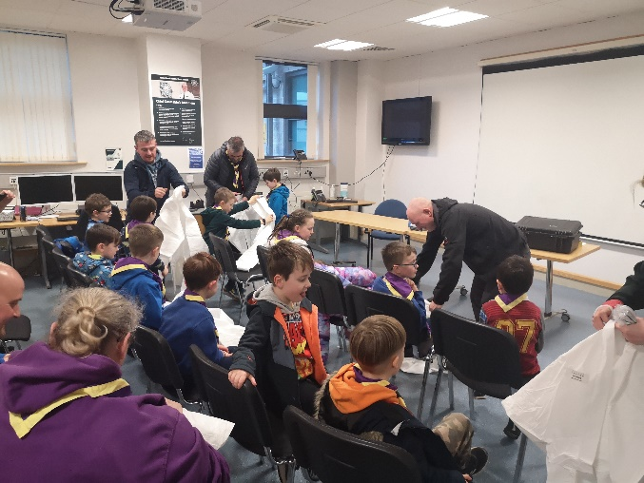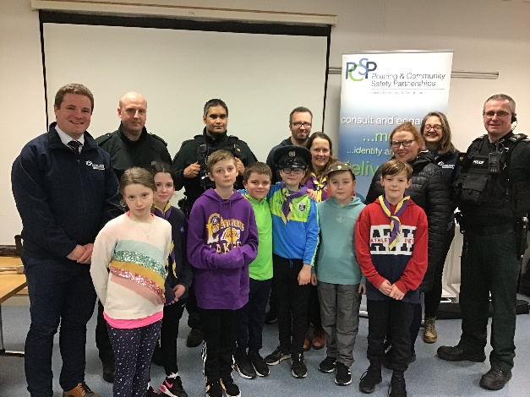
Engagement activity with NPTs
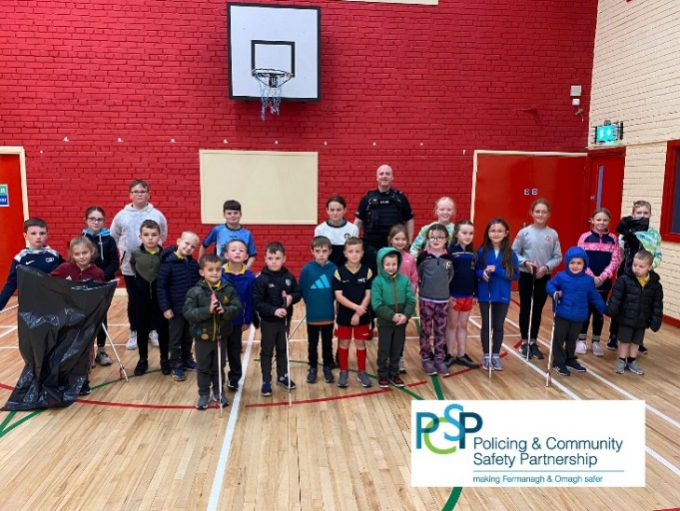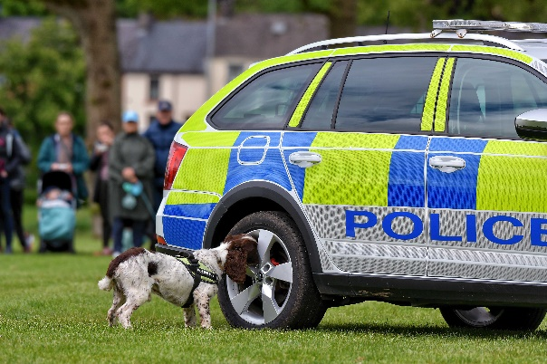

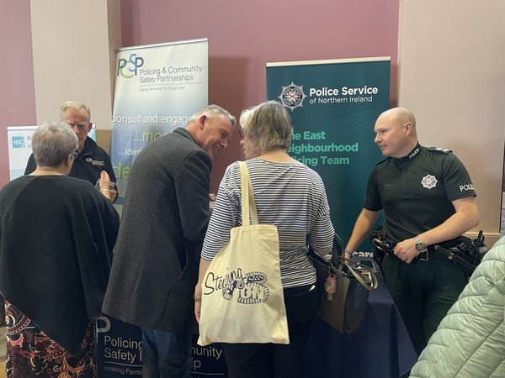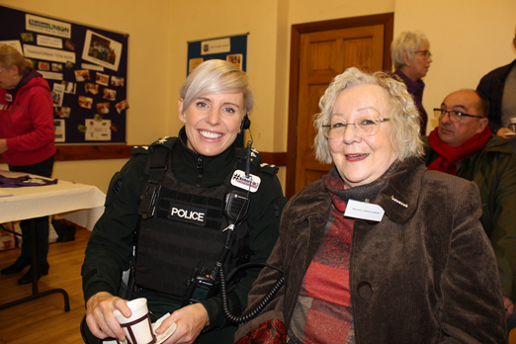

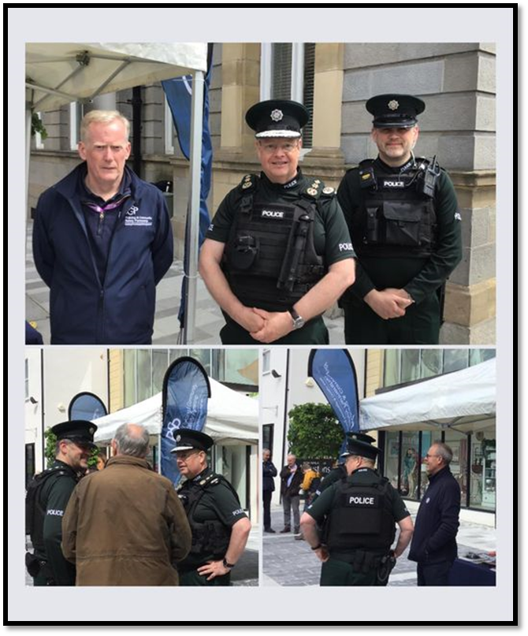
Chief Constable Visit

The Chief Constable Simon Byrne visited in May where he took the opportunity to meet PCSP staff hosting a crime prevention pop up stall and engaged with the public in a walkabout in Enniskillen Town Centre.

Neighbourhood Watch
We recognise the role of Neighbourhood Watch schemes in helping the community be safer. The co-ordinators give their time voluntarily and it is important that they are supported in their role and have access to relevant information about local crime and emerging trends.
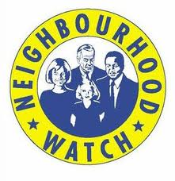
Operating Neighbourhood Watch requires significant staff resource to ensure that the co-ordinators are kept up to date with relevant issues in their area. One PCSP staff member acts as the main contact for all the Neighbourhood Watch schemes.
There was a fantastic turnout for the Fermanagh and Omagh Neighbourhood Watch Conference in the Silverbirch Hotel, Omagh. Over fifty Neighbourhood Watch Scheme Coordinators attended the annual event to meet and voice opinions on policing, crime, antisocial behaviour and community safety issues in their areas.
Speakers from the PSNI, Consumer Council NI, Hourglass NI and Fermanagh and Omagh Council provided information on topics including local policing matters, recent trends in scams and frauds, Elder Abuse and Recycling.
We also held several co-ordinator engagement events throughout during the year.

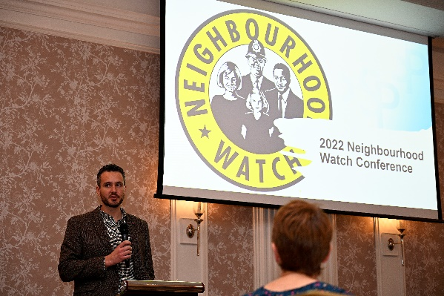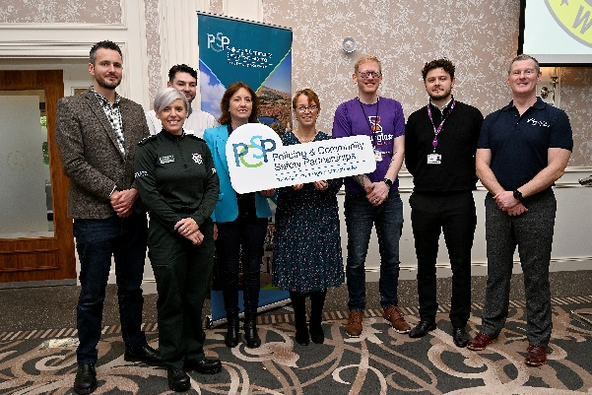
Neighbourhood Watch Conference

OVERVIEW- POLICING COMMITTEE

Overview of the work of the Fermanagh and Omagh PCSP – The Policing Committee
Project | Performance Measures | Budget
Monitor local people performance | How much did we do?  - 5 Policing Committee meetings  - 45 events/activities delivered in collaboration with the PSNI/NPTs  How well did we do it?  - 66% Member attendance at Policing Committee meetings  Is anyone better off?  - 100% Members reporting increased confidence in the PSNI to deliver the Local Policing Plan. | £1,000
Neighbourhood Watch Scheme  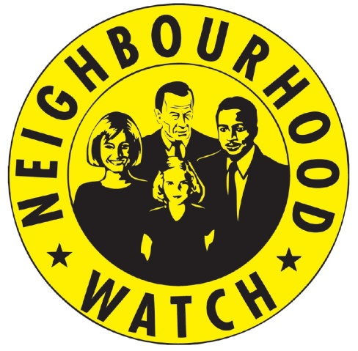 | How much did we do?  - 89 active NHW Schemes  - 2 NHW Coordinator development events.  - 133 active coordinators  - 6,122 homes in active NHW Schemes.  How well did we do it?  - 78% coordinators reporting satisfaction with NHW  Is anyone better off?  - 80% coordinators feeling supported, confident and equipped in their role  - 84% coordinators believed that their NHW scheme improved the safety of their neighbourhood. | £46,656

APPENDICES

Appendix A: Financial Statement 2022-2023 to follow when released by Joint Committee

Appendix B: Fermanagh and Omagh Local Policing Plan 2022-2023

The Fermanagh and Omagh Local Policing Plan for 22/23 has three themes:

1. WE HAVE A SAFER COMMUNITY
2. WE HAVE CONFIDENCE IN POLICING
3. WE HAVE ENGAGED & SUPPORTIVE COMMUNITIES

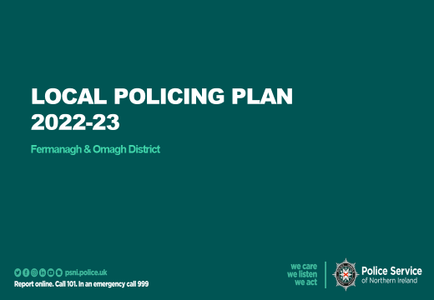

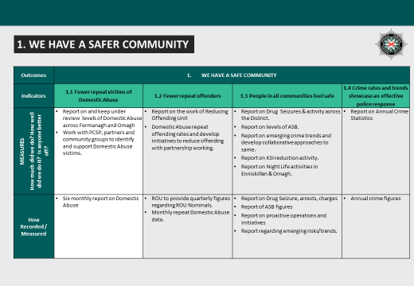

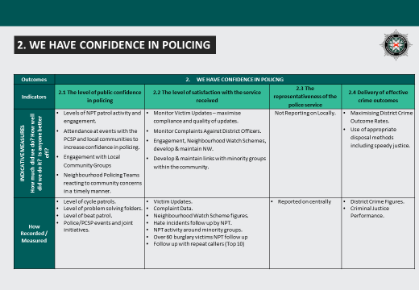

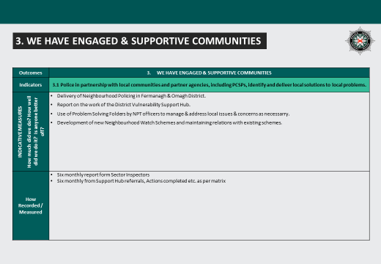

Appendix C: Policing Committee Report for the period 1 April 2022– 31 March 2023

