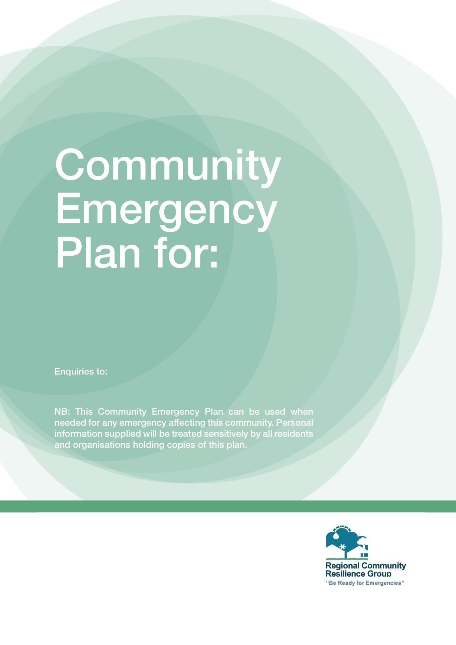
LEAD RESIDENTS CONTACT DETAILS
XXXXXXXXX Town/Village

Risk assessment:

Flooding from xxxxx, impacts on the following streets;

- xxxxx
- xxxxx
- xxxxx
- xxxxx etc.

See attached plan outlining areas at risk of flooding or may have flooded before.

Further details may be found at:
https://www.nidirect.gov.uk/information-and-services/your-neighbourhood-roads-and-streets/flooding-your-area

Local skills and resource assessment:

- Sandbags available in storage containers at:
  - xxxxx
  - xxxxx

See attached details on locations for containers and who to contact.

Emergency Support Centre locations (Place(s) of safety):

- xxxxx e.g. Community Centre, Church Hall

Community / Voluntary organisations that may help (especially vulnerable residents):

- e.g. Red Cross (TBC)
- xxxxx
- xxxxx

Activation triggers:

- Met Office warnings click on ‘e-mail alerts’ at:
- https://www.metoffice.gov.uk/public/weather
- https://www.metoffice.gov.uk/guide/weather/severe-weather-advice
- https://www.metoffice.gov.uk/services/mobile-digital-services/weather-app

(Residents to take responsibility and register for Met Office warnings)

  - Yellow – Severe weather is possible either today or in the coming days that may disrupt your plans. The impact of the weather may be worse in some areas than others.
  - Amber – There is an increased likelihood of severe weather affecting you, resulting in travel delays, power-cuts, interruptions to utility services or even a danger to life. You should think about changing your plans.
  - Red – There is high confidence of dangerous weather occurring. Ensure you take action to protect yourself, others and your property. Power cuts, prolonged travel disruption and a danger to life are all possible.

- Residents to be aware of severe weather warnings on news media or Internet
- Residents can set up Met Office App on their Smart Phone or Tablet device (Android / iPhone versions available)

First steps in the lead up to an emergency

- Check access to sandbags and agree deployment needed
- Report to Flooding Incident Line (FIL)
- Contact local Elected Members/community leaders
- Seek assistance to lift furniture etc.
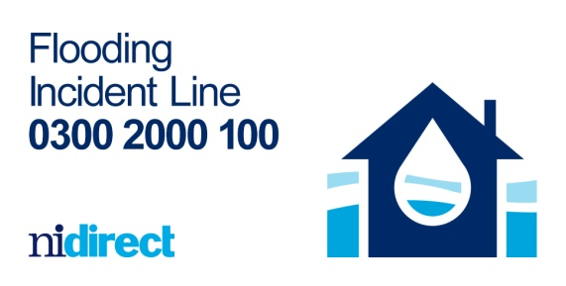
- Move vehicles to higher ground
- Contact xxxxx if emergency shelter is required

First steps in an emergency

- If life is at risk contact 999
- Remember that you should never put yourself in danger
- Report any flooding to Flooding Incident Line (FIL) 0300 2000 100

Community Emergency Group First Agenda

- What is the current situation?
- Are there any vulnerable people involved?
- What resources do we need?

How can we support the emergency responders?

What actions can safely be taken?

Who is going to take the lead for the agreed actions?
- Any other issues?
- Actions agreed with emergency responders in the event of an evacuation:
  - Help Police/Fire & Rescue Service with door knocking
  - Tell emergency services who might need extra help to leave their home
  - Contact NIE to have electricity supply switched off in homes which are flooded

Emergency Contact List:

- Emergency Services: 999
- Flooding Incident Line (FIL): 0300 2000 100
- NIE Customer Helpline: 03457 643 643
- NI Gas Emergency Line: 0800 002 001
- NI Housing Executive Emergency Repairs: 03448 920 901
- NI Water: 03457 440088 (use FIL to report flooding)
- DFI Rivers: xxxxx (use FIL to report flooding)
- DfI Roads: xxxxx (use FIL to report flooding)
- Local Council Environmental Health Service:
  - xxxxx (office hours) (use FIL to report flooding)
- Local Council Emergency Helpline: xxxxx (for recovery assistance)
- xxxxx Hall
- Resident 1: 07xxx xxxxxx
- Resident 2: 07xxx xxxxxx
- Resident 3: 07xxx xxxxxx
- Resident 4: 07xxx xxxxxx etc

Telephone Communication Tree (to be agreed):

