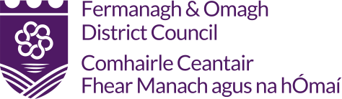

Lateral Flow Device (LFD) Collect Form for Small Businesses
By completing this form, you are giving your consent to participating in the home testing programme.

Data Protection: Under the Data Protection Act 2018, Fermanagh and Omagh District Council has a legal duty to protect any information we collect about you. The associated NHS Privacy Notice sets out how your personal information will be processed in support of the NHS Test and Trace Programme.

Name:

Name of Business:

Contact Tel No:

I would like to participate in Lateral Flow (LFD) testing and wish to collect LFD Test Kits from the following location
(Please select one location):
The Connect Centre, Enniskillen

The Connect Centre, Omagh

Quantity of test packs required:

Please note a maximum of 20 packs per business can be collected at any one time.
Signed:

Date:

Connect Centre (Enniskillen)
County Buildings, 15 East Bridge Street, Enniskillen, BT74 7BW

Connect Centre (Omagh)
Strule House, 16 High Street, Omagh, BT78 1BQ

Please note: Once we have received your form, we will be in touch to make arrangements for collection of the test packs.

