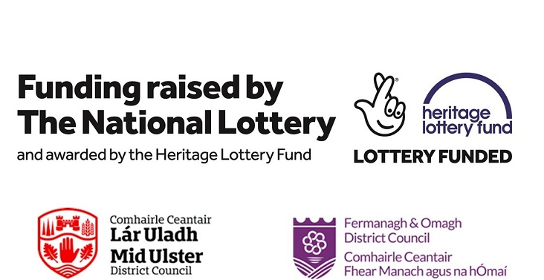

HERITAGE INTEREST SURVEY
The Heart of Ancient Ulster LPS

Please return completed forms by Friday 23rd March 2018 to:
Moira O’Rourke
Development Officer
The Heart of Ancient Ulster LPS
Cookstown Leisure Centre
Fountain Road
Cookstown
BT80 8QF
T: 028 867 63853
E: moira.orourke@midulstercouncil.org

Office Use:
Date Received:
Signed:

COMPLETING THE HERITAGE INTEREST SURVEY

- Please complete the form clearly in typescript or black ink if handwritten.

- Please contact Moira O’Rourke, Development Officer if you require an electronic version or help completing the form.

- Please return the completed Heritage Interest Form along with the Expression of Interest Form no later than 4.00pm Friday 23rd March 2018.

Please indicate which of the following your organisation are interested in:-

Traditional Crafts
Dry Stone Walling
Patchwork
Stonemasonry
Sewing/Tapestry/
Knitting/Crochet
Hedge lying
Pottery Making
Carpentry
Basket Making
Tree Planting
Blacksmithing
Traditional home baking/cooking
Archaeology
Conservation
Young People & Volunteering
Tour Guides
Skills Training
First Aid Training
Disability Access
Bog Restoration

Industrial Heritage
Health & Safety
Bird watching
Grow your own
Geology
Old Farm Practices
Songs & Music
Festivals
Food Markets
Local History
Oral History
Folklore
World War I & II
Drama
Poetry & Prose
Astronomy
Hill Walking
Angling
Outdoor sports
Research
Biodiversity
Walk & Talks

Other

On a scale of 1 – 5 how important is the following to your organisation;-
 | 1  Not Important | 2  Less Important | 3  Important | 4  Fairly Important | 5  Very Important
Archaeology

Conservation

Oral History Projects

Tourism e.g. Tour guides / providing B&Bs / attracting visitors to the area

Economic Development e.g. creating employment / supporting local businesses

Entrepreneurship e.g. creating new businesses

Infrastructure e.g. roads / paths

Signage / Interpretative Panels

Incentives for farmers continuing to work the land for future generations

Health & Well Being

Outdoor Activities

 | 1  Not Important | 2  Less Important | 3  Important | 4  Fairly Important | 5  Very Important
Maintaining an area of natural beauty

Volunteering

Working in partnership with other local communities for the good of the area & Landscape

Other (please detail)

What do you see as the greatest heritage need in The Heart of Ancient Ulster Landscape Partnership.

What heritage projects have your group completed in the past.

Contact Name: ______________________________________________
Name of Organisation: ______________________________________________
Date: ______________________________________________
Signed: ______________________________________________

