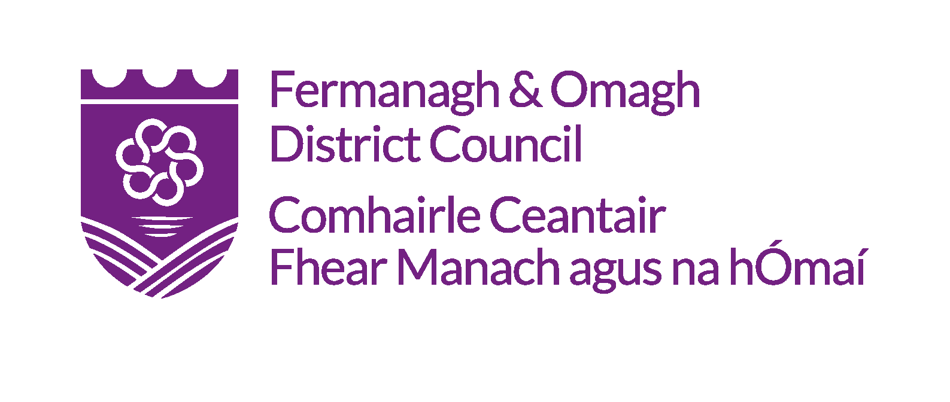
Enniskillen Castle Christmas Craft Fair 2018
Guidelines for Applicants
Extended deadline: Monday 26 November 2018 at 4pm.
Introduction

Enniskillen Castle’s Christmas Craft Fair is a new annual event which showcases a wide range of bespoke craft items created by local craft designer-makers and artists from the Fermanagh & Omagh District. This year’s event will take place on Saturday 15th December 2018. The fair takes place in the historical Enniskillen Castle visitors centre the event aims at attracting a large number of visitors looking for that special gift or purchase.

The Fermanagh & Omagh District Council Christmas Craft Fair aims to become established throughout the craft industry and will become a calendar event within the sector due to the high standard of goods for sale resulting from its strict selection process. We hope It is the event of choice for many local makers and artists as no imported or bought in work is allowed at the event, with all of the goods on display being handmade in the Fermanagh and Omagh District.

Event Structure
This year’s event will run over one day on Saturday 15th December 2018 from 11am – 5pm and will be located at Enniskillen Castle as follows;
Craft Stands
Level One
All stalls upstairs in the Visitors Centre in front of big glass window

Selection Criteria

Arts & Craft Applications

Applications are invited from craft designer-makers and artists working in
- Ceramics –functional and sculptural
- Jewellery - non-precious and precious
- Interior textiles
- Fashion textiles and accessories
- Knitwear and woven textiles
- Leather
- Print-making
- Wood
- Lighting
- Furniture and product design
- Glass
- Metal
- Basket-making
- Miscellaneous
All of the products for sale at the fair must be;

- Hand-made in the Fermanagh & Omagh District
- Exhibitors own design
- Reflect a high level of skill in manufacture
- Finished to a high standard
- Durable and fulfil their expected function
- Aesthetically pleasing

It is imperative that exhibitors comply with the above criteria regarding all of the products they bring to sell at the craft fair, failure to do so may result in exhibitors being asked to remove items from their trade stand at the event.

Please note that products should not carry political messages

Requirements for Submission of Craft Applications

All applicants must submit a completed application form which can be downloaded from Fermanagh & Omagh District Council website and submitted electronically by email or by post. The deadline for applications to be submitted is Monday 26 November 2018 at 4pm.

Exhibitors for the Fermanagh & Omagh District Council Christmas Craft Fair MUST include 3-6 images of the crafts they wish to sell. Images should be no more than 3 years old.

Assessment of All Applications
A panel will assess each of the applications received for the fair, taking the following elements into account;

- Quality and standard of work
- Skill Involved
- Originality

Please note that products that are handmade WILL have preference over products that contain core elements that are produced in batches, as the fair is a platform first and foremost for local handmade crafts which are individual and bespoke.
Due to the growing demand for space it is imperative that previous exhibitors display consistent development both of their product range and also of their stand and product presentations. We are interested in promoting both established and emerging makers at the craft fair.

Applicants should note that the Council does not guarantee exclusivity to any specific craft therefore a particular craft may be represented on a number of stands.

Stand Allocation

Due to the high demand for space, the stands are allocated by the Council’s Arts Service and cannot be pre-booked. Where possible we will try to provide each exhibitor with the size of trade stand they have requested. Taking this into consideration traders are duly asked to note that the Arts Service layout for the event is final.
Successful Applicants
By accepting your application to exhibit, it is assumed that you have read and accepted the following terms and conditions:
All of the items exhibited by a trader must be the hand work of that exhibitor. No resale items are allowed.
There can be no sub-letting of space however applications are welcome from exhibitors who wish to share a trade stand. If applying to share a stand please highlight this in the ‘Additional Information’ section of your application form and note that each trader must submit an application form due to limited trade stands.
Please note that we require you to have public liability insurance. If successful you will be asked to provide us with a copy of your insurance in advance of the event. No payment can be taken in advance of insurance being verified. Please note that affordable insurance for visual artists can be purchased in association with membership of the Artists Information Company https://www.a-n.co.uk/register-artist/
Any electrical equipment must comply with current legislation and have a valid Portable Appliance Test (PAT) certificate.
All sales, orders, etc. are to be handled by the exhibitor. (Please bring adequate change for your use).
Council does not accept responsibility for any loss of or damage to the exhibitor’s items during the event unless the loss or damage is caused directly through Council’s negligence.
You are expected to ensure that your trading area is clean and tidy at all times. No goods must encroach into the public walkways, onto or block another stand. Traders must display their company name and additional information such as your returns policy and all goods must be clearly labelled and priced.
In the event of cancellation by the organiser no liability is applicable.
In the event of cancellation by the stall holder (30 days prior to the event max.) space cannot be re-let to another exhibitor without the approval of the event organiser.

