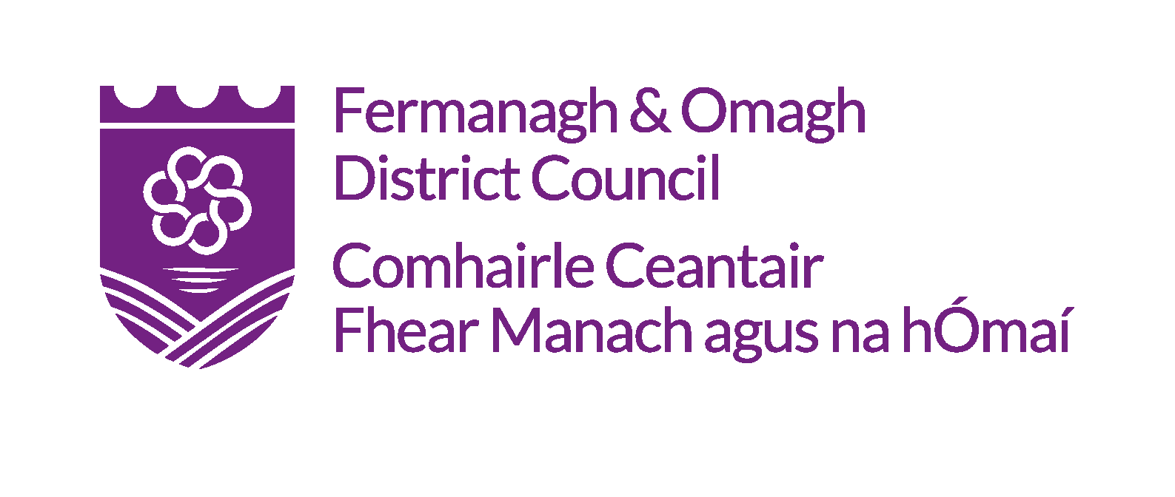

APPLICATION FORM FOR

THE ENNISKILLEN CASTLE CHRISTMAS CRAFT FAIR 2018

Please read our ‘Guideline for Applicants’ before completing this application form.

All applicants must submit a completed application form which can be downloaded from Fermanagh & Omagh District Council website and submitted electronically by email or by post. The extended deadline for applications to be submitted is Monday 26 November 2018 at 4pm.

BACKGOUND INFORMATION
Company Name

Address

Email Address |  | Post Code
Tel. No |  | Fax No
Web Address
(and/or Social Media)

Contact Name

Business Start Date |  |  | Business Status  Full Time /  Part-Time
Artistic Genre

* E.g. Ceramics, Jewellery Non-Precious and Precious, Interior Textiles, Fashion Textiles and Accessories, Knitwear and Woven Textiles, Leather, Print-Making, Wood, Lighting, Furniture and Product Design, Glass, Metal, Basket-Making and Miscellaneous. Please note only applications will be considered by Artists / Craft workers from the Fermanagh & Omagh District who make bespoke Fine and applied art and craft work.

ALL APPLICANTS
Product Range Description

Are you responsible for the design and entire production of the product from start to finish? (please provide details of both design and manufacturing/
production)

All applicants MUST enclose a recent image of their art / craft work. Failure to do this may result in application being disqualified | Please describe your exhibition stand and presentation including details of any electrical and freestanding equipment that will form part of your trade stand. A Health and Safety Officer may be required to assess the suitability of layout/materials used if deemed necessary.
Please list the details  submitted with this application | Please detail and attach with your application / Biography OR Artistic CV / Image of your work in Jpeg format (300dpi) / short blurb for marketing and promotional purposes / Logo
Additional Information | Please include any additional information that you feel is relevant

Please indicate the price range of your products? (tick all that apply)

£1-£5 £5-£10 £10-£20 £20-£50

£50-£100 £100-£200 £200+

EXHIBITORS (Please include sample/photographs of your current work / product range,
NB: images should be no more than 3 years old)

Please detail what you intend to exhibit

STAND SIZE

Please indicate which size you may require by ticking one of the following, noting that there is no guarantee that the size you select may be available.

Small Table Approx. 152cms x 68cms

Large Table Approx. 160cms x 80cms

STAND REQUIREMENTS

Please indicate if you require a table to be provided for your stand

I need a table I do not need a table

Please indicate if you require electrical sockets to be provided

I do need access to electricity I don’t need access to electricity

For any queries in relation to this application please contact the Arts Service for Fermanagh & Omagh District Council at: 0300 303 1777 or email diane.henshaw@fermanaghomagh.com

Deadline extension: Monday 26 November 2018 at 4pm.

