Would you like to get involved in a
Recreational Rowing Project?
Fermanagh and Omagh District Council invites Expressions of Interest from community, voluntary and sporting organisations who would be interested in developing and delivering a community recreational rowing project. Please note Schools or Education Authority facilities cannot be considered.
The provision of this proposed project will be subject to the Council securing external funding. The aim of the project is to support groups to help them deliver recreational rowing opportunities in their own communities.
What is being proposed?
The Council is seeking external funding to deliver this project. The Council is now seeking community groups / clubs who would be interested in providing recreational rowing opportunities in their community, helping people to get outdoors for all the health and wellbeing benefits that comes with this type of activity.
To achieve / deliver this project it is proposed that the Council will provide groups with a boat making kit and materials, equipment (life jackets etc), basic tools and a trailer.
Groups will be required to build their own boat. The Council will help support groups in the boat building process (we believe we have experienced individuals and groups who have been involved in boat building in the community that will be happy to help and support group), however it would be advisable that any group thinking of taking this project forward should have people in the their community who have some basic skills and tools and are skilled enough to help with this build. In other areas where the skiff project has been delivered, Men’s Sheds have been involved in these boat builds and have assisted in ongoing maintenance.
The type of boat the Council is looking at is called a “St Ayles Skiff” (please see photos below of these type of boats) and also links to information about “Skiff Boats”. These boats are being provided primarily to assist people to get out onto the water and enjoy nature in a low impact and sustainable way. However if through time, any groups or individuals wish to go further and compete in races or larger events then there are “Skiff” races organised throughout the home nations.
Strangford Coastal Rowing Club – St. Ayles skiff rowing in Strangford village (wordpress.com)
Blog – Strangford Coastal Rowing Club (wordpress.com)
Strangford Coastal Rowing Club - Irish Coastal Rowing Federation
Skiffie Worlds - Strangford & Lecale (strangfordlough.org)
St. Ayles Skiff (staylesskiff.org.uk)

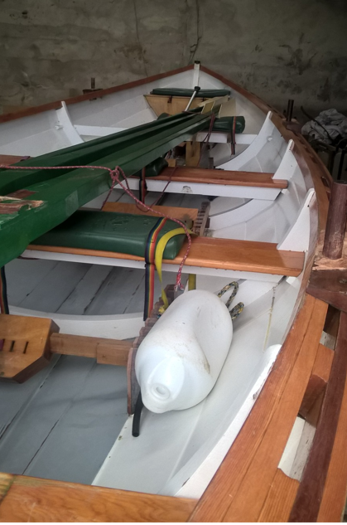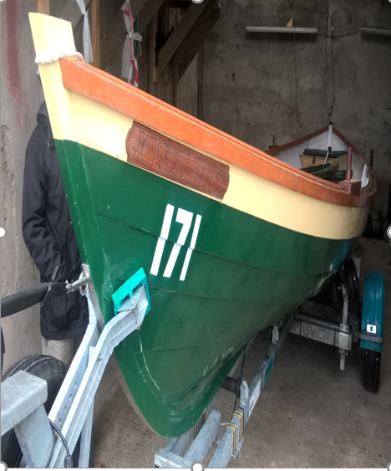
Where we are with this project and what will happen next?
Through this expression of interest (EOI) the Council is seeking to assess is there a need in the community or desire to deliver this project? If there is an identified need the Council will use these EOIs to support an external funding application. If the Council is over - subscribed with EOI requests it may be necessary to follow up with a scored application process to help identify groups that we will take forward.
If all goes according to plan, we would hope by September 2022 to provide the boat building kits to the successful groups with a view to these groups building their boats and availing of training over 6 months Sept 2022 – Feb 2023.
It is planned that the boats will be built and on the water in March 2023 and be involved in a local recreational rowing event in the FODC district April 2023.
Please note as these boats will come with a trailer they can be transported and easily launched on the water, therefore this project is a possibly for any group either in urban or rural areas.
Groups that are successful will receive the following:
- Boat building kit, equipment and a trailer.
- Support to assist with boat building.
- Support to attain various courses, first aid, safeguarding etc
- Training to launch a boat and use a boat on the water.
- Support to help with Risk Assessments and use of the boat, links to NGBs
Groups that are successful will need to:
- Be a constituted community/ voluntary / club or group.
- Have the necessary garage, shed or out building to build and then store the boat. The Skiff is 22 feet (6.7m) in length and approx. 6 feet (2m) wide therefore you will need a building to accommodate the boat on the trailer so it will need to be approx. 27 feet (8.5m) length and 10 feet (3m) wide.
- Provide the necessary insurances for the boat, whilst in use, in storage, as well as being transported on the trailer.
- Be responsible for the boat build as well as ongoing maintenance and upkeep of the boat. The boat build is to be completed before 28 Feb 2023.
- Undertake the necessary training that the group will need to complete before going out on the water, this training is to be completed between Sept 2022 – Feb 2023.
- Provide monitoring information and reports to the Council as and when required.
- Agree and sign up to a Service Level Agreement with the Council to protect the Councils and potential funder’s investment in this project.
- Ensure that within the group there will be people who can tow the boat via the trailer (ie licence to permit them to tow a trailer).
- Some group representatives to attend an away fact finding day (possibly Strangford Lough).
How to complete an Expression of Interest for your group:
In order to express an interest to get involved in this recreational rowing project, simply complete the application form below.

Assessing submissions:
When assessing submissions, the Council may need to take into consideration geographic spread across the Council district.

Closing date for submissions:
Wednesday 16 March 2022 at 12.00 noon.

For further information:
Please contact;
keith.collen@fermanaghomagh.com Tel: 07979 530765 or
ryan.hanna@fermanaghomagh.com Tel: 07702919798

Expression of Interest Application
for the delivery of the Recreational Rowing Project.

Organisation Name

What area of the district is your group based in what is your groups address?.

Name of contact person dealing with this application and contact details. | Name  Telephone number  Email address

Where are you proposing to build and store the boat? – please provide details include an address and confirm the size of your building. | Where are you proposing to keep, build and store your Skiff?  What size is your storage building? – the Skiff will need approx. 8.5m x 3m to be stored.

Where are you proposing to use the Skiff if you had it where is your proposed location for everyday use?.

Are you happy that within your wider community or group that you have the enough experience to support a boat build? – please provide some detail.

In relation to proposed use please can you give some initial indication of how you would use a Skiff if you had one within your group?

Please can you confirm if you had a Skiff that you have the necessary means to be able to tow it ie. group members have vehicles and licences to tow the trailer.

Returning submissions:
Completed application forms can be returned by email to:
keith.collen@fermanaghomagh.com also please can you CC Ryan Hanna into this email ryan.hanna@fermanaghomagh.com

Alternatively, you can print out a hard copy and post it to:
Recreational Rowing Project Expression of Interest
Fermanagh & Omagh District Council
County Buildings
15 East Bridge Street
Enniskillen
BT74 7BW

Closing date for submissions:
Wednesday 16 March 2022 at 12.00 noon.
.
For further information:
Please contact keith.collen@fermanaghomagh.com Tel: 07979 530765 or
ryan.hanna@fermanaghomagh.com Tel: 07702919798

