Michele Matthews 25th May 2017
Sport NI
Clubmark NI Accreditation
User Guide for Clubs

Table of Contents

Table of Contents 2
1 URL’s & Bookmarking 3
1.1 URL’s 3
1.1.1 Pre-Production 3
1.1.2 Production 3
2 Club User Information 3
2.1 Registering for Clubmark NI 3
2.1.1 Basic Information 5
2.1.2 Club Addresses 6
2.1.3 Contact Details 7
2.1.4 Club Member Numbers 9
2.1.5 Club Summary 11
2.1.6 Registration Interrupted 14
2.2 Application for Accreditation 15
2.2.1 Online Club Account - Login 15
2.2.2 Online Club Account – Contents 17
2.2.3 Online Club Account – Workflow 18
2.2.4 Online Club Account – Club Support Folder 19
2.3 Maintaining your Accreditation 24
2.3.1 Health Check 24
2.3.2 Renewal 28
2.4 Automated Email Notifications 30

SPORTS NI Citizen - Clubs

URL’s & Bookmarking

URL’s
Navigate to the ‘Clubmark NI Online Portal’:

Pre_Production
https://mtpadminpreprod.intranet.nigov.net/Accredit/TenantList

Production
https://mtpadmin.intranet.nigov.net/Accredit/TenantList

Club User Information
The ‘Clubmark NI Administration Portal’ will be your access point for all Clubmark NI Accreditation activities. Firstly, you will need to register your club with Clubmark NI, which in doing so creates an online club account. This online club account allows you to log in and monitor your club’s progress through the accreditation process and will be used to upload any documentation required.

Registering for Clubmark NI
To register your club for Clubmark Accreditation, you will be asked to provide Information about your club under the following headings: Basic Information, Club Addresses, Contact Details and Club Member Numbers. A progress bar will track your movement through the registration. To begin the process, click on the green ‘Register for Clubmark NI’ button.
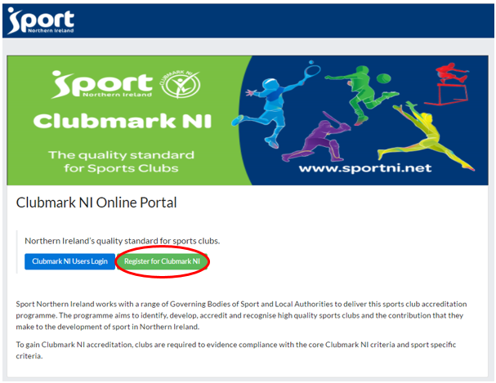
NOTE: Please take a note of the email and password entered at this stage as it will be used as your club’s login credentials for the ‘Clubmark NI Administration Portal’ covered in section 2.2 of this document
Enter an email address [This should be an email address of the club official who will use it to login into the system.]
Then enter a password [Password should be at least 8 characters in length and contain at least one number, one uppercase character, one lowercase character and no special characters.]
Confirm the password by retyping and click the ‘Register’ button.
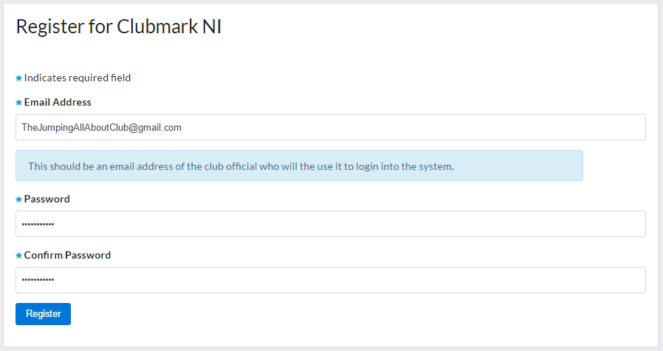

Basic Information
Enter the details requested
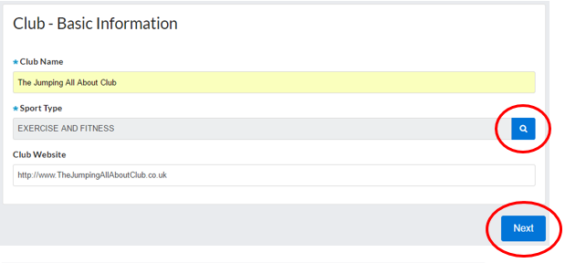
b
a
- Sport Type: Clicking on the ‘Search’ button will display a Choose dialog box – type in the name of your sporting discipline to filter the list. Selecting the option which best represents your club’s activities and clicking the ‘Close’ button will update the Sport Type.

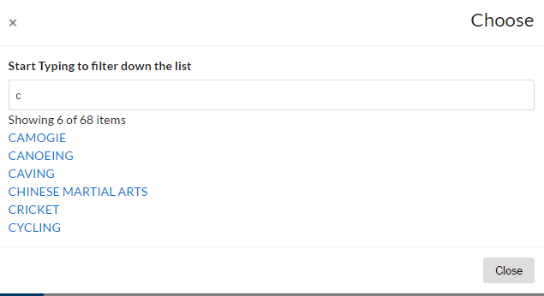
b. Next: Once you are happy that all the details have been correctly filled in, please click the ‘Next’ button to move to the next screen.

Club Addresses
Fill out all the fields requested.
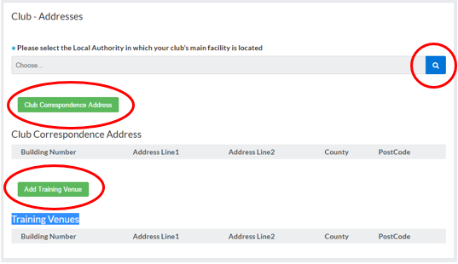
b
a

- Select the Local Authority: Clicking the ‘search icon’ button will invoke a popup list of NI Local Authorities. You can filter the list by entering the first letter(s) of the local authority you are searching for. Once found, click on your choice and hit the ‘Close’ button to update the field.
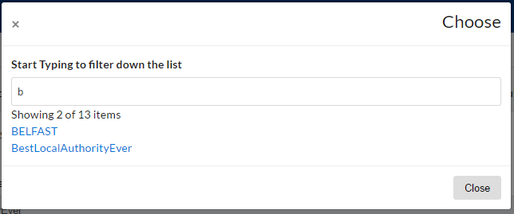

- Club Correspondence Address and Add Training Venue: Clicking either button will invoke a ‘Find Address’ dialog box where you can use the postcode lookup to find your address or type your address directly into to the fields provided. Clicking ‘Add’ will update the corresponding address table shown below. Clicking ‘Cancel’ will close the dialog box without updating.
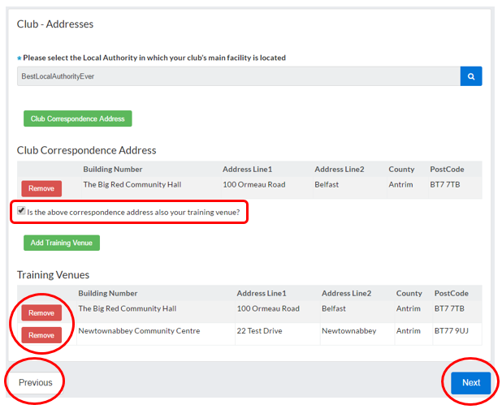
a
d
c
b
- Checkbox: Once you have added the Club’s address to the ‘Club Correspondence Address’ table, the checkbox will be displayed to allow you to copy this address into the ‘Training Venues’ table if applicable.
- Remove: Clicking the ‘remove’ button will delete the associated address from the table.
- Next: Once you are happy that all the details have been correctly filled in, clicking the ‘Next’ button will move the registration to the next screen.
- Previous: Clicking this button will return you to the ‘Basic Information’ screen.

Contact Details
Fill out all the fields requested.
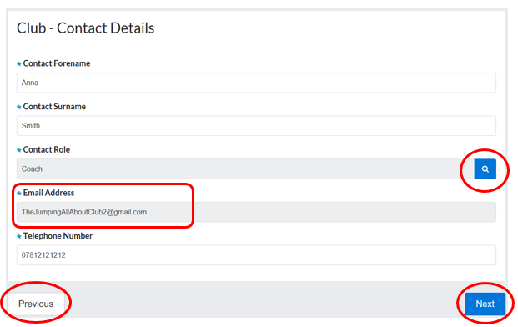
c
b
d
a
- Email Address: This field is automatically updated with the email address entered on the first screen ‘Register for Clubmark NI’
- Contact Role: Clicking on the ‘Search’ button will display a Choose dialog box – selecting the option which best represents your contacts role and clicking the ‘Close’ button will update the ‘Contact Role’ field.

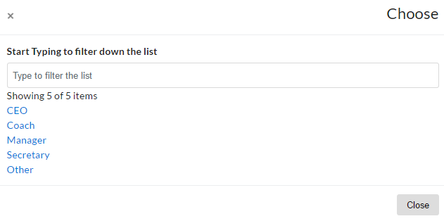
If none of the options match your role, selecting the ‘Other’ from the list and clicking ‘Close’ will create a new field called ‘Other Role’ which will allow you to type in your role.

- Next: Once you are happy that all the details have been correctly filled in, clicking the ‘Next’ button will move the registration to the next screen.
- Previous: Clicking this button will return you to the ‘Club Addresses’ screen.

Club Member Numbers
Accreditation Type Information: Clicking on this will expand the information panel to help you make your choice

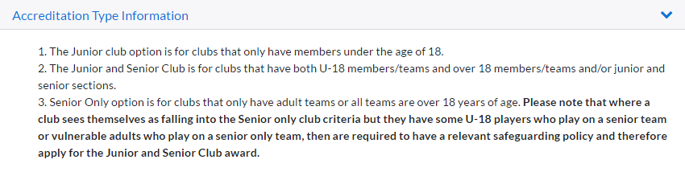
Accreditation Type - Choose: Clicking this will produce a dropdown list with the following options:
- Senior Club Only
- Junior Club Only
- Senior & Junior Club

Depending on the choice above, different fields will be displayed:

Senior Club Only:

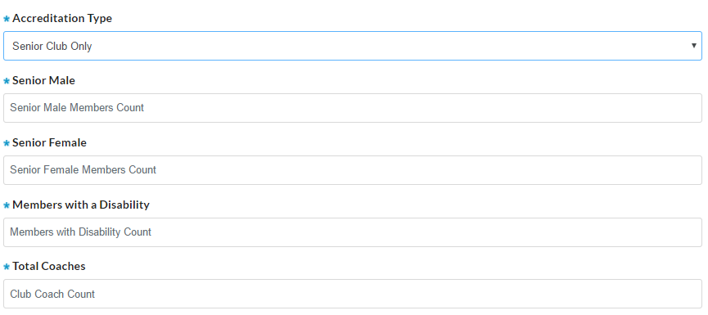
Junior Club Only:

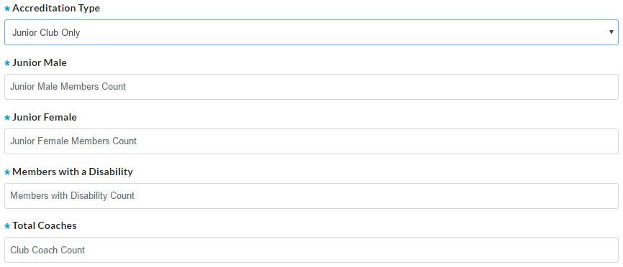

Senior & Junior Club:

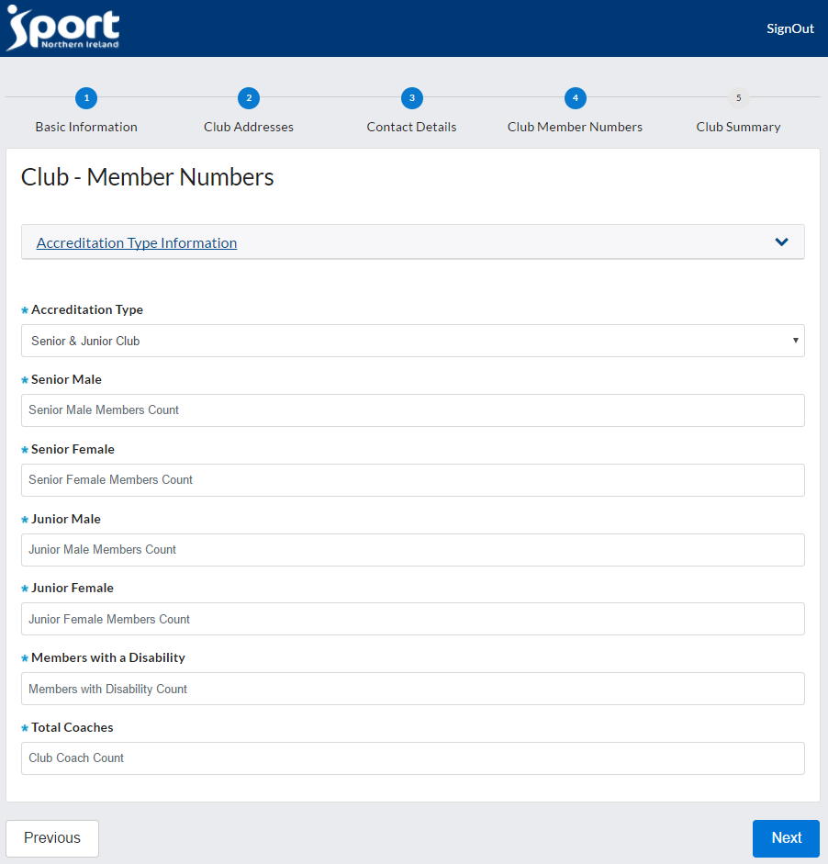

Next: Once you are happy that all the details have been correctly filled in, clicking the ‘Next’ button will move the registration to the next screen.
Previous: Clicking this button will return you to the ‘Contact Details’ screen.

Club Summary
This screen will summarise all the information that you have entered for your club registration and will allow you to go through and verify that each section is correct before submitting your application.
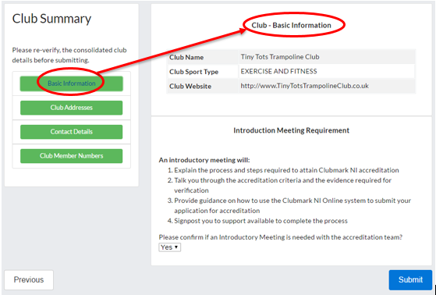

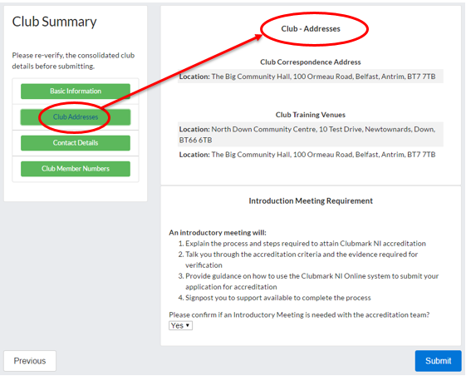

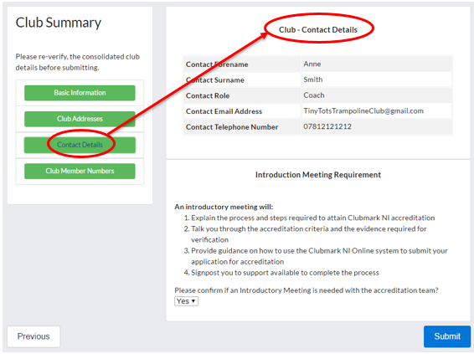
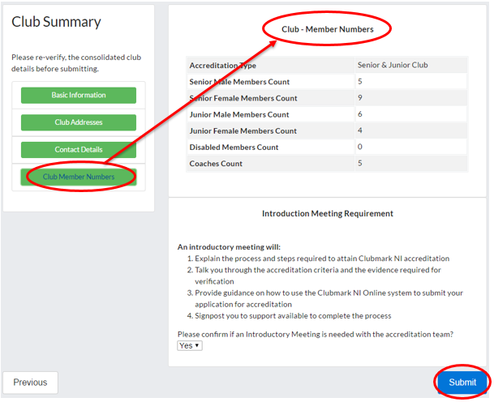

Pressing any of the four green buttons on the left-hand side of the screen will update the upper right-hand part of the screen with the corresponding information you entered for that section as the screenshots above illustrate.
If you do need to make any changes to any of the details you have entered, you can do so by using the ‘Previous’ button to go back through your registration until you reach the correct screen. Once you have made your update, pressing the ‘Next’ button will update the changes. When you reach the ‘Club Summary’ page again, you will be able to verify the updated information.
Introductory Meeting Requirement: this section is always visible regardless of which section of the registration is currently being displayed. It explains exactly what an introductory meeting will involve and its benefits to you in embarking on this accreditation process. The query asking you to confirm if you require an introductory meeting with the accreditation team, will default to a ‘Yes’ value. If you DO NOT require a meeting then change this using the dropdown list to ‘No’.
Submit: Clicking this button will submit your registration to Clubmark NI for review and the following screen will be displayed
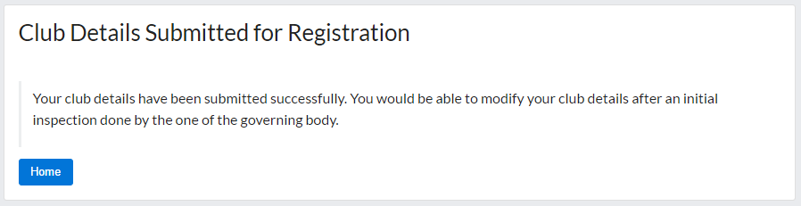

On successful completion of the online club registration, you will receive two automated email notifications confirming your Club Account creation and successful club registration. All automated email notifications are detailed at the end of this document (please refer to section 2.4 – Automated Email Notifications in this document for more information)

Registration Interrupted
If for any reason you did not complete your registration, either due to a time-out or loss of connection then do not worry. Navigate to ‘Clubmark NI Administration Portal’ as you did previously but this time use the blue ‘Clubmark NI Users Login’ button to bring you to the ‘Clubmark User Login’ screen. Enter the email and password you used at the beginning of the registration process and when you click on ‘Log in’ button, it will bring you back into the ‘Basic Information’ section of the registration and allow you to continue. It will remember all the information you previously entered up to the last completed section where you had clicked the ‘next’ button.

Application for Accreditation
All the club’s details entered during the registration process have been stored in an accessible ‘online club account’ and the ‘state’ will reflect its progress through the accreditation process. Sports NI will assign your club’s application to either a Local Authority or Governing Body, who will then work with you throughout. They will contact you via email to schedule any meetings, inspections or to request the relevant documentation.
You will be asked to log into the ‘Clubmark NI Administration Portal’ using the credentials you created during the ‘Register for Clubmark NI’ online process to action any of these requests.

Online Club Account - Login
Navigate to ‘Clubmark NI Administration Portal’ as you did previously.
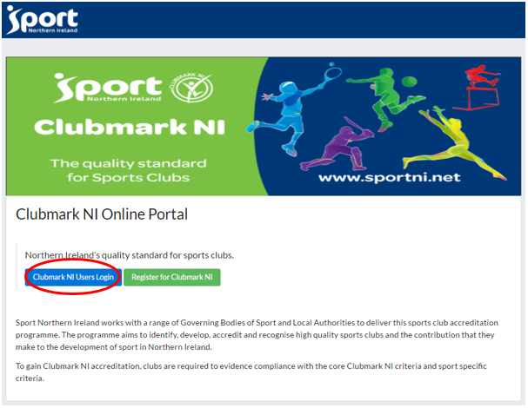
This time you will use the blue ‘Clubmark NI Users Login’ button to bring you to the ‘Clubmark User Login’ screen.

Enter your club’s email and password (created during the ‘Register for Clubmark NI’ online process - please refer to section 2.1 – Registering for Clubmark NI in this document for more information)
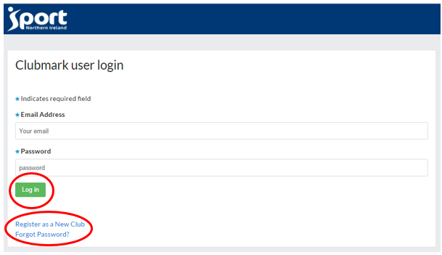
Login: Clicking the login button will validate your email and password. If correct, it will log you into your club’s ‘online club account’.
Register as a New Club: Clicking this link will bring you to the ‘Register for Clubmark NI’ screen (please refer to section 2.1 – Registering for Clubmark NI in this document for more information)
Forgot Password?: Clicking this will invoke a screen which will help you reset your password (see section 2.2.2.1 - Re-setting Account Password of this document for more details)

Issues with Account Login
If you have any issues logging into your club’s account or wish to update the associated email address used for logging in, please contact Sport NI.
Note: if you try to log into the portal using your club credentials and you receive the following information page, this will be because Sports NI has not yet assigned your club’s application to a Local Authority or Governing Body.
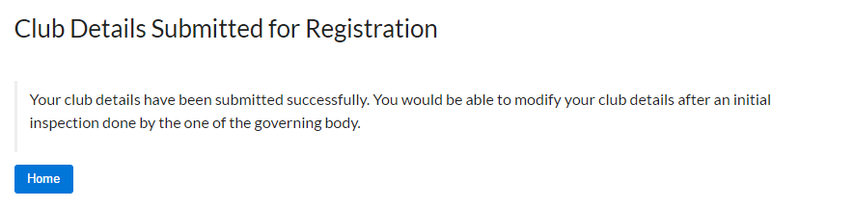

Re-setting Account Password
If you have forgotten your password, please click the ‘Forgot Password’ link at the bottom of the login screen.
When the ‘Forgot your Clubmark NI password’ screen is displayed, enter your email address and click on the ‘Reset password’ button.
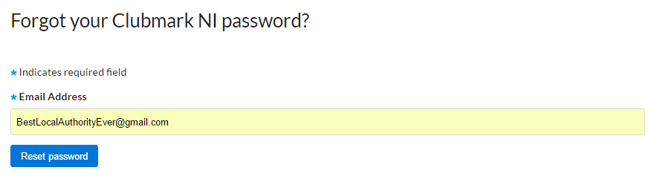
You will then receive a message that you will be contacted via your email account for more instructions.
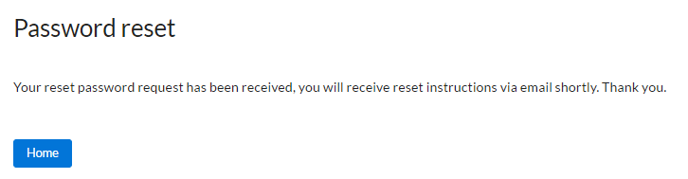

Online Club Account – Contents
Once you’ve logged into the account, you will see the progress bar at the top of the screen which reflects the current state of the club’s application for accreditation (please refer to section 2.2.3 – Online Club Account Workflow in this document for more information)
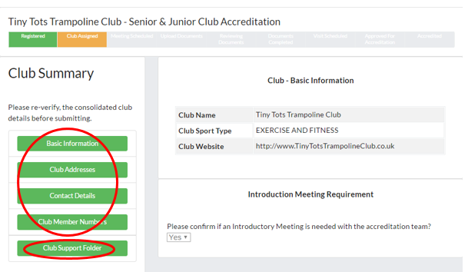
b
a(please refer to section 3.3 – Manage Targets in this document for more information)
- Clicking any of the first four green buttons on the left-hand side of the screen will update the upper right-hand side of the screen with read-only information supplied during the registration process.
- Club Support Folder: clicking this button will bring you to a separate section covering all the mandatory documentation that will be required for accreditation (please refer to section 2.2.4 – Online Club Account – Club Support Folder in this document for more information)

Online Club Account – Workflow
Once Sport NI have assigned the club’s application to a Local Authority or Governing Body, it’s state is set to ‘Club Assigned’ and all the current details are viewable. As your application makes its way through the process, the progress bar at the top of the screen will change.
Green = Complete Orange = Current/In progress Grey = Not Started
Club Assigned: application changes to this state when it has been assigned to a Local Authority or Governing Body
Meeting Scheduled: application changes to this state when the Local Authority or Governing Body has scheduled an ‘introductory meeting’ with the club (this meeting was requested by the by the club during registration – if none was requested, then this state is bypassed)
Upload Documents: after the ‘introductory meeting’ has taken place, the application changes to this state when the Local Authority or Governing Body requests that the club now sends all the necessary documentation required for accreditation.
Documents Completed: the application changes to this state after the club has uploaded and submitted all the requested documents (Reviewing Documents state is bypassed)
Reviewing Documents: the application changes to this state if the Local Authority or Governing Body request any missing or further documentation from the club (This state is not always used)
Visit Scheduled: if all the documentation is in order then the Local Authority or Governing Body will then schedule an ‘inspection visit’ which will change the state of the application.
Approved for Accreditation: if the ‘inspection visit’ has been successful and the Local Authority or Governing Body has approved the club for accreditation, the application will change to this state.
Accredited: Once Sport NI has issued the Accreditation Certificate to the club, its final state will be changed to this.

Online Club Account – Club Support Folder
This separate section covers all the documented criteria required to apply for Clubmark NI Accreditation. The documentation is broken down into 5 key areas, each with its own button on the left which when clicked will update the right-hand side of the screen with the list of documents that must be provided that section.
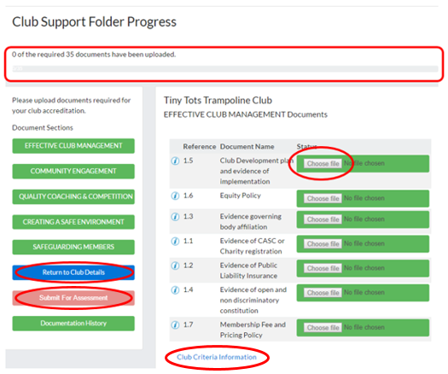
a
b
d
c
a

- Club Support Folder Progress: This will display how many of the documents have been provided from a total number. When you first log in, it will look like the above image.
- Choose File: this button is only displayed when the associated file has not yet been attached. It will remain ‘inactive’ until the application has been put into the ‘Upload Documents’ state.
- Return to Club Details: clicking this button will return you to the main ‘Club Details’ screen.
- Submit for Assessment: While there are no files attached, this button remains ‘pink’ and inactive. The button will turn ‘red’ when it becomes active.
- Club Criteria Information: Clicking this link will open the ‘Clubmark Eligibility Criteria’ page in a new browser tab. From here you can download a copy of the ‘Clubmark NI Brochure’.

Uploading Documentation
After the ‘introductory meeting’ has taken place, the application changes to the ‘Upload Documents’ state when the Local Authority or Governing Body requests that the club now sends all the necessary documentation for assessment.
Please ensure that all the requested documents have been completed and a digital copy saved in an accessible location before you begin. Then log into the ‘online club account’ (see section 2.2.1 – Online Club Account - Login of this document for more details) and open the ‘Club Support Folder’ to begin the upload process.
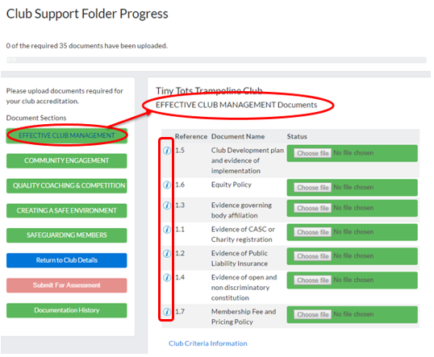
a
- Note that each file has a clickable ‘information’ icon to the left of the file name, which will give you important information about that file. Clicking on it will invoke a popup ‘document information’ panel.

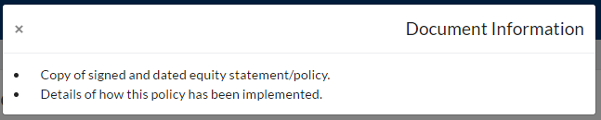

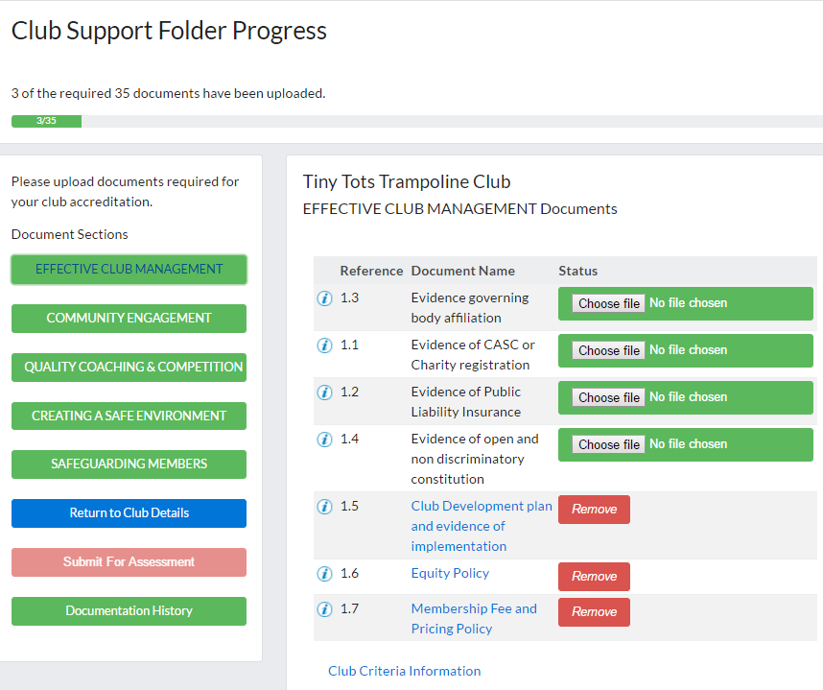
c
b
- Click on the ‘Choose file’ button which will invoke the standard windows ‘Open’ dialog box. This will allow you to navigate to the location of your file, highlight it and click the ‘open’ button in order to attach it to the application.
- Once attached the file will move to the bottom of the document list, the ‘Choose file’ button will be replaced by a ‘Remove’ button which will allow you to remove the file if required. The filename becomes a downloadable link allowing you to open and view the file after it has been attached.
As each file is attached, the ‘Club Support Folder Progress’ area is updated accordingly.
Note that the ‘Submit For Assessment’ button remains inactive until ALL documents in ALL 5 sections have been attached.

When you have finished attaching all of the requested documents, you can then submit your application for assessment.
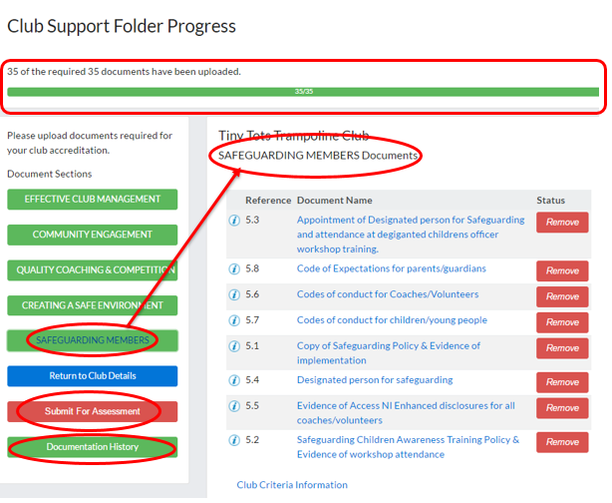
f
e
d

- Club Support Folder Progress: will reflect that ALL required files have been attached
- Submit for Assessment: this button has now turned ‘red’ and when clicked will move the application to the next screen to complete the process.
- Document History: Clicking on it will invoke a popup ‘document history’ panel which at this stage will be empty

Once the ‘Submit for Assessment’ button has been clicked, the application will be moved on to the next screen.
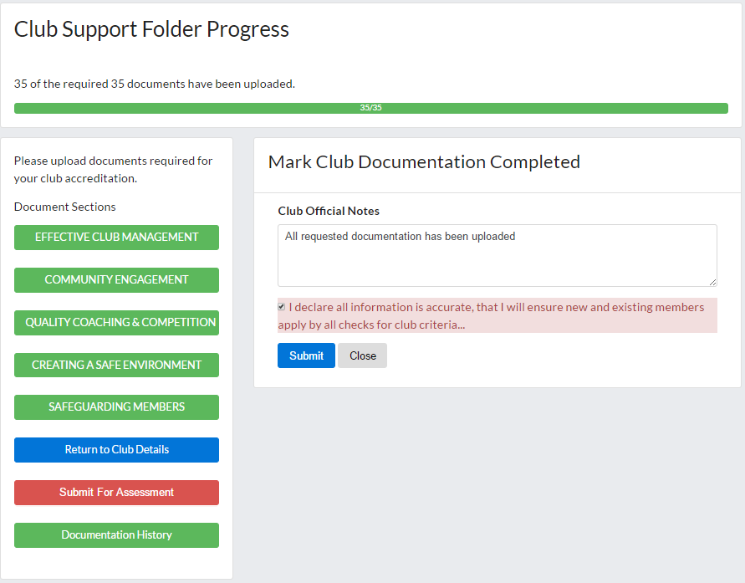
h
g
i

- ‘Club Official Notes’: you may add any text you wish in the section.
- Declaration: the system will not allow you to proceed until the declaration checkbox is checked.
- ‘Submit’: clicking this button will submit all the attached documentation for review by the Local Authority or Governing Body. ‘Close’ will abandon the submission and return you to the previous screen.
When completed, your application will be set to the ‘Documents Completed’ state and you will be returned to the ‘Club Details’ screen
You will receive an automated email notification confirming receipt and informing you of the next stage. All automated email notifications are detailed at the end of this document (please refer to section 2.4 – Automated Email Notifications in this document for more information)

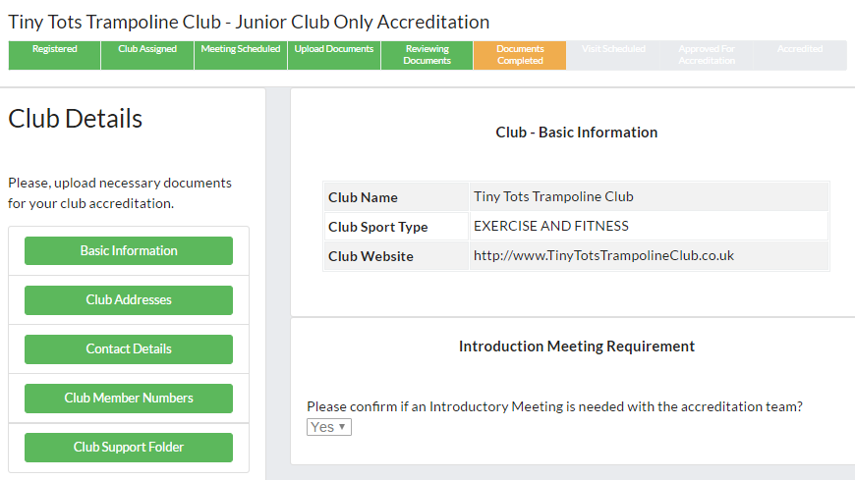

Maintaining your Accreditation
Each accredited club must perform an annual ‘Health Check’ and on each 3rd year this will be replaced by a ‘Renewal’. You will receive an automated email reminder when either becomes due.
First year [Health Check] -> 2nd year [Health Check] -> 3rd year [Renewal]
-> 4th year [Health Check] -> 5th year [Health Check] -> 6th year = [Renewal] ….
-> and so on and so forth.

Health Check
Log into your club’s ‘online club account’ (see section 2.2.1 – Online Club Account - Login of this document for more details)
When your yearly health check is due, the ‘Club Health Check’ button on your club’s details page will display in ‘red’ as illustrated below.
Clicking the red ‘Club Health Check’ button will update the right-hand side of the screen to display a series of declarations and text fields asking you to provide details where necessary. As the club official, please ensure that all fields on both screens have been updated fully before submitting the health check.
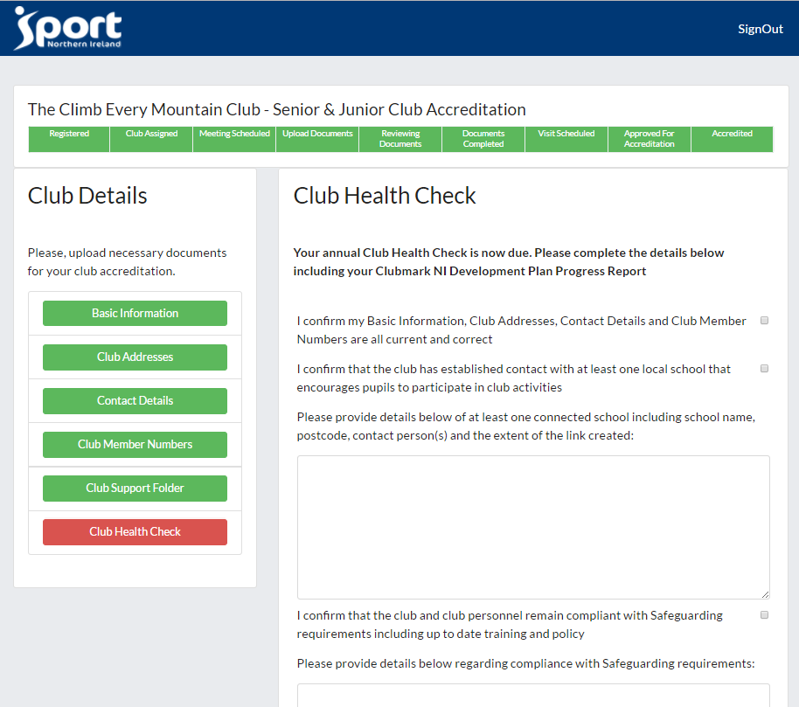
Once you have completed section ‘Club Health Check’ on the first screen, click the ‘Next’ button at the bottom to move to the ‘Clubmark NI Development Plan Progress Report’ on the second screen. The application will not allow you to proceed to the next screen until ALL fields have been updated.
You can use the ‘Back’ button at any point to return to the ‘Club Health Check’ on the first screen.
When you are satisfied that everything has been completed, click the green ‘Submit Health Check’ button at the bottom of the second screen.
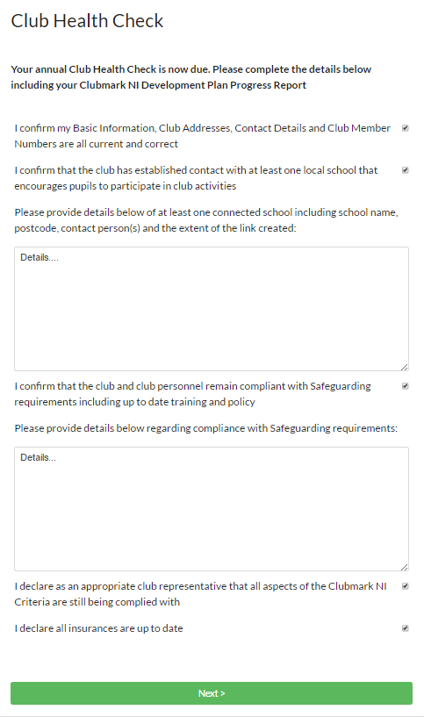

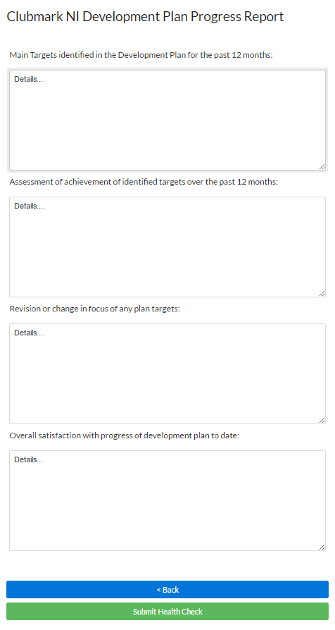

Once you have submitted the health check, you will see the following message confirming that it has been submitted successfully.
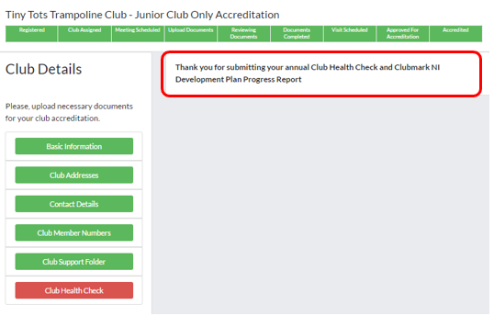
The Local Authority or Governing Body will then review your submission and if they are happy with the information you have provided, they will approve it and your next health check will be scheduled in the system.
The next time you log into the account, the ‘Club Health Check’ button will have been removed until your health check becomes due again.
Note: Please ensure that your ‘Health Check’ has been filled in and submitted in a timely manner to avoid any delay in maintaining your accreditation. Be aware that Sport NI reserve the right to suspend a club’s accreditation at any time.

Renewal
In order to maintain your club’s accreditation, you will be required to perform a ‘Renewal’ when your club reaches the end of its three year (maximum) accreditation period. When this becomes due, you will be notified by email and the re-accreditation process will begin.
When you now log into your club account, the following message will be displayed prominently.

Your Reaccreditation Is Now Due
Your club reaccreditation is now due. Please make sure all your details are up to date. To
continue with your reassessment please proceed to your Club Support Folder, ensure all
your documentation is up to date and click 'Submit for Reassessment'.
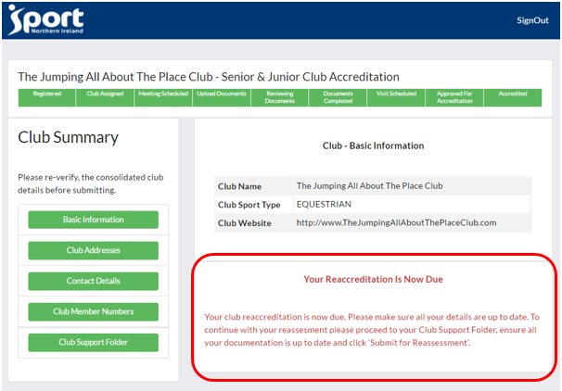
Review your documentation in a timely manner and upload any changes to the system in the same way as you did for your initial accreditation (please refer to section 2.2.4.1 – Uploading Documentation in this document for more information).
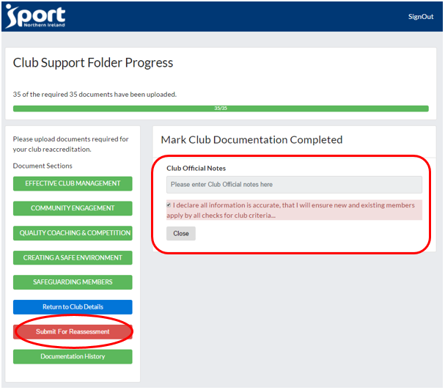
Clicking the ‘Submit For Reassessment’ button will display the ‘Mark Club Documentation Completed’ panel. You may add a note but ensure that the declaration checkbox has been checked as the system will not allow you to proceed otherwise. Then click ‘Close’ to complete.

The ‘renewal’ will then follow the same process as the initial accreditation; the documents will be reviewed by your Local Authority or Governing Body, an Inspection Visit will be scheduled and carried out before your accreditation can be renewed.
Note: Please ensure the required documentation has been updated and uploaded in a timely manner to avoid any delay in renewing your accreditation. Be aware that Sport NI reserve the right to suspend a club’s accreditation at any time.

Automated Email Notifications
As you go through the registration and accreditation process, you will be notified automatically via email as your application’s state changes. Note that the Local Authority that you selected in the ‘Club Addresses’ screen will also receive copies of selected emails to ensure that they are kept informed.
On successful completion of the online club registration, you will receive two automated email notifications:
- Subject: CLUB ACCOUNT CREATED
To: Club ONLY
CC: none
Dear User
Your login account to the Clubmark NI Online portal has been created for username {your email address}. Please complete your application for submission to Sport NI.
Clubmark NI Online

- Subject: CLUB REGISTRATION SUCCESSFUL
To: Club & Local Authority
CC: none
Dear {Club Name}
We have received your registration and will assign you to the appropriate Clubmark NI scheme. The managing agent for the scheme will then contact you to discuss how to progress your accreditation.
Clubmark NI Online

After your application has been assigned to a managing agent (LA/GB), they will then schedule an ‘introductory meeting’ unless you specified ‘no’ during the registration process. The application status will move to ‘Meeting Scheduled’ and the following email will be triggered:
- Subject: CLUB INTRO MEETING SCHEDULED
To: Club & Local Authority
CC: Governing Body (if one has been assigned)
Dear {Club Name}
An Introductory meeting has been scheduled for 2017-05-25T13:30:35.091Z with {Local Authority or Governing Body representative’s name}. In this meeting you will be provided with information on the requirements to attain accreditation and the support available to achieve Clubmark NI accreditation.
Clubmark NI Online

When the ‘introductory meeting’ has been completed or if no meeting was requested, the application goes to ‘Upload Documentation’ status and the following email is dispatched:
- Subject: AWAITING CLUB DOCUMENTATION UPLOAD
To: Club & Local Authority
CC: none
Dear {Club Name}
As part of the accreditation process, we need you to upload supporting documentary evidence of adherence to Clubmark NI standards. Please access your club portal here {url} and upload supporting documentation required. Further detail of the evidence required can be found here {url}. Should you have any queries please contact your Support Officer.
Clubmark NI Online

Once you have uploaded and submitted all the requested documentation, your club’s application status will move to ‘Documents Completed’ and the following automated confirmation email will be sent:

- Subject: DOCUMENTATION RECEIVED FOR PROCESSING
To: Club & Local Authority
CC: Governing Body (if one has been assigned)
Dear {Club Name}
Thank you for uploading the required documentation. The next stage of the process will be a scheduled club visit during a club session. {Local Authority or Governing Body representative’s name} will be in contact shortly to arrange a suitable date and time for the club visit to take place.
Clubmark NI Online

If for any reason the local authority or governing body’s reviewer requires more information or has any issues with the documentation that you have provided, they will update your application. This changes its status to ‘Reviewing Documents’ and thus triggering the following automated email:

- Subject: DOCUMENTATION REVIEW REQUIRED BY CLUB
To: Club & Local Authority
CC: none
Dear {Club Name}
We have received your application and require you to review aspects of the documentation previously uploaded. Can you please login to your portal {url} and review club documentation notes for details of required amendments.
Clubmark NI Online

Once the local authority or governing body’s reviewer is happy with the documentation, they will schedule the ‘inspection visit’, changing the application’s status to ‘Visit Scheduled’ and sending the following notification:

- Subject: CLUB VISIT SCHEDULED
To: Club & Local Authority
CC: Governing Body (if one has been assigned)
Dear {Club Name}
A club visit has been scheduled for 2017-05-26T14:59:23.338Z. During the visit the Clubmark NI Assessor will benchmark your club against the scheme and assess practical evidence to support the policies, processes and evidence within your online submission. The Assessor will be required to speak to a selection of people within the club including participants, parents, coaches and administrators. This will be agreed in advance of the meeting.
Clubmark NI Online

Any successful application will be approved by the assigned local authority or governing body. The club will automatically be notified via email when their status changes to ‘Approved for Accreditation’

- Subject: CLUBMARK NI ACCREDITATION APPROVED
To: Club & Local Authority
CC: Governing Body (if one has been assigned)
Dear {Club Name}
Congratulations. We are pleased to inform you that your Clubmark NI accreditation has been approved. A certificate will be issued to you within one month of accreditation by {Local Authority or Governing Body representative’s name}.
Clubmark NI Online

