Fermanagh and Omagh District Council

Village and Rural SEttlement Enhancement Proposals

EXPRESSION OF INTEREST FORM
AND GUIDANCE NOTES

Introduction

In its role as lead applicant Fermanagh and Omagh District Council wishes to invite Expressions of Interest from eligible settlements who wish to be considered for funding under the Covid Recovery Small Settlements Regeneration Programme.

If you are interested in submitting an Expression of Interest the following conditions apply:

- Valid settlements must have a population of between 50 and 5,000;
- Provide an overview of the proposed project including indicative independent costs;
- Provide evidence that the project has the support of the wider village community by its inclusion in the Village Action Plan, with the Expression of Interest coming from one bona-fide Community Group
(If there is more than one Community Group/Association operating in a village then these Groups will need to come together to agree, prepare and submit the Expression of Interest as only one per village will be accepted);
- Demonstrate that the project is complementary to the current offering in the village and is contained within the Village Action Plan;
- Demonstrate that the project is situated within the 30mph boundaries of the village or rural settlement;
- Demonstrate that the project would be able to commence in September 2022 and complete in March 2023;
- Provide evidence that there are no issues with ownership of the land/ building where the proposed project will take place and that all statutory approvals are in place or can be provided by end of September 2022, this may include planning approvals, lease agreements, and agreements with any other statutory bodies. If statutory approvals are not in place by this date, the project will not be progressed;
- In a competitive process, priority may be given to those villages that have not received Rural Development funding in previous Village Rural Development Schemes and/or COVID-19 Recovery Revitalisation Programme; and
- It is anticipated that the rural funding will be limited to no more than one project from each of the rural District Electoral Areas (DEAs) and outside the boundaries of Omagh and Enniskillen. Please see Appendix 1 for map showing DEAs.

The Expression of Interest form can be downloaded from www.fermanaghomagh.com or a copy can be requested by emailing villagerenewal@fermanaghomagh.com or by contacting the Rural Regeneration Officer on 0300 303 1777.

Completed forms should be returned no later than 12 noon on Thursday 30 June 2022 by email to villagerenewal@fermanaghomagh.com

If you would prefer to submit a hard copy, please send all paperwork in a sealed envelope clearly marked on the outside ‘Village Renewal Expression of Interest’ to Fermanagh and Omagh District Council:

Connect Centre,  16 High Street,  Omagh,  Co Tyrone,  BT78 1BQ | The Townhall,  2 Townhall Street,  Enniskillen,  BT74 7BA

Expressions of Interest received after the closing date and time will be deemed ineligible.

For further information on the Expression of Interest process please contact the Rural Regeneration Officer on 0300 303 1777.

Background

The Covid Recovery Small Settlement Regeneration Programme (CRSSRP) is aimed at regenerating settlements with a population of below 5,000. It is funded in partnership by Department of Agriculture, Environment and Rural Affairs (DAERA), Department for Communities (DfC) and the Department for Infrastructure (DfI). This partnership funding will complement the recently delivered COVID-19 Recovery Revitalisation Programme and provide a mechanism for investing in rural areas to aid recovery from the pandemic.

The programme is aimed at delivering projects that are already well developed and should result in positive, visible impacts in the short term. These projects should contribute to assisting small settlements recover from the COVID-19 pandemic, and complement funding support already provided by the three Departments.

The CRSSRP will provide capital funding to support the regeneration and development of villages in ways which support their important social and economic roles.

Fermanagh and Omagh District Council wishes to invite Expressions of Interest from eligible villages and rural settlements who wish to be considered for funding opportunities for capital projects that would be able to commence in September 2022 and complete in March 2023.

Indicative actions that Council is looking to address and could be supported are:

- the vision of creating village centres which are sustainable, welcoming and accessible to live, work and relax. These include revitalisation, public realm, and comprehensive development schemes;
- infrastructural improvements such as enhanced public realm, better footpaths, street furniture and lighting, and public seating;
- Projects relating to active travel, promoting connectivity and access to services, and/or creating and enhancing green / blue spaces. Potential projects could include:
- cycle tracks or lanes - including pop-up cycle lanes and creating space on pathways for cyclists;
- pavement or footway widening to allow for physical distancing;
- cycle parking and charging facilities;
- connection pathways to access town centres the centre of settlements and key services – adapting existing routes and/or creating desirable new ingress and egress routes;
- tree planting incidental to creating/improving walking or cycling paths; and
- parklets, rain gardens, living roofs and living vertical gardens.
- dereliction and vacant site enhancement;
- environment improvements;
- conservations and upgrading of rural culture (natural and built);
- gateway projects;
- walkways, nature trails and play facilities (subject to compliance to the Council’s Play Park Strategy);
- sign posting local heritage features;
- improving physical access to amenities or attractions; and
- entrance features and signage.

Funding Options

The funding will be administered as support for up to 8 stand-alone village projects identified within their Village Plan, with project funding of £50,000 (minimum) to £100,000 (maximum) at a rate of 90% per project with the potential for 10% match funding contribution from the Council. There is no requirement for the group to make a contribution to this funding.

To be considered for participation in the programme Village’s must complete and submit an Expression of Interest.

Expressions of Interest will be assessed and scored against an agreed ‘Village Renewal Selection Framework’.

PLEASE NOTE: This is a competitive programme. The submission of an Expression of Interest is MANDATORY for villages to be considered under the Village Renewal Scheme but DOES NOT indicate that your village will be selected for participation in the programme.
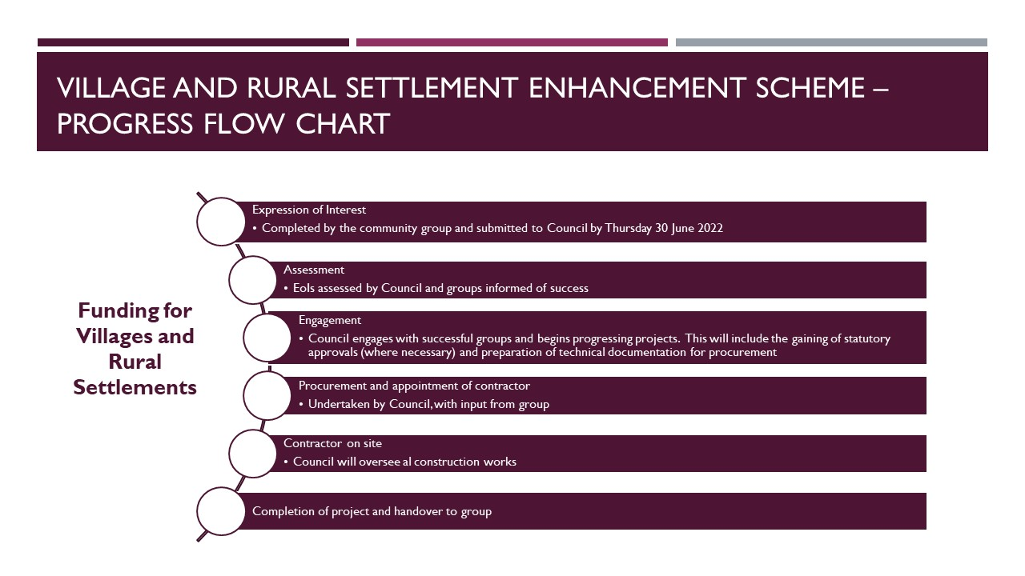

Covid Recovery Small Settlements Regeneration Programme

Village and Rural Settlement Enhancement Proposals

Expression of Interest Form

Applicant Details
1 | Organisation Name
 | Address
 | Town
 | Postcode
 | Contact Person
 | Position in Organisation
 | Address for Correspondence (if different from above)
 | Telephone Number:
 | Mobile Number:
 | Email:

2 | Does the village you represent have between 50-5,000 inhabitants? (please tick) If yes, approximately how many inhabitants are there?
YES |  | NO

Please state the approximate number of inhabitants (if known): ____________________

3 | Please provide an overview of the proposed project including (where relevant) Designs and Drawings

4 | Please provide indicative project costs
Works | Costs (approximate)
Anticipated Total Costs

5 | Please provide a potential start date and estimated period of works
6 | Please give details of the ownership of the land/site/building and provide evidence for example Title Deeds, Lease Agreement etc.
7 | Please provide evidence that the project has the support of the wider village community and that the project is contained within the Village Action Plan
8 | Do the proposed works require Planning Permission. If so, please provide evidence of the approval, or suggested timeframe for submission and approval.
9 | Do the proposed works require any other Statutory Approvals. If so, please provide details
10 | Please summarise any public funding (Council, Central Government, EU or other) that has been granted in the past five years and how it has been invested

I/we can confirm that the details supplied are true and correct to the best of my/our knowledge.

Name(s): Block Capitals

Signed

Village Organisation ___________________________________________________________

The closing date and time for the submission of completed Expression of Interest Forms is

12.00 noon on Thursday 30 June 2022
Expression of Interest Forms received after this date and time will be deemed ineligible.

Appendix 1

Map of District Electoral Areas (DEAs) within Fermanagh and Omagh District Council
