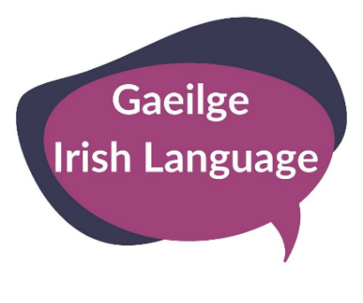

Volunteer
Registration
Pack

To register for Volunteer Opportunities please complete this pack and return to:
volunteer@fermanaghomagh.com
or one of the following addresses:

Human Resources
Fermanagh and Omagh District Council
Townhall
2 Townhall Street
Enniskillen
Co. Fermanagh
BT74 7BA

Human Resources
Fermanagh and Omagh District Council
The Grange
Mountjoy Road, Lisnamallard
Omagh
Co. Tyrone
BT79 7BL

Volunteer Role Description:
Irish Language Assistant
V024

What is an Irish Language Assistant?
This opportunity allows individuals to welcome participants and support the delivery of Irish Language classes and activities.

Main Volunteering Tasks:
- Meeting & greeting participants;
- Facilitating Irish Language conversations with Irish Language learners of all levels,
- Facilitating Irish Language activities at organised events
- Encouraging confidence building in learners;
- Supporting Irish Language learners at events and activities;
- Learning music to accompany singing in Irish (not essential);
- Playing music to accompany singing in Irish (not essential).
- To comply with all the Council’s policies and procedures.
- To undertake volunteering at all times in a manner that enhances and promotes the positive image of Fermanagh and Omagh District Council.

Supervisor:
Irish Language Officers
Location:
Strule Arts Centre, Enniskillen Castle and occasionally other venues district wide
Dates/ Time of Volunteering:
Wednesday and Thursday evenings, Saturday daytime and occasional performances throughout the year.
Closing Date: Friday 19th July 2019, 12 noon

The volunteering may be subject to:
- Two References
- Access NI Check (where appropriate)
Volunteer Registration Form

Please note: the information you give on this form will be used to match potential volunteers with the most appropriate opportunity at the time the registration form is received.
In accordance with the Data Protection Act 2018, Fermanagh and Omagh District Council has a duty to protect any information we hold on you. The personal information you provide on this form will only be used for the purpose of arranging meetings and times for volunteering and will not be shared with any third party unless law or regulation compels such a disclosure and will be shared with other relevant internal services for the purpose of volunteering. For further guidance on how we hold your information please visit the Privacy section at www.fermanaghomagh.com/your-council/privacy-statement/

Contact Details:
Name:
Address:

Postcode:
Date of Birth:
Telephone Number:
Email Address:

Emergency Contact Name:
Emergency Contact Phone Number:

Please tell us why you are interested in volunteering with the Council:

What skills, knowledge and/or experience do you have that will help in this volunteering role:

Please indicate if there any additional support that you would require whilst volunteering (For example medical/ health needs, dietary requirements or access requirements).

Please provide two referees (who are not relatives) that can be contacted to provide a reference:
Name:
Address:

Postcode:
Telephone Number:
Email Address:

Name:
Address:

Postcode:
Telephone Number:
Email Address:

Signed _______________________________________

Date _______________________________________

Thank you for your interest.

Thank you for your interest in volunteering with Fermanagh & Omagh District Council

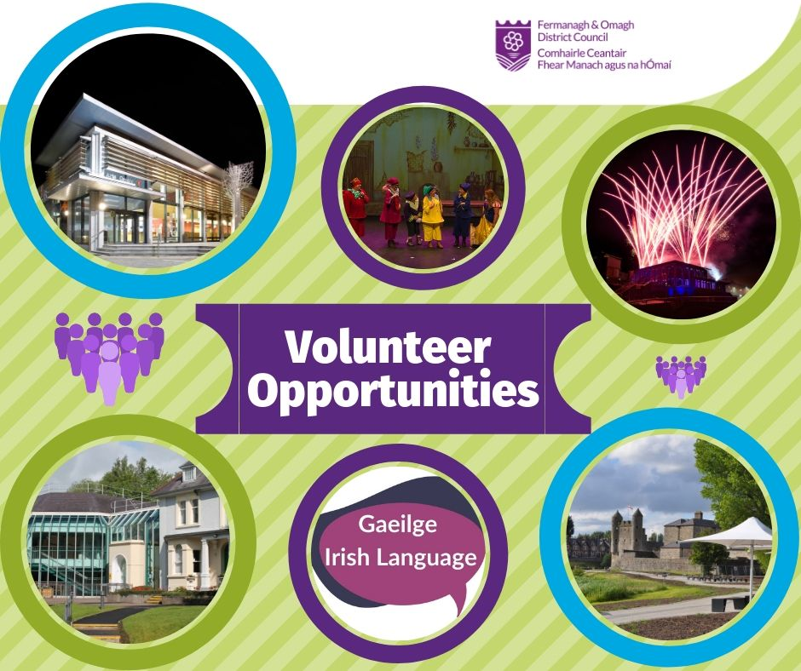

Fermanagh and Omagh District Council
Equal Opportunity Monitoring Sheet

In accordance with the Data Protection Act 2018, Fermanagh and Omagh District Council has a duty to protect any information we hold on you. The personal information you provide on this form will only be used for the purpose of Equal Opportunity Monitoring only and will not be shared with any third party unless law or regulation compels such a disclosure and will be shared with other relevant internal services for the purpose of volunteering. For further guidance on how we hold your information please visit the Privacy section at www.fermanaghomagh.com/your-council/privacy-statement/

Fermanagh and Omagh District Council is committed to achieving fairness and equality. We want to ensure that information stored on Council Volunteers is both up-to-date and accurate, in relation to Section 75 and Equality Monitoring.

In order to achieve this goal, we need your help. One of the most important ways of doing this is by monitoring our Volunteers across eight of Section 75 categories. The information provided will be used by Fermanagh and Omagh District Council to assist in complying with our statutory duty under the Northern Ireland Act 1998 and will be reported to the Council’s Policy and Resources Committee.
All information will be collated confidentially and stored securely. Final reports will contain overall statistics and will not include names, or the ability to match certain statistics to individual employees.

Fermanagh and Omagh District Council Equality Monitoring (Volunteers)

- Religious Belief

Do you have a religious or denominational belief? Yes No
If Yes are you:
Bahai Hindu Presbyterian
Baptist Jewish Roman Catholic
Buddhist Methodist Sikh
Church of Ireland Muslim Other

- Political Opinion.
How would you describe your political opinion?

Unionist generally Nationalist generally Other

- Racial Group
To which of these Racial Groups do you consider you belong?
Bangladeshi Chinese Pakistani
Black African Indian White
Black Caribbean Irish Traveller Other
Black (Other) Mixed Ethnic Group

- Age.
  - 16-29 30-44 45-59 60-74 75+

- Marital Status.
Civil Partnership Single Widowed
Co-habiting Separated
Divorced Married

- Sexual Orientation.
How would you describe your sexual orientation?
Heterosexual Homosexual (Gay or Lesbian) Bi-sexual

- Gender.
Female Male Trans-gendered

- Disability.
Under the Disability Discrimination Act 1995, a disabled person is defined as a person with “a physical or mental impairment which has a substantial and long-term effect on his/her ability to carry out normal day to day activities”.

Do you consider that you meet this definition of disability? Yes No
If yes, please state the type of disability,

Visual Impairment Communication Difficulty Learning Difficulty
Hearing Impairment Multiple Impairment
Mobility Impairment Learning Difficulty

- Dependants.
We are asking you to tell us something about your caring responsibilities. By that we mean looking after a child, whether as a parent, guardian or foster parent, or helping an adult carry out their daily routine. This might mean providing assistance to an adult relative or friend who is disabled or has a long-term illness.

I look after children I help an adult with their daily routine N/A

Please indicate how often you undertake these responsibilities:

Daily Frequently Occasionally

For office use only:
Date Received:

