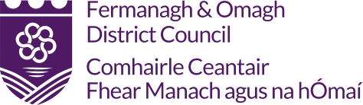
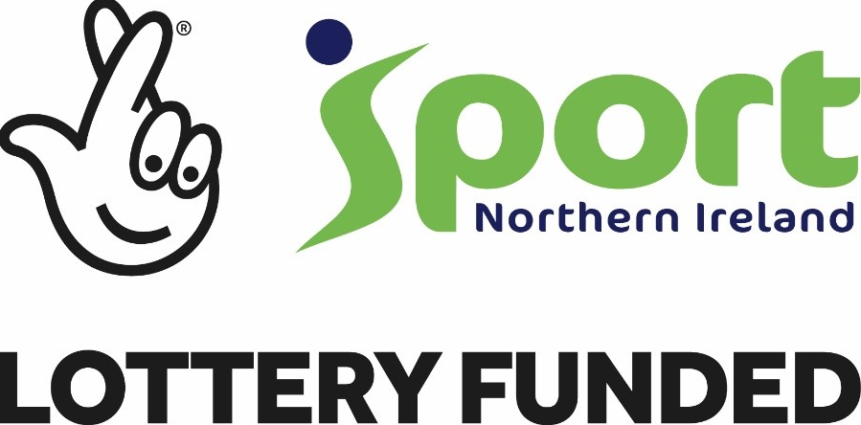
EVERY BODY ACTIVE 2020 PROGRAMME
PARTICIPANT REGISTRATION FORM
1. CONTACT DETAILS
First Name:_____________________________ | Surname:_________________________________
Address: _________________________________________________________________________
_________________________________________________________________________________
Postcode: _______________________________
Email address: ____________________________________________________________________
Contact Number: _________________________ Emergency Contact: ________________________

2. GENDER:
Male  | Female 

3. D.O.B: ___/___ /___

5. MEDICAL CONDITION – Please state any medical condition(s) that the coach may be required to know ____________________________________________________________________________
4. DISABILITY
Do you have a disability or life long illness? | Yes  | No 

_________________________________________________________________________________
Sport Northern Ireland Every Body Active 2020 (EBA 2020) Privacy Notice
I agree to the following;
- The information provided in this form is correct and accurate.
- The information provided in this form will be shared with our programme Partners (Local Council) in the area you currently reside.
- This information will be for used for research and analysis of participation figures in council run sport and fitness activities/classes as part of the Every Body Active 2020 programme.
- Photos may be taken at events and used for promotional purposes (participants will be notified of this before session begins) – Can be removed as you are asking their permission to take photos on the next page.
- Sport NI, as the Data Controller, will retain this information in line with their Retention and Disposal Policy.
- Fermanagh and Omagh District Council will retain this information for one year following the end of the EBA2020 programme.

6. DECLARATION
I give permission to be photographed and / or filmed while participating in sporting activities associated with the Every Body Active 2020 Programme.
Yes  | No 
I understand that while participating in this programme, injuries may occur for which coaches are not directly responsible.
Signed: | Date:

Please note that this Participant Registration Form must be signed by a parent / guardian, if the participant is under 18 years of age.

Fermanagh and Omagh District Council / Sport Northern Ireland would like to contact you for the following reasons (please tick options below) –
To take part in EBA2020 surveys with the aim of improving services.
To offer tailored activities/classes based on your analysed data.
To offer incentive schemes for EBA2020 participation.
To offer opportunity to participate in programme focus groups giving feedback on the programme with the aim of improving future services/programmes for your community

